Table 3. Genotype distributions of SNPs
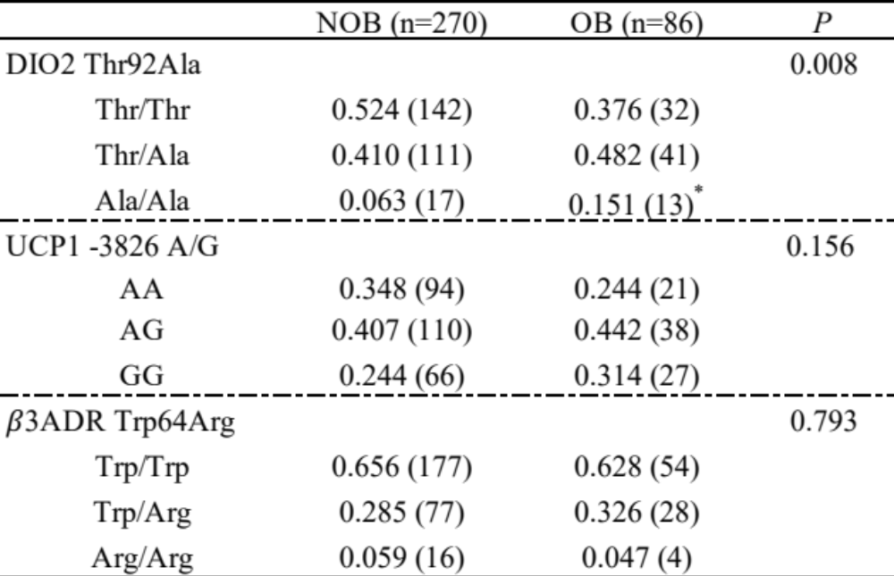
Numbers in the parentheses indicate the number of the subjects. *Compared to
the NOB group on the Thr/Thr and Ala/Ala genotype (P = 0.004).

