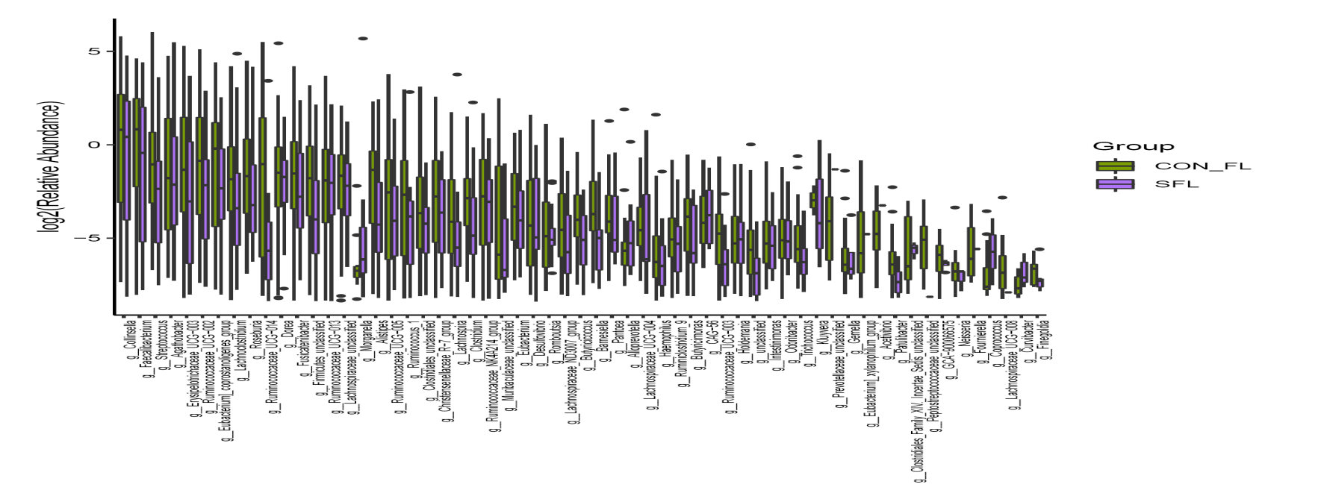
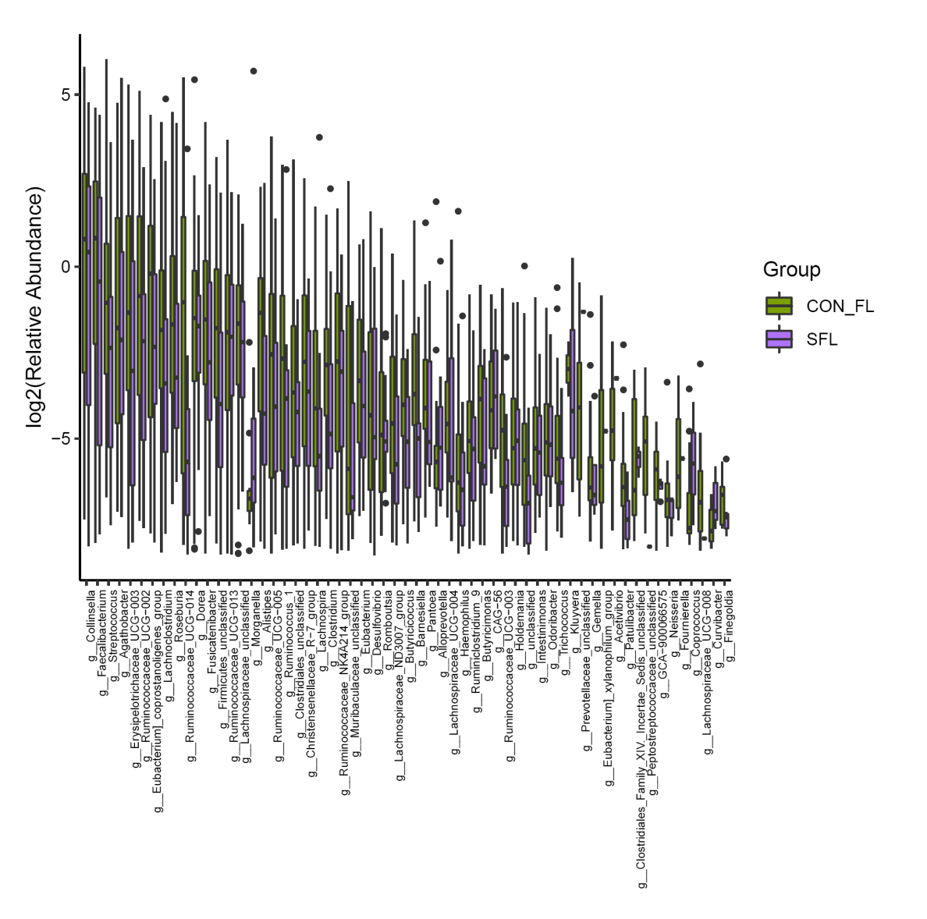
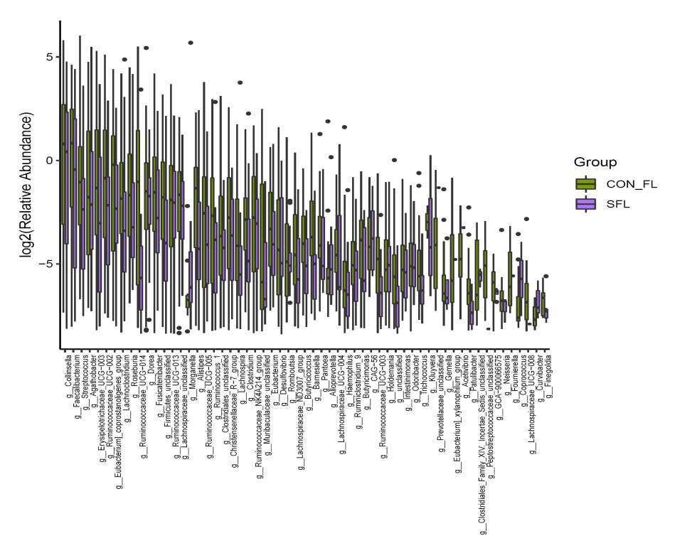
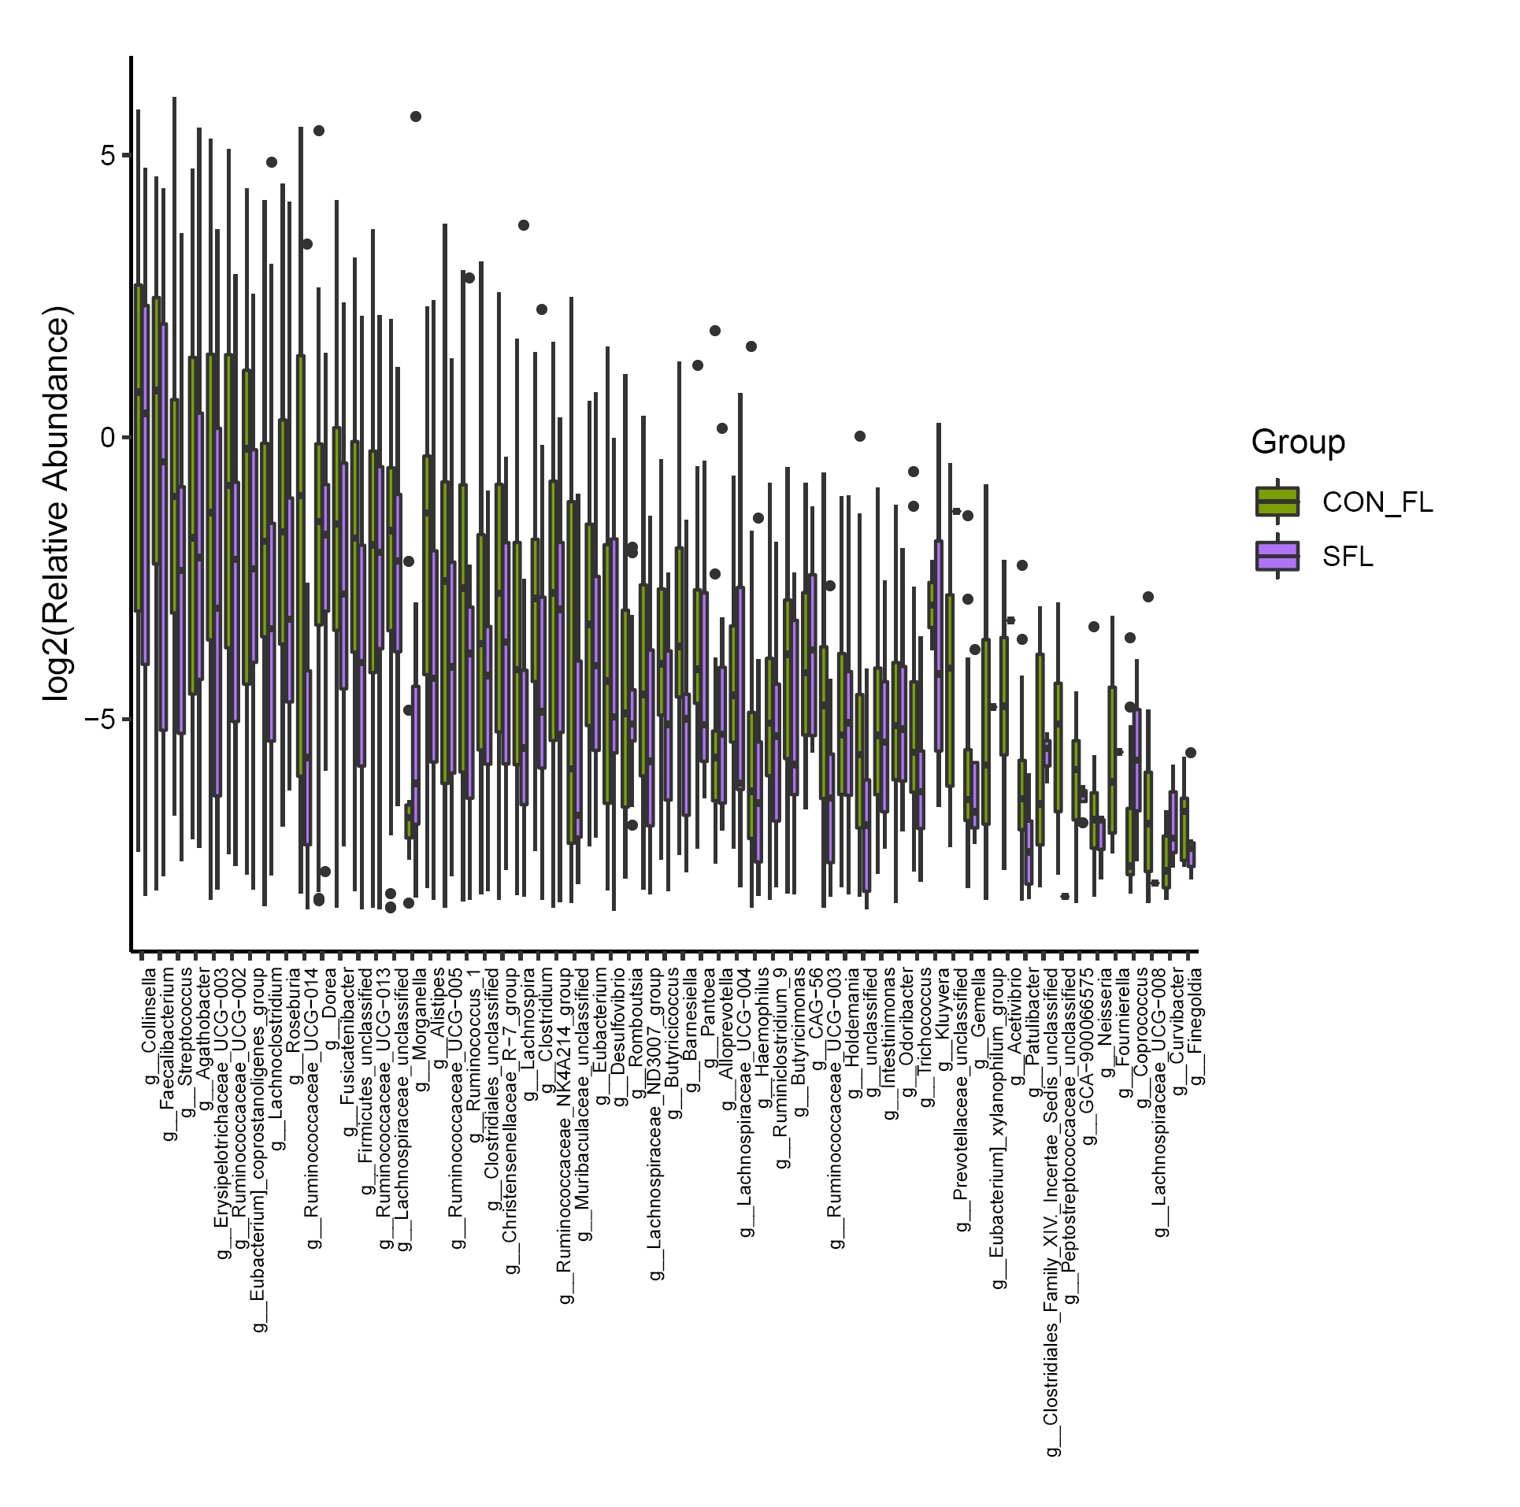
non-PDR
PDR

Fig. S1 The significant altered bacteria at genus level in proliferative diabetic retinopathy (PDR) patients

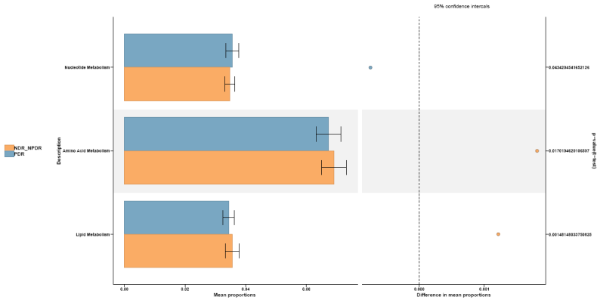

Nucleotide metabolism
Amino acid metabolism
Lipid metabolism
Difference in mean proportions
Mean proportions
0.02
0.04
0.06
0
0
0.001
95% confidence intervals
non-PDR
PDR
0.043
0.017
0.015
P-value

Fig. S2 The enriched pathways of significantly differential expressed metabolites between patients with and without proliferative diabetic retinopathy (PDR).

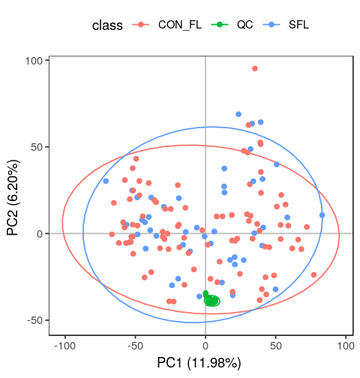
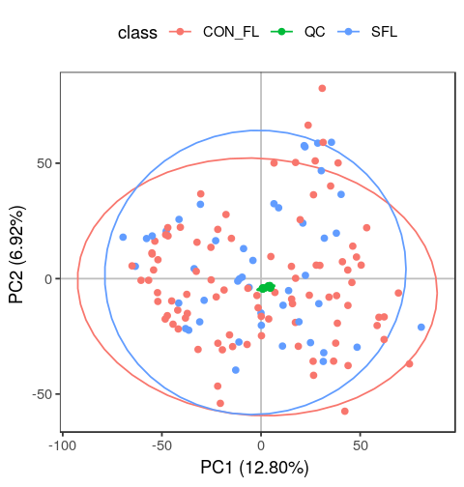
Positive
Negative
PDR
non-PDR
QC
PDR
non-PDR
QC

Fig. S2 Principal component analysis (PCA) score plots of metabolomics data. PDR, proliferative diabetic retinopathy; QC, quality control.

