SUPPLEMENTARY MATERIAL
for
The spatial resolution of micro-Raman spectroscopy for particulate LiFePO₄
Alexander A. Ryabin and Dmitry V. Pelegov *
Institute of Natural Sciences and Mathematics, Ural Federal University, Ekaterinburg, Russia
(*) Corresponding author: dmitry.pelegov@urfu.ru
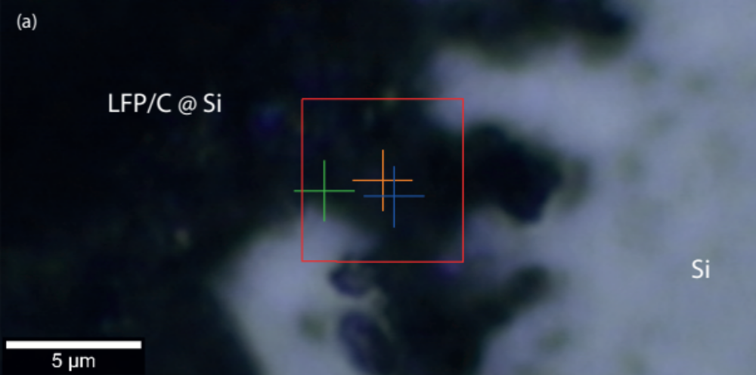
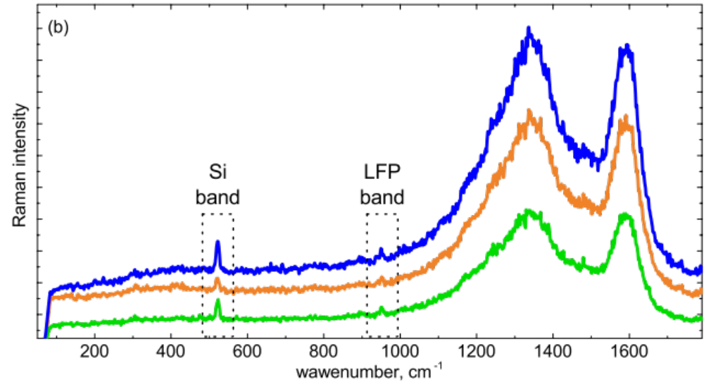
Fig. S1. The demonstration of the large probing depth for LFP/C powder on a Si substrate. Colored cross-marks at the optical image (a) indicate the locations of Raman spectra measurements (b). Color of the cross-mark corresponds to that of the Raman spectra.

Fig. S2. The illustration of non-reproducible enhancement of Raman response from Si substrate via comparison of SEM (a)-(c) and optical (d)-(f) images with Si substrate maps. Si mapping regions are marked by red rectangular at the corresponding optical images.
Fig. S3. The experimental results of the spatial resolution estimation. Intensity profiles were carried out using “scanning-knife method” for Cr-covered LiNbO₃: 874 cm⁻¹ peak amplitude is measured as a function of lateral displacement for horizontal (b) and vertical (a) phase boundary. The curve has been approximated by $I(x)=\frac{I_{0}}{2}(1+erf⁡(\frac{\sqrt{2}(x_{0}-x)}{w(Z)}))$, where w(Z) is the beam waist, x₀ is the position where the edge is in the middle of the beam, I₀ is the maximum intensity, and erf is the error function. Depth profiling of Si plate: dependences of the 521 cm⁻¹ peak amplitude on the Z-axe shift (c).

