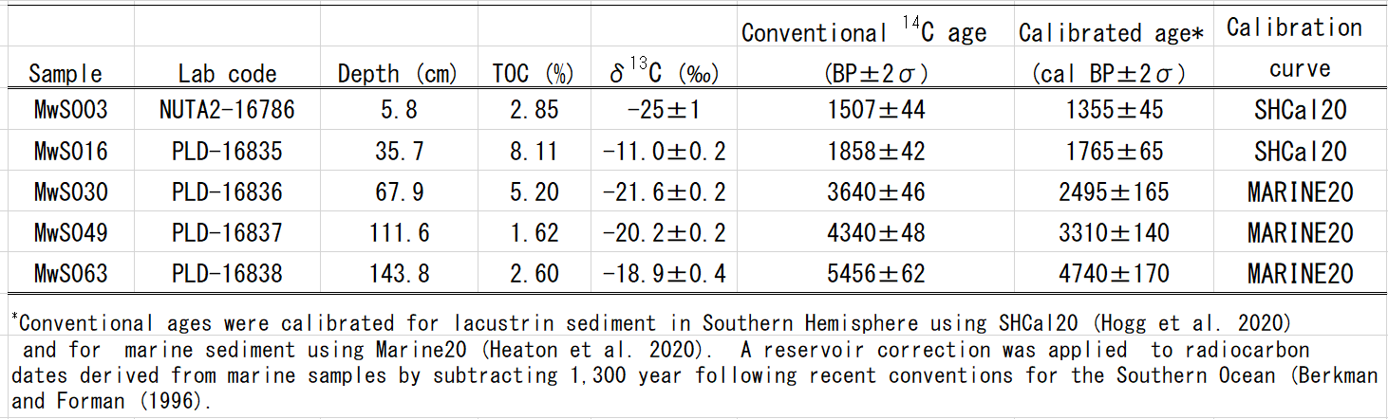
Table 1 Conventional and calibrated ages of the MwS4C-01 sediment core from Lake Maruwanminami-ike.

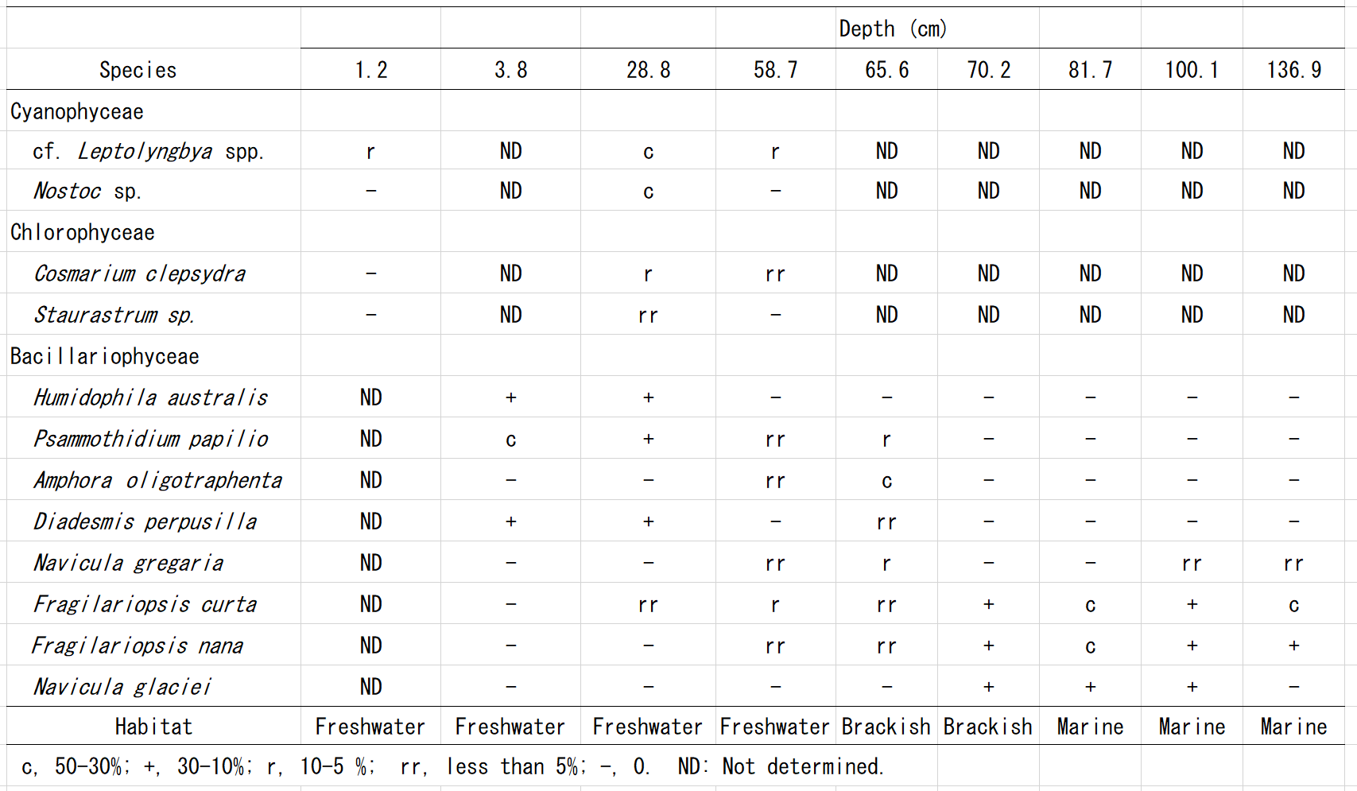
Table 2 Algae and cyanobacteria found in the MwS4C-01 sediment core from Lake Maruwanminami-ike.

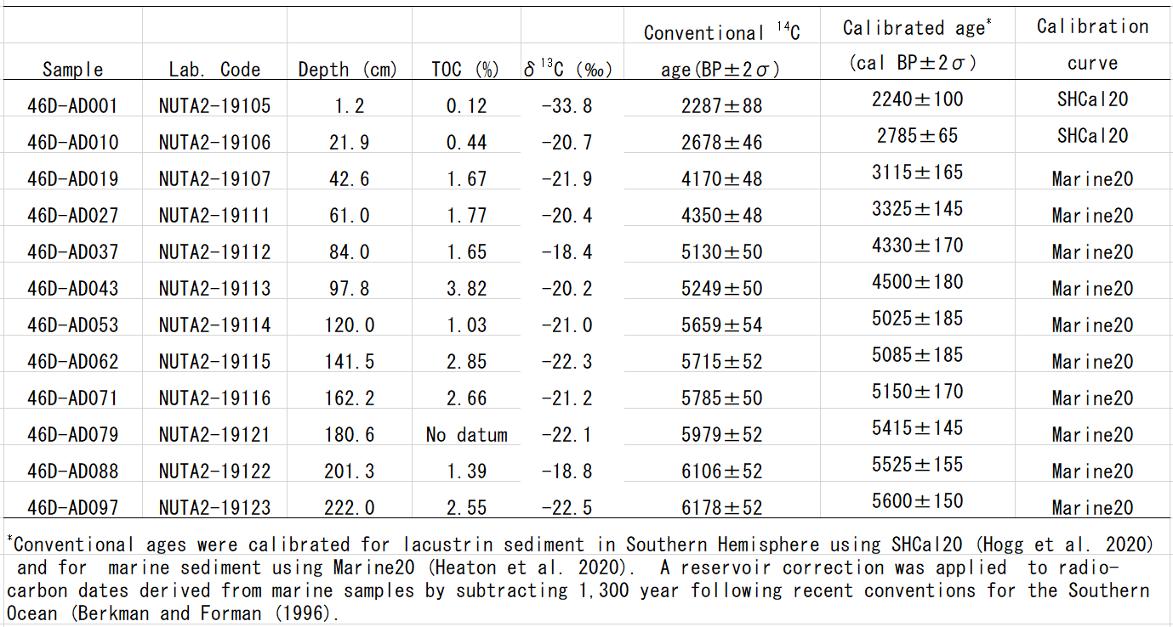
Table 3 Conventional and calibrated ages of the Mw4C-01 sediment core from Lake Maruwan-oike.

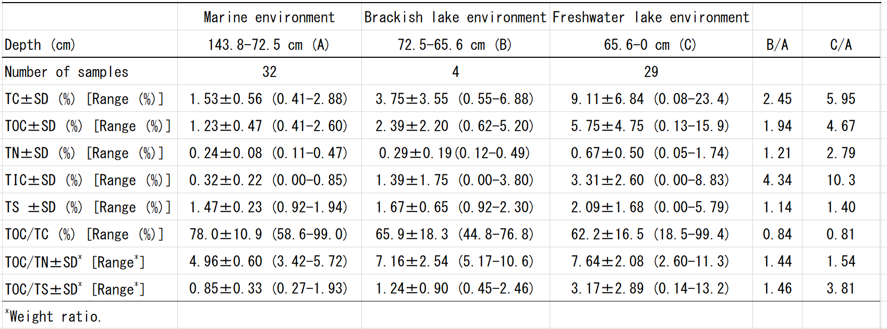
Table 4 TOC, TN, TS contents and their ratios (average±standard deviation) for the MwS4C-01 sediment core from Lake Maruwanminami-ike.

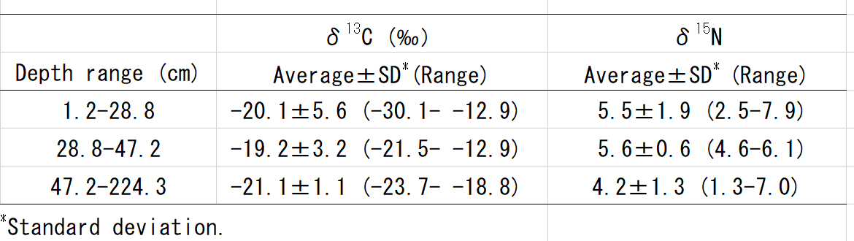
Table 5 Isotope ratios of δ¹³C and δ¹⁵N in the Mw4C-01 sediment core from Lake Maruwan-oike.

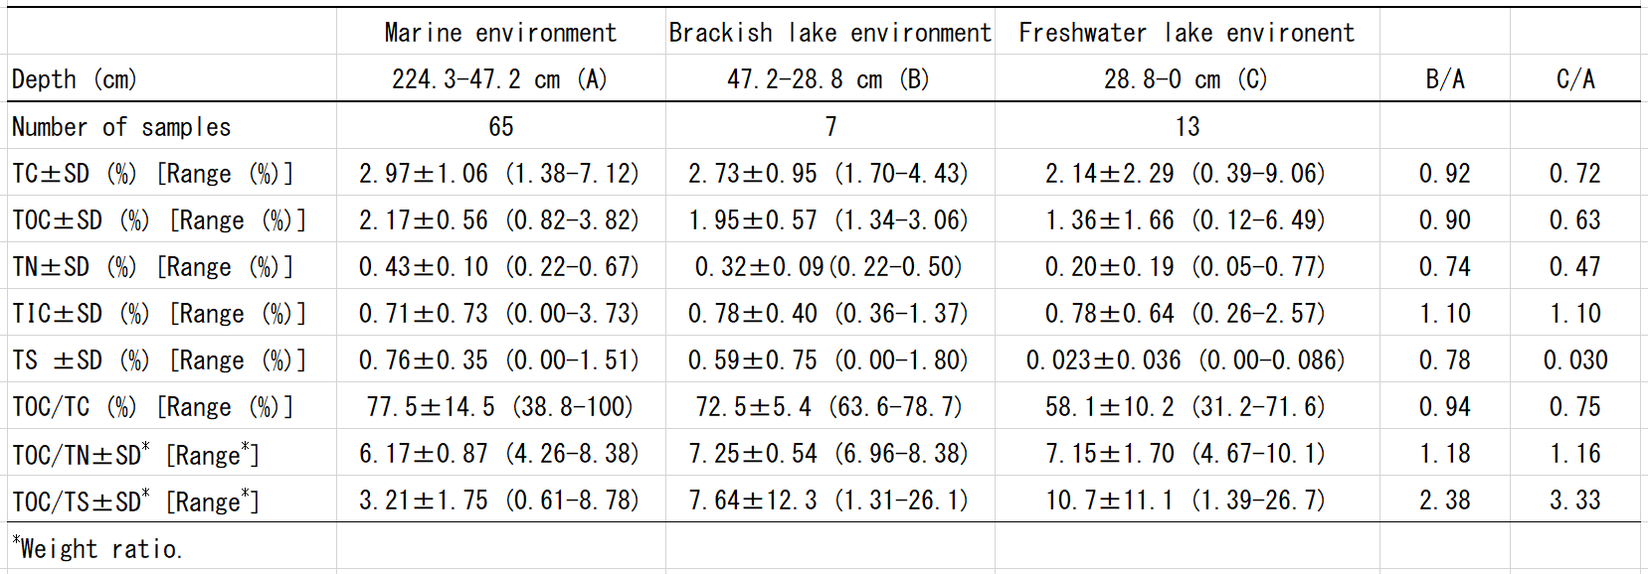
Table 6 TOC, TN, TS contents and their ratios (average±standard deviation) for the Mw4C-01 sediment core from Lake Maruwan-oike.

Table 7 Relative sea level (RSL), transition ages and glacio-isostatic uplift rates (GIUR) of raised beaches and isolated basins in the Soya Coast region and East Antarctica.
