Supplementary Information

Table S1 CNS elemental data in the MwS4C-01 sediment core from Lake Maruwanminami-ike.
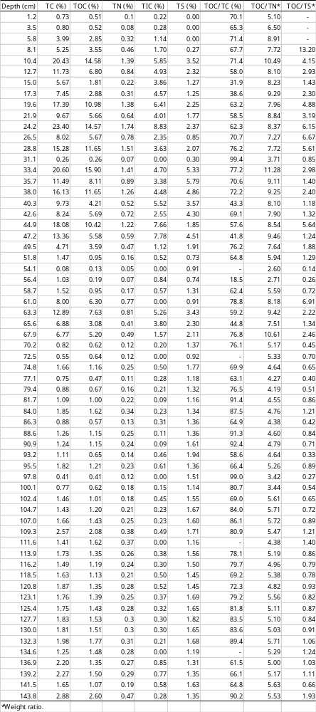
Table S2 Hydrocarbons found in the MwS4C-01 sediment core from Lake Maruwanminami-ike (%).
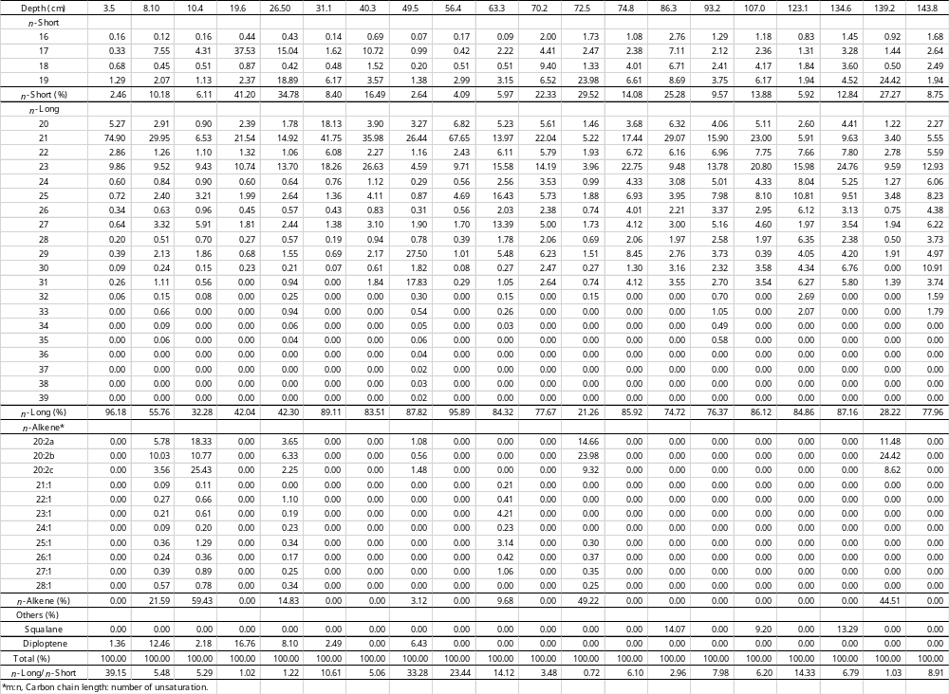

Table S3 Fatty acids found in the MwS4C-01 sediment core from Lake Maruwanminami-ike (%).
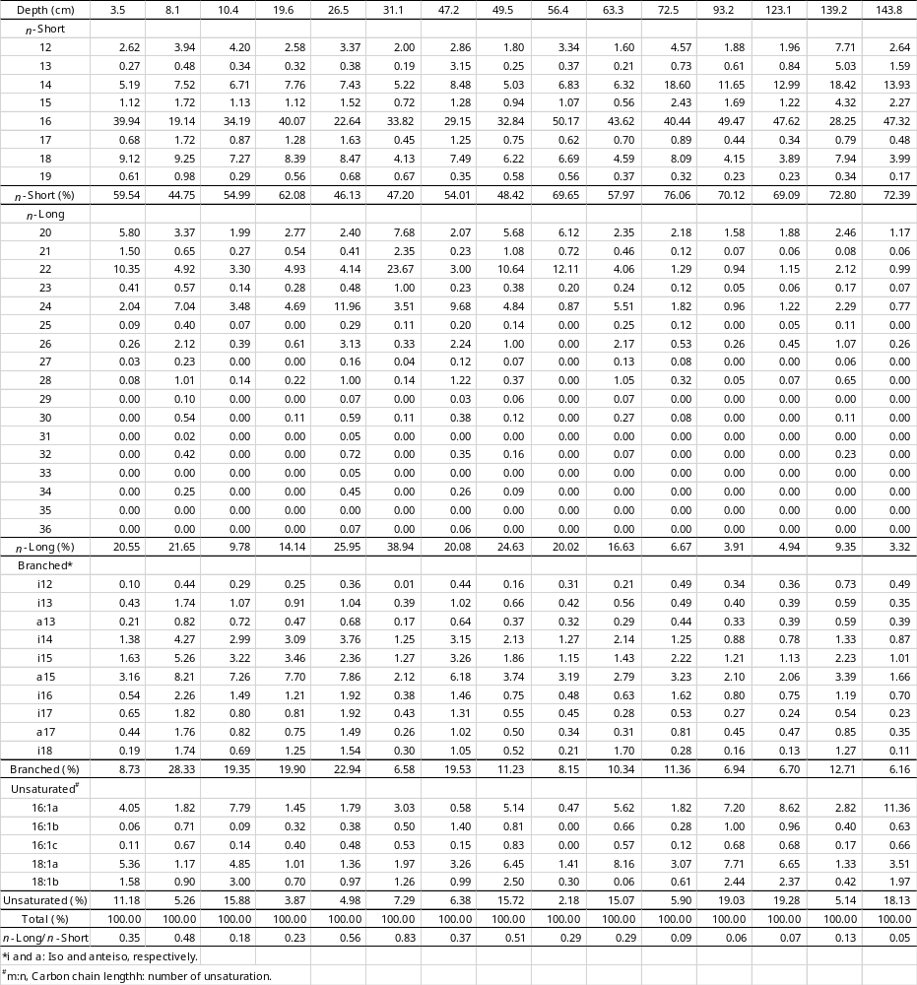

Table S4 Sterols found in the MwS4C-01 sediment core from Lake Maruwanminami-ike (%).
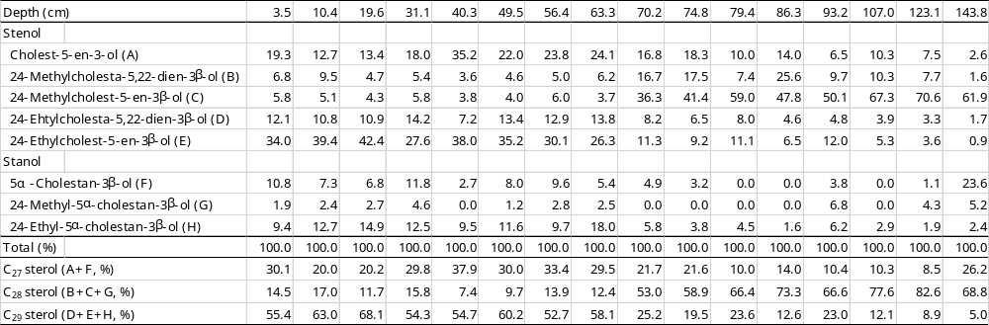

Table S5 Chlorophyll compounds and carotenoids found in the MwS4C-01 sediment core from Lake Maruwanminami-ike (μg/g).
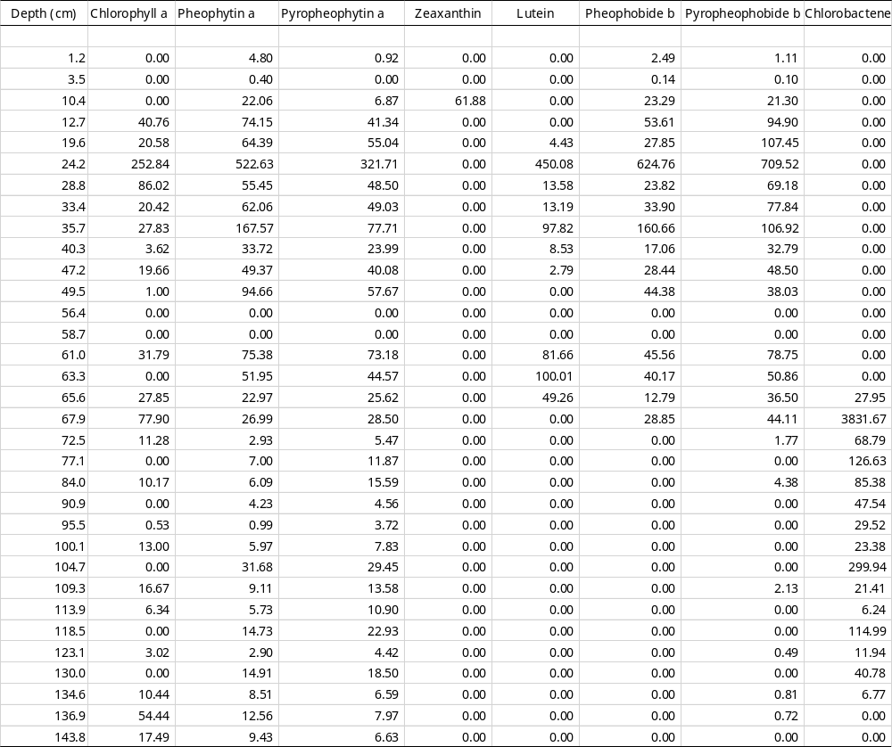

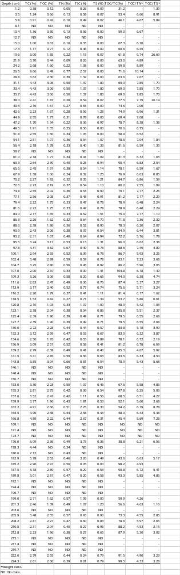
Table S6 CNS elemental data in the Mw4C-01 sediment core from Lake Maruwn-oike.

Table S7 δ¹³C(‰) and δ¹⁵N(‰) values in the Mw4C-01 sediment core from Lake Maruwan-oike.
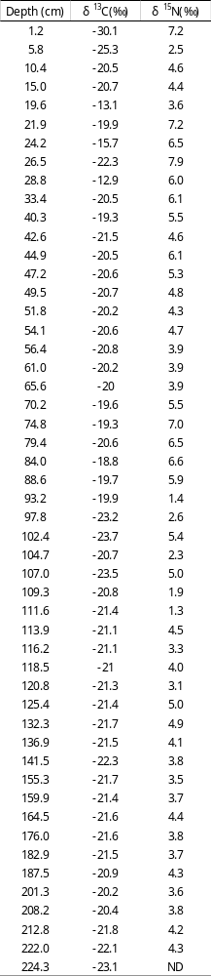

Table S8 Chlorophyll compounds and carotenoids found in the Mw4C-01 sediment core from Maruwan-oike (μg/g).
