Supporting Data for:
Optimal Allocation of Tomato Supply to Minimize Greenhouse Gas Emissions in Major U.S. Metropolitan Markets
Eric Bell¹, Yuwei Qin¹, Arpad Horvath¹
¹Department of Civil and Environmental Engineering, University of California, Berkeley, CA 94720, USA

Table of Contents
S1. Production 1
S2. Processing 2
S3. Packaging 3
S4. Transportation 3
S5. Uncertainty assessment 4
S6. Figures of cradle-to-market GHG emissions for other cities 5
S7. Figures of tomato supply portfolio for other cities 14
S8. Figures of environmental impact of fresh tomatoes delivered to the other cites 22

S1. Production
The life-cycle GHG emissions of producing open-field tomatoes were directly calculated using the methodology and emission factor described in Bell et al. 2018¹. The GHG emissions of tomatoes produced in protected environment come from various literature.

Table S1. Annual yields and GHG emissions from production of fresh tomatoes.
Production region and method | Annual yield (2011-2019 avg) kg/ha ² | Carbon footprint from production kgCO2e/kg
California | 100,316 | 0.25 ³
California_GH |  | 1.65 ⁴
Florida | 33,625 | 0.28 ³
Florida_GH |  | 1.65 ⁴
Mexico | 28,521 | 0.32 ³
Mexico_AE |  | 0.37 ⁴
Mexico_CE |  | 1.80 ⁴
South Carolina | 41,471 | 0.34 ³
Virginia | 32,505 | - ³

S2. Processing
Table S2. Processing stage and electricity consumption of fresh tomatoes.
Stage |  | Electricity use [kWh/metric ton] | Source
Short-term cold storage |  | 35 | ⁵
Total |  | 35

Table S3. Electricity portfolio by production region.
Production region | Coal | Oil | Gas | Nuclear | Hydro | Biomass | Wind | Solar | Geothermal | Source
California | 0.1% | 0.2% | 43.0% | 8.1% | 19.2% | 2.9% | 6.8% | 14.2% | 5.5% | ⁶
Florida | 20.1% | 1.0% | 68.5% | 8.1% | 0.1% | 2.1% | 0.0% | 0.1% | 0.0% | ⁷
Mexico | 11.2% | 11.0% | 57.1% | 3.2% | 12.9% | 1.2% | 2.5% | 0.8% | 0.2% | ⁸
South Carolina | 17.0% | 0.2% | 28.6% | 51.8% | 1.8% | 0.2% | 0.3% | 0.1% | 0.0% | ⁹
Virginia | 4.2% | 0.6% | 63.2% | 31.6% | 0.0% | 0.1% | 0.2% | 0.1% | 0.0% | ¹⁰

Table S4: Life-cycle GHG emission factors for electricity production ¹¹.
 | Coal | Oil | Gas | Nuclear | Hydro | Biomass | Wind | Solar | Geothermal
gCO2e/kWh | 897 | 877 | 497 | 17 | 24.5 | -384 | 18.1 | 90.3 | 75.8

Table S5: Calculated life-cycle electricity GHG emission factors and GHG emissions from post-harvest processing of fresh tomatoes.
Production region | Life-cycle electricity GHG emission factors [gCO2e/kWh] | GHG emissions from post- harvest processing  [kgCO2e/kg tomatoes]
California | 230 | 0.0080
Florida | 523 | 0.018
Mexico | 481 | 0.017
South Carolina | 305 | 0.011
Virginia | 362 | 0.013

S3. Packaging
Tomatoes are usually packaged in 25lb cartons, which is about 11 kg of tomatoes per box. This study assumes the following packaging configuration for all tomato shipments:
Length: 38 cm
Width: 24cm
Height: 23 cm
Thickness: 3.2 mm

Total volume: 0.00067 m³/box
Total mass: 0.060 kg/box


Assuming a density of 90 kg per cubic meter of cardboard and a life-cycle GHG emissions of 1.05 kgCO₂e/kg of cardboard ¹². Thus, the emissions of packaging are 0.063 kgCO₂e/kg of tomatoes.

S4. Transportation
Table S6: Transportation distances between tomato production regions and metropolitan areas [km].
[km] | NY | LA | CH | DA | HO | DC | MI | PH | AT | BO | SF
California | 4685 | 499 | 3425 | 2651 | 2992 | 4535 | 4804 | 4628 | 3856 | 4989 | 166
Florida | 1955 | 4223 | 2047 | 1933 | 1740 | 1572 | 261 | 1782 | 879 | 2279 | 4727
Mexico | 4014 | 2572 | 3058 | 1502 | 1323 | 3644 | 3277 | 3846 | 2639 | 4352 | 3186
South Carolina | 1218 | 3928 | 1442 | 1682 | 1679 | 835 | 901 | 1044 | 430 | 1542 | 4406
Virginia | 578 | 4319 | 1349 | 2160 | 2229 | 206 | 1606 | 406 | 966 | 903 | 4730
*Determined from Google Maps.

Table S7: Transportation emissions matrix for transportation between tomato production regions and metropolitan areas [kgCO₂e/kg oranges].
[kgCO2e/kg] | NY | LA | CH | DA | HO | DC | MI | PH | AT | BO | SF
California | 0.40 | 0.04 | 0.29 | 0.23 | 0.26 | 0.39 | 0.41 | 0.40 | 0.33 | 0.43 | 0.01
Florida | 0.17 | 0.363 | 0.18 | 0.17 | 0.15 | 0.14 | 0.02 | 0.15 | 0.08 | 0.20 | 0.41
Mexico | 0.35 | 0.22 | 0.26 | 0.13 | 0.11 | 0.31 | 0.28 | 0.33 | 0.23 | 0.37 | 0.27
South Carolina | 0.10 | 0.34 | 0.12 | 0.14 | 0.14 | 0.07 | 0.08 | 0.09 | 0.04 | 0.13 | 0.38
Virginia | 0.05 | 0.37 | 0.12 | 0.19 | 0.19 | 0.02 | 0.14 | 0.03 | 0.08 | 0.08 | 0.41
The transportation emission factors used in this analysis include production, distribution, storage, and in-vehicle use of transportation fuels, vehicle, vessel, and aircraft manufacturing and maintenance, and end-of-life processes. In the study, tomatoes are delivered by heavy-duty trucks ¹³.

S5. Uncertainty assessment
The uncertainty sources in the study include the variation in production practices, and uncertainty in packaging materials and emission factors.

Table S8: Probability distributions of factors in Monte Carlo simulation.
Factor | Unit | Distributioin type | Variation | Source
Open-field EF | kgCO2e/kg | Triangular | -20%/+36% | ^{3,4}
AE EF | kgCO2e/kg | Triangular | -65%/+57% | ^{4,14,15}
CE EF | kgCO2e/kg | Triangular | -90%/+70% | ^{4,16,17}
Greenhouse EF | kgCO2e/kg | Triangular | -91%/+68% | ^{4,16,17}
Processing electricity use | kWh | Triangular | -19%/+44% | ¹⁸
Energy EF | kgCO2e/kWh | Uniform | +15%/-15% | a
Cardboard | kg | Lognormal | GSD = 1.4 | ¹⁸
Packaging EF | kgCO2e/kg | Lognormal | GSD = 1.7 | ¹⁸
Transportation distance | km | Uniform | +20%/-20% | a
Truck EF | kgCO2e/tkm | Uniform | -36%/+44% | ¹³

S6. Figures of cradle-to-market GHG emissions for other cities
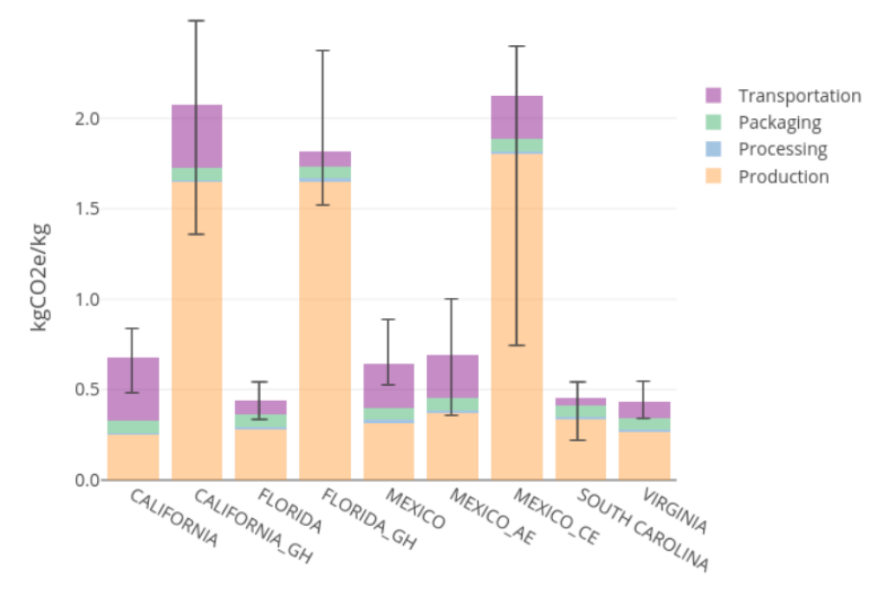
Figure S1. Cradle-to-market life-cycle GHG emissions for Atlanta fresh tomato supply. Errors bars represent 90% uncertainty ranges from Monte Carlo simulations
Key: AE = adapted environment, CE = controlled environment, GH = greenhouse
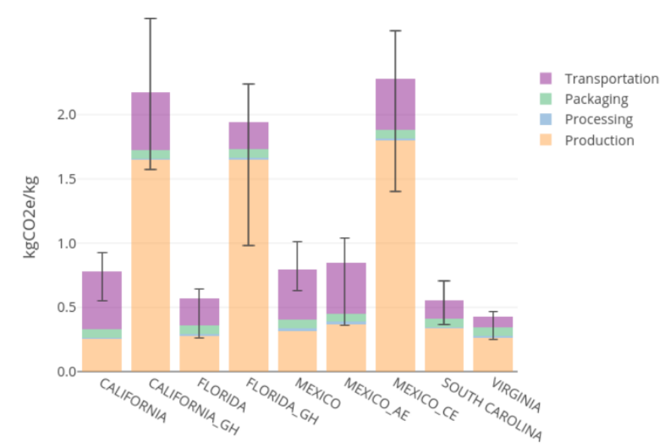
Figure S2. Cradle-to-market life-cycle GHG emissions for Boston fresh tomato supply. Errors bars represent 90% uncertainty ranges from Monte Carlo simulations
Key: AE = adapted environment, CE = controlled environment, GH = greenhouse

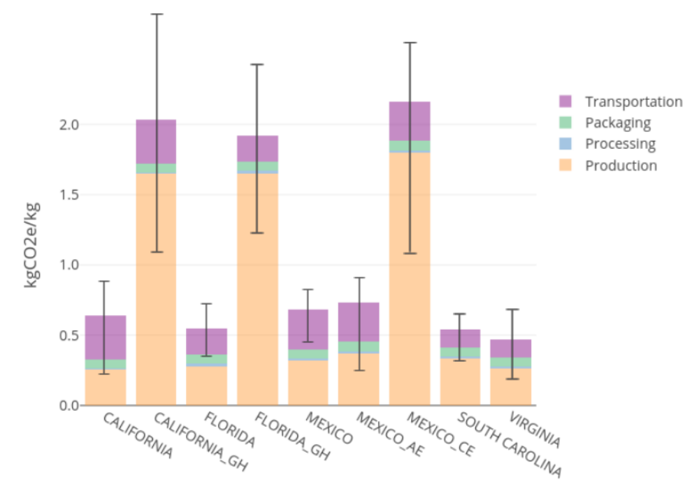
Figure S3. Cradle-to-market life-cycle GHG emissions for Chicago fresh tomato supply. Errors bars represent 90% uncertainty ranges from Monte Carlo simulations
Key: AE = adapted environment, CE = controlled environment, GH = greenhouse

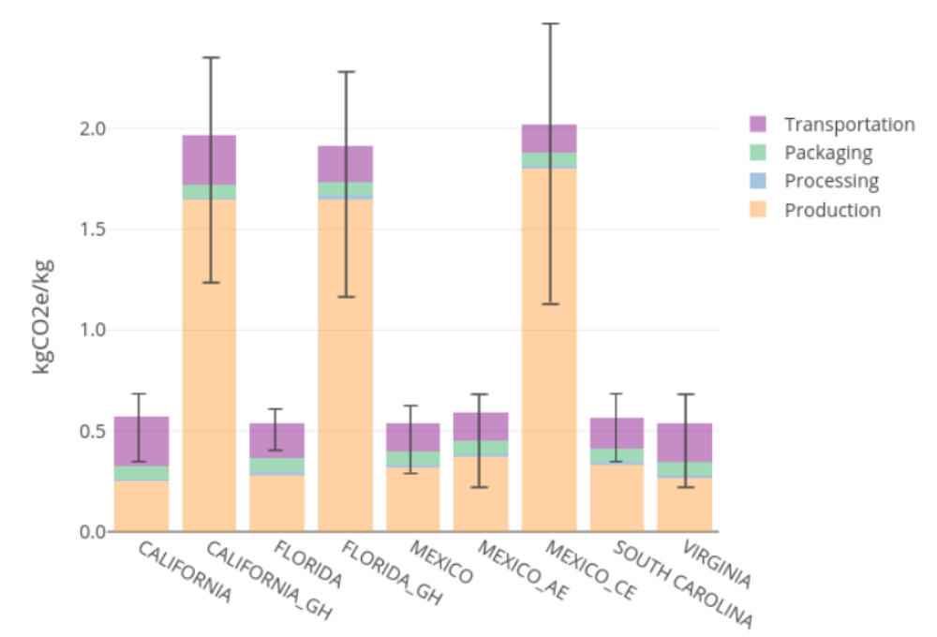
Figure S4. Cradle-to-market life-cycle GHG emissions for Dallas fresh tomato supply. Errors bars represent 90% uncertainty ranges from Monte Carlo simulations
Key: AE = adapted environment, CE = controlled environment, GH = greenhouse

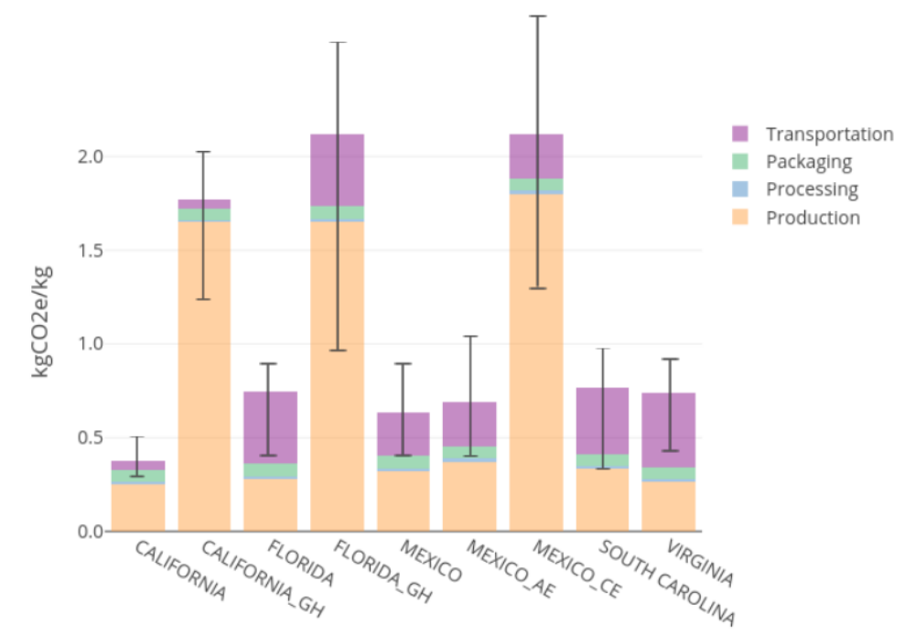
Figure S5. Cradle-to-market life-cycle GHG emissions for Los Angeles fresh tomato supply. Errors bars represent 90% uncertainty ranges from Monte Carlo simulations
Key: AE = adapted environment, CE = controlled environment, GH = greenhouse

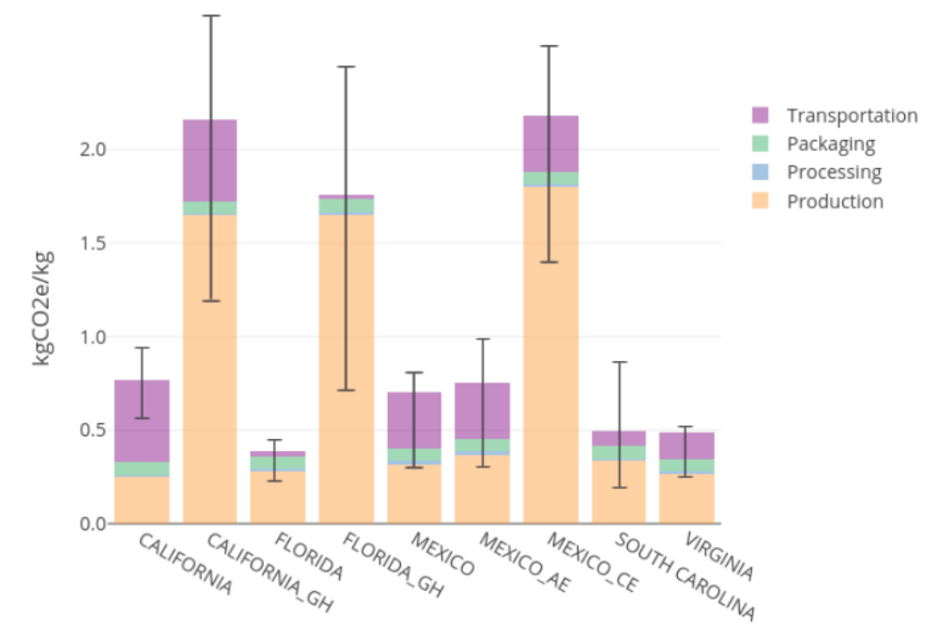
Figure S6. Cradle-to-market life-cycle GHG emissions for Miami fresh tomato supply. Errors bars represent 90% uncertainty ranges from Monte Carlo simulations
Key: AE = adapted environment, CE = controlled environment, GH = greenhouse

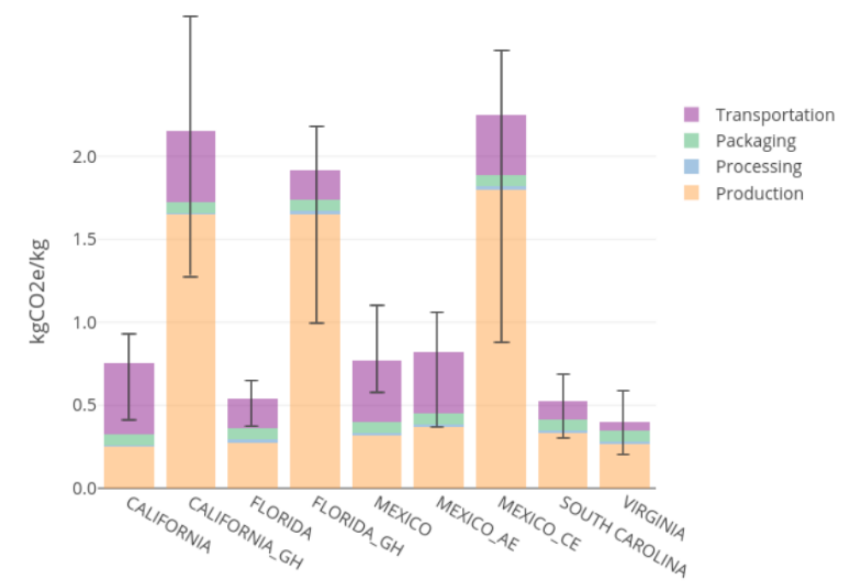
Figure S7. Cradle-to-market life-cycle GHG emissions for New York fresh tomato supply. Errors bars represent 90% uncertainty ranges from Monte Carlo simulations
Key: AE = adapted environment, CE = controlled environment, GH = greenhouse
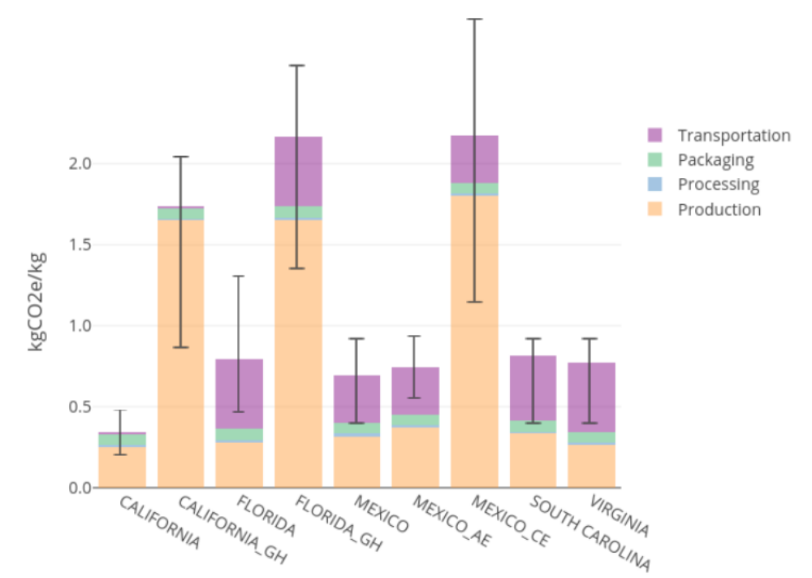
Figure S8. Cradle-to-market life-cycle GHG emissions for San Francisco fresh tomato supply. Errors bars represent 90% uncertainty ranges from Monte Carlo simulations
Key: AE = adapted environment, CE = controlled environment, GH = greenhouse

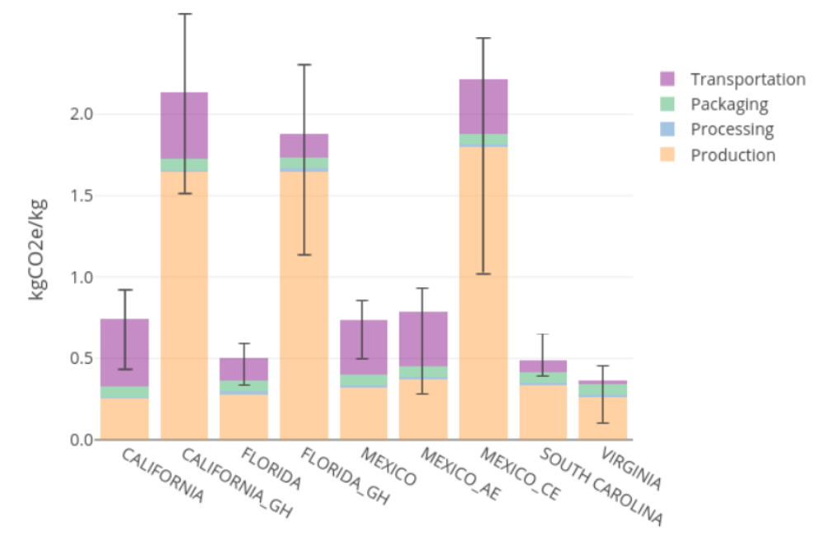
Figure S9. Cradle-to-market life-cycle GHG emissions for Washington DC fresh tomato supply. Errors bars represent 90% uncertainty ranges from Monte Carlo simulations
Key: AE = adapted environment, CE = controlled environment, GH = greenhouse

S7. Figures of tomato supply portfolio for other cities
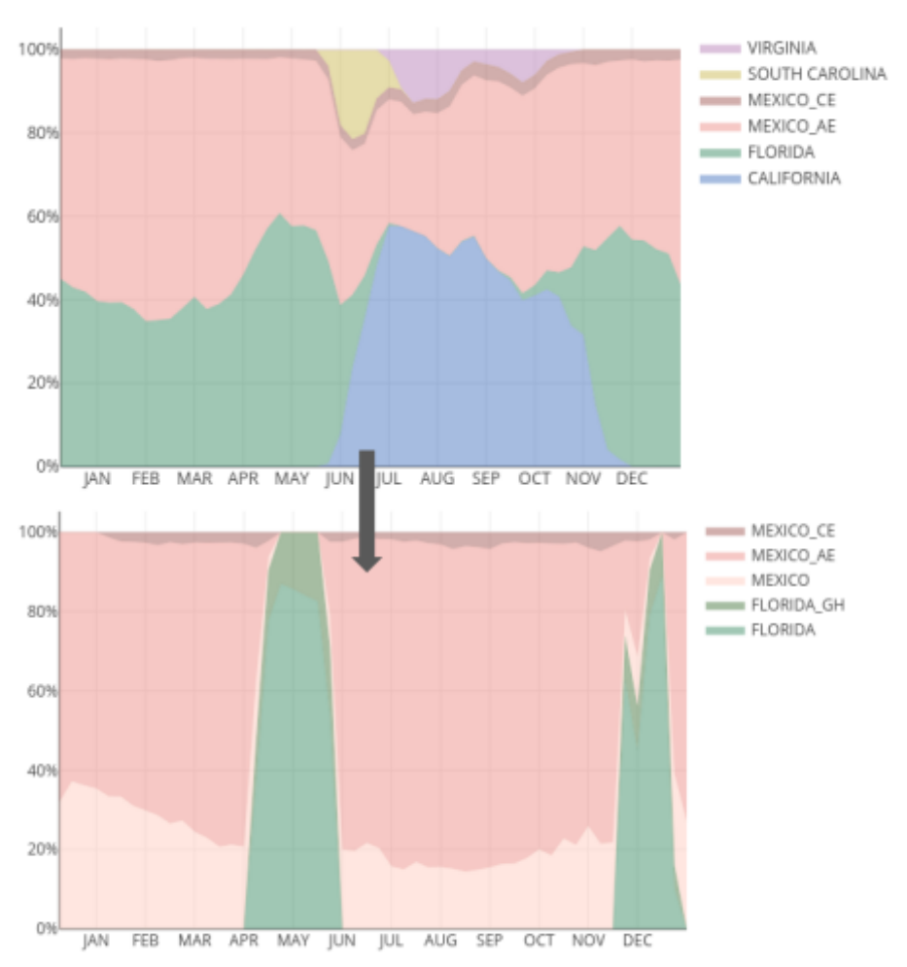
Figure S10. Tomato supply portfolio for Atlanta market under baseline (top) and optimized scenario (bottom)

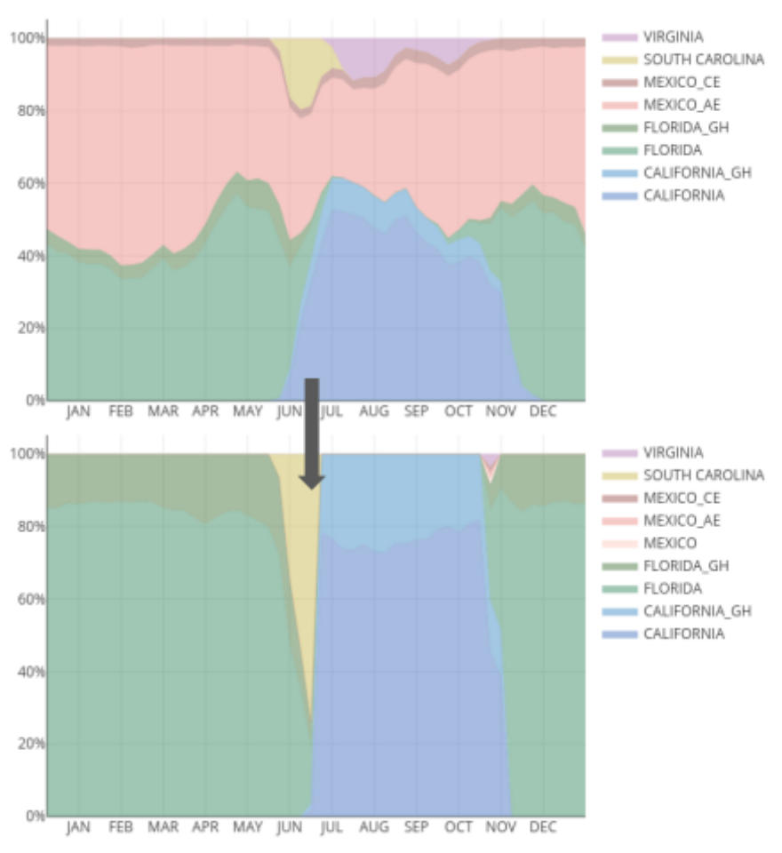
Figure S11. Tomato supply portfolio for Boston market under baseline (top) and optimized scenario (bottom)

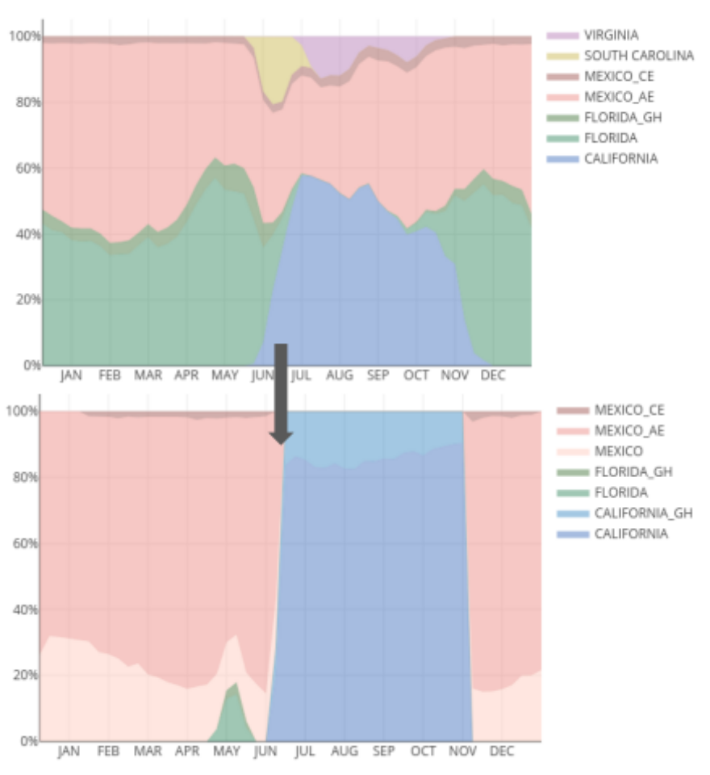
Figure S12. Tomato supply portfolio for Chicago market under baseline (top) and optimized scenario (bottom)

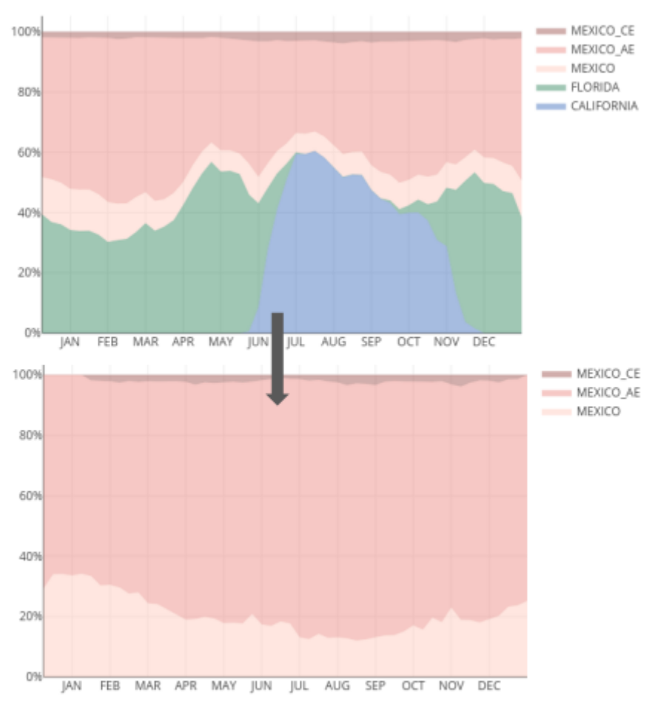
Figure S13. Tomato supply portfolio for Dallas market under baseline (top) and optimized scenario (bottom)
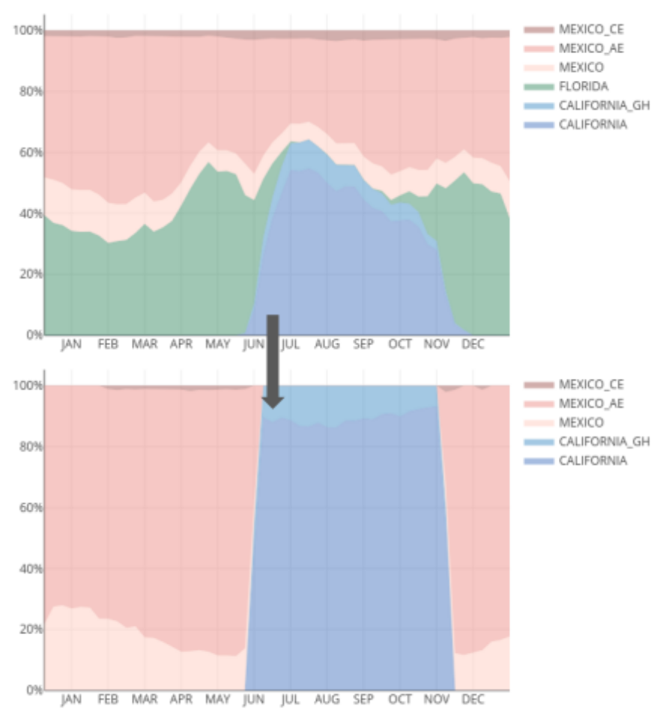
Figure S14. Tomato supply portfolio for Los Angeles market under baseline (top) and optimized scenario (bottom)

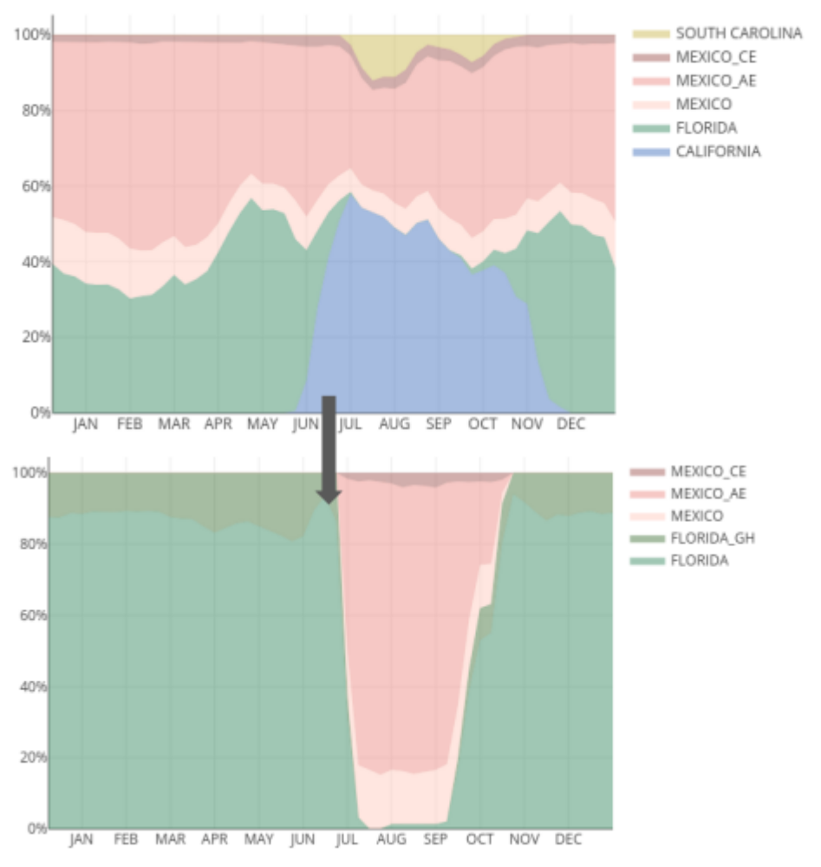
Figure S15. Tomato supply portfolio for Miami market under baseline (top) and optimized scenario (bottom)

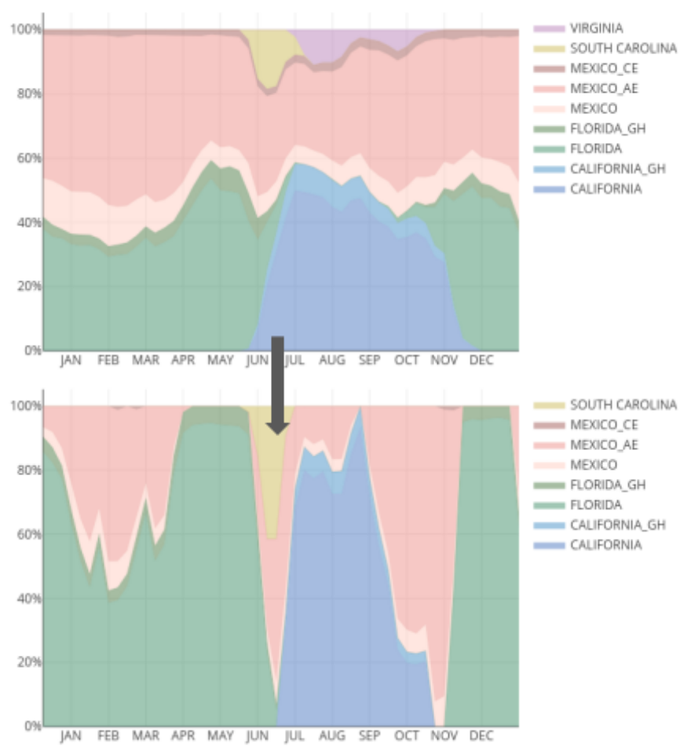
Figure S16. Tomato supply portfolio for New York market under baseline (top) and optimized scenario (bottom)
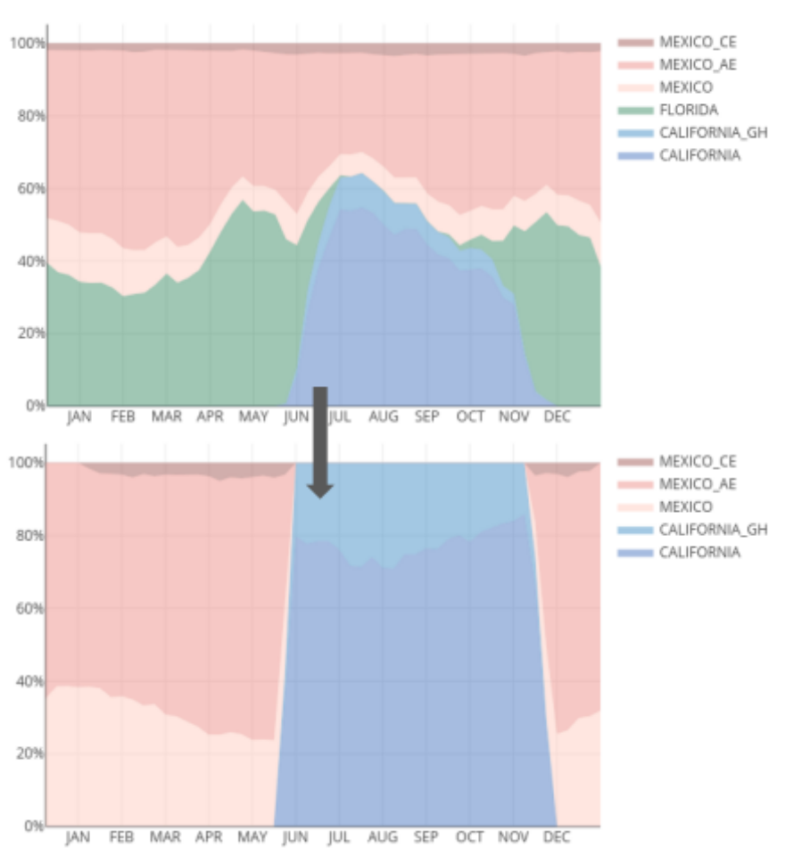
Figure S17. Tomato supply portfolio for San Francisco market under baseline (top) and optimized scenario (bottom)
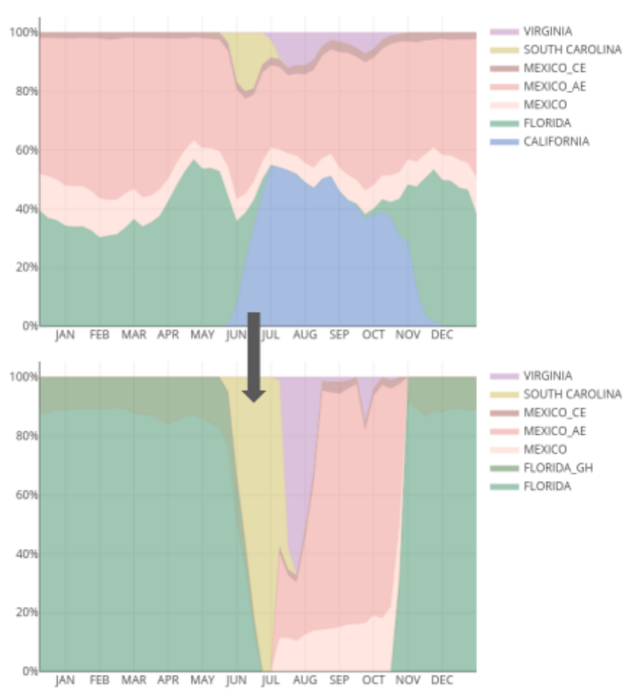
Figure S18. Tomato supply portfolio for Washington DC market under baseline (top) and optimized scenario (bottom)

S8. Figures of environmental impact of fresh tomatoes delivered to the other cites

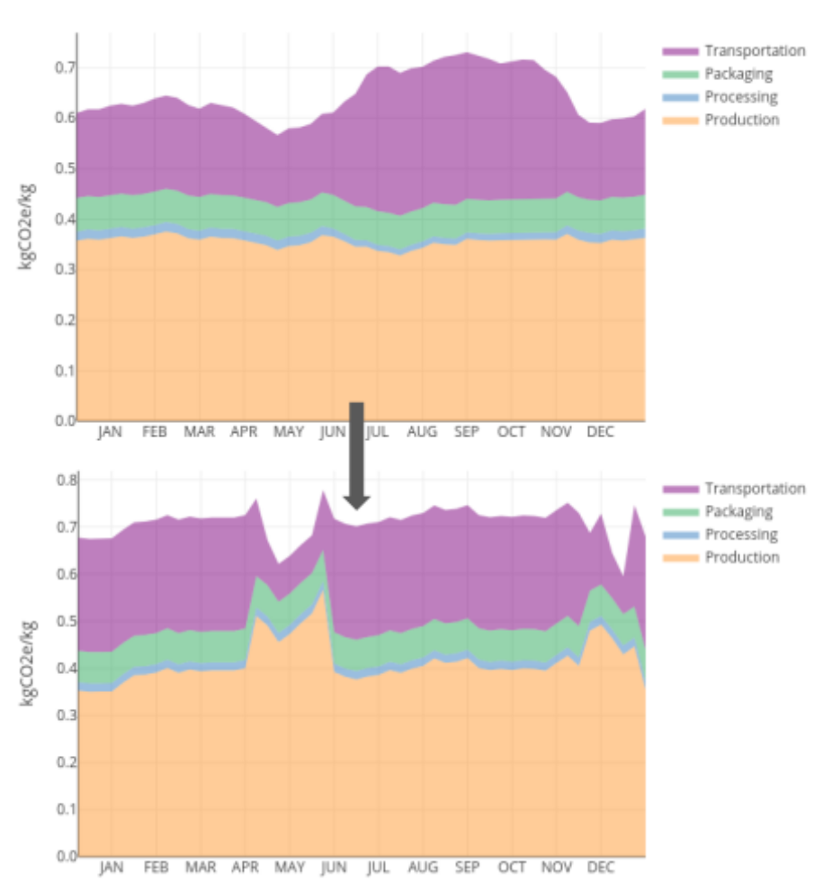
Figure S19. Environmental impact of fresh tomatoes delivered to Atlanta market under baseline (top) and optimized scenario (bottom)

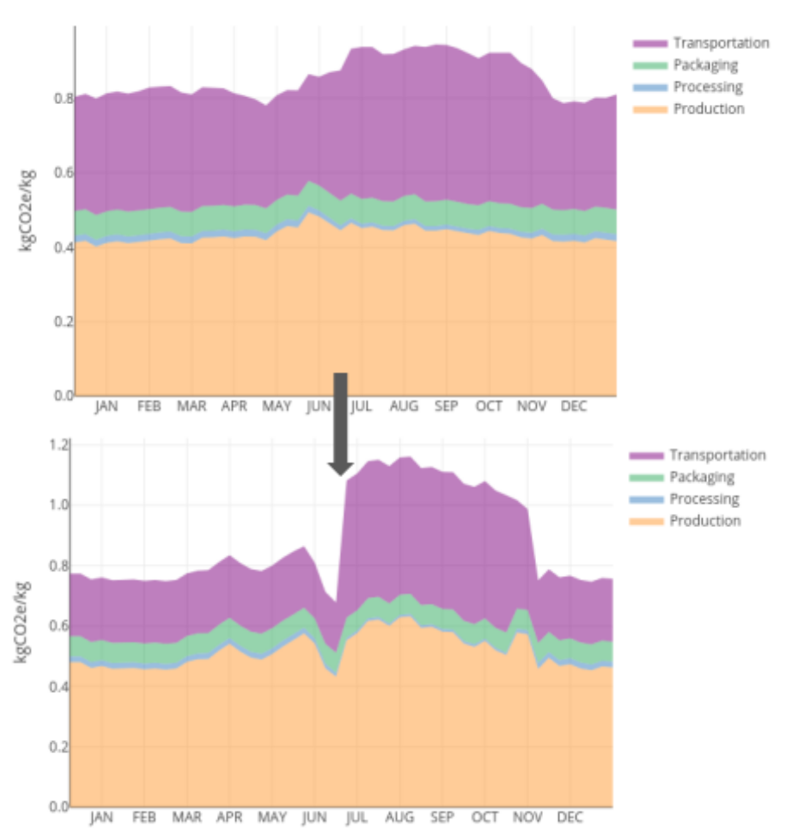
Figure S20. Environmental impact of fresh tomatoes delivered to Boston market under baseline (top) and optimized scenario (bottom)

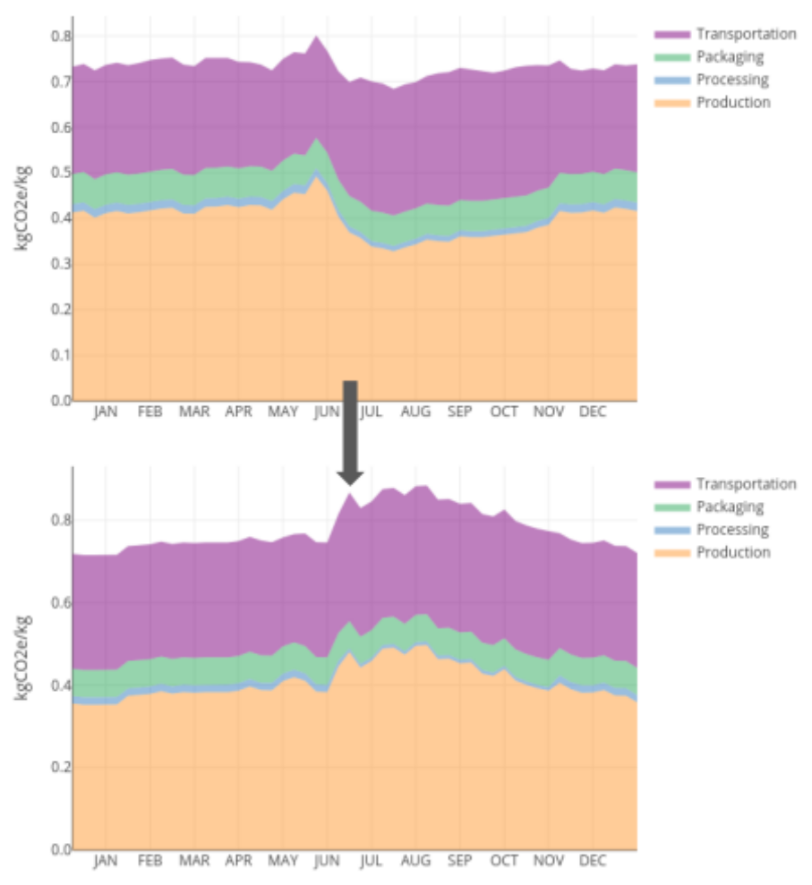
Figure S21. Environmental impact of fresh tomatoes delivered to Chicago market under baseline (top) and optimized scenario (bottom)
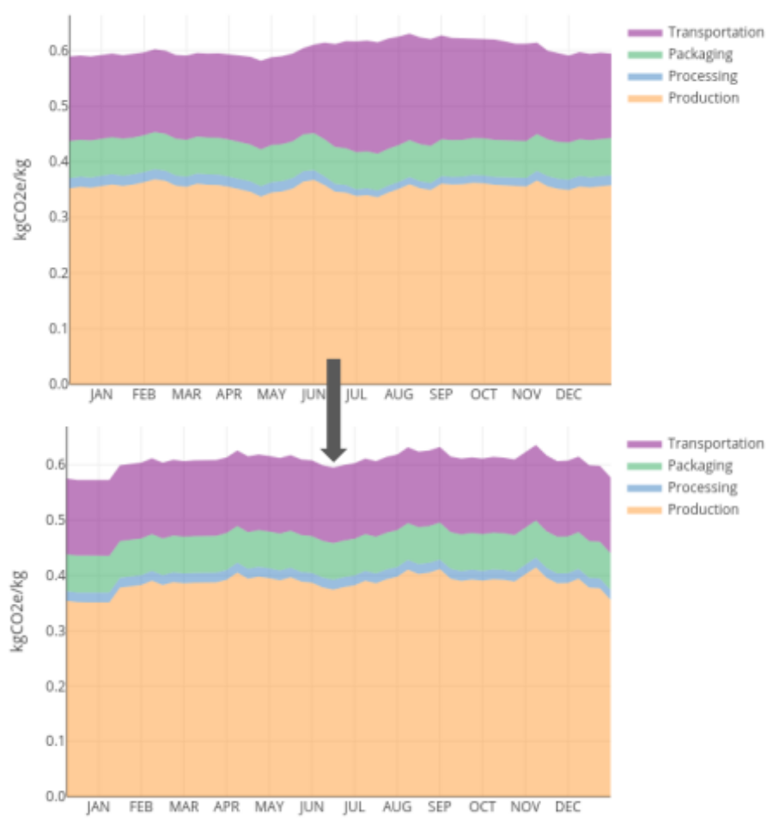
Figure S22. Environmental impact of fresh tomatoes delivered to Dalass market under baseline (top) and optimized scenario (bottom)
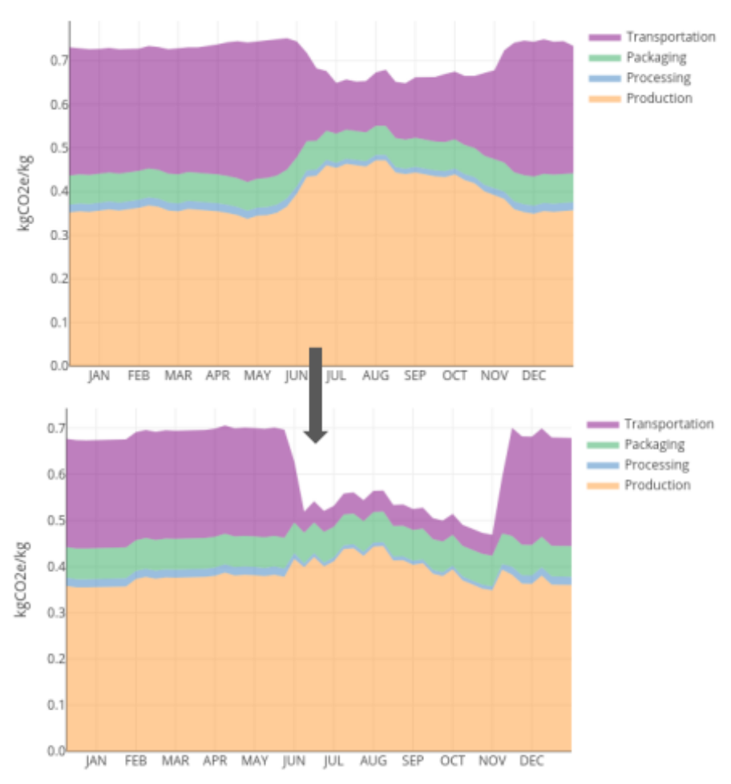
Figure S23. Environmental impact of fresh tomatoes delivered to Los Angeles market under baseline (top) and optimized scenario (bottom)

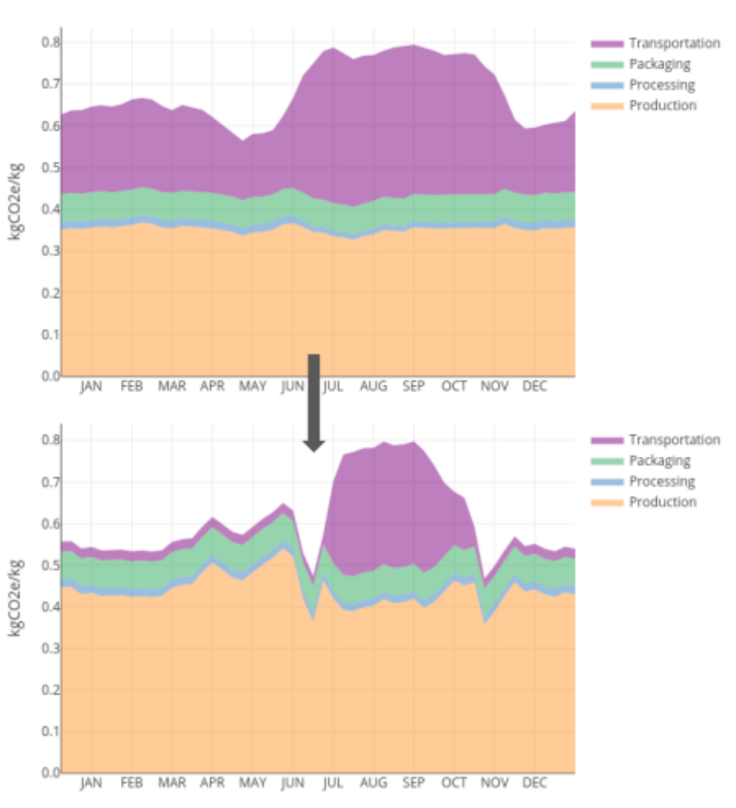
Figure S24. Environmental impact of fresh tomatoes delivered to Miami market under baseline (top) and optimized scenario (bottom)

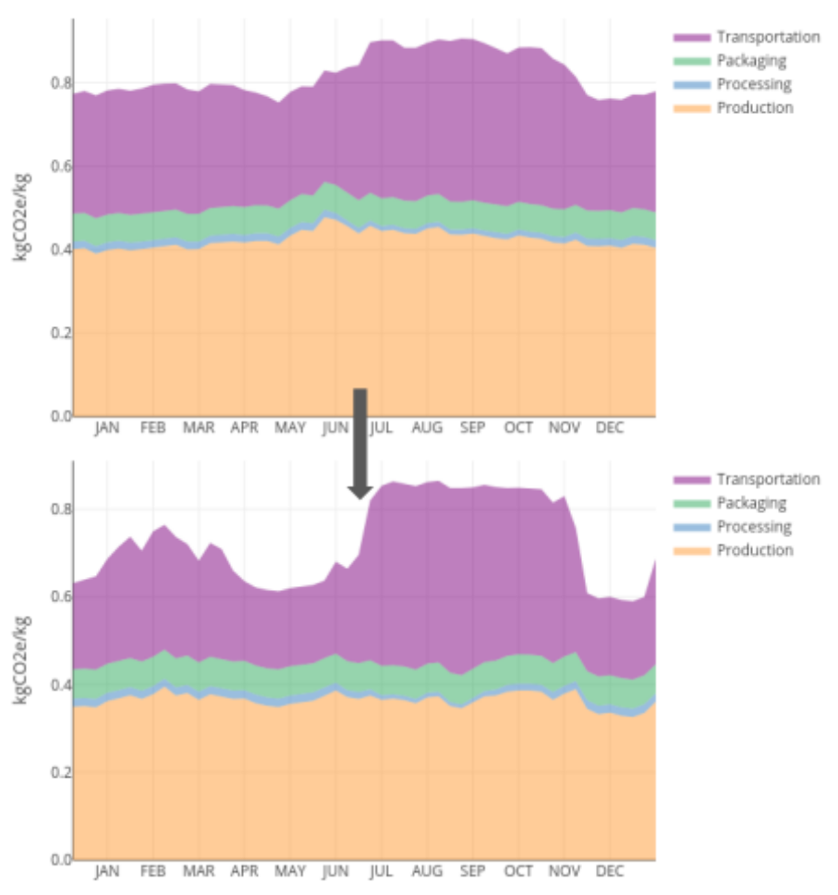
Figure S25. Environmental impact of fresh tomatoes delivered to New York market under baseline (top) and optimized scenario (bottom)

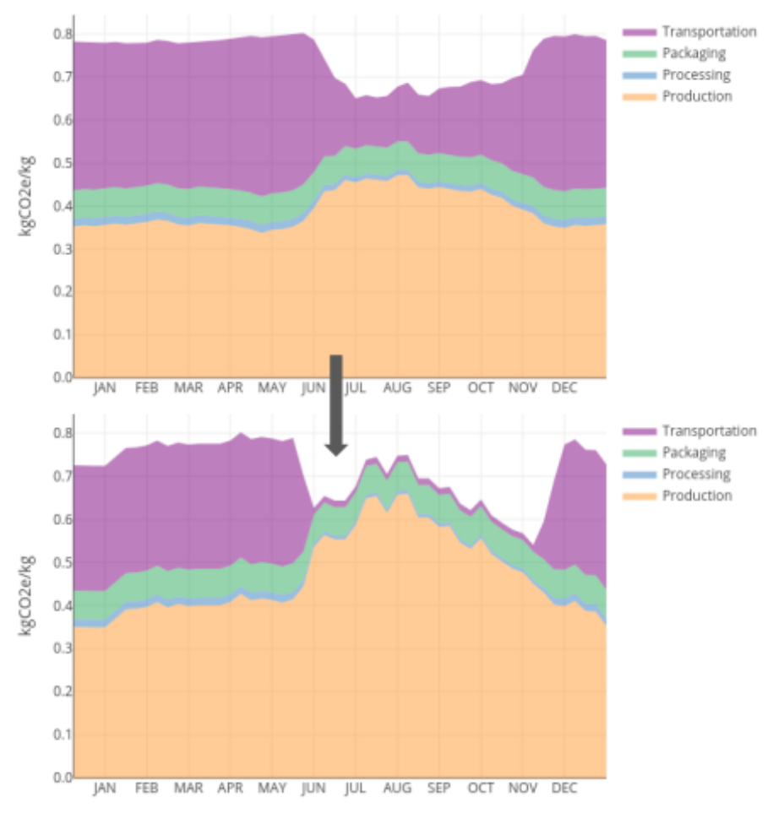
Figure S26. Environmental impact of fresh tomatoes delivered to San Francisco market under baseline (top) and optimized scenario (bottom)

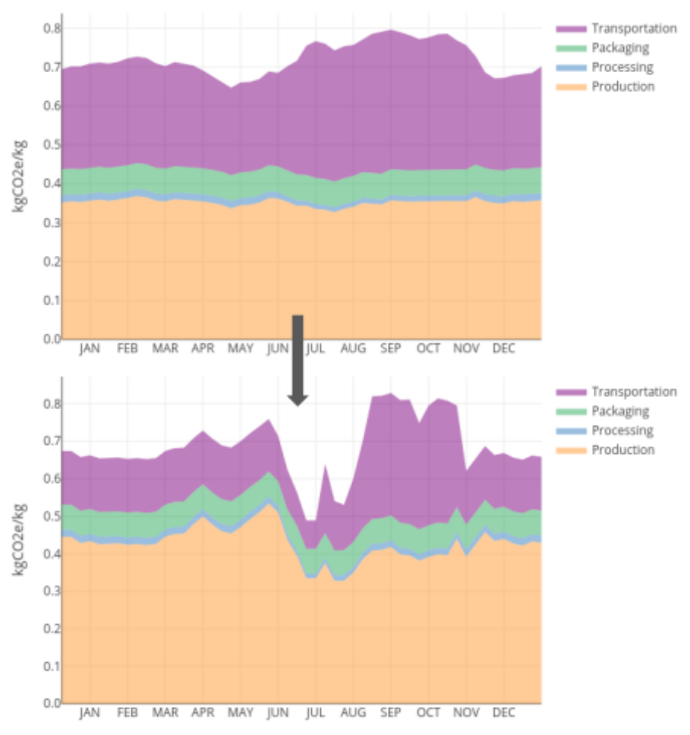
Figure S27. Environmental impact of fresh tomatoes delivered to Washington DC market under baseline (top) and optimized scenario (bottom)

References

1. Bell, E. M., Stokes-Draut, J. R. & Horvath, A. Environmental evaluation of high-value agricultural produce with diverse water sources: case study from Southern California. Environ. Res. Lett. 13, 025007 (2018).
2. USDA. Quick Stats Tools. https://www.nass.usda.gov/Quick_Stats/index.php (2020).
3. Maraseni, T. N., Cockfield, G., Maroulis, J. & Chen, G. An assessment of greenhouse gas emissions from the Australian vegetables industry. J. Environ. Sci. Health Part B 45, 578–588 (2010).
4. Page, G., Ridoutt, B. & Bellotti, B. Carbon and water footprint tradeoffs in fresh tomato production. J. Clean. Prod. 32, 219–226 (2012).
5. USDA. Empowering Agriculture: Energy Options for Horticulture. http://ucce.ucdavis.edu/files/datastore/234-1386.pdf (2009).
6. California Energy Commission. 2019 Total System Electric Generation. https://www.energy.ca.gov/data-reports/energy-almanac/california-electricity-data/2019-total-system-electric-generation (2019).
7. DOE. State of Florida Energy Sector Risk Profile. https://www.energy.gov/sites/prod/files/2015/05/f22/FL-Energy%20Sector%20Risk%20Profile.pdf (2015).
8. IEA. Mexico - Countries & Regions. https://www.iea.org/countries/mexico (2020).
9. EIA. South Carolina - State Energy Profile Overview. https://www.eia.gov/state/?sid=SC (2020).
10. EIA. Virginia - State Energy Profile Overview. https://www.eia.gov/state/?sid=VA (2020).
11. Gursel, A. P. Life-cycle assessment of concrete: decision-support tool and case study application. (UC Berkeley, 2014).
12. Karakaya, A. & Özilgen, M. Energy utilization and carbon dioxide emission in the fresh, paste, whole-peeled, diced, and juiced tomato production processes. Energy 36, 5101–5110 (2011).
13. Nahlik, M. J., Kaehr, A. T., Chester, M. V., Horvath, A. & Taptich, M. N. Goods movement life cycle assessment for greenhouse gas reduction goals. J. Ind. Ecol. 20, 317–328 (2016).
14. Wang, X. et al. Integrated systematic approach increase greenhouse tomato yield and reduce environmental losses. J. Environ. Manage. 266, 110569 (2020).
15. Cellura, M., Longo, S. & Mistretta, M. Sensitivity analysis to quantify uncertainty in life cycle assessment: the case study of an Italian tile. Renew. Sustain. Energy Rev. 15, 4697–4705 (2011).
16. González, A. D., Frostell, B. & Carlsson-Kanyama, A. Protein efficiency per unit energy and per unit greenhouse gas emissions: potential contribution of diet choices to climate change mitigation. Food Policy 36, 562–570 (2011).
17. Winans, K., Brodt, S. & Kendall, A. Life cycle assessment of California processing tomato: an evaluation of the effects of evolving practices and technologies over a 10-year (2005–2015) timeframe. Int. J. Life Cycle Assess. 25, 538–547 (2020).
18. De Marco, I., Riemma, S. & Iannone, R. Uncertainty of input parameters and sensitivity analysis in life cycle assessment: An Italian processed tomato product. J. Clean. Prod. 177, 315–325 (2018).

