Effect of antibiotic treatment on Oxalobacter formigenes colonization of the gut microbiome and urinary oxalate excretion.

Lama Nazzal *, Fritz Francois, Nora Henderson, Menghan Liu, Huilin Li, Hyunwook Koh, Chan Wang, Zhan Gao, Guillermo Perez Perez, John R. Asplin, David S Goldfarb, Martin J Blaser

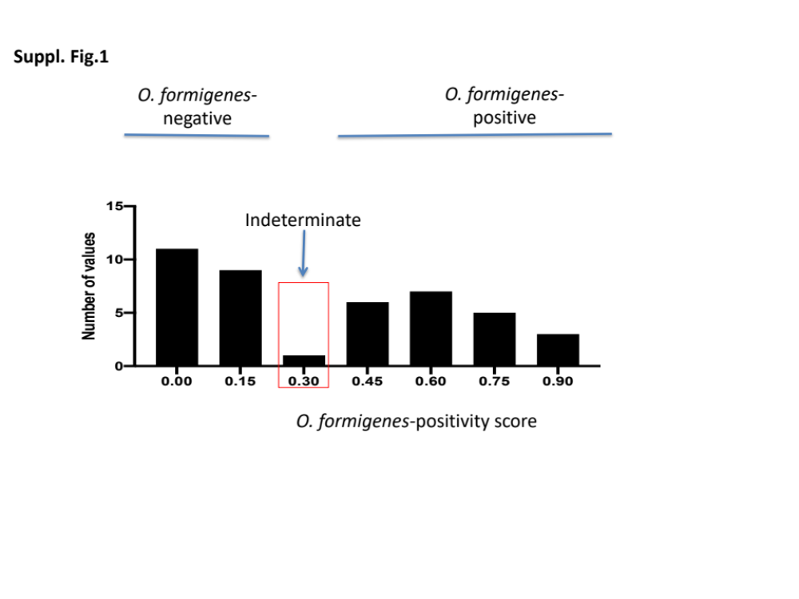

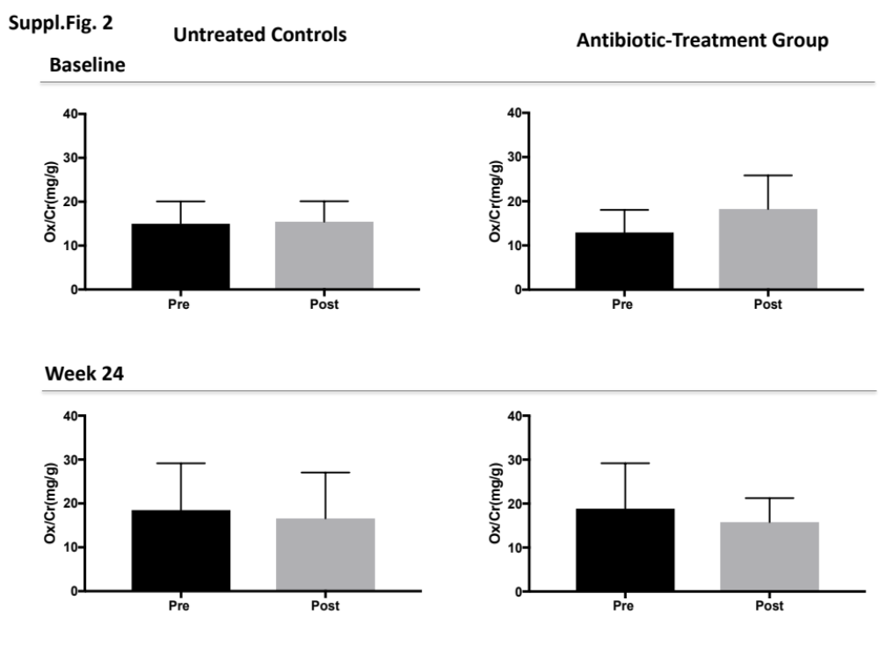

Table S1 : Nutrients present in Ensure*
Component | Present  in Ensure | Recommended  Daily Value (%)
Oxalate | No | 0
Vitamin C | Yes | 50
Calcium | Yes | 30
Chloride | Yes | 8
Potassium | Yes | 11
Magnesium | Yes | 25
Sodium | Yes | 8
Phosphorus | Yes | 25
Protein | Yes | 18
*Ensure, nutritional supplement manufactured by Abbott Laboratories.

Table S2: Demographics of 64 study subjects by O. formigenes status at baseline

 | O. formigenes-  positive (n=32) | O. formigenes-  negative (n=32) | P value
Age (Years) | 26.6 + 6.2 | 24.0 + 5.1 | 0.1
Sex (Male/Female) | 13/19 | 10/22 | 0.6
Ethnicity (White/AA/Asian/Hispanic/Other) | 11/5/9/6/1 | 11/3/12/5/1 | 0.3
BMI (kg/m²) | 24.5 + 4.8 | 23.1 + 3.5 | 0.2
Mode of delivery (Vaginal/C-section) | 21/8 | 19/4 | 0.4
Place of birth (US/Non-US) | 13/19 | 16/16 | 0.6

Table S3: Urinary electrolytes in controls and treated subjects
 | Controls |  |  |  | Treated
Electrolyte | Pre–time 0  (n=32) | Pre-Time 24 (n=23) | Post–time 0 (n=32) | Post-Time 24 (n=14) | Pre–time 0  (n=14) | Pre-Time 24 (n=11) | Post–time 0 (n=14) | Post-Time 24 (n=11)
pH | 6.3 + 0.7 | 6.2 + 0.6 | 6.6 + 0.6 | 6.5 + 0.6 | 6.2 + 0.5 | 6.6 + 0.6* | 6.6 + 0.5 | 6.8 + 0.4*
Ox/Cr | 15.0 + 5.1 | 18.5 + 10.7* | 15.4 + 4.7 | 16.6 + 10.5 | 13.0 + 5.1 | 18.8 + 10.3* | 16.2 + 4.2 | 16.6 +9.0
Amm/Cr | 1.9 + 0.7 | 2.6 + 1.2┼┼ | 2.6 + 0.7 | 3.6 + 1.8* | 2.3 + 0.5┼ | 2.00 + 0.6┼┼ | 2.3 +0.9 | 2.6 + 1.0*
Ca/Cr | 3.1 + 2.5 | 5.2 + 3.6* | 12.1 + 6.3 | 14.6 + 7.9* | 3.3 + 2.1 | 3.5 + 2.1* | 11.2 + 5.8 | 11.3 + 6.1
Cit/Cr | 2.7 + 2.0 | 2.7 + 1.8 | 4.4 + 2.4 | 4.4 + 2.2 | 2.1 + 0.9 | 2.9 + 1.8* | 3.9 + 2.0 | 4.2 + 2.4
Cl/Cr | 6.2 + 3.0 | 9.3 + 4.6* | 8.8 + 3.5 | 10.7 + 4.2 | 9.0 + 4.4 | 9.4 + 5.6* | 10.8 + 3.8 | 11.7 + 4.0
K/Cr | 3.5 + 2.0 | 4.2 + 1.8 | 7.3 + 2.9 | 8.8 + 3.7 | 3.3 + 1.5 | 4.6 + 2.3 | 2.8 + 1.3┼ | 3.8 + 1.3
Mg/Cr | 3.2 +1.4 | 4.0 + 1.6 | 7.8 + 3.4 | 8.5 + 3.4 | 3.4 + 1.0 | 3.7 + 1.8 | 7.7 + 3.2 | 8.5 + 4.1
Na/Cr | 4.5 + 2.2 | 7.1 + 3.8* | 7.3 + 2.9 | 8.8 + 3.7 | 7.0 + 3.2 | 7.4 +3.8* | 9.6 + 3.9 | 10.7 + 3.7
Phos/Cr | 2.8 + 1.1 | 3.7 + 1.5* | 3.6 + 1.6 | 3.9 + 2.0 | 2.9 + 1.7 | 3.1 +1.2* | 2.9 + 1.3 | 3.8 + 1.8
UN/Cr | 4.6 + 1.6 | 5.6 +1.8* | 6.4 + 1.9 | 7.2 + 2.0 | 5.4 + 1.4 | 5.6 + 1.4* | 6.6 + 1.0 | 6.7 + 1.4

Cr: creatinine (mg/dL), Ox: oxalate (mg/dL), Amm: ammonium (mmol/L)Ca: calcium (mg/dL), Cit: citrate (mg/dL), Cl: chloride (mmol/L), K: potassium (mmol/dL), Mg: magnesium (mg/dL), Na: sodium (mmol/L), Phos: phosphorus (mg/dL), UN: Urea Nitrogen (mg/dL)
+ values significantly different at baseline
++ significantly increased in controls and decreased in treated subjects
*p< 0.05, comparison between time 0 and 24,

*

