Supplementary Material
Spectral characteristic of the waters with different sizes of particles: impact of hydrochemical property and land use type

Zelan Lvª, Peng Wangª, Caixia Yan^{a,*}, Minghua Nie^{a,b}, Xiaoying Xiongª, Mingjun Dingª
ª School of Geography and Environment, Key Laboratory of Poyang Lake Wetland and Watershed Research, Ministry of Education, Jiangxi Normal University, 99 Ziyang Road, Nanchang, 330022, China
^{b} Key Laboratory of Eco-geochemistry, Ministry of Natural Resource, Beijing 100037, China
Email: yancaixia@jxnu.edu.cn

Table legends
- Table S1 Landscape compositions of the 500 m and 1000 m buffer strips for the sampling sites from the Yuan River basin
- Table S2 Comparison of the fluorescence indices from different studies
- Table S3 Identification of the fluorescence components in Yuan River basin according to the OpenFlour database

Figure legends
- Figure S1 The hydrochemical parameter values of the water samples from the mainstreams and tributaries in the Yuan River basin
- Figure S2 Spatial distribution of Fn₂₈₀ and Fn₃₅₅ values for water samples from the Yuan River basin
- Figure S3 Fluorescence indices distribution of the water samples from the Yuan River basin
- Figure S4 3D-EEMs of the PARAFAC components

Tables:
Table S1 Landscape compositions of the 500 m and 1000 m buffer strips for the sampling sites from the Yuan River basin (%).
 |  | cropland | forestland | grassland | water | residential land
500m | mainstreams | 54.61±21.57 | 11.34±17.93 | 2.83±3.93 | 18.17±16.58 | 13.09±15.38
500m | tributaries | 55.20±24.16 | 23.36±23.57 | 3.48±3.45 | 5.39±7.48 | 12.57±15.15
1000m | mainstreams | 45.56±23.73 | 23.93±24.14 | 4.52±4.42 | 15.19±12.44 | 10.73±9.48
1000m | tributaries | 51.20±23.27 | 27.35±21.51 | 3.84±2.60 | 3.86±4.83 | 13.75±15.92

Table S2 Comparison of the fluorescence indices from different studies
Sites | FI | HIX | BIX
Dian lake | 1.5-1.7 | 3.0-10.0 | 0.7-1.0 | (Li et al. 2021)
Kushiro River | 1.1-1.4 | 1.1-14.4 | 0.6-1.0 | (Shafiquzzaman et al. 2020)
Urban stormwater runoff | 1.0-1.2 | 2.9-14.0 | 0.5-0.7 | (Liao et al. 2021)
Chao Lake | 1.6-2.4 | 1.4-2.5 | 0.8-1.2 | (Zhang et al. 2020)
Rural watersheds | 1.7-2.3 | 0.5-5.0 | 0.6-1.2 | (Lu et al. 2021)
Poyang Lake | 1.2-1.4 | 1.8-2.7 | 0.7-0.8 | (Yan et al. 2018)
This study | 1.3-1.6 | 1.5-5.9 | 0.7-1.7

Table S3 Identification of the fluorescence components in Yuan River basin according to the OpenFlour database
Components | Tucker's Congruence Coefficients |  |  | Ex/Em wavelength  (peak or shoulder) | Composition description | Component in database | OpenFluor ID | References
Components | Ex | Em | ExEm
C1 | 0.998 | 0.995 | 0.993 | 245/430 nm | Terrestrial humic substance | C1 | 1158 | (Chen et al. 2017)
C2 | 0.993 | 0.990 | 0.983 | 225(275)/330 nm | Protein-like substances | C7 | 66 | (Yamashita et al. 2010)
C3 | 0.993 | 0.989 | 0.982 | 235(300)/350 nm | Tryptophan-like substances | C3 | 56 | (Amaral et al. 2016)

Figures:

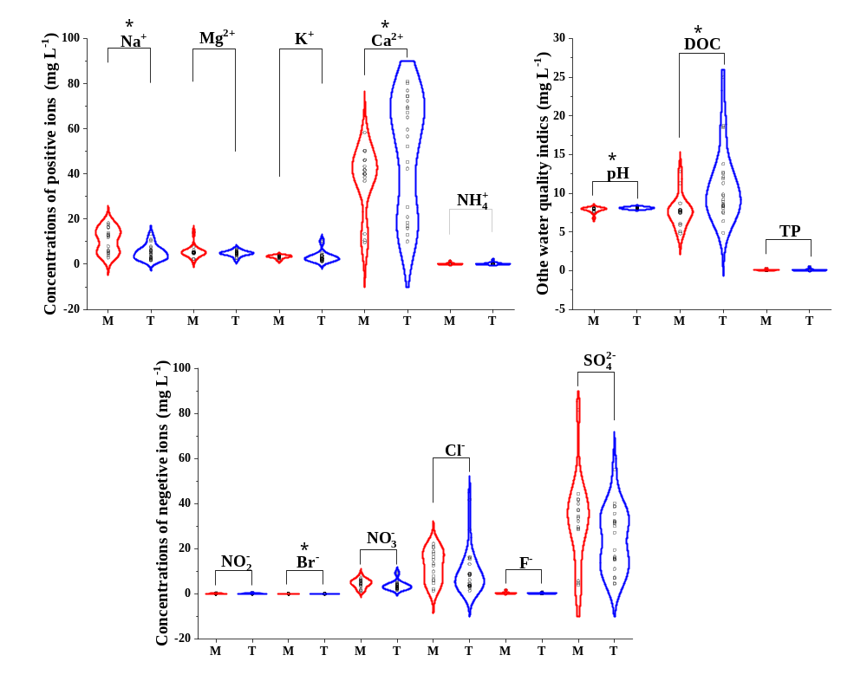

Figure S1 The hydrochemical parameter values of the water samples from the mainstreams and tributaries in Yuan River basin (* represents the significant difference between the corresponding parameters between the mainstreams and tributaries)

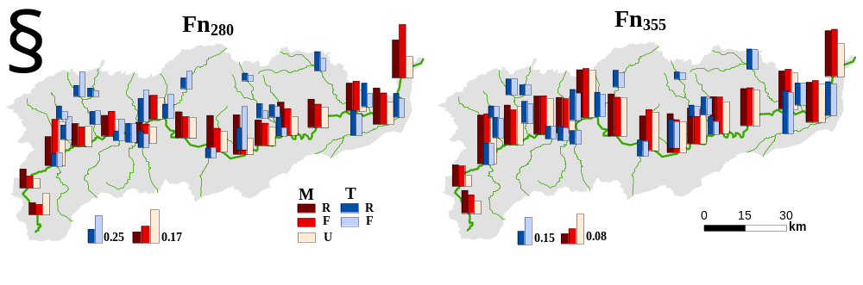 Figure S2 Spatial distribution of Fn₂₈₀ and Fn₃₅₅ values for water samples from the Yuan River basin
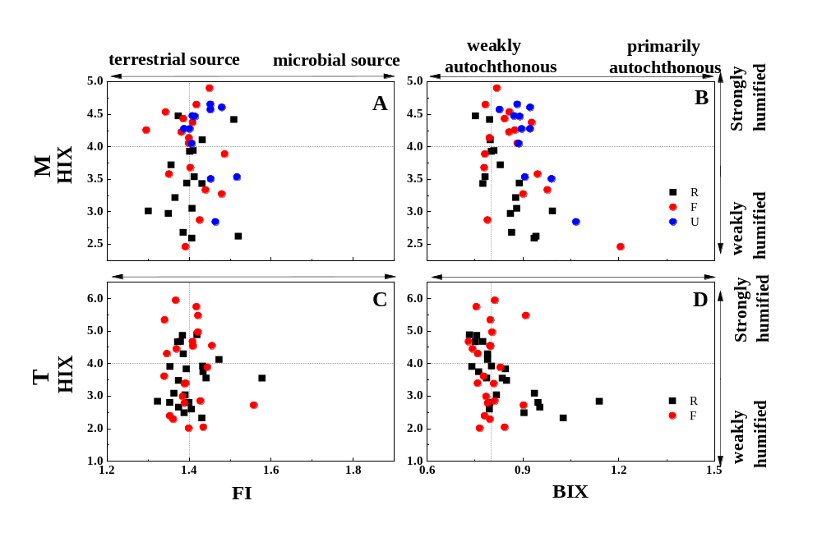
Figure S3 Fluorescence indices distribution of the water samples from the Yuan River basin
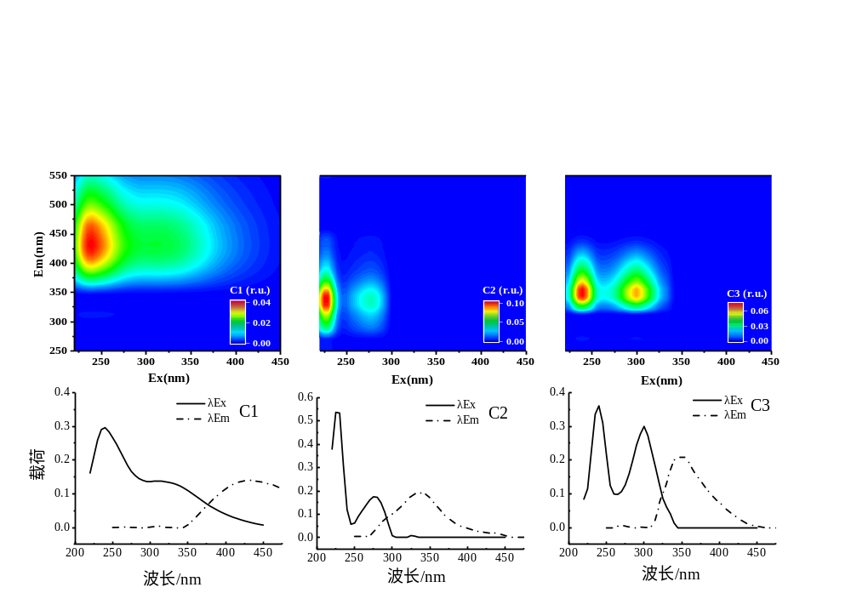
Figure S4 3D-EEMs of the PARAFA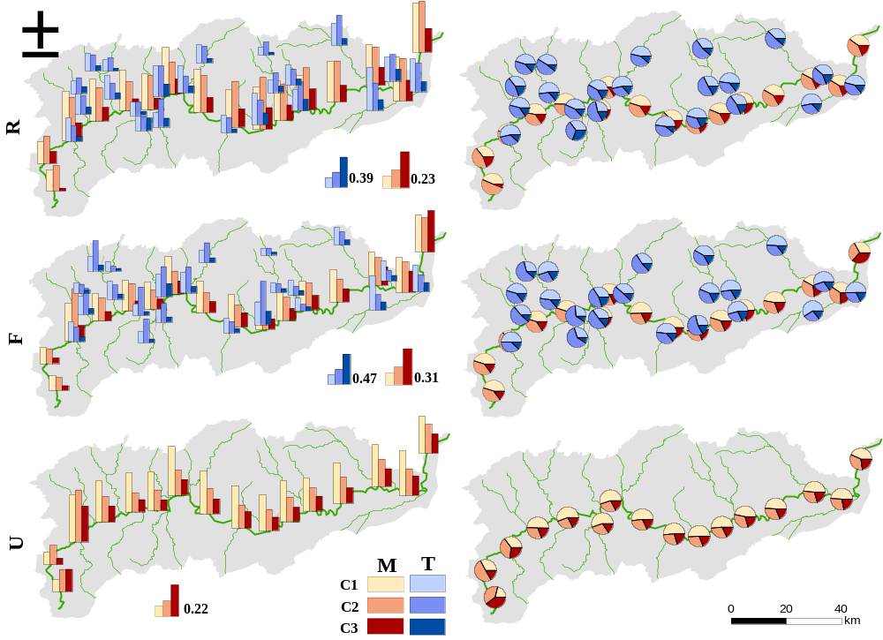
Figure S5 Spatial distribution of C1-C3 for the water samples from the Yuan River basin
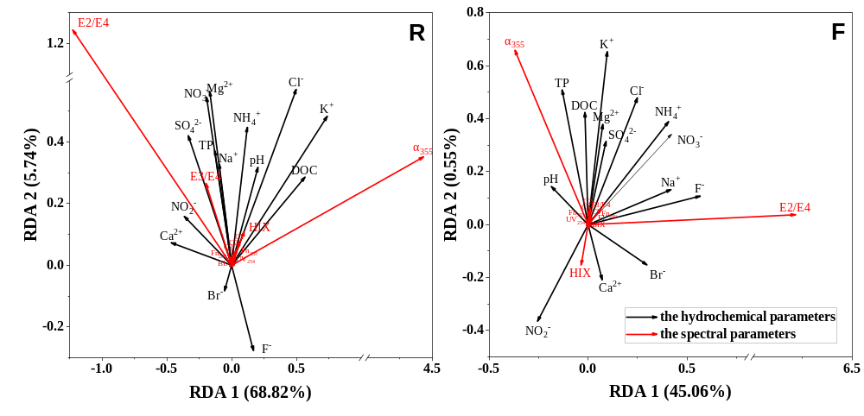
Figure S6 RDA of the hydrochemical parameters and the spectral parameters for the water samples from the Yuan River basin

References
Amaral V, Graeber D, Calliari D, Alonso CJL (2016) Strong linkages between DOM optical properties and main clades of aquatic bacteria. Limnol Oceanogr 61: 906-918. https://doi.org/10.1002/lno.10258
Chen M, Kim SH, Jung HJ, Hyun JH, Choi JH, Lee HJ, Huh IA, Hur J (2017) Dynamics of dissolved organic matter in riverine sediments affected by weir impoundments: Production, benthic flux, and environmental implications. Water Res 121:150-161. https://doi.org/10.1016/j.watres.2017.05.022
Li S, Lu L, Wu Y, Zhao Z, Huang C, Huang T, Yang H, Ma X, Jiang Q (2021) Investigation on depth-dependent properties and benthic effluxes of dissolved organic matter (DOM) in pore water from plateau lake sediments. Ecol Indic 125: 107500. https://doi.org/10.1016/j.ecolind.2021.107500
Liao Z, Chu J, Luo C, Chen H (2021) Revealing the characteristics of dissolved organic matter in urban runoff at three typical regions via optical indices and molecular composition. J Environ Sci 108: 8-21. https://doi.org/10.1016/j.jes.2021.02.012
Lu K, Gao H, Yu H, Liu D, Zhu N, Wan K (2021) Insight into variations of DOM fractions in different latitudinal rural black-odor waterbodies of eastern China using fluorescence spectroscopy coupled with structure equation model. Sci Total Environ: 151531. https://doi.org/10.1016/j.scitotenv.2021.151531
Shafiquzzaman M, Haider H, Bhuiyan MA, Ahmed AT, AlSaleem SS, Ghumman AR (2020) Spatiotemporal variations of DOM components in the Kushiro River impacted by a wetland. Environ Sci Pollut Res 27. https://doi.org/10.1007/s11356-020-08192-7
Yamashita Y, Scinto LJ, Maie N, Jaffé R (2010) Dissolved Organic Matter Characteristics Across a Subtropical Wetland’s Landscape: Application of Optical Properties in the Assessment of Environmental Dynamics. Ecosystems 13:1006-1019. https://doi.org/10.1007/s10021-010-9370-1
Yan C, Liu H, Sheng Y, Huang X, Nie M, Huang Q, Baalousha M (2018) Fluorescence characterization of fractionated dissolved organic matter in the five tributaries of Poyang Lake, China. Sci Total Environ 637-638:1311-1320. https://doi.org/10.1016/j.scitotenv.2018.05.099
Zhang H, Cui K, Guo Z, Li X, Chen J, Qi Z, Xu S (2020) Spatiotemporal variations of spectral characteristics of dissolved organic matter in river flowing into a key drinking water source in China. Sci Total Environ 700:134360. https://doi.org/10.1016/j.scitotenv.2019.134360

