Supplementary materials for Antonie van Leeuwenhoek

Jeotgalibacillus kunyuensis sp. nov., a novel orange-pigmented species with relative genes or gene clusters, isolated from wetland soil in Yantai, China
Hui-Ning Jiang · Shuai-Ting Yun · Bao-Xun Wang · Ming-Jing Zhang · Yu Ma · Yan-Xia Zhou*
Marine College, Shandong University, Weihai, 264209, China

*Authors for correspondence: Yan-Xia Zhou
E-mail: zhouyx@sdu.edu.cn
Table S1. General features of strain T12^{T} genome.
Size (bp) | 3506682
G+C | 43.7%
Gene number | 3717
Average Gene length (bp) | 818
tRNAs | 67
rRNAs | 6
sRNAs | 2
Secondary metabolite | 3

Table S2. ANI, dDDH and AAI values between strain T12^{T} and neighbour type strains.
Reference genome  (Accession no.) | ANI (%) | dDDH (%) | AAI (%)
Jeotgalibacillus kunyuensis T12^{T}  (MW527064) | 100 | 100 | 100
Jeotgalibacillus campisalis SF-57^{T}  (KJ716470) | 71.3 | 19.2 | 68.8
Jeotgalibacillus proteolyticus 22-7^{T}  (KX816420) | 71.9 | 19.0 | 69.2
Jeotgalibacillus soli P9^{T}  (FR693626) | 70.9 | 19.1 | 67.4
Jeotgalibacillus marinus strain 581^{T}  (AB021190) | 67.9 | 20.3 | 55.0
Jeotgalibacillus salarius ASL-1^{T}  (EU874389) | 73.9 | 20.5 | 74.6
Jeotgalibacillus terrae JSM 081008^{T}  (FJ527421) | 74.3 | 20.1 | 73.9
Jeotgalibacillus alimentarius YKJ-13^{T}  (AF281158) | 74.3 | 20.0 | 74.3
Jeotgalibacillus malaysiensis D5^{T}  (KJ460028) | 74.9 | 20.6 | 74.4

Fig. S1. Maximum-likelihood tree based on 16S rRNA gene sequences showing the phylogenetic position of strain T12^{T} and other related taxa. Bar, 0.01 substitution per nucleotide position. Bootstrap values were evaluated with 1000 replicates and values above 50 % are shown.
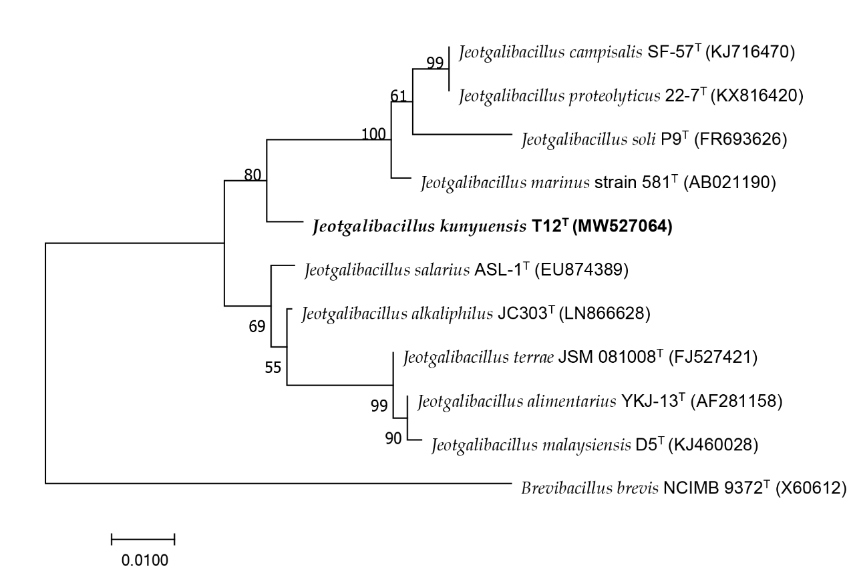

Figure. S2. The Cluster of Orthologous Groups of proteins (COG) of strain T12^{T}. The statistics of the number of genes in different COG classifications were presented.
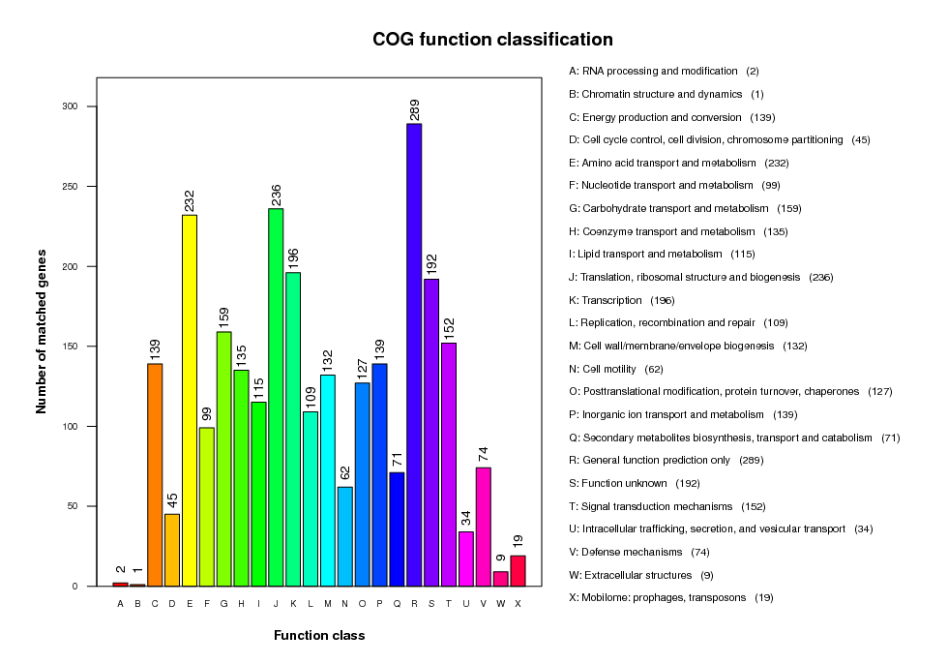
Figure. S3. Number of genes associated with KEGG metabolic pathway in the genome of strain T12^{T}.
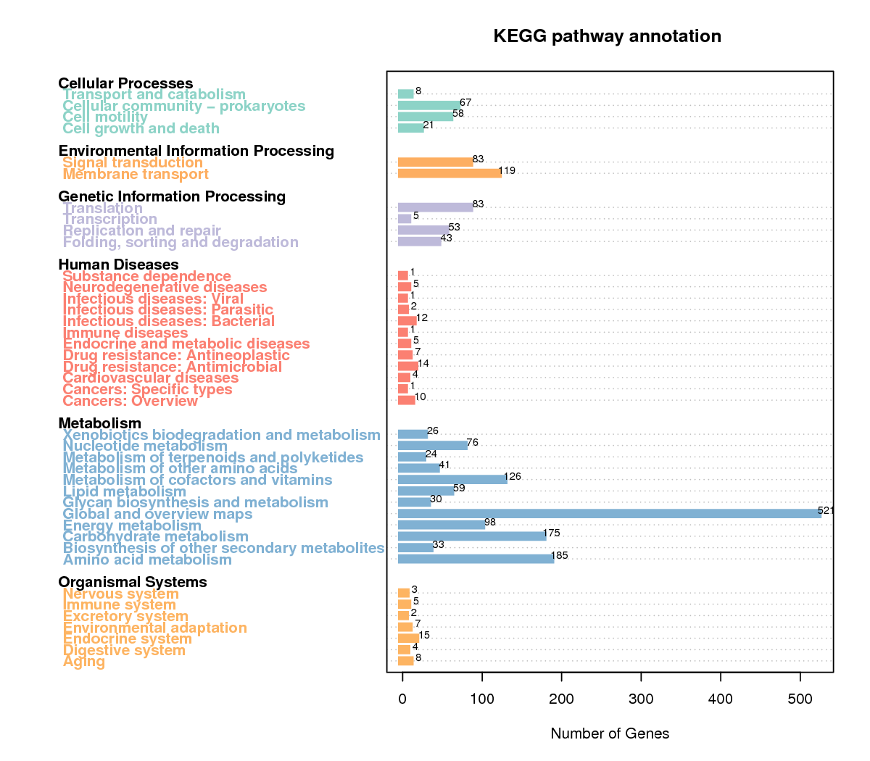

Figure. S4. Subsystem category distribution of strain T12^{T} by RAST server.
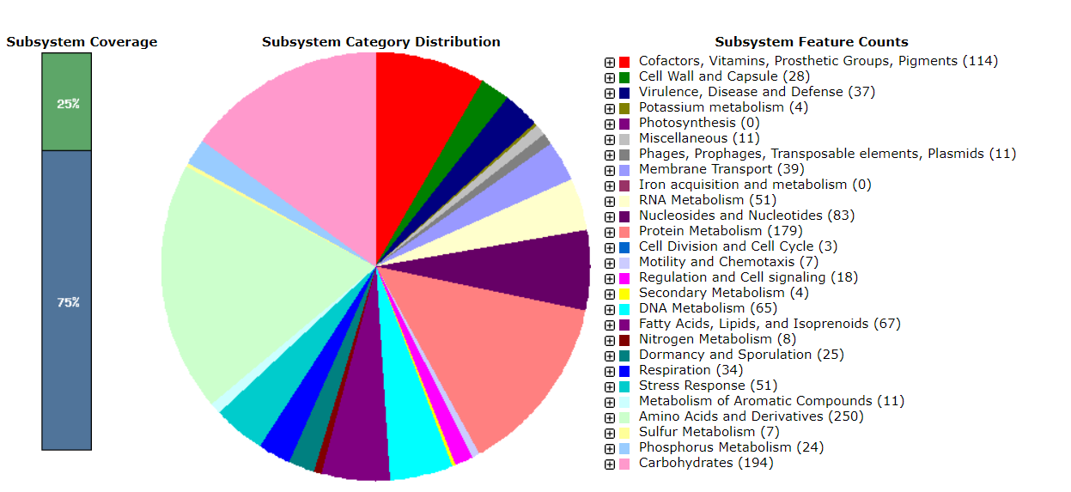

Figure. S5. After incubating the bacterium on MA at 37 ℃ for 2 days, cell morphology of strain T12^{T} was observed by a transmission electron microscope. Bar, 500 nm for pane A, 1 μm for pane B.
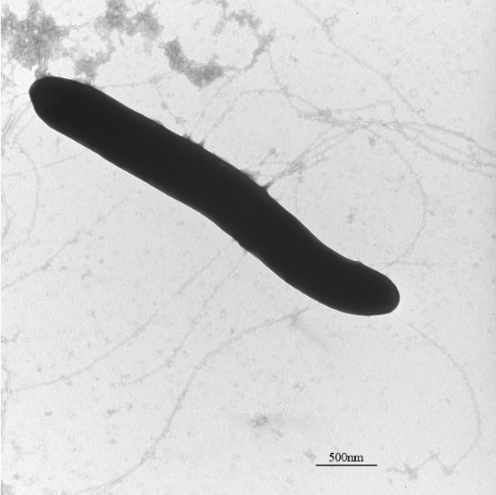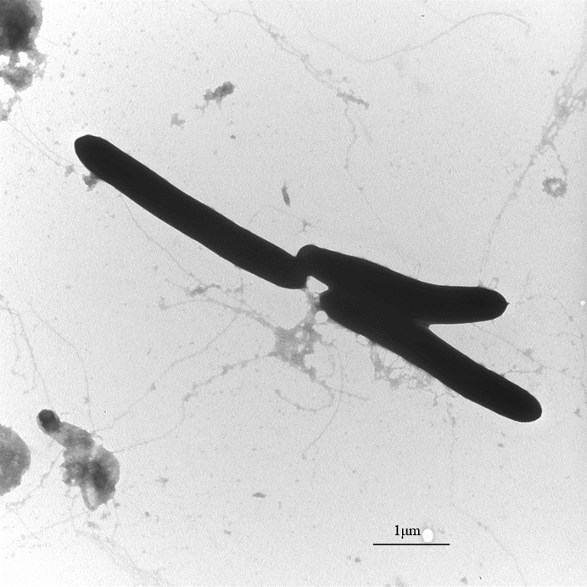
(A) (B)

Figure. S6. Two-dimensional Thin Layer Chromatography (TLC) pattern of the total polar lipids from strain T12^{T}. 5% ethanolic molybdatophosphoric acid for total lipids. DPG, diphosphatidylglycerol; PC, phosphatidylcholine; PG phosphatidylglycerol; PL, unidentified phospholipid.
