A fairer way to compare researchers at any career stage and in any discipline using open-access citation data

Corey J. A. Bradshaw, Justin M. Chalker, Stefani A. Crabtree, Bart A. Eijkelkamp, John A. Long, Justine R. Smith, Kate Trinajstic, and Vera Weisbecker

Supplementary Information
Contents:
Supplementary Information Figure S1
Supplementary Information Figure S2
Supplementary Information Figure S3
Supplementary Information Figure S4

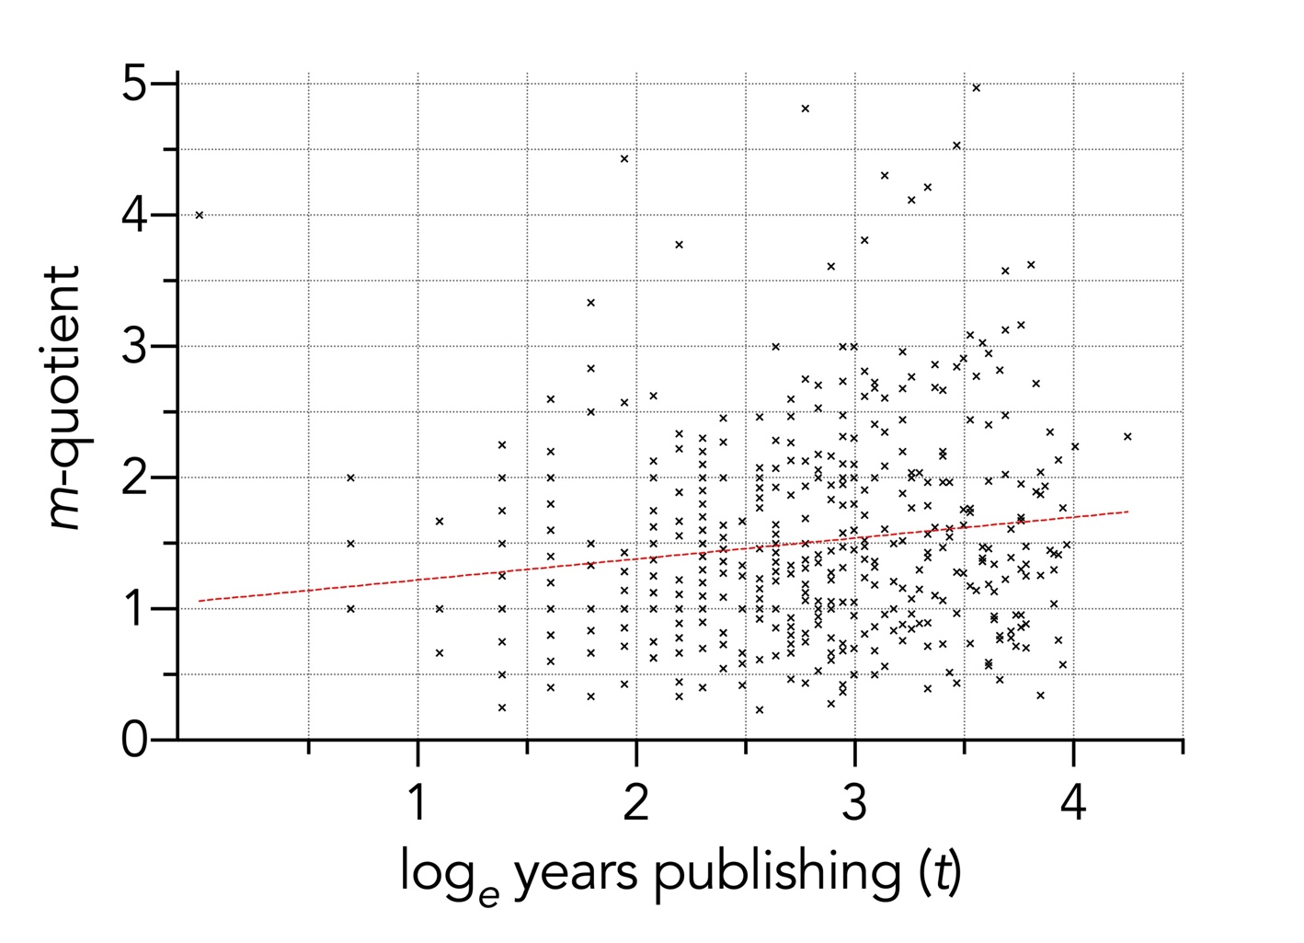
Figure S1. Relationship between the m-quotient and log_{e} years publishing (t) for 480 researchers in eight different disciplines. There is a weak, but statistically supported positive relationship (information-theoretic evidence ratio = 68.7).

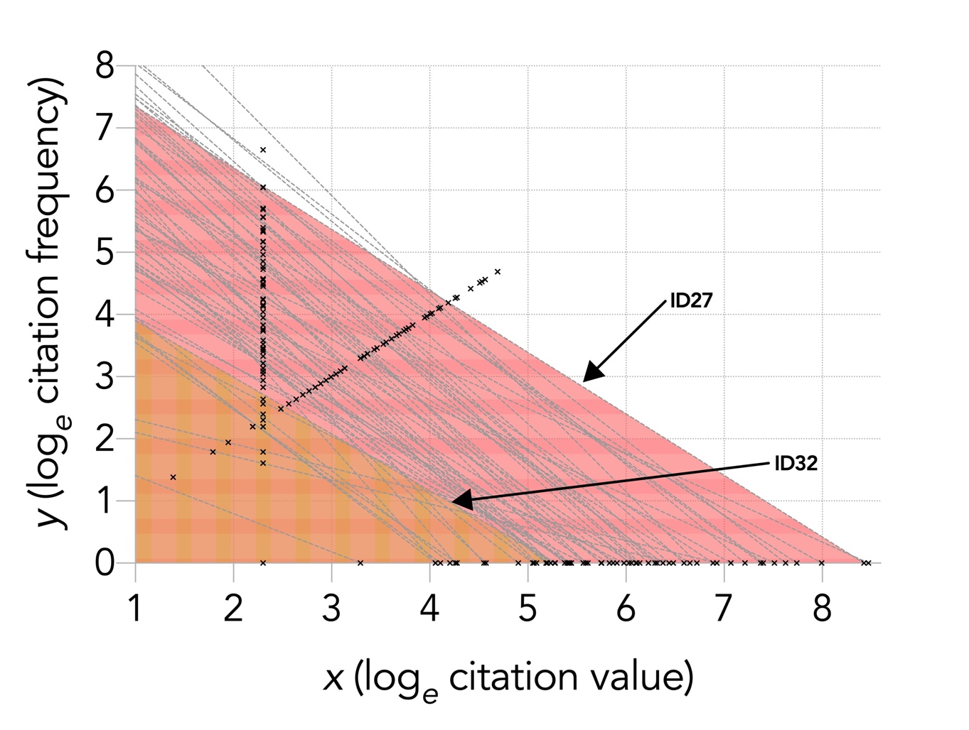
Figure S2. Relationship between log_{e} citation frequency (y) and log_{e} citation value (x) for 60 researchers within the discipline of ophthalmology. Each light grey, dashed line is the linear (on the log_{e}-log_{e} scale) fit for each individual researcher. The area under the fitted line (A_{rel}) is shown for individual 32 (ID32; red horizontal hatch) and individual 27 (orange vertical hatch).

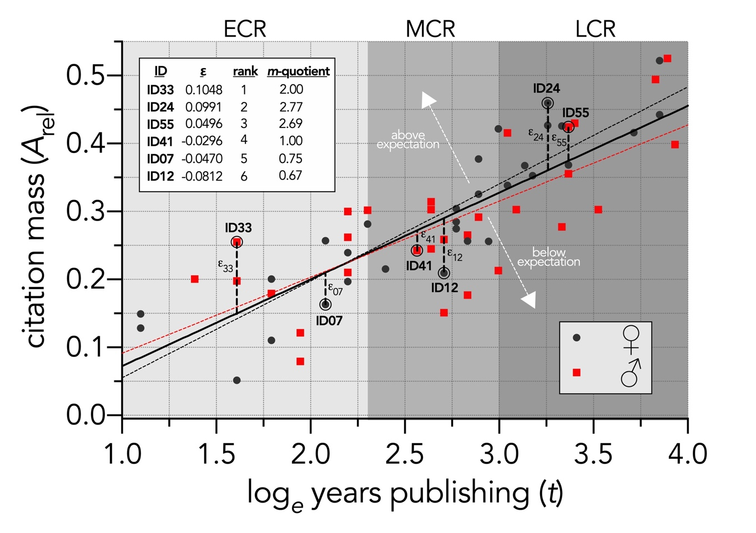
Figure S3. Relationship between a researcher’s citation mass (A_{rel}; area under the citation frequency–value curve — see Fig. S2) and log_{e} years since first peer-reviewed publication (Y₁) for an example sample of 60 microbiology researchers in three different career stages: early career researcher (ECR), mid-career researcher (MCR), and late-career researcher (LCR). The residuals (ε) for each researcher relative to the line of best fit (solid black line) indicate relative citation rank — researchers below this line perform below expectation (relative to the sample), those above, above expectation. Also shown are the lines of best fit for women (black dashed line) and men (red dashed line — see also Fig. S4). Here we have also selected two researchers at random (1 female, 1 male) from each career stage and shown their results in the inset table. The residuals (ε) provide a relative rank from most positive to most negative. Also shown is each of these six researchers’ m-quotient (h-index ÷ number of years publishing).

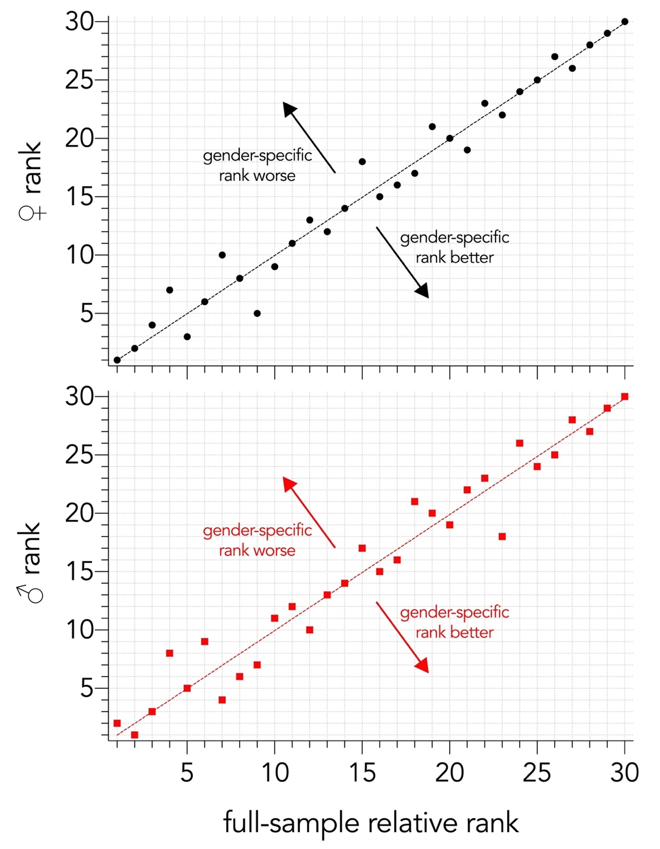
Figure S4. Gender-specific researcher ranks versus ranks derived from the entire sample (in this case, the microbiology sample shown in Fig. S3). For women who increased ranks when only compared to other women (negative residuals; top panel), the average increase was 1.50 places higher. For women with reduced ranks (positive residuals; top panel), the average was 1.88 places lower. For men who increased ranks when only compared to other men (negative residuals; bottom panel), or who declined in rank (positive residuals; bottom panel), the average number of places moved were both 1.75 for both.

