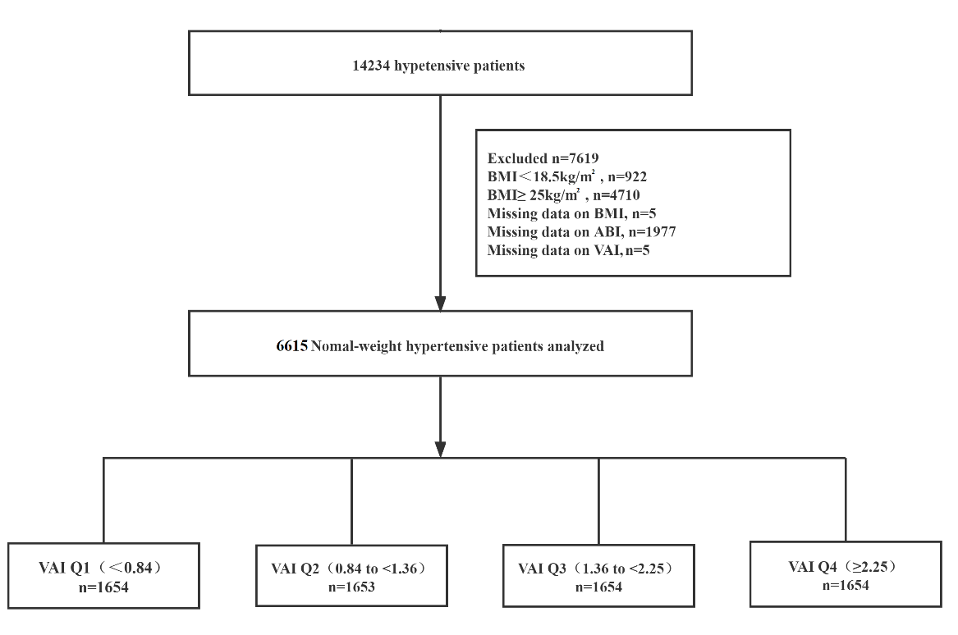
Figure S1 Flow chart of study participants
Figure S2. Stratified Analyses by Potential Modifiers of the Association Between VAI and the prevalence of PAD* *Each subgroup analysis adjusted for age, sex, BMI, SBP, DBP, pulse rate, Diabetes mellitus, stroke, CHD, Antihypertensive drugs, Lipoprotein-lowering drugs, Glucose-lowering drugs, current smoking, current drinking, education, physical activity, Hcy, FBG, TC, LDL, eGFR, Serum aspartate aminotransferase, Serum alanine aminotransferase, Serum γ -glutamyltransferase. except for the stratifying variable.

