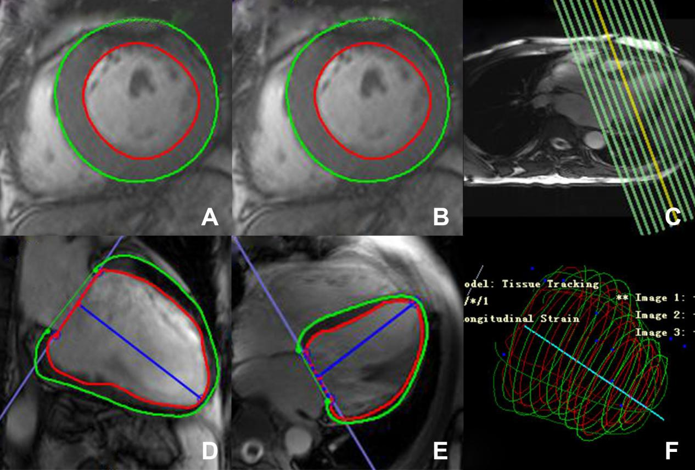
Fig. S1. Analysis of left ventricular volume and function by cardiac magnetic resonance cine images. The left ventricular endocardium (red) and epicardium (green) were outlined on the left ventricular short axis images of end diastolic (A) and end systolic (B) according to the reference line(C), two-chamber long axis (D) and four-chamber long axis (E) images of end diastolic. The blue T-line defines the mitral plane and apex. Figure (F) shows the 3D volume tissue tracking model of left ventricle automatically established.

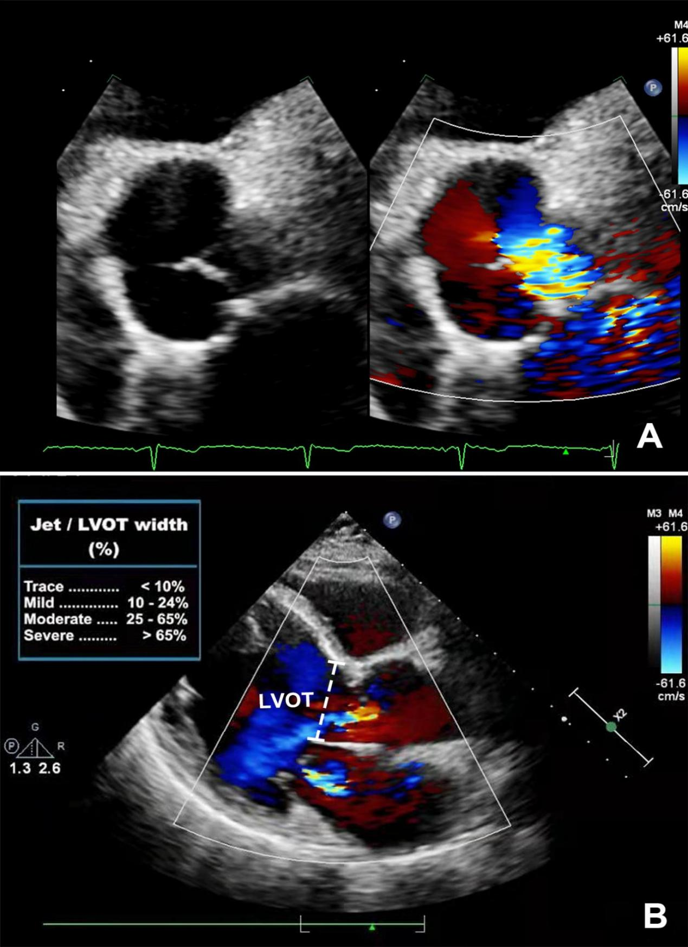
Fig. S2. Ratio of the aortic jet width (diameter) to left ventricular outflow tract (LVOT) diameter. The diameter of the color jet is measured immediately beneath the aortic valve is a semi-quantitative index of aortic regurgitation severity.Parasternal short axis view(A);Parasternal long axis view(B)

