Navigator-Free Submillimeter Diffusion Imaging using Multishot-encoded Simultaneous Multi-slice (MUSIUM)

Wei-Tang Chang^{1,2*}, Khoi Minh Huynh¹, Pew-Thian Yap^{1,2}, Weili Lin^{1,2}

¹ Biomedical Research Imaging Center, University of North Carolina at Chapel Hill, NC, USA

² Department of Radiology, University of North Carolina at Chapel Hill, NC, USA

*Corresponding author at: Biomedical Research Imaging Center, University of North Carolina at Chapel Hill, NC, USA. Fax: +1 (919) 843-4456.
E-mail address: weitang_chang@med.unc.edu (W.-T. Chang).
Key words: SMS, gSlider, dMRI, multishot

SUPPLEMENTARY MATERIALS
Low-rank Reconstructions
The low-rank matrix completion exploits the redundancy between the neighboring k-space data points. The linear dependency between the k-space points comes from the images with limited spatial support and/or slowly varying phase [1]. The procedure of low-rank reconstruction is illustrated in Figure S1. The reconstructed image is the solution of the equation in Figure S1. The equation is similar to the eq. (11) except that no estimated phase is involved and the solution includes the images of all the shots. The regularization parameter λ is calculate as
$λ$ = ${\left\|Y\right\|}_{2}^{2}/{\left\|{H(m}_{ini})\right\|}_{*}$ , (S1)
where $m_{ini}$ is the initial solution in eq. (S1) without the regularization term.
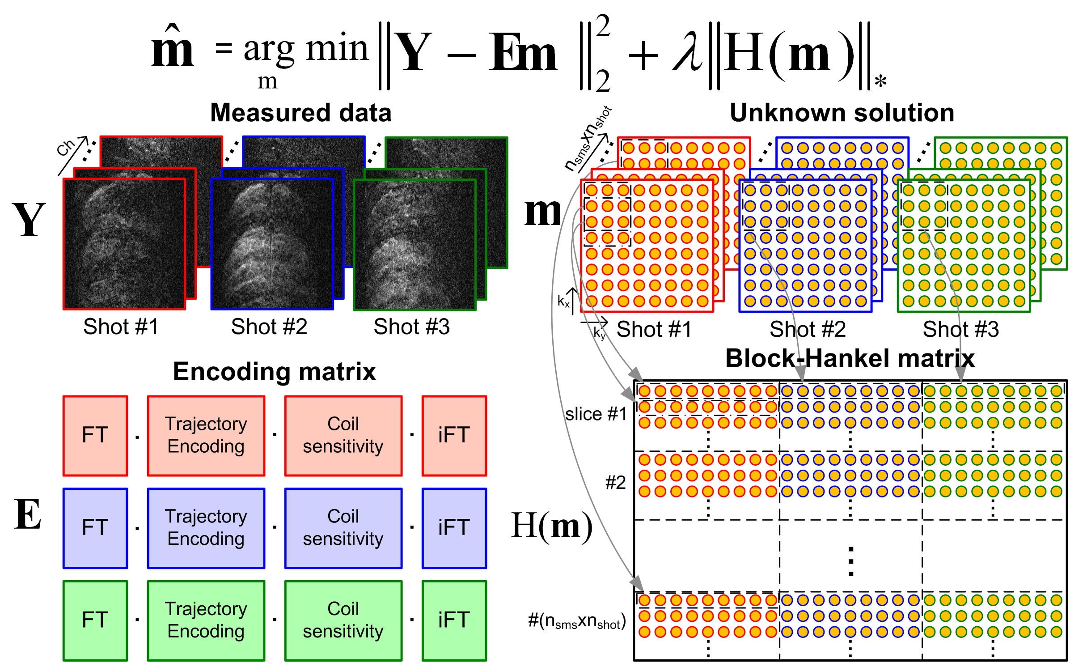
Figure S1: The illustration of low-rank reconstruction of MUSIUM data. Y denotes the measured data, E denotes the MUSIUM encoding matrix, m denotes the unknown image, λ denotes the regularization paramter and H(∙) denotes the Block-Hankel operation.

Figure S2a demonstrates the reconstruction results of eq. (11), which is SENSE-based. Figure S2b and S2c are both the results of low-rank reconstruction but with different regularization parameters. The image resolution is 0.86 mm isotropic and b value is 1000. The regularization parameter λ in Figure S2b is calculated by eq. (S1) and the parameter in Figure S2c is 3λ. The SENSE-based images demonstrate less striping artifacts and better image contrast than those of low-rank images. Besides, Figure S2b and S2c demonstrate that the low-rank reconstruction is sensitive to the regularization parameter.
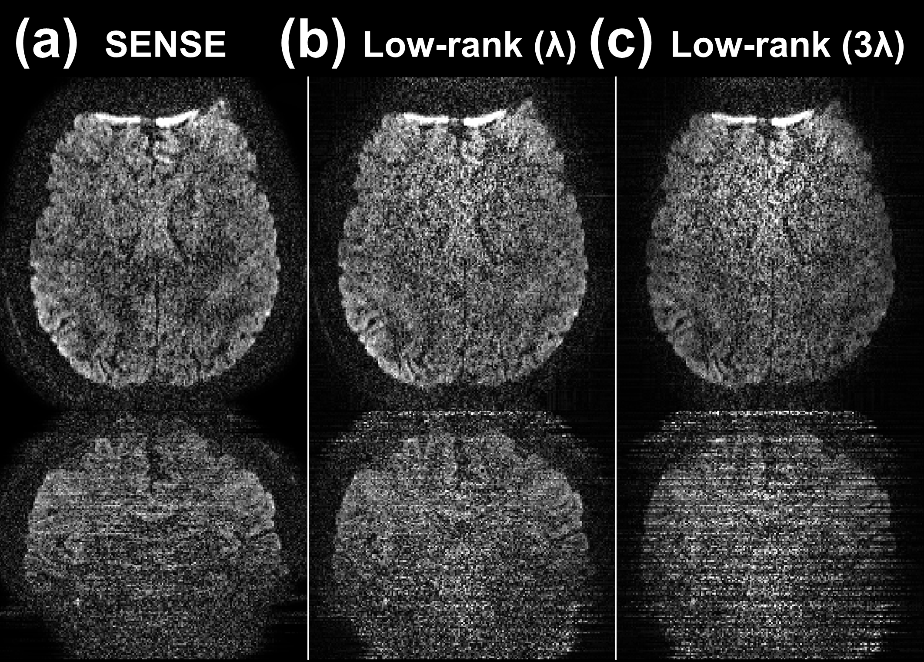
Figure S2: The reconstructed images of MUSIUM data. (a) The SENSE-based reconstruction. (b) The low-rank reconstruction with regularization parameter = λ. (c) The low-rank reconstruction with regularization parameter = 3λ.

RFERENCES
1. Haldar, J.P., Low-rank modeling of local k-space neighborhoods (LORAKS) for constrained MRI. IEEE Trans Med Imaging, 2014. 33(3): p. 668-81.

