Supplementary Material

Table S1. The Classification Criteria of Severity of COVID-19
Classification | Criteria
Mild type | The clinical symptoms were mild, and no pneumonia was found on the chest computed tomography (CT)
Common type | Patient had fever, respiratory symptoms, and imaging manifestations of pneumonia
Severe type | Fulfilling one of the following three conditions: 1. Respiratory distress, respiratory rate ≥ 30 times/min; 2. In resting state, oxygen saturation ≤ 93%; 3. Partial arterial oxygen pressure (PaO2)/oxygen absorption concentration (FiO2) ≤ 300 mmHg (1 mmHg = 0.133 kPa).
Critical type | Fulfilling one of the following three conditions: 1. Patient had respiratory failure and needed mechanical ventilation; 2. Patient suffered from shock; 3. Patient had other organ failure and needed ICU monitoring.

Table S2. Cumulative Number and Incidence Density of Confirmed and Clinically Diagnosed Cases in All Districts of Wuhan
District | Permanent Residents, 2018 (Ten Thousand) | Cumulative Confirmed Cases | Incidence Density of Confirmed Cases (/Ten Thousand) | Cumulative Clinically Diagnosed Cases | Incidence Density of Clinically Diagnosed Cases (/Ten Thousand)
P | 96.27 | 4112 | 42.71 | 3114 | 32.35
Jianghan | 72.97 | 3195 | 43.79 | 2585 | 35.43
Qiaokou | 86.87 | 3288 | 37.85 | 2712 | 31.22
Hanyang | 66.42 | 2421 | 36.45 | 2329 | 35.06
Wuchang | 128.28 | 5117 | 39.89 | 2451 | 19.11
Qingshan | 52.89 | 2045 | 38.67 | 1075 | 20.33
Hongshan | 167.73 | 3590 | 21.4 | 2737 | 16.32
Dongxihu | 58.48 | 1500 | 25.65 | 1051 | 17.97
Hannan | 13.58 | 519 | 38.22 | 612 | 45.07
Caidian | 76.16 | 994 | 13.05 | 795 | 10.44
Jiangxia | 96.2 | 738 | 7.67 | 775 | 8.06
Huangpi | 101.19 | 1205 | 11.91 | 1011 | 9.99
Xinzhou | 91.06 | 621 | 6.82 | 511 | 5.61
Wuhan | 1108.1 | 29345 | 26.48 | 21758 | 19.64

Table S3. Epidemiological Characteristics of Clinically Diagnosed Cases with Different Severities
Characteristics | Confirmed Cases |  |  |  |  | Clinically Diagnosed Cases |  |  |  |  | P
Characteristics | Mild (%) | Moderate (%) | Severe (%) | Critical (%) | Proportion of severe and critical cases (%) | Mild (%) | Moderate (%) | Severe (%) | Critical (%) | Proportion of severe and critical cases (%) | P
Total | 18192 | 4148 | 5278 | 823 | 21.5 | 11326 | 7446 | 2749 | 315 | 14.0 | <0.001
Age, median (IQR ª), years | 56.0(42.0–65.0) | 56.0(44.0–67.0) | 64.0(52.0–71.0) | 67.0(58.0–75.0) |  | 53.0(39.0–63.0) | 53.0(39.0–64.0) | 63.0(50.0–71.0) | 66.0(60.0–74.0) | —— | ——
Age group, years
0~ | 132(0.7) | 40(1.0) | 2(0.0) | 1(0.1) | 1.7 | 110(1.0) | 93(1.2) | 16(0.6) | 1(0.3) | 7.7 | <0.001
10~ | 162(0.9) | 35(0.8) | 12(0.2) | 2(0.2) | 6.6 | 91(0.8) | 73(1.0) | 9(0.3) | 0(0.0) | 5.2 | 0.226
20~ | 936(5.1) | 225(5.4) | 117(2.2) | 12(1.5) | 10.0 | 748(6.6) | 558(7.5) | 95(3.5) | 3(1.0) | 7.0 | 0.005
30~ | 2579(14.2) | 490(11.8) | 423(8.0) | 22(2.7) | 12.7 | 1895(16.7) | 1136(15.3) | 237(8.6) | 1(0.3) | 7.3 | <0.001
40~ | 2994(16.5) | 657(15.8) | 552(10.5) | 53(6.4) | 14.2 | 2061(18.2) | 1348(18.1) | 278(10.1) | 20(6.3) | 8.0 | <0.001
50~ | 4055(22.3) | 921(22.2) | 937(17.8) | 134(16.3) | 17.7 | 2626(23.2) | 1625(21.8) | 522(19.0) | 52(16.5) | 11.9 | <0.001
60~ | 4518(24.8) | 1003(24.2) | 1605(30.4) | 246(29.9) | 25.1 | 2471(21.8) | 1612(21.6) | 788(28.7) | 113(35.9) | 18.1 | <0.001
70~ | 1994(11.0) | 512(12.3) | 1037(19.6) | 221(26.9) | 33.4 | 979(8.6) | 706(9.5) | 505(18.4) | 81(25.7) | 25.8 | <0.001
80~ | 728(4.0) | 226(5.4) | 507(9.6) | 112(13.6) | 39.4 | 308(2.7) | 239(3.2) | 249(9.1) | 33(10.5) | 34.0 | 0.010
≥90 | 71(0.4) | 36(0.9) | 79(1.5) | 16(1.9) | 47.0 | 24(0.2) | 40(0.5) | 45(1.6) | 10(3.2) | 46.2 | 0.888
Missing | 23(0.1) | 3(0.1) | 7(0.1) | 4(0.5) | 29.7 | 13(0.1) | 16(0.2) | 5(0.2) | 1(0.3) | 17.1 | 0.209
Sex
Male | 8990(49.4) | 2094(50.5) | 2733(51.8) | 463(56.3) | 22.4 | 5168(45.6) | 3422(46.0) | 1324(48.2) | 191(60.6) | 15.0 | <0.001
Female | 9202(50.6) | 2054(49.5) | 2545(48.2) | 360(43.7) | 20.5 | 6158(54.4) | 4024(54.0) | 1425(51.8) | 124(39.4) | 13.2 | <0.001
Occupation
Child and student | 321(1.8) | 77(1.9) | 14(0.3) | 1(0.1) | 3.6 | 259(2.3) | 197(2.6) | 24(0.9) | 1(0.3) | 5.2 | 0.259
Cadre | 1005(5.5) | 217(5.2) | 203(3.8) | 16(1.9) | 15.2 | 526(4.6) | 501(6.7) | 81(2.9) | 4(1.3) | 7.6 | <0.001
Freelancer | 115(0.6) | 45(1.1) | 27(0.5) | 6(0.7) | 17.1 | 56(0.5) | 108(1.5) | 24(0.9) | 5(1.6) | 15.0 | 0.579
Physical labor | 484(2.7) | 112(2.7) | 86(1.6) | 14(1.7) | 14.4 | 381(3.4) | 199(2.7) | 53(1.9) | 7(2.2) | 9.4 | 0.005
Public service staff | 1393(7.7) | 192(4.6) | 163(3.1) | 10(1.2) | 9.8 | 937(8.3) | 407(5.5) | 103(3.7) | 4(1.3) | 7.4 | 0.014
Housework or unemployed | 3290(18.1) | 861(20.8) | 1133(21.5) | 241(29.3) | 24.9 | 2576(22.7) | 2061(27.7) | 669(24.3) | 91(28.9) | 14.1 | <0.001
Retirees | 5563(30.6) | 1459(35.2) | 2396(45.4) | 350(42.5) | 28.1 | 2909(25.7) | 1919(25.8) | 1108(40.3) | 139(44.1) | 20.5 | <0.001
Farmer or pastoral worker | 883(4.9) | 261(6.3) | 164(3.1) | 39(4.7) | 15.1 | 664(5.9) | 208(2.8) | 109(4.0) | 21(6.7) | 13.0 | 0.150
Healthcare worker | 803(4.4) | 125(3.0) | 183(3.5) | 5(0.6) | 16.9 | 542(4.8) | 507(6.8) | 147(5.3) | 1(0.3) | 12.4 | 0.002
Missing | 4335(23.8) | 799(19.3) | 909(17.2) | 141(17.1) | 17.0 | 2476(21.9) | 1339(18.0) | 431(15.7) | 42(13.3) | 11.0 | <0.001
Death or not
Not | 17589(96.7) | 4079(98.3) | 4801(91.0) | 613(74.5) | 20.0 | 11247(99.3) | 7415(99.6) | 2676(97.3) | 276(87.6) | 13.7 | <0.001
Yes | 603(3.3) | 69(1.7) | 477(9.0) | 210(25.5) | 50.6 | 79(0.7) | 31(0.4) | 73(2.7) | 39(12.4) | 50.5 | 0.978
Date of onset
Before Dec 31, 2019 | 31(0.2) | 6(0.1) | 22(0.4) | 12(1.5) | 47.9 | 17(0.2) | 45(0.6) | 19(0.7) | 7(2.2) | 29.6 | 0.018
Jan 1–10, 2020 | 153(0.8) | 37(0.9) | 146(2.8) | 71(8.6) | 53.3 | 112(1.0) | 145(1.9) | 78(2.8) | 17(5.4) | 27.0 | <0.001
Jan 11–20, 2020 | 1288(7.1) | 141(3.4) | 792(15.0) | 186(22.6) | 40.6 | 874(7.7) | 640(8.6) | 382(13.9) | 65(20.6) | 22.8 | <0.001
Jan 21–31, 2020 | 8997(49.5) | 986(23.8) | 2781(52.7) | 386(46.9) | 24.1 | 4347(38.4) | 2105(28.3) | 1131(41.1) | 121(38.4) | 16.3 | <0.001
Feb 1–10, 2020 | 6140(33.8) | 1985(47.9) | 1260(23.9) | 148(18.0) | 14.8 | 4682(41.3) | 2877(38.6) | 926(33.7) | 79(25.1) | 11.7 | <0.001
Feb 11–20, 2020 | 1391(7.6) | 940(22.7) | 264(5.0) | 18(2.2) | 10.8 | 1294(11.4) | 1634(21.9) | 213(7.7) | 26(8.3) | 7.6 | <0.001
Feb 21–24, 2020 | 191(1.0) | 53(1.3) | 11(0.2) | 0(0.0) | 4.3 | 0(0.0) | 0(0.0) | 0(0.0) | 0(0.0) | —— | ——
Missing | 1(0.0) | —— | 2(0.0) | 2(0.2) | 80.0 | 43(0.4) | 18(0.2) | 9(0.3) | —— | 12.9 | ——
Days from onset to diagnosis, median (IQR) | 8(4–12) | 9(5–15) | 11(7–15) | 11.5(7–16) |  | 11(6–17) | 9(3–17) | 15(9–21) | 15.5(9–23) | —— | ——
District of residence
City centre | 14429(79.3) | 3285(79.2) | 4447(84.3) | 685(83.2) | 22.5 | 8550(75.5) | 5988(80.4) | 2163(78.7) | 219(69.5) | 14.1 | <0.001
Suburb | 3625(20.0) | 821(19.8) | 757(14.3) | 116(14.1) | 16.4 | 2702(23.9) | 1395(18.7) | 559(20.3) | 92(29.2) | 13.7 | <0.001
Outside Wuhan | 138(0.8) | 42(1.0) | 69(1.3) | 17(2.1) | 32.3 | 74(0.7) | 63(0.8) | 27(1.0) | 4(1.3) | 18.5 | 0.002
Missing | —— | —— | 5(0.1) | 5(0.6) | 100.0 | —— | —— | —— | —— | ——
Level of hospital
Tertiary hospital | 13242(72.8) | 2720(65.6) | 4033(76.4) | 636(77.4) | 22.6 | 9743(86.0) | 5948(79.9) | 2528(92.0) | 267(84.8) | 15.0 | <0.001
Primary/ secondary hospital | 4951(27.2) | 1428(34.4) | 1245(23.6) | 186(22.6) | 18.3 | 1583(14.0) | 1498(20.1) | 221(8.0) | 48(15.2) | 8.0 | <0.001
Note.ª IQR=interquartile range.
Table S4. Risk Factors of the Severity of COVID-19 Infection from Univariable Logistic-regression Analysis*
Variable | Confirmed Cases |  | Clinically Diagnosed Cases
Variable | OR(95%CI) | P | OR(95%CI) | P
Age, years
<60 | 1(reference) |  | 1(reference)
≥60 | 2.45(2.32-2.6) | <0.001 | 2.87(2.65-3.10) | <0.001
Sex
Female | 1(reference) |  | 1(reference)
Male | 1.12(1.06-1.18) | <0.001 | 1.16(1.07-1.25) | <0.001
Occupation
Others | 1(reference) |  | 1(reference)
Housework or unemployed | 2.27(2.06-2.51) | <0.001 | 1.67(1.47-1.89) | <0.001
Retirees | 2.69(2.46-2.94) | <0.001 | 2.63(2.34-2.96) | <0.001
Healthcare worker | 1.39(1.17-1.66) | <0.001 | 1.44(1.18-1.75) | <0.001
Date of onset
Before Dec 31, 2019 | 1(reference) |  | 1(reference)
Jan 1–10, 2020 | 1.24(0.75-2.06) | 0.398 | 0.88(0.53-1.48) | 0.631
Jan 11–20, 2020 | 0.75(0.46-1.2) | 0.222 | 0.70(0.44-1.13) | 0.143
Jan 21–31, 2020 | 0.35(0.22-0.55) | <0.001 | 0.46(0.29-0.73) | 0.001
Feb 1–10, 2020 | 0.19(0.12-0.3) | <0.001 | 0.32(0.2-0.5) | <0.001
Feb 11–24, 2020 | 0.12(0.08-0.20) | <0.001 | 0.20(0.12-0.31) | <0.001
District of residence
Suburb | 1(reference) |  | 1(reference)
City centre | 1.48(1.36-1.60) | <0.001 | 1.03(0.94-1.13) | 0.52
Level of hospital
Secondary and lower level | 1(reference) |  | 1(reference)
Tertiary hospital | 1.3(1.22-1.39) | <0.001 | 2.04(1.79-2.33) | <0.001
Note. *The COVID-19 Cases with “Mild” and “Moderate” severity are defined as non-severe, and the COVID-19 Cases with “Severe” and “Critical” severity are defined as severe.

Table S5. Risk Factors of Death in COVID-19 Cases from Univariable Logistic-regression Analysis
Variable | Confirmed cases |  | Clinically diagnosed cases
 | OR(95%CI) | P | OR(95%CI) | P
Age, years
<60 | 1(reference) |  | 1(reference)
≥60 | 6.67(5.81-7.65) | <0.001 | 7.34(5.36-10.06) | <0.001
Sex
Female | 1(reference) |  | 1(reference)
Male | 1.94(1.75-2.16) | <0.001 | 2.6(1.99-3.38) | <0.001
Occupation
Others | 1(reference) |  | 1(reference)
Housework or unemployed | 2.21(1.79-2.73) | <0.001 | 2.01(1.26-3.19) | 0.003
Retirees | 3.65(3.02-4.4) | <0.001 | 3.25(2.11-5.01) | <0.001
Healthcare worker | 0.46(0.25-0.83) | 0.01 | 0.31(0.07-1.31) | 0.112
Case severity
Mild | 1(reference) |  | 1(reference)
Moderate | 0.49(0.38-0.63) | <0.001 | 0.6(0.39-0.9) | 0.015
Severe | 2.9(2.56-3.28) | <0.001 | 3.88(2.82-5.35) | <0.001
Critical | 9.99(8.38-11.92) | <0.001 | 20.12(13.46-30.06) | <0.001
Date of onset
Before Dec 31, 2019 | 1(reference) |  | 1(reference)
Jan 1–10, 2020 | 1.05(0.67-1.66) | 0.829 | 0.52(0.16-1.74) | 0.289
Jan 11–20, 2020 | 0.57(0.37-0.87) | 0.009 | 0.34(0.12-0.98) | 0.046
Jan 21–31, 2020 | 0.22(0.15-0.34) | <0.001 | 0.27(0.1-0.76) | 0.013
Feb 1–10, 2020 | 0.08(0.05-0.13) | <0.001 | 0.22(0.08-0.61) | 0.004
Feb 11–24, 2020 | 0.03(0.02-0.05) | <0.001 | 0.22(0.08-0.65) | 0.006
District of residence
Suburb | 1(reference) |  | 1(reference)
City centre | 1.26(1.09-1.46) | 0.002 | 0.81(0.6-1.1) | 0.176
Level of hospital
Secondary and lower level | 1(reference) |  | 1(reference)
Tertiary hospital | 1.56(1.37-1.77) | <0.001 | 0.71(0.52-0.96) | 0.028

Fig. S1 The time evolution of the total cases and subgroups. (a) confirmed cases, (b) clinically diagnosed cases

Fig. S2 Epidemiological curves of (a) confirmed cases and (b) clinically diagnosed cases in Wuhan by sexes

Fig. S3 The age distribution of (a) confirmed cases and (b) clinically diagnosed cases by sexes

Fig. S4 Time trend of interval between onset and diagnosis. (a) confirmed cases, (b) clinically diagnosed cases

Fig. S5 The relationship between age and disease severity / case fatality rate in COVID-19 patients. (a) the relationship between age and disease severity in confirmed cases, (b) the relationship between age and disease severity in clinically diagnosed cases, (c) the relationship between age and case fatality rate in confirmed cases, (b) the relationship between age and case fatality rate in clinically diagnosed cases
Fig. S6 The geographical disparity of disease severity and case fatality rates. (a) proportion of severe and critical types in confirmed cases, (b) proportion of severe and critical types in clinically diagnosed cases, (c) case fatality rate of confirmed cases, (d) case fatality rate of clinically diagnosed cases
Dongxihu district, one of suburbs in Wuhan, had the highest proportion of severe and critical types and case fatality rate in clinically diagnosed cases. Dongxihu district only had 2 fever clinics and one designated hospital (Jinyintan Hospital) in the battle against the epidemic. Jinyintan Hospital, the best hospital in Dongxihu district, is the backbone of the fight against the epidemic in Wuhan. In the early stage of the COVID-19 outbreak, Jinyintan Hospital was responsible for receiving confirmed and suspected cases throughout Wuhan. Before the implementation of clinical diagnosis, many severe and critical COVID-19 patients in the Dongxihu district couldn’t get laboratory-diagnosis and treatment timely due to a lack of medical resources. In Dongxihu district, clinical diagnosis is an important supplement to conventional diagnostic methods.

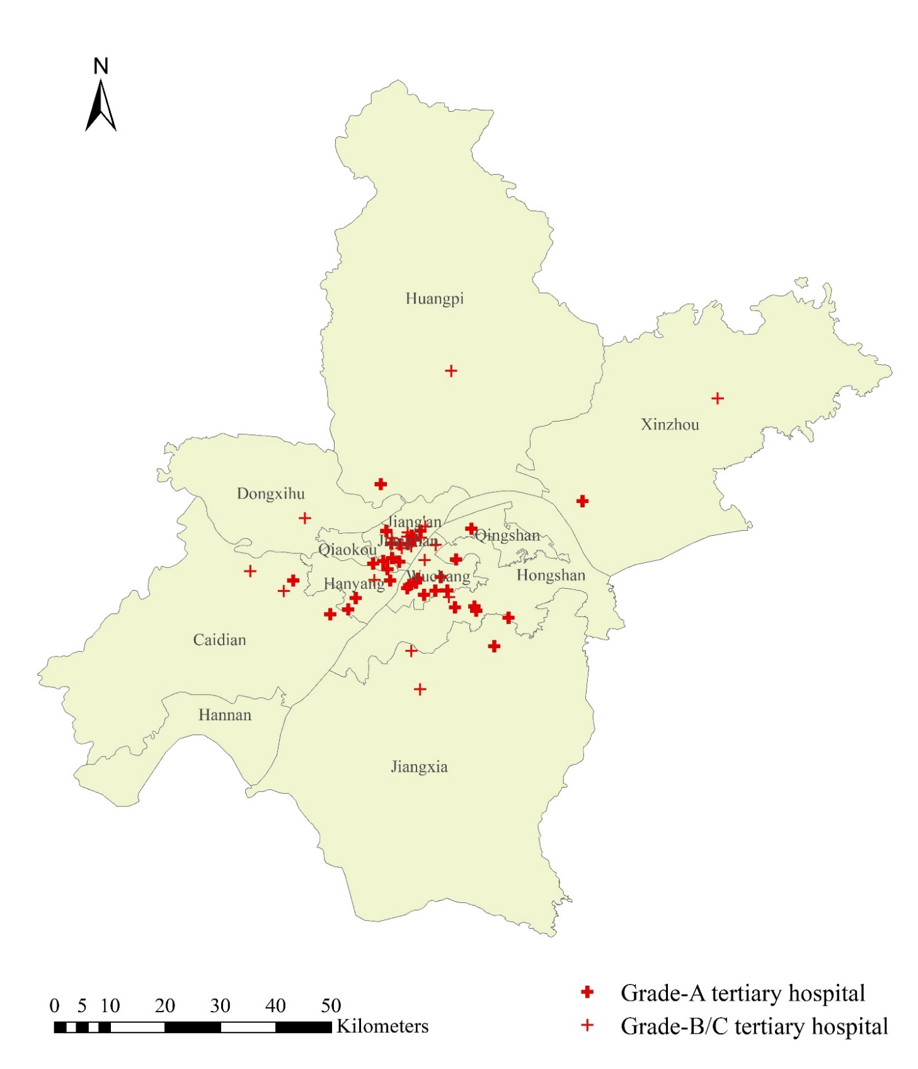
Fig. S7 The Distribution map of tertiary hospitals in Wuhan, China

