Supplementary Information for manuscript titled “SARS-CoV-2 variants’-Alpha, Delta and Omicron D614G and P681R/H mutations impact virus entry, transmissibility and infectivity”
Authors: Ritika Khatri¹ and Sweety Samal¹*

Affiliations:
¹Translational Health Science & Technology Institute, NCR Biotech Science Cluster, Faridabad, Haryana 121001, India.
*Correspondence：Sweety Samal, sweety.samal@thsti.res.in

This file includes:
Figures S1 to S3
Supplementary Figures

Supplementary Fig.1.
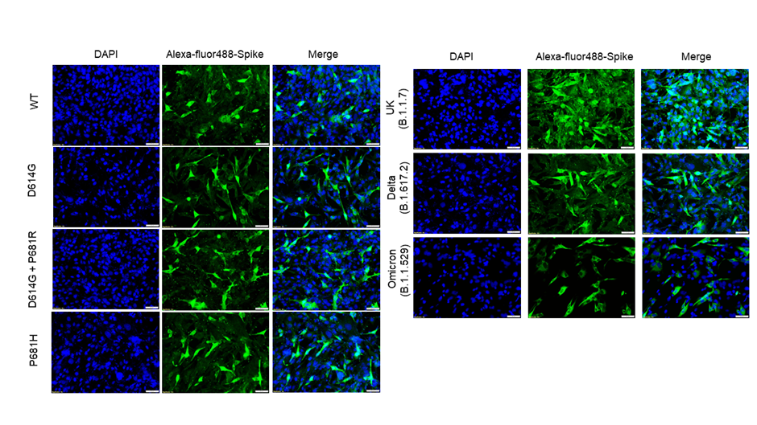
Supplementary fig.1: Expression of SARS-CoV-2 ancestral and variants spike protein in BHK-21 cell line as measured by Immunofluorescence. BHK-21 cells were transfected with spike protein. 36h post transfection, the cells were fixed and the expression was checked by probing with primary anti-spike mouse polyclonal sera (1:200) (polyclonal mouse sera raised against ancestral spike protein, BEI Resources NR-52394) and secondary antibody Alexa-Fluor 488-labeled anti-mouse antibody (green) (1:1000). The images were taken in Olympus fluorescence microscope. The experiments were repeated three times. The nuclei were stained with 4′,6-diamidino-2-phenylindole (DAPI, blue); scale bar: 50 μm and magnification 20x.

Supplementary fig.2:
Supplementary fig.2: Cell surface expression of variants spike protein as measured by flow cytometry. FACS-based cell surface expression assay was carried out by transfecting the 293T cells with different spike plasmids. 24h post transfection cells were harvested using 5mM EDTA, washed three times with FACS buffer (PBS+ 5% HIFBS) and stained with anti-spike mouse polyclonal sera for 1h at room temperature (RT). The cells were washed three times with FACS buffer and then stained with PE-conjugated goat anti-mouse secondary antibody (1:200 dilutions, Jackson ImmunoResearch) for 1 h at RT. The cells were again washed three times with FACS buffer and fixed with 0.5% paraformaldehyde. The stained cells were then analyzed in a FACS Canto analyzer (BD Biosciences) and data analyzed with FlowJo software (version 10.0.6, Tree Star Inc). The data were expressed as mean fluorescent intensity (MFI).

Supplementary fig.3.
Supplementary fig.3. Growth characteristic of SARS-CoV-2 ancestral and variants live viruses in Vero E6 cells. Plaque assay was performed using SARS-CoV-2 live viruses in Vero E6 cells. Serially diluted viruses were allowed to infect the Vero E6 monolayer of cells seeded onto 12-well plates. Following 1 h of adsorption, the plate was washed with 2% Dulbecco's Modified Eagle Medium (DMEM) and overlaid with 2% carboxymethyl cellulose (CMC) prepared in DMEM. Forty-eight hour p.i the plates were fixed with 6% formalin for 4 h at RT and stained with 1% crystal violet to visualize the plaques.

