Fig S1. Expression of 20 candidate nanobodies using the E.coli system.

Fig S2. Reactivities of 18 to the E2 protein of CHIKV measured by indirect ELISA.

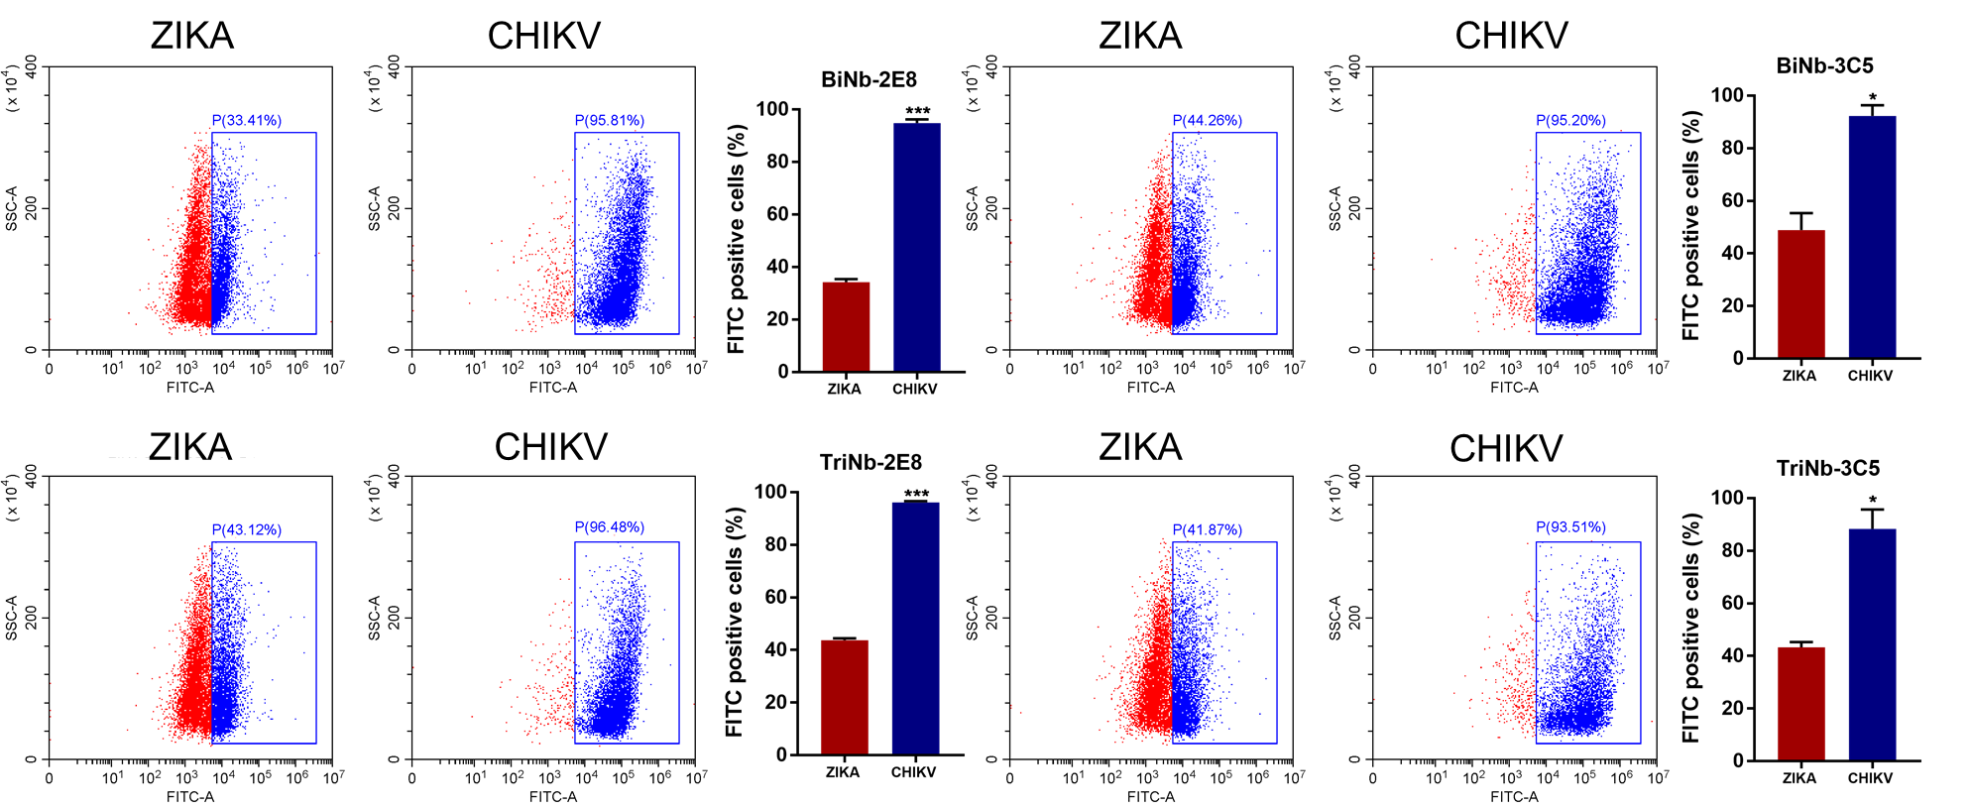
Fig S3. Representative flow cytometry plots and data analysis of mean fluorescence value. A representative experiment among 2 is shown.

