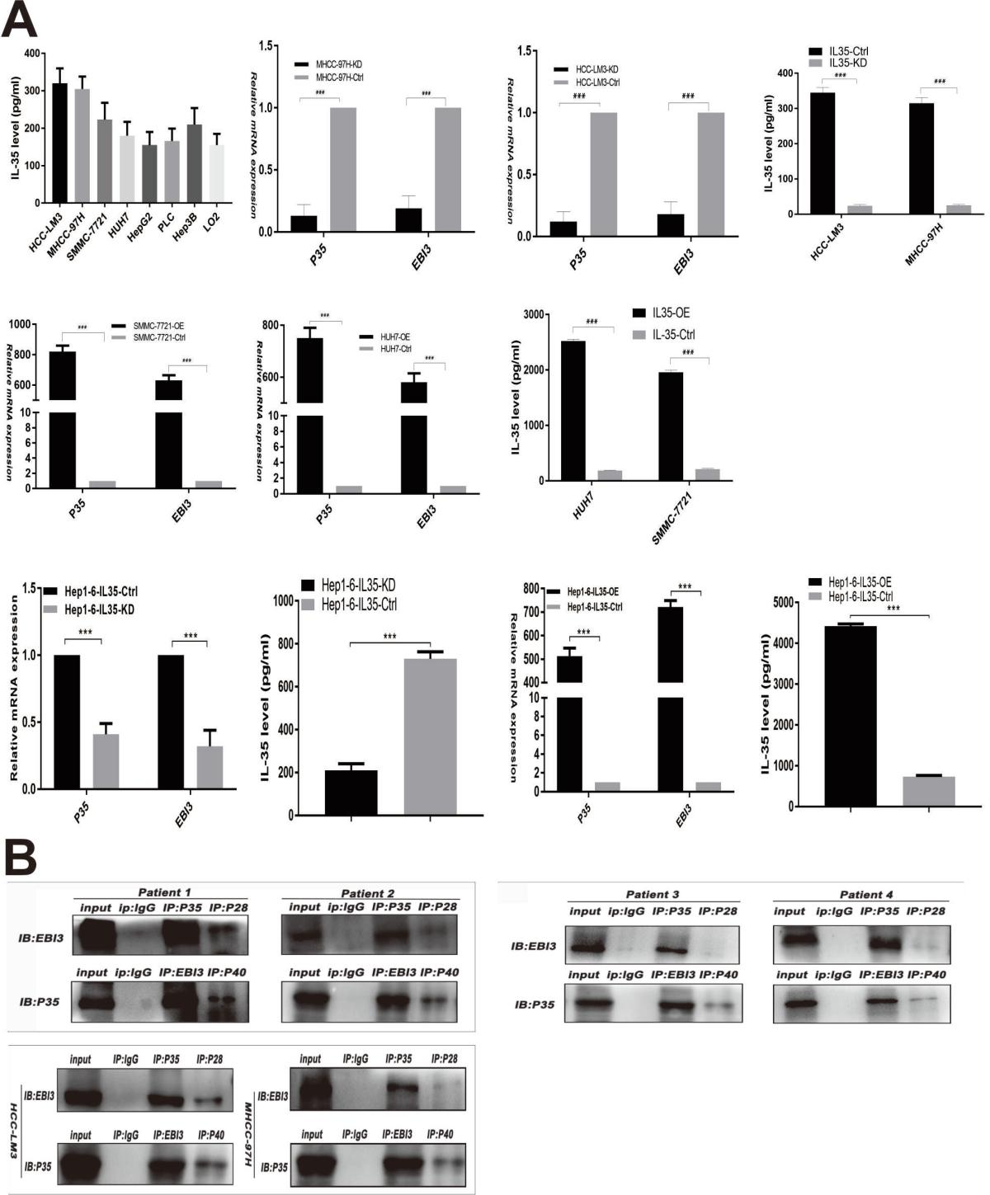
FIGS1.Construction of stable IL-35 cell line.
- The expression of IL-35 in hepatoma cell line was detected by ELISA assay. And we have HCC-LM3 and MHCC97H constructed to IL-35 knock down stable cell line, and SMCC-7721 and HUH7 was constructed to IL-35 over expression stable cell line. Also Hepa1-6 cell line was chosed to constructed both IL-35 knock down and over expression stable cell line.
- 4 cases of HCC samples and 2 cell line was used to study the structural relationship of the 4 subunits by CO-IP technique. The P35 antibody was demonstrated to successfully immunoprecipitate EBI3 but rarely bound to P40 and P28.
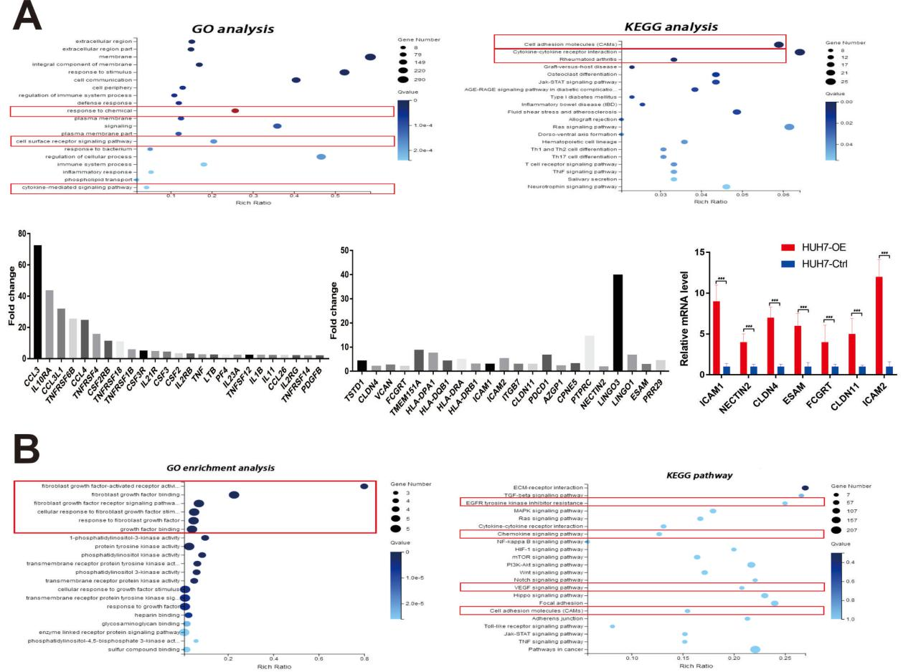
FIGS2.Go analysis and KEGG analysis of the gene expression difference after IL-35 stimulated HCC and Neutrophils.
A. the gene expression difference analysis of HCC after IL-35 stimulated.
B. the gene expression difference analysis of neutrophils after IL-35 stimulated.

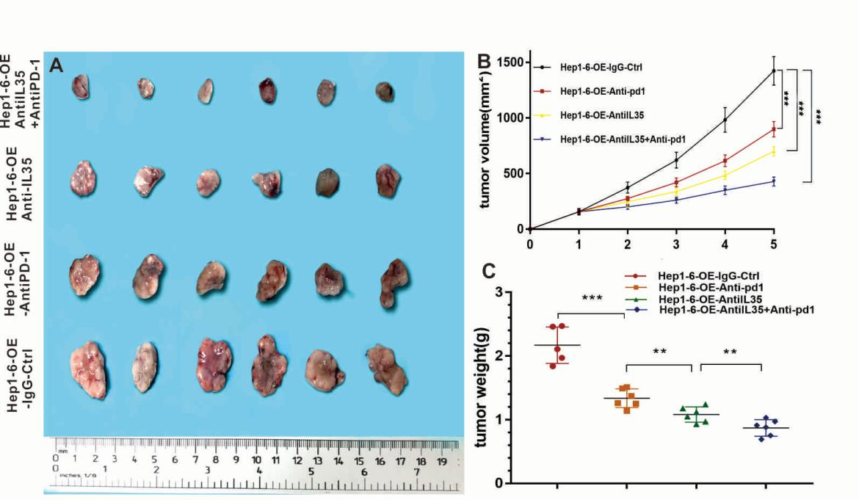
FIGS3.The combination of IL-35 antibody and PD-1 antibody has a stronger synergistic anticancer effect in subcutaneous tumor model of immunocompetent mice recipients bearing Hepa1-6-IL35-OE cells.
- the typical tumor mass of four therapy groups.
- tumor growth was slightly suppressed after treatment with either an anti-IL-35 or a PD-1 neutralizing antibody. However, we observed more dramatic and durable responses, compared with the responses in the control treatment, when the anti-PD-1 antibody was combined with the anti-IL-35 neutralizing antibody.
- Lighter tumor weight was found after treatment with either an anti-IL-35 or a PD-1 neutralizing antibody than the control group. And the combined therapy with anti-IL-35 neutralizing antibody and anti-PD-1 antibody has the apparently tumor weight loss.

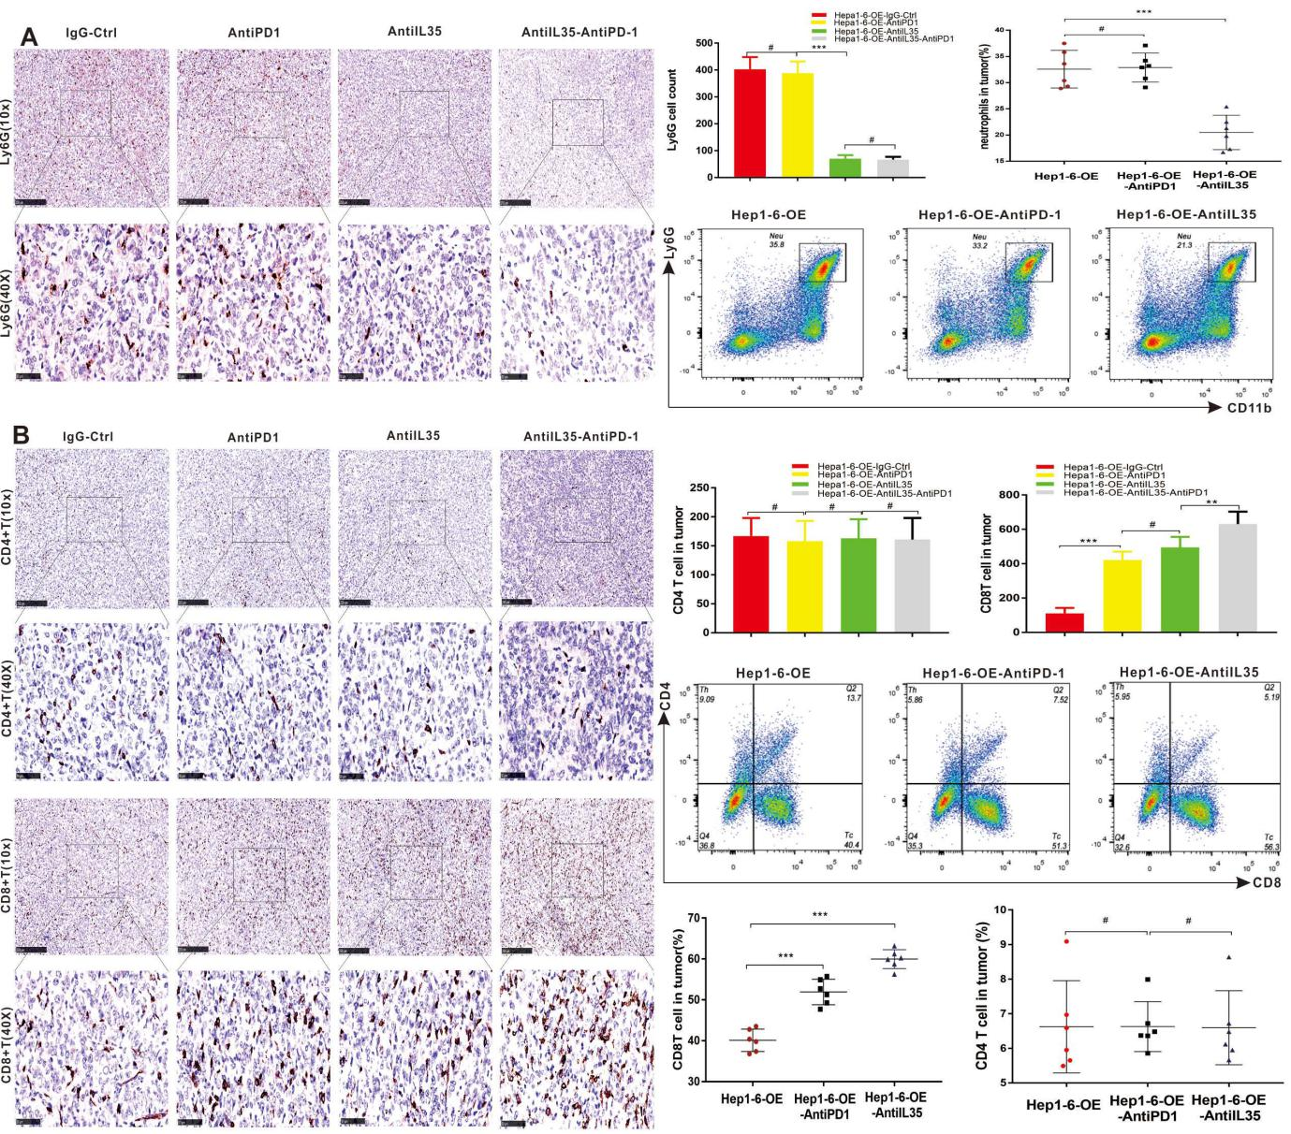
FIGS4. AntiIL-35 antibody significantly reduced the infiltration of Ly6G⁺ neutrophiles and increase the infiltration of CD8⁺T cell in subcutaneous tumor model of immunocompetent mice recipients bearing Hepa1-6-IL35-OE cells.
- IHC and flow cytometric plot were utilized to explore the infiltration of immune cells of these tumors tissue. Anti-PD-1 antibody has no effect on the infiltration of Ly6G⁺ neutrophiles, but significant difference were catch in combined treatment group and antiIL-35 group. There were less infiltration of neutrophils among these two groups.
B. Interesting we also found that CD8⁺T cell were also significant increase in both PD-1 antidy group and combined treatment group.

