Table S1 Plant species investigated in this study.
Species | Family | Growth form | Life history | Nutrient-acquisition strategy
Acacia ramulosa W.Fitzg. var. ramulosa | Fabaceae | Shrub/tree | Perennial | AM/NF
Allocasuarina acutivalvis subsp. prinsepiana  (C.R.P.Andrews) L.A.S.Johnson | Casuarinaceae | Tree | Perennial | ECM/AM/NF/CR
Austrostipa scabra (Lindl.) S.W.L.Jacobs & J.Everett | Poaceae | C3 grass | Perennial | AM
Eucalyptus loxophleba subsp. supralaevis | Myrtaceae | Tree | Perennial | ECM/AM
Hakea recurva Meisn. subsp. recurva | Proteaceae | Shrub/tree | Perennial | CR/NM
Maireana georgei (Diels) Paul G.Wilson | Chenopodiaceae | Shrub | Perennial | NM

AM, arbuscular mycorrhizal; CR, cluster roots; ECM, ectomycorrhizal; NF, nitrogen-fixing; NM, non-mycorrhizal

Table S2 Results from three-way Analysis of Variance (ANOVA) for the effects of substrate, inoculation, species and their interactions on substrate changes per total biomass, with plant species as random effect. DF: Degree of freedom; F: F ratio; P: probability. C: carbon, N: nitrogen, P: phosphorus, MBC: microbial biomass carbon, MBN: microbial biomass nitrogen, MBP: microbial biomass phosphorus, ECEC: effective cation exchange capacity, EC: electrical conductivity.
Soil parameters | Effect | DF | F | P
pH (CaCl₂) | Species | 5 | 3.7619 | 0.0044
 | Inoculation | 1 | 12.0569 | 0.0009
 | Species*Inoculation | 5 | 3.5859 | 0.0060
 | Substrates | 2 | 6.3944 | 0.0028
 | Species*Substrates | 10 | 3.3772 | 0.0012
 | Inoculation*Substrates | 2 | 3.6129 | 0.0320
 | Species*Inoculation*Substrates | 10 | 2.5250 | 0.0115
pH (H₂O) | Species | 5 | 1.8562 | 0.1128
 | Inoculation | 1 | 10.5753 | 0.0017
 | Species*Inoculation | 5 | 2.1095 | 0.0740
 | Substrates | 2 | 4.9779 | 0.0094
 | Species*Substrates | 10 | 1.5191 | 0.1503
 | Inoculation*Substrates | 2 | 2.8432 | 0.0648
 | Species*Inoculation*Substrates | 10 | 1.6382 | 0.1131
NH₄-N (mg kg⁻¹) | Species | 5 | 0.9280 | 0.4681
 | Inoculation | 1 | 3.7463 | 0.0569
 | Species*Inoculation | 5 | 0.6849 | 0.6364
 | Substrates | 2 | 16.4526 | <0.0001
 | Species*Substrates | 10 | 0.9280 | 0.5130
 | Inoculation*Substrates | 2 | 3.7463 | 0.0283
 | Species*Inoculation*Substrates | 10 | 0.6849 | 0.7350
NO₃-N (mg kg⁻¹) | Species | 5 | 7.3303 | <0.0001
 | Inoculation | 1 | 61.2055 | <0.0001
 | Species*Inoculation | 5 | 9.7148 | <0.0001
 | Substrates | 2 | 61.6533 | <0.0001
 | Species*Substrates | 10 | 11.5245 | <0.0001
 | Inoculation*Substrates | 2 | 20.2593 | <0.0001
 | Species*Inoculation*Substrates | 10 | 9.5709 | <0.0001
Organic C  (mg kg⁻¹) | Species | 5 | 2.0608 | 0.0803
Organic C  (mg kg⁻¹) | Inoculation | 1 | 1.6488 | 0.2032
Organic C  (mg kg⁻¹) | Species*Inoculation | 5 | 2.5033 | 0.0380
Organic C  (mg kg⁻¹) | Substrates | 2 | 12.1526 | <0.0001
Organic C  (mg kg⁻¹) | Species*Substrates | 10 | 2.5737 | 0.0101
Organic C  (mg kg⁻¹) | Inoculation*Substrates | 2 | 7.0569 | 0.0016
Organic C  (mg kg⁻¹) | Species*Inoculation*Substrates | 10 | 2.7345 | 0.0066
Total N (mg kg⁻¹) | Species | 5 | 0.5964 | 0.7027
 | Inoculation | 1 | 3.5283 | 0.0644
 | Species*Inoculation | 5 | 0.9016 | 0.4849
 | Substrates | 2 | 0.3448 | 0.7095
 | Species*Substrates | 10 | 0.6313 | 0.7823
 | Inoculation*Substrates | 2 | 0.7683 | 0.4676
 | Species*Inoculation*Substrates | 10 | 0.7960 | 0.6328

Table S2 Continued.
Soil parameters | Effect | DF | F | P
MBC (mg kg⁻¹) | Species | 5 | 3.2657 | 0.0103
 | Inoculation | 1 | 0.1957 | 0.6595
 | Species*Inoculation | 5 | 5.5702 | 0.0002
 | Substrates | 2 | 5.0992 | 0.0085
 | Species*Substrates | 10 | 4.2332 | 0.0001
 | Inoculation*Substrates | 2 | 6.6656 | 0.0022
 | Species*Inoculation*Substrates | 10 | 2.8705 | 0.0046
MBN (mg kg⁻¹) | Species | 5 | 2.0766 | 0.0782
 | Inoculation | 1 | 0.0594 | 0.8081
 | Species*Inoculation | 5 | 3.2967 | 0.0098
 | Substrates | 2 | 5.4283 | 0.0064
 | Species*Substrates | 10 | 1.8896 | 0.0606
 | Inoculation*Substrates | 2 | 2.6445 | 0.0779
 | Species*Inoculation*Substrates | 10 | 1.0699 | 0.3965
MBP (mg kg⁻¹) | Species | 5 | 2.8185 | 0.0222
 | Inoculation | 1 | 5.7500 | 0.0191
 | Species*Inoculation | 5 | 3.6134 | 0.0059
 | Substrates | 2 | 0.8002 | 0.4532
 | Species*Substrates | 10 | 4.6195 | <0.0001
 | Inoculation*Substrates | 2 | 3.6355 | 0.0313
 | Species*Inoculation*Substrates | 10 | 3.8326 | 0.0003
ECEC  (cmol(+) kg⁻¹) | Species | 5 | 7.5404 | <0.0001
ECEC  (cmol(+) kg⁻¹) | Inoculation | 1 | 7.1548 | 0.0092
ECEC  (cmol(+) kg⁻¹) | Species*Inoculation | 5 | 6.8394 | <0.0001
ECEC  (cmol(+) kg⁻¹) | Substrates | 2 | 21.9302 | <0.0001
ECEC  (cmol(+) kg⁻¹) | Species*Substrates | 10 | 6.6679 | <0.0001
ECEC  (cmol(+) kg⁻¹) | Inoculation*Substrates | 2 | 12.5056 | <0.0001
ECEC  (cmol(+) kg⁻¹) | Species*Inoculation*Substrates | 10 | 5.7183 | <0.0001
Colwell P  (mg kg⁻¹) | Species | 5 | 2.3184 | 0.0520
Colwell P  (mg kg⁻¹) | Inoculation | 1 | 20.2654 | <0.0001
Colwell P  (mg kg⁻¹) | Species*Inoculation | 5 | 1.9446 | 0.0974
Colwell P  (mg kg⁻¹) | Substrates | 2 | 5.0448 | 0.0089
Colwell P  (mg kg⁻¹) | Species*Substrates | 10 | 2.7524 | 0.0063
Colwell P  (mg kg⁻¹) | Inoculation*Substrates | 2 | 5.8937 | 0.0043
Colwell P  (mg kg⁻¹) | Species*Inoculation*Substrates | 10 | 1.5759 | 0.1314
EC (mS m⁻¹) | Species | 5 | 10.3999 | <0.0001
 | Inoculation | 1 | 18.4496 | <0.0001
 | Species*Inoculation | 5 | 7.9027 | <0.0001
 | Substrates | 2 | 47.3766 | <0.0001
 | Species*Substrates | 10 | 9.2830 | <0.0001
 | Inoculation*Substrates | 2 | 22.6816 | <0.0001
 | Species*Inoculation*Substrates | 10 | 6.8878 | <0.0001
Colwell K  (mg kg⁻¹) | Species | 5 | 5.6323 | 0.0002
Colwell K  (mg kg⁻¹) | Inoculation | 1 | 0.9498 | 0.3330
Colwell K  (mg kg⁻¹) | Species*Inoculation | 5 | 4.6485 | 0.0010
Colwell K  (mg kg⁻¹) | Substrates | 2 | 14.3340 | <0.0001
Colwell K  (mg kg⁻¹) | Species*Substrates | 10 | 5.0646 | <0.0001
Colwell K  (mg kg⁻¹) | Inoculation*Substrates | 2 | 2.9657 | 0.0579
Colwell K  (mg kg⁻¹) | Species*Inoculation*Substrates | 10 | 4.0074 | 0.0002

Table S2 Continued.
Soil parameters | Effect | DF | F | P
Exchangeable Al  (cmol(+) kg⁻¹) | Species | 5 | 3.0231 | 0.0156
Exchangeable Al  (cmol(+) kg⁻¹) | Inoculation | 1 | 0.9868 | 0.3238
Exchangeable Al  (cmol(+) kg⁻¹) | Species*Inoculation | 5 | 2.9042 | 0.0191
Exchangeable Al  (cmol(+) kg⁻¹) | Substrates | 2 | 4.5693 | 0.0135
Exchangeable Al  (cmol(+) kg⁻¹) | Species*Substrates | 10 | 2.6094 | 0.0092
Exchangeable Al  (cmol(+) kg⁻¹) | Inoculation*Substrates | 2 | 3.8650 | 0.0254
Exchangeable Al  (cmol(+) kg⁻¹) | Species*Inoculation*Substrates | 10 | 3.0261 | 0.0030
Exchangeable Ca  (cmol(+) kg⁻¹) | Species | 5 | 3.4215 | 0.0079
Exchangeable Ca  (cmol(+) kg⁻¹) | Inoculation | 1 | 9.2087 | 0.0034
Exchangeable Ca  (cmol(+) kg⁻¹) | Species*Inoculation | 5 | 4.2375 | 0.0020
Exchangeable Ca  (cmol(+) kg⁻¹) | Substrates | 2 | 26.8568 | <0.0001
Exchangeable Ca  (cmol(+) kg⁻¹) | Species*Substrates | 10 | 3.2915 | 0.0015
Exchangeable Ca  (cmol(+) kg⁻¹) | Inoculation*Substrates | 2 | 14.0846 | <0.0001
Exchangeable Ca  (cmol(+) kg⁻¹) | Species*Inoculation*Substrates | 10 | 4.2431 | 0.0001
Exchangeable Mg  (cmol(+) kg⁻¹) | Species | 5 | 10.0313 | <0.0001
Exchangeable Mg  (cmol(+) kg⁻¹) | Inoculation | 1 | 67.4638 | <0.0001
Exchangeable Mg  (cmol(+) kg⁻¹) | Species*Inoculation | 5 | 9.8142 | <0.0001
Exchangeable Mg  (cmol(+) kg⁻¹) | Substrates | 2 | 11.4979 | <0.0001
Exchangeable Mg  (cmol(+) kg⁻¹) | Species*Substrates | 10 | 9.5804 | <0.0001
Exchangeable Mg  (cmol(+) kg⁻¹) | Inoculation*Substrates | 2 | 7.4181 | 0.0012
Exchangeable Mg  (cmol(+) kg⁻¹) | Species*Inoculation*Substrates | 10 | 8.0778 | <0.0001
Exchangeable K  (cmol(+) kg⁻¹) | Species | 5 | 14.1348 | <0.0001
Exchangeable K  (cmol(+) kg⁻¹) | Inoculation | 1 | 1.7281 | 0.1928
Exchangeable K  (cmol(+) kg⁻¹) | Species*Inoculation | 5 | 16.6002 | <0.0001
Exchangeable K  (cmol(+) kg⁻¹) | Substrates | 2 | 12.1587 | <0.0001
Exchangeable K  (cmol(+) kg⁻¹) | Species*Substrates | 10 | 9.3183 | <0.0001
Exchangeable K  (cmol(+) kg⁻¹) | Inoculation*Substrates | 2 | 9.7047 | 0.0002
Exchangeable K  (cmol(+) kg⁻¹) | Species*Inoculation*Substrates | 10 | 11.1019 | <0.0001
Exchangeable Na  (cmol(+) kg⁻¹) | Species | 5 | 8.7171 | <0.0001
Exchangeable Na  (cmol(+) kg⁻¹) | Inoculation | 1 | 10.3974 | 0.0019
Exchangeable Na  (cmol(+) kg⁻¹) | Species*Inoculation | 5 | 6.4173 | <0.0001
Exchangeable Na  (cmol(+) kg⁻¹) | Substrates | 2 | 43.6890 | <0.0001
Exchangeable Na  (cmol(+) kg⁻¹) | Species*Substrates | 10 | 7.7581 | <0.0001
Exchangeable Na  (cmol(+) kg⁻¹) | Inoculation*Substrates | 2 | 20.8563 | <0.0001
Exchangeable Na  (cmol(+) kg⁻¹) | Species*Inoculation*Substrates | 10 | 5.3013 | <0.0001

Table S3 Results from non-parametric analysis (Wilcoxon test) for the effects of inoculation and species on substrate changes per total biomass. P: probability. C: carbon, N: nitrogen, P: phosphorus, MBC: microbial biomass carbon, MBN: microbial biomass nitrogen, MBP: microbial biomass phosphorus, ECEC: effective cation exchange capacity, EC: electrical conductivity.
Soil parameters | Substrates | P
pH (CaCl₂) | Capped tailings | 0.0021
 | Tailings | 0.0302
 | Topsoil | 0.1733
pH (H₂O) | Capped tailings | 0.0023
 | Tailings | 0.1458
 | Topsoil | 0.5654
NH₄-N (mg kg⁻¹) | Capped tailings | 1
 | Tailings | 1
 | Topsoil | 0.0190
NO₃-N (mg kg⁻¹) | Capped tailings | 0.0113
 | Tailings | 1
 | Topsoil | 0.0066
Organic C (mg kg⁻¹) | Capped tailings | 0.0018
 | Tailings | 0.2322
 | Topsoil | 0.0257
Total N (mg kg⁻¹) | Capped tailings | 0.0873
 | Tailings | 0.8790
 | Topsoil | 0.0748
MBC (mg kg⁻¹) | Capped tailings | 0.0005
 | Tailings | 0.0003
 | Topsoil | 0.0043
MBN (mg kg⁻¹) | Capped tailings | 0.0005
 | Tailings | 0.0003
 | Topsoil | 0.0575
MBP (mg kg⁻¹) | Capped tailings | 0.0006
 | Tailings | 0.0003
 | Topsoil | 0.0110
ECEC (cmol(+) kg⁻¹) | Capped tailings | 0.1547
 | Tailings | 0.0397
 | Topsoil | 0.0044
Colwell P (mg kg⁻¹) | Capped tailings | 0.0004
 | Tailings | 0.0017
 | Topsoil | 0.1763
Colwell K (mg kg⁻¹) | Capped tailings | 0.0009
 | Tailings | 0.0951
 | Topsoil | 0.0836
EC (mS m⁻¹) | Capped tailings | 0.0657
 | Tailings | 0.0074
 | Topsoil | 0.0044

Table S3 Continued.
Soil parameters | Substrates | P
Exchangeable Al (cmol(+) kg⁻¹) | Capped tailings | 0.0049
 | Tailings | 0.2198
 | Topsoil | 0.0468
Exchangeable Ca (cmol(+) kg⁻¹) | Capped tailings | 0.0012
 | Tailings | 0.9771
 | Topsoil | 0.0062
Exchangeable Mg (cmol(+) kg⁻¹) | Capped tailings | 0.0012
 | Tailings | 0.0026
 | Topsoil | 0.0053
Exchangeable K (cmol(+) kg⁻¹) | Capped tailings | 0.0020
 | Tailings | 0.0098
 | Topsoil | 0.0216
Exchangeable Na (cmol(+) kg⁻¹) | Capped tailings | 0.0028
 | Tailings | 0.0063
 | Topsoil | 0.3200

Table S4 Measured soil parameters for six selected species grown in different substrates at the end of a glasshouse trial. Data are mean values with standard error in the parentheses. EC: electrical conductivity, MBC, MBN and MBP: microbial biomass carbon, nitrogen and phosphorus, respectively; Exc.: exchangeable; ECEC: effective cation exchange capacity.
Substrate | Species | Inoculation | pH (CaCl₂) | pH (H₂O) | EC  (mS m⁻¹)
Topsoil | Acacia | + | 5.80 (0.06) | 6.33 (0.03) | 31 (7)
 | ramulosa | - | 5.70 (0.06) | 6.27 (0.03) | 25 (2)
 | Allocasuarina | + | 5.53 (0.15) | 6.07 (0.15) | 51 (03)
 | acutivalvis | - | 5.57 (0.07) | 6.23 (0.07) | 29 (2)
 | Austrostipa | + | 5.83 (0.03) | 6.23 (0.07) | 53 (5)
 | scabra | - | 5.67 (0.09) | 6.23 (0.12) | 29 (1)
 | Eucalyptus | + | 5.63 (0.07) | 6.20 (0.06) | 53 (8)
 | loxophleba | - | 5.50 (0.06) | 6.03 (0.09) | 35 (5)
 | Hakea | + | 5.83 (0.15) | 6.57 (0.15) | 14 (3)
 | recurva | - | 5.73 (0.03) | 6.27 (0.03) | 15 (2)
 | Maireana | + | 5.73 (0.09) | 6.17 (0.09) | 67 (12)
 | georgei | - | 5.67 (0.03) | 6.17 (0.03) | 28 (2)
Capped tailings | Acacia | + | 8.70 (0.06) | 9.47 (0.12) | 76 (6)
 | ramulosa | - | 8.53 (0.06) | 9.10 (0.06) | 91 (2)
 | Allocasuarina | + | 8.63 (0.07) | 9.50 (0.06) | 59 (3)
 | acutivalvis | - | 8.53 (0.03) | 9.33 (0.03) | 41 (12)
 | Austrostipa | + | 8.50 (0.17) | 9.43 (0.15) | 20 (1)
 | scabra | - | 8.60 (0.06) | 9.43 (0.09) | 61 (7)
 | Eucalyptus | + | 8.47 (0.09) | 9.47 (0.07) | 26 (1)
 | loxophleba | - | 8.57 (0.03) | 9.53 (0.03) | 44 (2)
 | Hakea | + | 8.70 (0.06) | 9.67 (0.09) | 21 (2)
 | recurva | - | 8.43 (0.09) | 9.37 (0.03) | 18 (1)
 | Maireana | + | 8.77 (0.09) | 9.67 (0.03) | 19 (2)
 | georgei | - | 8.67 (0.09) | 9.53 (0.09) | 74 (17)
Tailings | Acacia | + | 8.87 (0.03) | 9.70 (0.06) | 34 (5)
 | ramulosa | - | 8.87 (0.03) | 9.77 (0.03) | 34 (11)
 | Allocasuarina | + | 8.97 (0.07) | 9.80 (0.06) | 46 (14)
 | acutivalvis | - | 8.97 (0.03) | 9.87 (0.03) | 23 (4)
 | Austrostipa | + | 8.93 (0.07) | 9.77 (0.03) | 33 (8)
 | scabra | - | 9.07 (0.03) | 9.80 (0.06) | 40 (3)
 | Eucalyptus | + | 8.97 (0.03) | 9.70 (0.06) | 32 (5)
 | loxophleba | - | 8.90 (0.06) | 9.77 (0.09) | 19 (1)
 | Hakea | + | 8.87 (0.09) | 9.77 (0.03) | 43 (6)
 | recurva | - | 8.83 (0.07) | 9.67 (0.09) | 17 (3)
 | Maireana | + | 8.83 (0.07) | 9.77 (0.03) | 23 (3)
 | georgei | - | 8.93 (0.07) | 9.83 (0.07) | 32 (< 1)
Topsoil | Blank |  | 5.83 (0.07) | 6.37 (0.03) | 29 (4)
Capped tailings | Blank |  | 8.27 (0.09) | 8.93 (0.12) | 57 (7)
Tailings | Blank |  | 8.87 (0.03) | 9.70 (0.06) | 63 (< 0.1)

Table S4 Continued.
Substrate | Species | Inoculation | NH₄-N  (mg kg⁻¹) | NO₃-N  (mg kg⁻¹) | Organic C  (mg g⁻¹)
Topsoil | Acacia | + | 1.67 (0.67) | 20.67 (3.38) | 6.77 (0.24)
 | ramulosa | - | 2.00 (0.58) | 12.67 (1.33) | 6.67 (0.28)
 | Allocasuarina | + | 1.33 (0.33) | 39.67 (6.39) | 7.33 (0.59)
 | acutivalvis | - | 1.00 (0.00) | 23.33 (1.76) | 6.80 (0.25)
 | Austrostipa | + | 1.33 (0.33) | 42.67 (5.24) | 7.17 (0.55)
 | scabra | - | 1.00 (0.00) | 21.67 (4.10) | 7.53 (1.28)
 | Eucalyptus | + | 1.00 (0.00) | 36.33 (8.09) | 6.83 (0.18)
 | loxophleba | - | 1.00 (0.00) | 34.33 (7.54) | 6.60 (0.21)
 | Hakea | + | 1.67 (0.67) | 8.00 (4.58) | 6.37 (0.24)
 | recurva | - | 1.00 (0.00) | 14.67 (4.26) | 6.27 (0.24)
 | Maireana | + | 2.67 (0.67) | 24.00 (6.43) | 6.80 (0.15)
 | georgei | - | 1.67 (0.33) | 11.00 (3.79) | 5.93 (0.44)
Capped tailings | Acacia | + | 1.00 (0.00) | 7.67 (2.73) | 2.53 (0.09)
 | ramulosa | - | 1.00 (0.00) | 6.67 (1.45) | 3.17 (0.18)
 | Allocasuarina | + | 1.00 (0.00) | 7.67 (0.88) | 3.17 (0.15)
 | acutivalvis | - | 1.00 (0.00) | 3.67 (1.20) | 2.67 (0.26)
 | Austrostipa | + | 1.00 (0.00) | 1.00 (0.00) | 3.33 (0.12)
 | scabra | - | 1.00 (0.00) | 4.67 (0.88) | 2.87 (0.20)
 | Eucalyptus | + | 1.00 (0.00) | 1.67 (0.67) | 3.63 (0.38)
 | loxophleba | - | 1.00 (0.00) | 4.33 (0.33) | 2.37 (0.24)
 | Hakea | + | 1.00 (0.00) | 2.33 (0.33) | 3.13 (0.18)
 | recurva | - | 1.00 (0.00) | 1.33 (0.33) | 3.03 (0.09)
 | Maireana | + | 1.00 (0.00) | 1.00 (0.00) | 2.73 (0.23)
 | georgei | - | 1.00 (0.00) | 3.33 (0.67) | 2.17 (0.07)
Tailings | Acacia | + | 1.00 (0.00) | 1.00 (0.00) | 1.77 (0.07)
 | ramulosa | - | 1.00 (0.00) | 1.00 (0.00) | 1.83 (0.03)
 | Allocasuarina | + | 1.00 (0.00) | 1.00 (0.00) | 1.93 (0.09)
 | acutivalvis | - | 1.00 (0.00) | 1.00 (0.00) | 1.83 (0.12)
 | Austrostipa | + | 1.00 (0.00) | 1.00 (0.00) | 2.17 (0.12)
 | scabra | - | 1.00 (0.00) | 1.00 (0.00) | 1.93 (0.09)
 | Eucalyptus | + | 1.00 (0.00) | 1.00 (0.00) | 1.87 (0.07)
 | loxophleba | - | 1.00 (0.00) | 1.00 (0.00) | 2.20 (0.21)
 | Hakea | + | 1.00 (0.00) | 1.00 (0.00) | 1.97 (0.07)
 | recurva | - | 1.00 (0.00) | 1.00 (0.00) | 2.27 (0.09)
 | Maireana | + | 1.00 (0.00) | 1.00 (0.00) | 2.10 (0.15)
 | georgei | - | 1.00 (0.00) | 1.00 (0.00) | 2.20 (0.12)
Topsoil | Blank |  | 4.00 (1.00) | 135.7 (29.8) | 4.67 (0.28)
Capped tailings | Blank |  | 1.00 (0.00) | 9.67 (2.73) | 3.57 (0.18)
Tailings | Blank |  | 1.00 (0.00) | 1.00 (0.00) | 1.93 (0.03)

Table S4 Continued.
Substrate | Species | Inoculation | Total N  (mg kg⁻¹) | MBC  (mg kg⁻¹) | MBN  (mg kg⁻¹)
Topsoil | Acacia | + | 1.10 (0.10) | 294.8 (10.2) | 53.8 (10.2)
 | ramulosa | - | 0.90 (0.06) | 352.6 (11.6) | 57.8 (13.6)
 | Allocasuarina | + | 1.07 (0.09) | 258.9 (13.2) | 98.0 (13.4)
 | acutivalvis | - | 0.97 (0.03) | 317.4 (10.3) | 49.0 (15.8)
 | Austrostipa | + | 1.00 (0.12) | 296.0 (14.6) | 115.1 (10.7)
 | scabra | - | 0.93 (0.07) | 286.9 (34.4) | 61.3 (8.5)
 | Eucalyptus | + | 1.07 (0.03) | 285.4 (28.0) | 70.5 (27.9)
 | loxophleba | - | 0.97 (0.03) | 478.8 (76.2) | 65.2 (23.3)
 | Hakea | + | 1.00 (0.06) | 351.4 (19.7) | 43.0 (11.2)
 | recurva | - | 1.03 (0.09) | 415.1 (28.6) | 46.0 (8.4)
 | Maireana | + | 0.97 (0.03) | 388.5 (21.2) | 66.2 (12.5)
 | georgei | - | 1.03 (0.03) | 371.3 (35.1) | 77.8 (31.9)
Capped tailings | Acacia | + | 0.63 (0.03) | 324.3 (56.9) | 29.6 (2.2)
 | ramulosa | - | 0.63 (0.09) | 220.4 (29.2) | 27.0 (4.1)
 | Allocasuarina | + | 0.67 (0.09) | 396.3 (63.8) | 37.6 (6.7)
 | acutivalvis | - | 0.63 (0.03) | - | -
 | Austrostipa | + | 0.57 (0.03) | 188.8 (28.4) | 18.5 (2.7)
 | scabra | - | 0.67 (0.03) | - | -
 | Eucalyptus | + | 0.70 (0.06) | 288.1 (47.9) | 22.5 (3.5)
 | loxophleba | - | 0.53 (0.03) | - | -
 | Hakea | + | 0.60 (0.00) | 131.8 (3.9) | 19.9 (3.8)
 | recurva | - | 0.67 (0.09) | 146.5 (36.2) | 19.8 (2.8)
 | Maireana | + | 0.57 (0.03) | 105.9 (8.6) | 11.5 (0.3)
 | georgei | - | 0.53 (0.03) | - | -
Tailings | Acacia | + | 0.63 (0.03) | - | -
 | ramulosa | - | 0.53 (0.03) | - | -
 | Allocasuarina | + | 0.57 (0.03) | - | -
 | acutivalvis | - | 0.57 (0.07) | - | -
 | Austrostipa | + | 0.57 (0.03) | - | -
 | scabra | - | 0.53 (0.03) | - | -
 | Eucalyptus | + | 0.60 (0.06) | - | -
 | loxophleba | - | 0.50 (0.06) | - | -
 | Hakea | + | 0.63 (0.03) | - | -
 | recurva | - | 0.53 (0.03) | - | -
 | Maireana | + | 0.63 (0.03) | 85.3 (3.8) | 9.8 (0.5)
 | georgei | - | 0.53 (0.03) | - | -
Topsoil | Blank |  | 1.10 (0.06) | - | -
Capped tailings | Blank |  | 0.67 (0.03) | - | -
Tailings | Blank |  | 0.53 (0.03) | - | -

Table S4 Continued.
Substrate | Species | Inoculation | MBP  (mg kg⁻¹) | Colwell P (mg kg⁻¹) | Colwell K (mg kg⁻¹)
Topsoil | Acacia | + | 5.87 (0.48) | 4.33 (0.33) | 201 (4)
 | ramulosa | - | 4.70 (0.52) | 4.00 (0.58) | 195 (2)
 | Allocasuarina | + | 5.62 (0.35) | 5.00 (0.58) | 208 (5)
 | acutivalvis | - | 4.77 (0.28) | 3.67 (0.33) | 191 (6)
 | Austrostipa | + | 5.94 (0.60) | 5.67 (0.33) | 210 (7)
 | scabra | - | 4.74 (0.10) | 5.00 (0.58) | 207 (9)
 | Eucalyptus | + | 6.24 (0.87) | 4.33 (0.88) | 204 (5)
 | loxophleba | - | 4.54 (0.75) | 3.67 (0.33) | 200 (4)
 | Hakea | + | 6.12 (0.32) | 4.33 (0.33) | 202 (7)
 | recurva | - | 5.89 (0.42) | 3.67 (0.33) | 193 (2)
 | Maireana | + | 5.68 (0.70) | 3.67 (0.33) | 214 (6)
 | georgei | - | 4.87 (0.31) | 3.33 (0.33) | 204 (5)
Capped tailings | Acacia | + | 13.05 (2.37) | 5.67 (0.67) | 6903 (430)
 | ramulosa | - | 3.43 (0.13) | 2.00 (0.00) | 6923 (419)
 | Allocasuarina | + | 5.75 (0.10) | 13.00 (2.31) | 6063 (171)
 | acutivalvis | - | - | 2.00 (0.00) | 6183 (299)
 | Austrostipa | + | 12.61 (3.21) | 8.67 (1.20) | 5917 (290)
 | scabra | - | - | 2.00 (0.00) | 6207 (233)
 | Eucalyptus | + | 7.22 (0.33) | 6.33 (0.33) | 4943 (145)
 | loxophleba | - | - | 2.33 (0.33) | 6597 (432)
 | Hakea | + | 4.25 (1.13) | 5.00 (0.58) | 5910 (157)
 | recurva | - | 2.78 (0.98) | 2.33 (0.33) | 6473 (675)
 | Maireana | + | 2.48 (0.23) | 2.33 (0.33) | 6310 (320)
 | georgei | - | - | 2.00 (0.00) | 6673 (245)
Tailings | Acacia | + | - | 2.67 (0.33) | 7163 (176)
 | ramulosa | - | - | 2.00 (0.00) | 7843 (602)
 | Allocasuarina | + | - | 4.67 (0.33) | 7600 (420)
 | acutivalvis | - | - | 2.00 (0.00) | 7980 (324)
 | Austrostipa | + | - | 4.67 (0.33) | 7293 (477)
 | scabra | - | - | 2.00 (0.00) | 8460 (350)
 | Eucalyptus | + | - | 4.00 (0.33) | 6987 (443)
 | loxophleba | - | - | 2.00 (0.00) | 7300 (471)
 | Hakea | + | - | 2.67 (0.67) | 7817 (559)
 | recurva | - | - | 2.00 (0.00) | 7270 (605)
 | Maireana | + | 7.18 (0.04) | 3.00 (0.33) | 7167 (285)
 | georgei | - | - | 2.00 (0.00) | 7703 (330)
Topsoil | Blank |  | - | 4.67 (0.67) | 210 (11)
Capped tailings | Blank |  | - | 4.33 (0.33) | 5017 (327)
Tailings | Blank |  | - | 2.00 (0.00) | 8230 (216)

Table S4 Continued.
Substrate | Species | Inoculation | Exc. Al  (cmol(+) kg⁻¹) | Exc. Ca  (cmol(+) kg⁻¹) | Exc. Mg  (cmol(+) kg⁻¹)
Topsoil | Acacia | + | 0.13 (0.00) | 3.52 (0.16) | 1.08 (0.10)
 | ramulosa | - | 0.16 (0.01) | 3.23 (0.03) | 1.00 (0.02)
 | Allocasuarina | + | 0.16 (0.02) | 3.54 (0.09) | 1.35 (0.05)
 | acutivalvis | - | 0.18 (0.00) | 3.17 (0.07) | 1.10 (0.02)
 | Austrostipa | + | 0.19 (0.01) | 3.85 (0.16) | 1.39 (0.04)
 | scabra | - | 0.23 (0.04) | 3.20 (0.06) | 0.97 (0.03)
 | Eucalyptus | + | 0.17 (0.02) | 3.88 (0.27) | 1.35 (0.15)
 | loxophleba | - | 0.15 (0.01) | 3.57 (0.09) | 1.19 (0.08)
 | Hakea | + | 0.17 (0.01) | 3.04 (0.04) | 0.91 (0.02)
 | recurva | - | 0.19 (0.04) | 2.92 (0.12) | 0.91 (0.06)
 | Maireana | + | 0.13 (0.01) | 4.14 (0.23) | 1.61 (0.20)
 | georgei | - | 0.18 (0.02) | 3.42 (0.12) | 1.01 (0.05)
Capped tailings | Acacia | + | 0.06 (0.00) | 2.16 (0.02) | 0.40 (0.01)
 | ramulosa | - | 0.06 (0.01) | 2.26 (0.04) | 0.40 (0.01)
 | Allocasuarina | + | 0.07 (0.01) | 2.52 (0.05) | 0.38 (0.02)
 | acutivalvis | - | 0.06 (0.00) | 2.45 (0.09) | 0.35 (0.04)
 | Austrostipa | + | 0.06 (0.00) | 2.37 (0.07) | 0.35 (0.02)
 | scabra | - | 0.06 (0.00) | 2.31 (0.05) | 0.35 (0.03)
 | Eucalyptus | + | 0.07 (0.01) | 2.73 (0.06) | 0.45 (0.03)
 | loxophleba | - | 0.06 (0.01) | 2.38 (0.11) | 0.36 (0.04)
 | Hakea | + | 0.06 (0.00) | 2.30 (0.11) | 0.33 (0.00)
 | recurva | - | 0.06 (0.00) | 2.53 (0.19) | 0.31 (0.03)
 | Maireana | + | 0.05 (0.00) | 2.22 (0.09) | 0.27 (0.03)
 | georgei | - | 0.06 (0.00) | 2.36 (0.12) | 0.31 (0.01)
Tailings | Acacia | + | 0.05 (0.00) | 2.50 (0.03) | 0.24 (0.01)
 | ramulosa | - | 0.05 (0.00) | 2.34 (0.11) | 0.25 (0.01)
 | Allocasuarina | + | 0.05 (0.00) | 2.28 (0.11) | 0.21 (0.01)
 | acutivalvis | - | 0.05 (0.00) | 2.42 (0.10) | 0.22 (0.01)
 | Austrostipa | + | 0.05 (0.00) | 2.34 (0.08) | 0.22 (0.01)
 | scabra | - | 0.05 (0.00) | 2.34 (0.03) | 0.20 (0.01)
 | Eucalyptus | + | 0.05 (0.00) | 2.35 (0.04) | 0.23 (0.01)
 | loxophleba | - | 0.06 (0.01) | 2.42 (0.06) | 0.23 (0.01)
 | Hakea | + | 0.05 (0.00) | 2.38 (0.01) | 0.22 (0.01)
 | recurva | - | 0.06 (0.01) | 2.45 (0.05) | 0.24 (0.01)
 | Maireana | + | 0.05 (0.00) | 2.36 (0.03) | 0.20 (0.01)
 | georgei | - | 0.05 (0.00) | 2.36 (0.02) | 0.21 (0.01)
Topsoil | Blank |  | 0.32 (0.01) | 6.07 (0.10) | 2.38 (0.10)
Capped tailings | Blank |  | 0.08 (0.00) | 3.14 (0.06) | 0.60 (0.01)
Tailings | Blank |  | 0.05 (0.00) | 2.34 (0.02) | 0.29 (0.00)

Table S4 Continued.
Substrate | Species | Inoculation | Exc. K  (cmol(+) kg⁻¹) | Exc. Na  (cmol(+) kg⁻¹) | ECEC  (cmol(+) kg⁻¹)
Topsoil | Acacia | + | 0.44 (0.04) | 0.96 (0.17) | 6.13 (0.43)
 | ramulosa | - | 0.37 (0.00) | 0.84 (0.07) | 5.61 (0.09)
 | Allocasuarina | + | 0.39 (0.04) | 1.59 (0.21) | 7.03 (0.20)
 | acutivalvis | - | 0.37 (0.01) | 1.01 (0.01) | 5.83 (0.06)
 | Austrostipa | + | 0.46 (0.02) | 1.86 (0.16) | 7.75 (0.37)
 | scabra | - | 0.41 (0.01) | 0.79 (0.02) | 5.60 (0.07)
 | Eucalyptus | + | 0.42 (0.02) | 1.93 (0.18) | 7.76 (0.58)
 | loxophleba | - | 0.39 (0.01) | 1.29 (0.19) | 6.59 (0.26)
 | Hakea | + | 0.42 (0.02) | 0.67 (0.05) | 5.22 (0.12)
 | recurva | - | 0.40 (0.02) | 0.57 (0.07) | 4.98 (0.12)
 | Maireana | + | 0.41 (0.01) | 1.80 (0.32) | 8.09 (0.76)
 | georgei | - | 0.44 (0.05) | 0.83 (0.08) | 5.88 (0.24)
Capped tailings | Acacia | + | 4.99 (0.16) | 2.18 (0.14) | 9.78 (0.32)
 | ramulosa | - | 6.55 (0.22) | 6.84 (0.67) | 16.11 (0.93)
 | Allocasuarina | + | 3.61 (0.03) | 1.99 (0.30) | 8.57 (0.26)
 | acutivalvis | - | 2.87 (0.36) | 1.68 (0.63) | 7.41 (0.99)
 | Austrostipa | + | 2.24 (0.04) | 0.41 (0.01) | 5.42 (0.10)
 | scabra | - | 3.82 (0.21) | 2.62 (0.39) | 9.16 (0.66)
 | Eucalyptus | + | 2.61 (0.18) | 0.90 (0.14) | 6.77 (0.36)
 | loxophleba | - | 3.32 (0.29) | 1.85 (0.30) | 7.97 (0.67)
 | Hakea | + | 2.63 (0.02) | 0.48 (0.08) | 5.80 (0.21)
 | recurva | - | 2.27 (0.06) | 0.48 (0.05) | 5.66 (0.23)
 | Maireana | + | 2.37 (0.12) | 0.39 (0.10) | 5.30 (0.17)
 | georgei | - | 3.75 (0.40) | 3.03 (0.79) | 9.51 (1.30)
Tailings | Acacia | + | 2.57 (0.09) | 0.60 (0.11) | 5.96 (0.23)
 | ramulosa | - | 2.57 (0.32) | 0.76 (0.29) | 5.97 (0.50)
 | Allocasuarina | + | 3.11 (0.43) | 0.95 (0.32) | 6.60 (0.63)
 | acutivalvis | - | 1.96 (0.17) | 0.50 (0.10) | 5.15 (0.24)
 | Austrostipa | + | 2.52 (0.17) | 0.83 (0.23) | 5.96 (0.36)
 | scabra | - | 2.74 (0.10) | 0.99 (0.03) | 6.32 (0.06)
 | Eucalyptus | + | 2.57 (0.18) | 0.56 (0.07) | 5.75 (0.22)
 | loxophleba | - | 1.81 (0.02) | 0.40 (0.02) | 4.92 (0.02)
 | Hakea | + | 2.73 (0.17) | 0.78 (0.11) | 6.17 (0.30)
 | recurva | - | 1.89 (0.15) | 0.35 (0.13) | 4.99 (0.25)
 | Maireana | + | 2.43 (0.21) | 0.55 (0.14) | 5.60 (0.33)
 | georgei | - | 2.59 (0.03) | 0.64 (0.01) | 5.86 (0.04)
Topsoil | Blank |  | 0.49 (0.02) | 2.87 (0.09) | 12.13 (0.29)
Capped tailings | Blank |  | 2.58 (0.02) | 2.06 (0.01) | 8.45 (0.04)
Tailings | Blank |  | 2.30 (0.01) | 1.62 (0.02) | 6.60 (0.03)

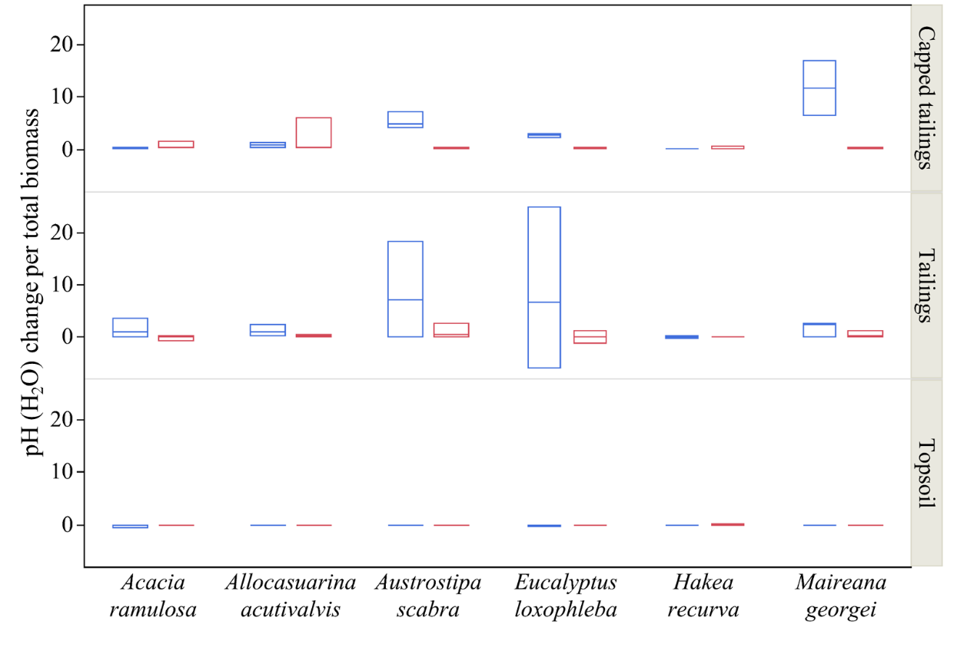
Fig. S1 Changes in bulk soil pH (H₂O) per total biomass as affected by six selected species grown in three different substrates at the end of a glasshouse trial. at the end of a glasshouse trial. Blue and red boxes refer to plant growth with and without addition of inoculant, respectively. Box plots are medians with 25th and 75th percentiles.

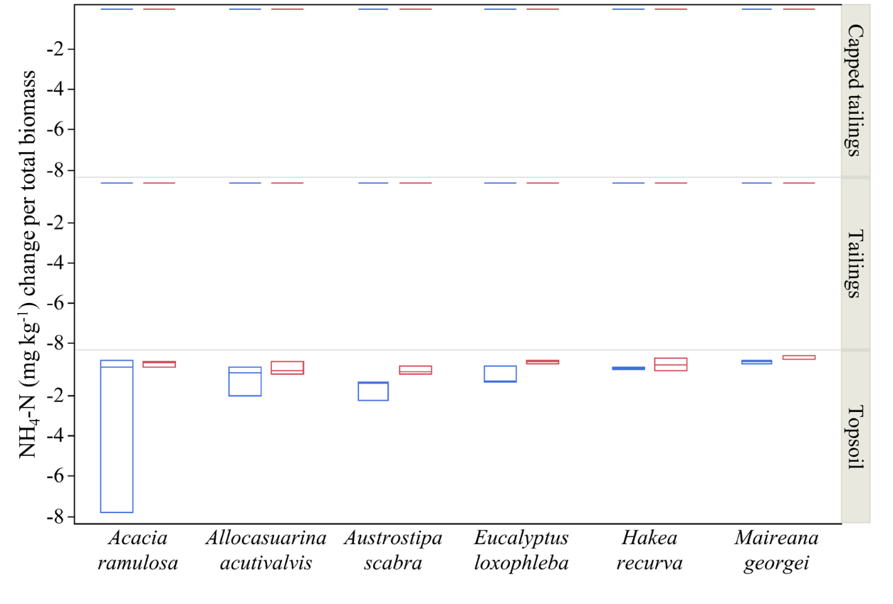
Fig. S2 Changes in soil NH₄-N per total biomass as affected by six selected species grown in three different substrates at the end of a glasshouse trial. Blue and red boxes refer to plant growth with and without addition of inoculant, respectively. Box plots are medians with 25th and 75th percentiles.

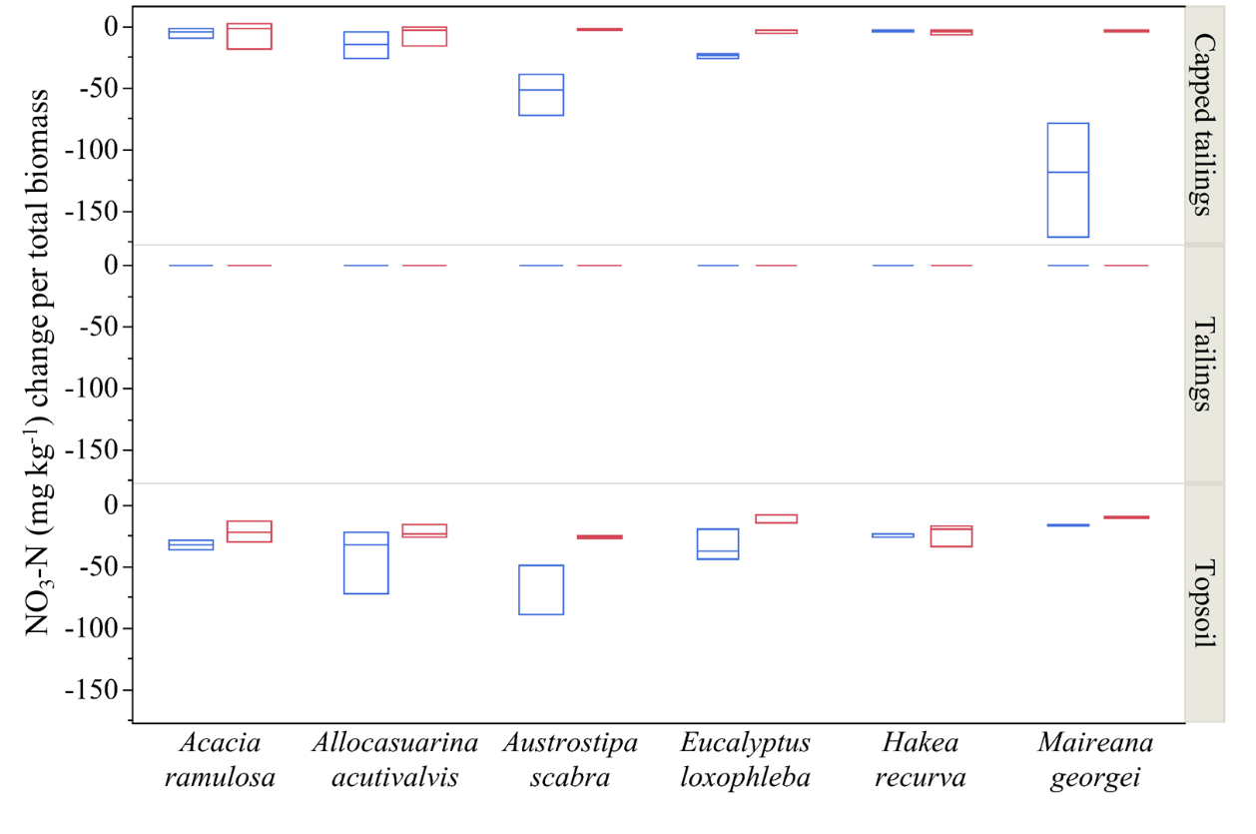
Fig. S3 Changes in soil NO₃-N per total biomass as affected by six selected species grown in three different substrates at the end of a glasshouse trial. Blue and red boxes refer to plant growth with and without addition of inoculant, respectively. Box plots are medians with 25th and 75th percentiles.

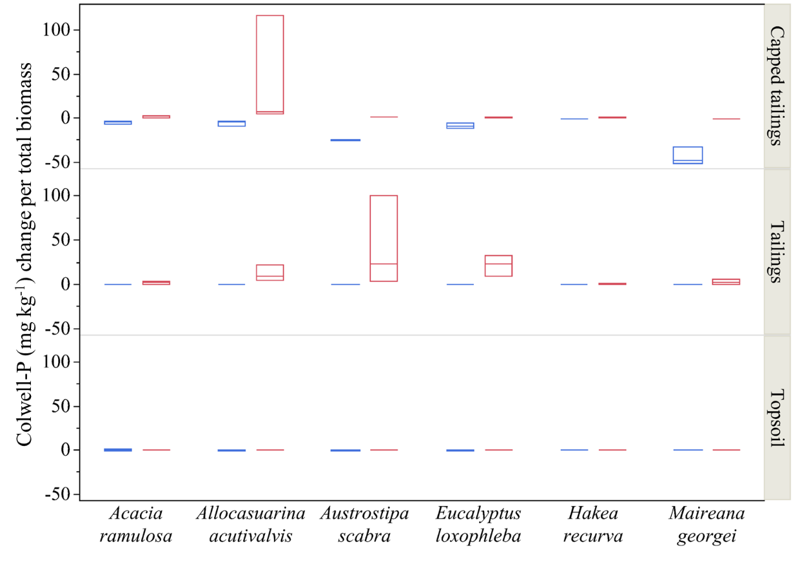
Fig. S4 Changes in soil Colwell-phosphorus (P) per total biomass as affected by six selected species grown in three different substrates at the end of a glasshouse trial. Blue and red boxes refer to plant growth with and without addition of inoculant, respectively. Box plots are medians with 25th and 75th percentiles.

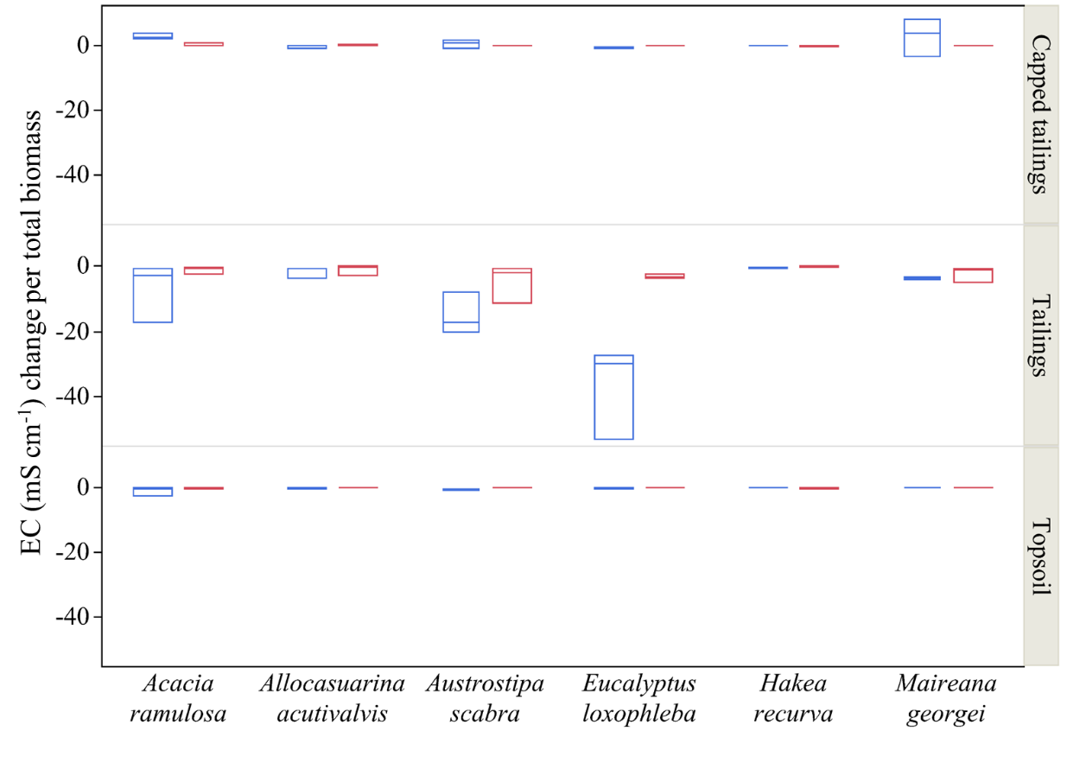
Fig. S5 Changes in soil electrical conductivity (EC) per total biomass as affected by six selected species grown in three different substrates at the end of a glasshouse trial. Blue and red boxes refer to plant growth with and without addition of inoculant, respectively. Box plots are medians with 25th and 75th percentiles.

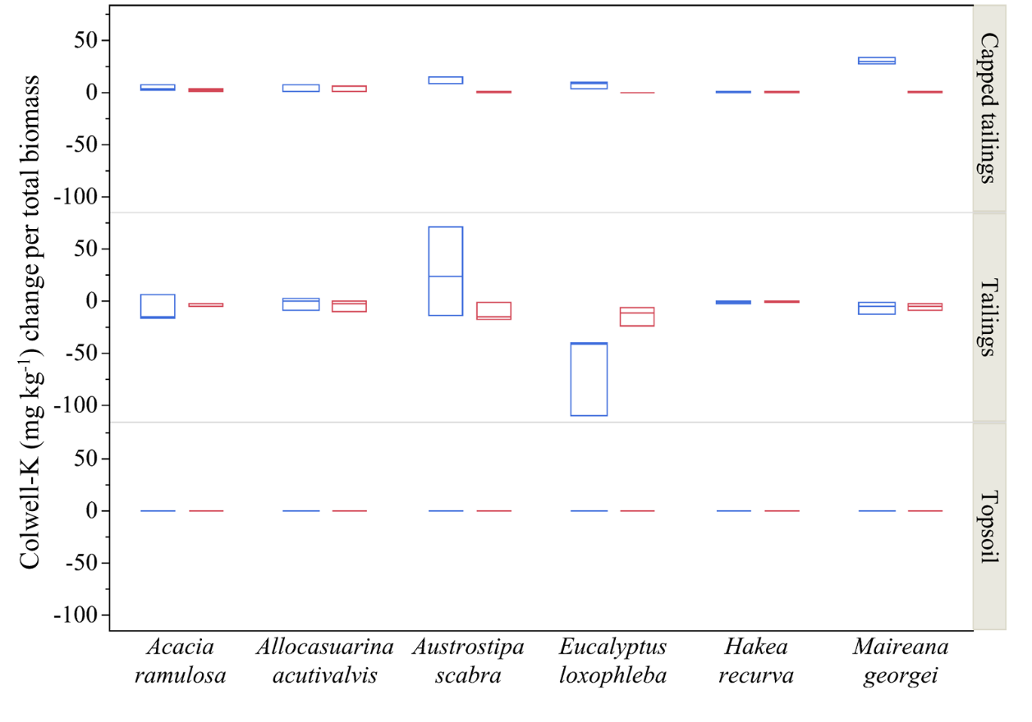
Fig. S6 Changes in Colwell-potassium (K) per total biomass as affected by six selected species grown in three different substrates at the end of a glasshouse trial. Blue and red boxes refer to plant growth with and without addition of inoculant, respectively. Box plots are medians with 25th and 75th percentiles.

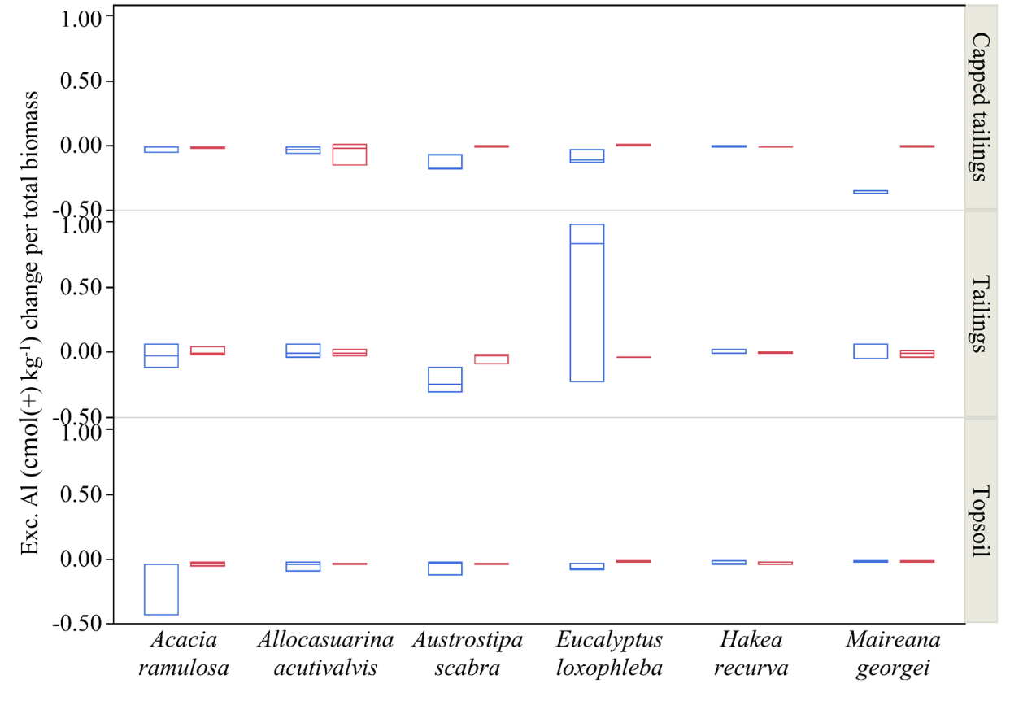
Fig. S7 Changes in exchangeable aluminium (Al) per total biomass as affected by six selected species grown in three different substrates at the end of a glasshouse trial. Blue and red boxes refer to plant growth with and without addition of inoculant, respectively. Box plots are medians with 25th and 75th percentiles.

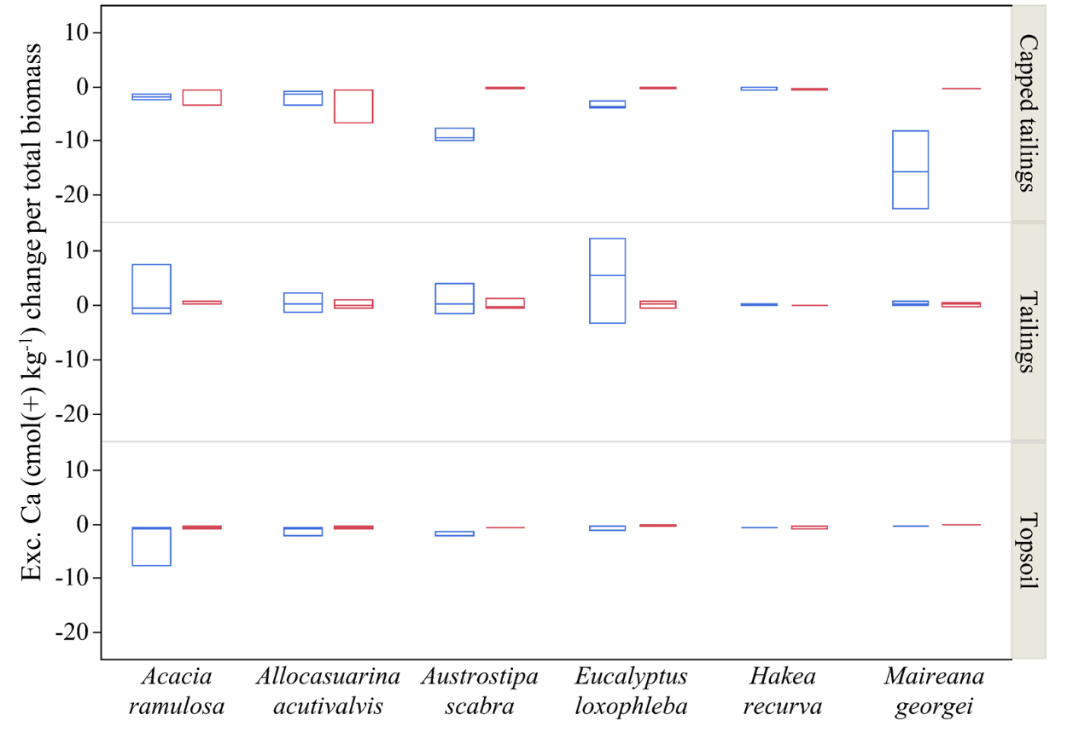
Fig. S8 Changes in exchangeable calcium (Ca) per total biomass as affected by six selected species grown in three different substrates at the end of a glasshouse trial. Blue and red boxes refer to plant growth with and without addition of inoculant, respectively. Box plots are medians with 25th and 75th percentiles.

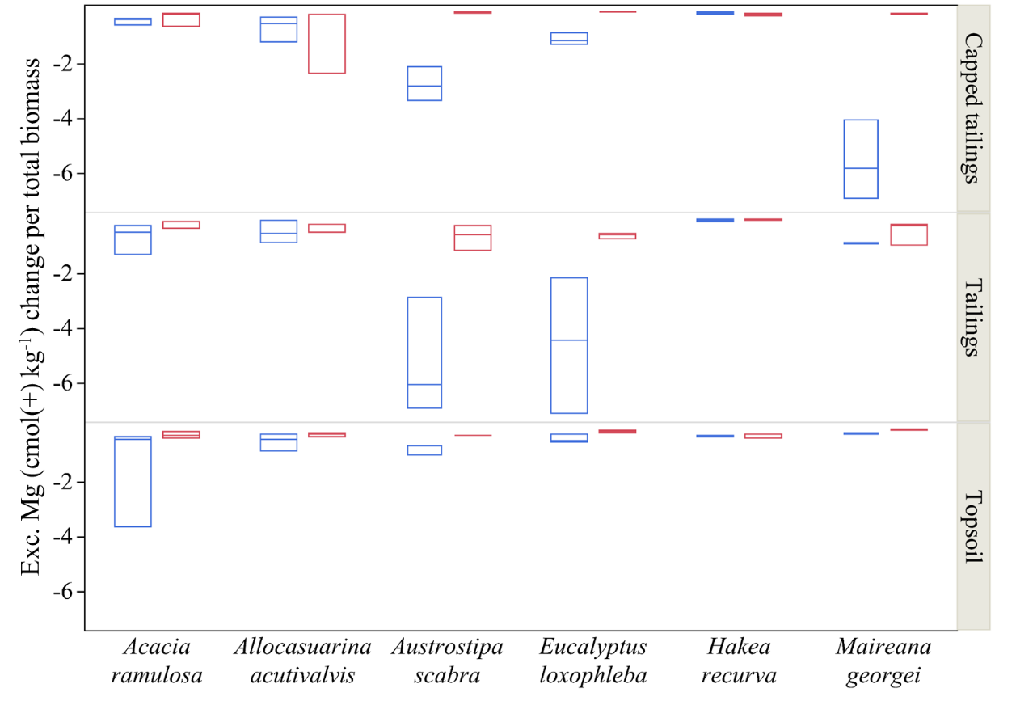
Fig. S9 Changes in exchangeable magnesium (Mg) per total biomass as affected by six selected species grown in three different substrates at the end of a glasshouse trial. Blue and red boxes refer to plant growth with and without addition of inoculant, respectively. Box plots are medians with 25th and 75th percentiles.

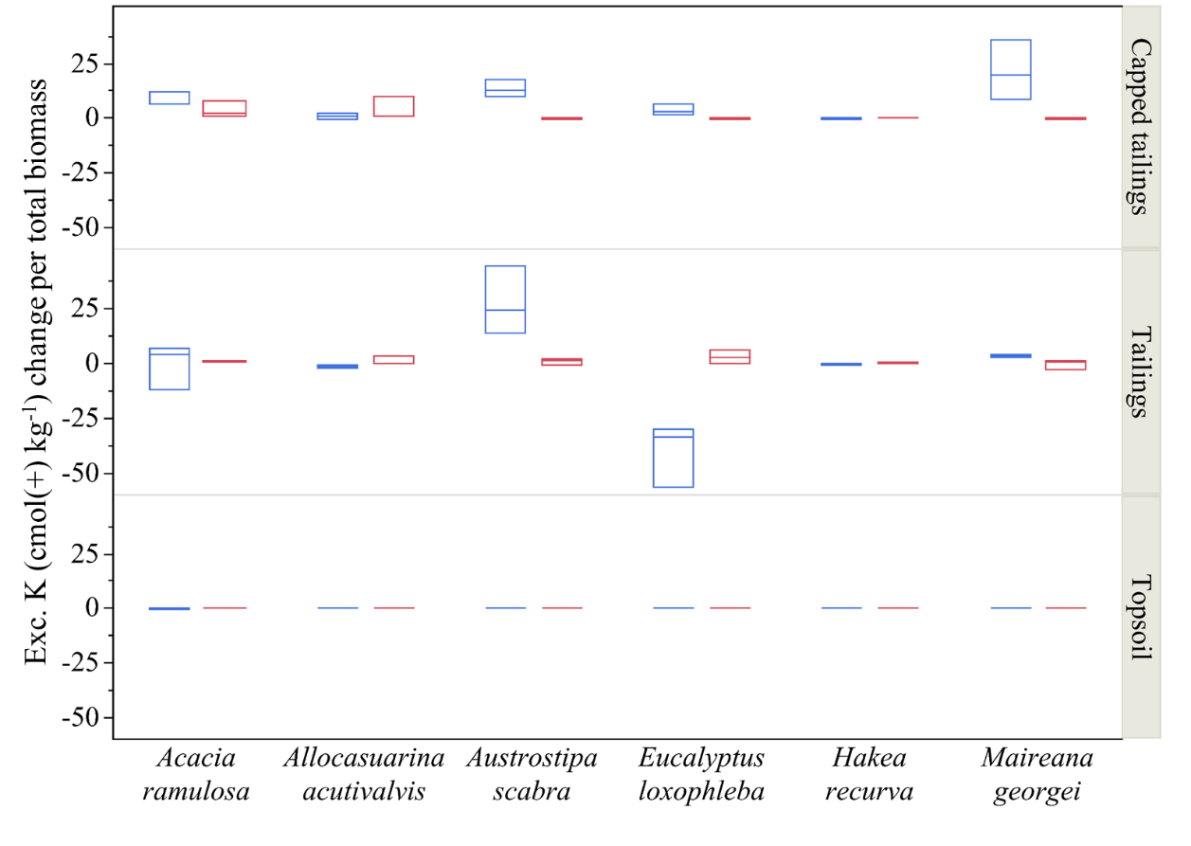
Fig. S10 Changes in exchangeable potassium (K) per total biomass as affected by six selected species grown in three different substrates at the end of a glasshouse trial. Blue and red boxes refer to plant growth with and without addition of inoculant, respectively. Box plots are medians with 25th and 75th percentiles.

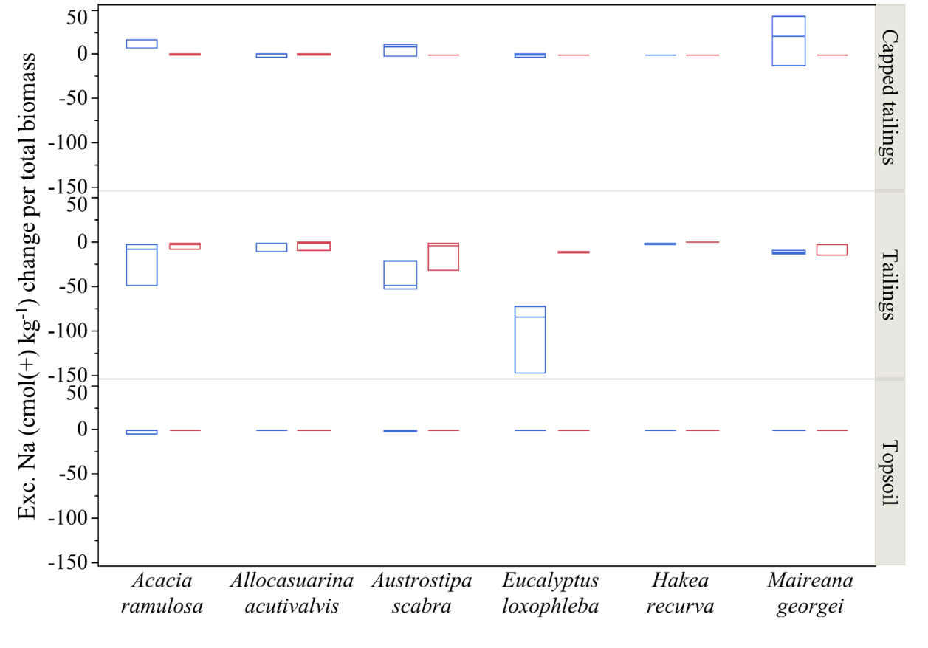
Fig. S11 Changes in exchangeable sodium (Na) per total biomass as affected by six selected species grown in three different substrates at the end of a glasshouse trial. Blue and red boxes refer to plant growth with and without addition of inoculant, respectively. Box plots are medians with 25th and 75th percentiles.

Appendix 1 Claimed composition of commercial microbial mixture: Troforte.
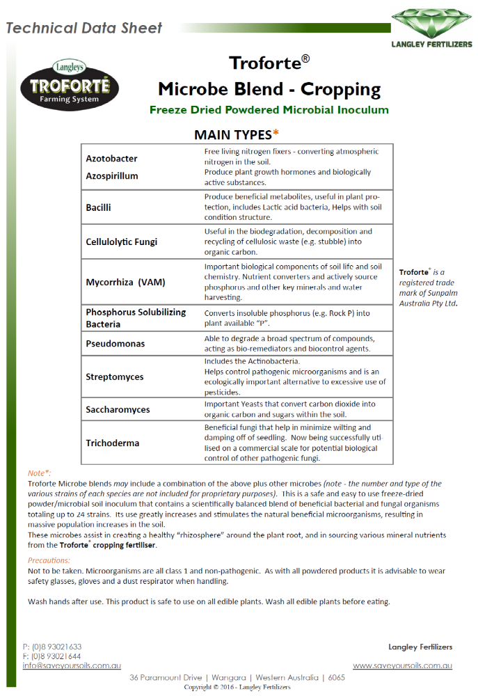

Appendix 2 Selected chemical characteristics and elemental concentrations of commercial microbial mixture: Troforte.
Chemical properties
pH |  | 7.1
EC | (mS m⁻¹) | 750
Organic C | (mg g⁻¹) | 226
Total N | (mg g⁻¹) | 15.1
Total P | (mg kg⁻¹) | 500
Ca | (mg kg⁻¹) | 4300
S | (mg kg⁻¹) | 250
Mg | (mg kg⁻¹) | 1000
Al | (mg kg⁻¹) | 410
As | (mg kg⁻¹) | 1.2
B | (mg kg⁻¹) | 2.6
Cd | (mg kg⁻¹) | <0.01
Co | (mg kg⁻¹) | 0.27
Cu | (mg kg⁻¹) | 0.6
Fe | (mg kg⁻¹) | 185
Mn | (mg kg⁻¹) | 104
Mo | (mg kg⁻¹) | 0.16
Na | (mg kg⁻¹) | 1000
Ni | (mg kg⁻¹) | 0.7
Pb | (mg kg⁻¹) | 0.8
Se | (mg kg⁻¹) | 0.1
Zn | (mg kg⁻¹) | 7.1

