Supplementary information for:

Distinguishing and Quantifying Reversible/Irreversible Lithium in Practical Lithium Metal Batteries

Wei Deng ^{a, #}, Xue Yin ^{a, #}, Wurigumula Bao ^{c,#}, Xufeng Zhou^{*, a, b}, Zhiyuan Hu ª, Bangyi He ª, Bao Qiu ^{a, b}, Ying Shirley Meng ^{*, c, d, e}, and Zhaoping Liu^{*, a, b}

a Advanced Li-ion Battery Engineering Laboratory of Zhejiang Province, Key Laboratory of Graphene Technologies and Applications of Zhejiang Province, and CAS Engineering Laboratory for Graphene, Ningbo Institute of Materials Technology & Engineering, Chinese Academy of Sciences, Zhejiang 315201, P. R. China
b Center of Materials Science and Optoelectronics Engineering, University of Chinese Academy of Sciences, Beijing 100049, P. R. China
c Department of NanoEngineering, University of California, San Diego, La Jolla, CA 92093, USA
d Materials Science and Engineering, University of California, San Diego, La Jolla, CA 92093, USA
e Pritzker School of Molecular Engineering, University of Chicago, Chicago, IL 60637
# These authors contribute equally to this work.
* Corresponding authors. Tel./Fax: +86-574-8668-5096.
E-mail address: zhouxf@nimte.ac.cn, shirleymeng@uchicago.edu, liuzp@nimte.ac.cn

Contents of Supplementary Information
Part 1. CiE_{cell} for anode-free Cu/NCM811 pouch cell
Part 2. Ideal consumption activities of active Li in practical LMBs
Part 3. Pouch cell assembly and apparatus
Part 4. Interference of residual Li salts
Part 5. Stability of SEI to biphenyl/THF solution
Part 6. Accuracy for Li-AEST
Part 7. Accuracy for H₂-GCT
Part 8. Determination of pristine mass of Li foil
Part 9. The original data for quantifying different samples
Part 10. Detailed parameters for the fitting curves
Part 11. Failure predictions of 0.5 Ah Li/NCM811 pouch cells
Part 12. Practical cycling of 0.9Ah Li/NCM811 pouch cells
Part 13. Reversibility/irreversibility analysis for 0.6 Ah Li/LR-NCM pouch cells
Part 14. Degradation analysis for 0.5 Ah Li/NCM811 pouch cells under C/2
Part 15. The morphology and Ar-BET characterizations of cycled LMAs.
Part 16. Thickness analysis for 0.5 Ah Li/NCM811 pouch cells under C/2 and C/5
Appendix: Original data for Li-AEST and H₂-GCT

Part 1. CiE_{cell} for an anode-free 0.5 Ah Cu/NCM811 pouch cell
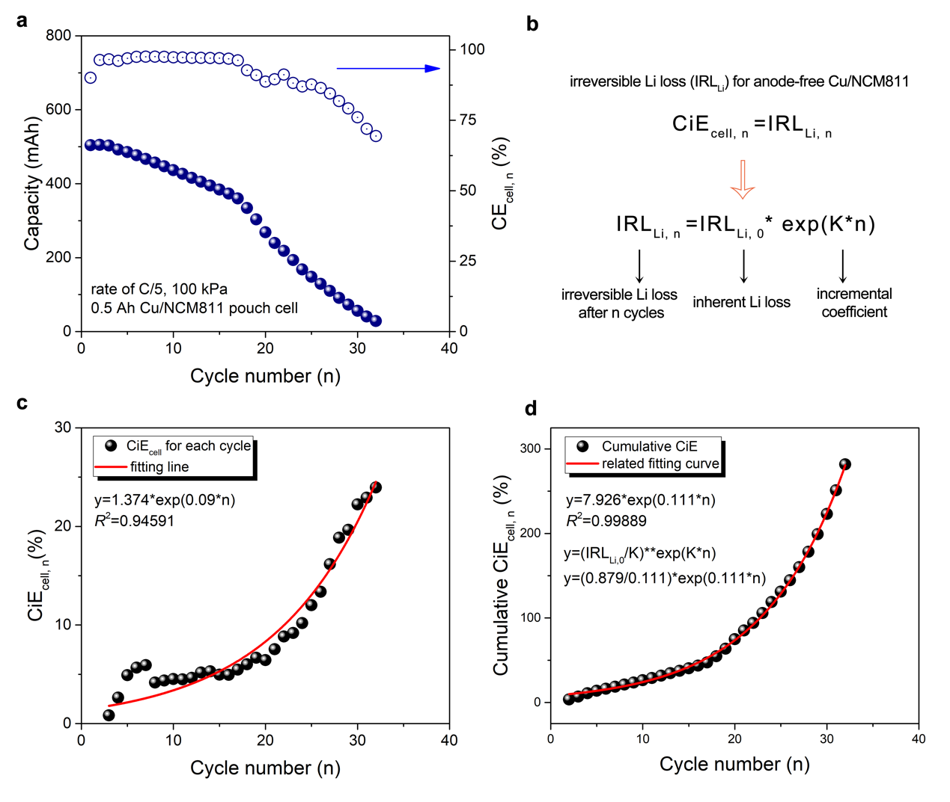
Supplementary Figure 1. (a) Electrochemical cycling performance and Coulombic efficiency (CE_{cell}) for a 0.5 Ah Cu/NCM811 pouch cell under stack pressure of 100 kPa and charge/discharge rate of C/5. (b) The transformation of CiE_{cell} to irreversible Li loss, and the proposed variation relationship between irreversible Li loss after n cycles (IRL_{Li,n}) and inherent irreversible Li loss (IRL_{Li,0}). First cycle isn’t included due to the activation at C/20. (c) CiE_{cell} obtained from another anode-free 0.5 Ah Cu/NCM811 pouch cell sample, which is different from Figure 1b. (d) Cumulative CiE_{cell} for anode-free Cu/NCM811 pouch cell and its related fitting curve.

Additional discussions:
Figure S1c demonstrates that the adverse effects of “dead Li” layer on anode-free cells is a common phenomenon, and the incremental principle of CiE_{cell} are well conformal with the exponential function as indicated in Figure S1b. The relationship between cumulative CiE_{cell} and cycle number (n) are displayed in Figure S1d. The summation mathematical relationship confirms the validity of Equation 3 and 4 in the main text. The IRL_{Li,0} obtained from the cumulative curves (Figure S1d) is 0.879%, which is quite identical to the value of 0.874% (for IRL_{Li,0}) in Figure 1b.

Part 2. Ideal consumption activities of active Li in practical LMBs
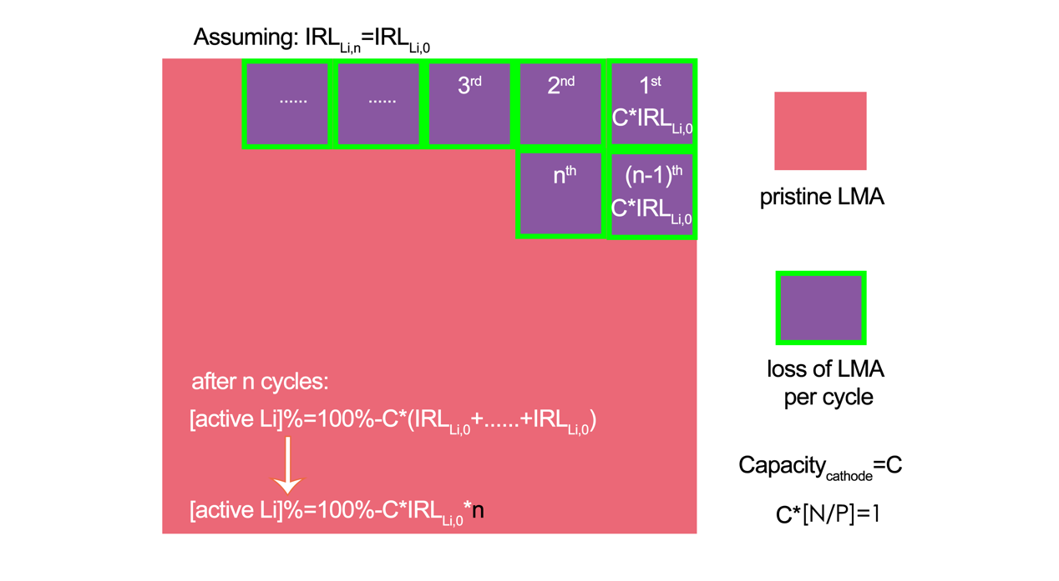
Supplementary Figure 2. The ideal consumption activities of active Li in practical LMBs.

Part 3. Pouch cell assembly and apparatus for quantitative analysis
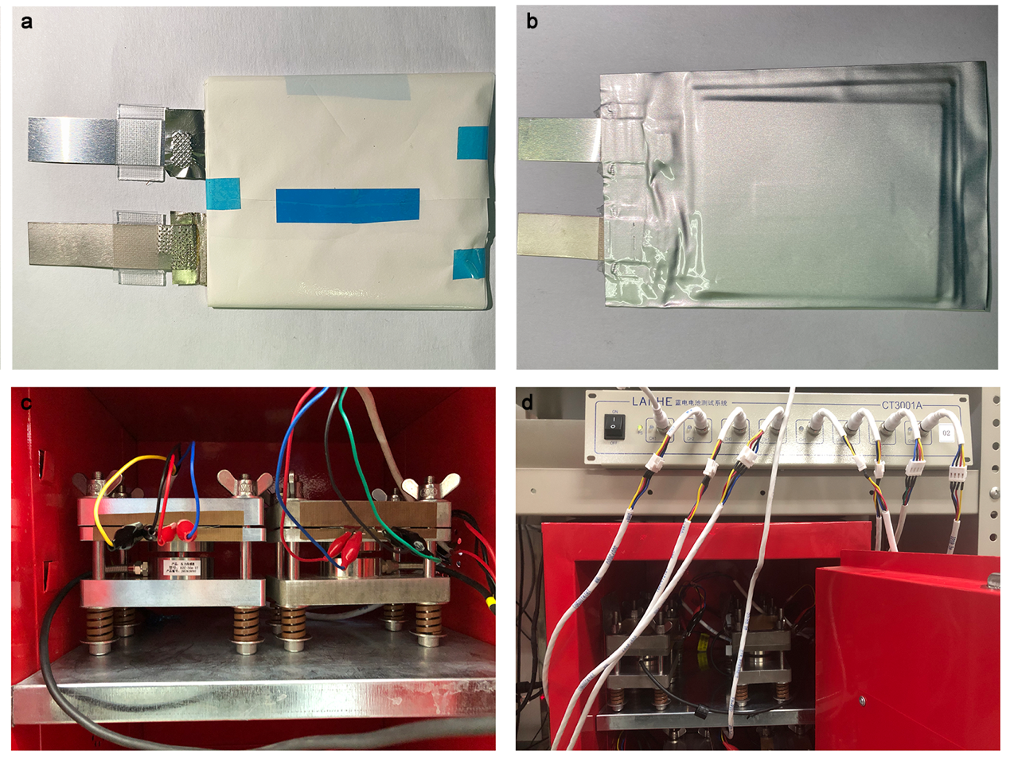
Supplementary Figure 3. (a-b) Digital photographs of a typical 0.5 Ah pouch cell studied in this work. (c-d) The cell holder for LMB pouch cells.

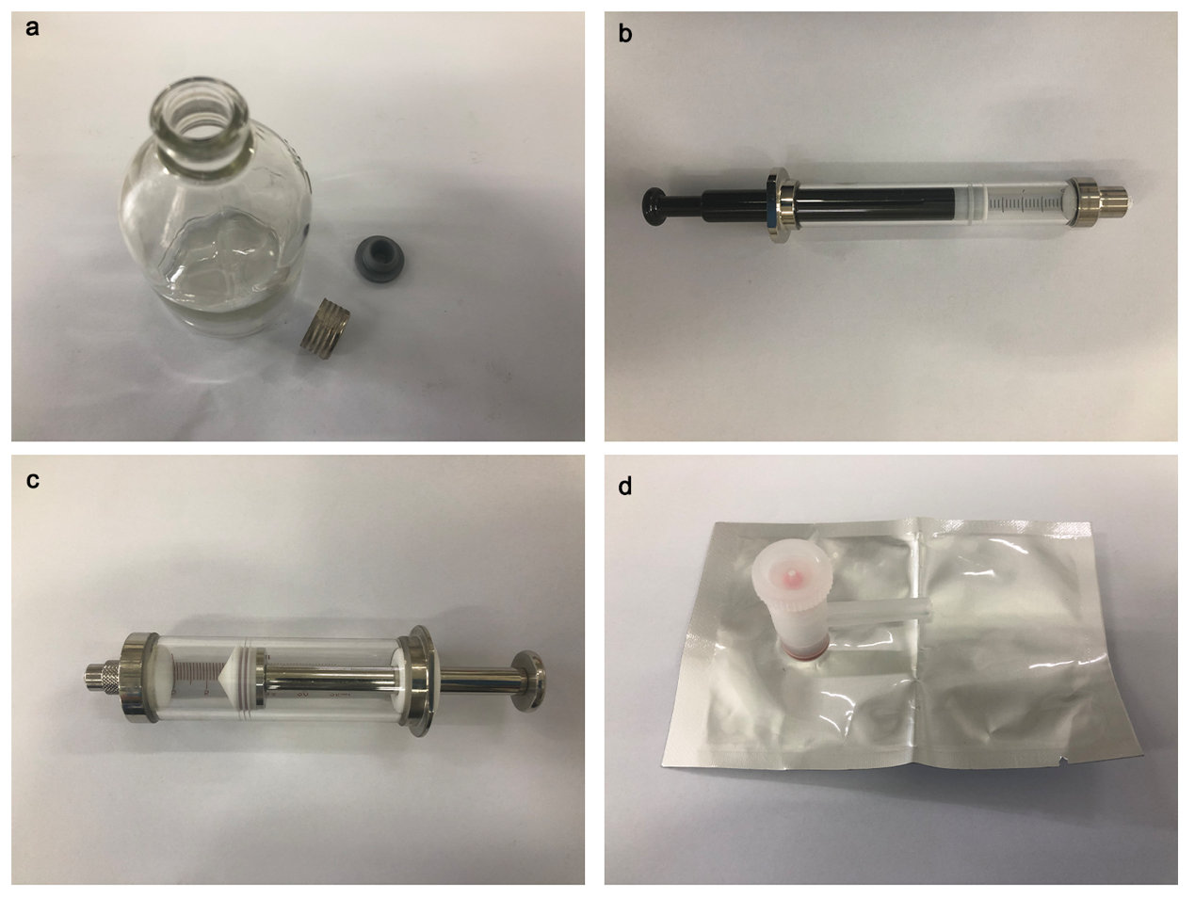
Supplementary Figure 4. Digital photographs of (a) an air-tight bottle with rubber plug and metal sealing ring, (b) an air-tight syringe with volume of 5 mL, (c) an air-tight syringe with volume of 25 mL and (d) air-tight Al foil packing with vacuum valve.

Part 4. Interference of residual Li salts
Supplementary Table 1. The results of ICP-AES for the supernatant of THF solution after three times rinse for LMAs from disassembled cells.
Samples | Mass  (g) | Results of ICP-AES  (mg/kg) | Residual Li in THF  (mg)
supernatant 1 | 1.7535 | 0.018 | <0.01
supernatant 2 | 1.7396 | 0.014 | <0.01
supernatant 3 | 1.7521 | 0.013 | <0.01

Additional discussions:
After purification of cycled LMAs by rinsing with THF for three times to remove residual LiPF₆, the supernatants of the THF solution were independently subjected to ICP-AES measurement. The results of ICP-AES show that there is no residual Li in the THF solution after purification, proving the complete removal of LiPF₆.

Part 5. Stability of SEI to the biphenyl/THF solution
Supplementary Table 2. The dissolution ability of different inorganic lithium compounds in the biphenyl/THF solution.
Inorganic component  (mass in solution) | Mass of biphenyl/THF  (g) | Results of ICP-AES  (mg/kg) | Dissolution mass  (mg)
LiF (10 g) | 16.2341 | 0.018 | <0.01
LiOH (10 g) | 15.3056 | 0.014 | <0.01
Li₂CO₃ (10 g) | 16.1042 | 0.013 | <0.01

Additional discussions:
The stability of the components in SEI to biphenyl/THF is quite important. LiF, Li₂CO₃ and LiOH with excessive amount (10 g) were immersed in the biphenyl/THF (with 10 wt.% of biphenyl) solution of ~20 mL for 72 h, then the supernatant of each solution was sampled for ICP-AES to measure the concentration of Li, which can determine the dissolution ability of these inorganic lithium compounds. Table S2 shows that the concentrations of Li-ions dissolved in biphenyl/THF are extremely low for all three inorganic components, demonstrating the chemical stability of inorganic lithium compounds against the biphenyl/THF solution. This is the foundation for using biphenyl/THF to separate inactive Li for GC-MS measurement without the interference of active Li.

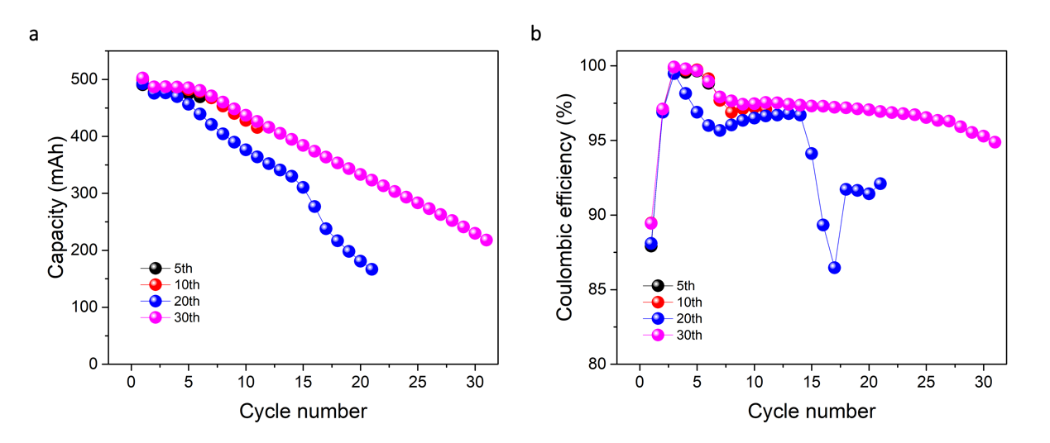
Supplementary Figure 5. (a) cycling performance and (b) CEs of 0.5Ah anode-free Cu/NCM811 pouch cells under rates of C/5 with stack pressure of 200 kPa. Four pouch cells were assembled and tested independently at the same time.

Supplementary Table 3. The dissolution ability of pure Li, Cu foil/inactive Li and cycled LMAs (corresponding to the samples in Figure 2b-d) in the biphenyl/THF solution.
Sample ID | Volume of THF/BP  (g) |  | Results of ICP-AES  (mg/kg) | Dissolution mass  (mg)
Sample 1-pure Li |  | 8.6725 | 17.331 | 8.32
Sample 2-5th-1st |  | 8.3253 | 0.027 | <0.01
Sample 2-5th-2nd |  | 8.3492 | 0.033 | <0.01
Sample 3-10th-1st |  | 8.2951 | 0.037 | <0.01
Sample 3-10th-2nd |  | 8.4569 | 0.024 | <0.01
Sample 4-30th-1st |  | 8.8157 | 0.8261 | 0.75
Sample 4-30th-2nd |  | 8.7795 | 0.9482 | 0.83
Sample 5-cycled LMA 1st |  | 8.6454 | 15.528 | 7.84
Sample 5-cycled LMA 2nd |  | 8.5758 | 14.044 | 7.28

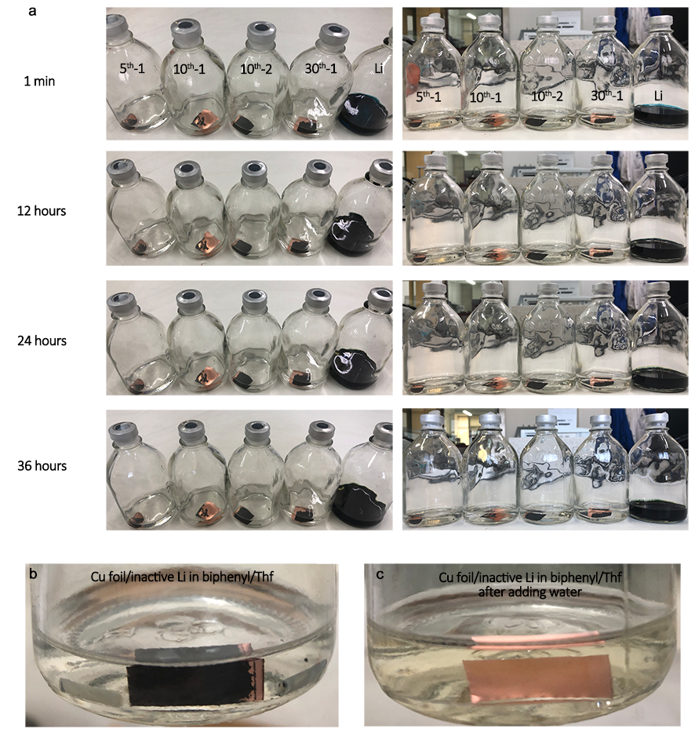
Supplementary Figure 6. (a) Digital photographs of “dead Li” on Cu foil obtained from anode-free Cu/NCM811 pouch cells after being added in biphenyl/THF for different hours. Digital photographs of “dead Li” on Cu foil obtained from anode-free Cu/NCM811 pouch cells in biphenyl/THF before (b) and after (c) adding water.

Additional discussions:
To further confirm the chemical stability of “dead Li” layer (SEI-encapsulated inactive Li) in biphenyl/THF, 0.5 Ah anode-free pouch cells (Cu/NCM811) were fabricated. In anode-free cells, after full charging/discharging process, residual materials on Cu foil were regarded as the “dead Li” layer, namely the SEI-encapsulated inactive Li. The residual materials can be used as pure “dead Li” layer without residual active Li to directly test its stability against the biphenyl/THF solution. The cells were cycled for 5, 10, 20 and 30 times under the voltage range of 2.6-4.3 V at C/5 with stack pressure of 200 kPa. All anode-free pouch cells demonstrate similar capacity decay and low-grade CE (nearly 97.5%) as shown in Figure S5. Low-grade CEs mean highly irreversible Li plating/stripping. After that, the Cu foil/“dead Li” layer (inactive Li) was rinsed by THF three times following the protocols proposed in Methods. Then the samples were immersed in biphenyl/THF. There were no evident color changes in the solution, which was quite different to pure Li foil with typical dissolution behavior after immersing in biphenyl/THF for just 1 min (Figure S6a and Figure 2b-d). The color change of the solutions with pure Li foil and cycled LMA demonstrated the instant dissolution of Li metal in the biphenyl/THF solution. After 36 h at 25ºC, there were still no evident color change in the bottles with cycled Cu foil from anode-free Cu/NCM811 pouch cells. In contrast, the color of the bottles with pure Li foil and cycled LMA were totally dark green.
The solutions of each sample (Figure 2b-d) were then subjected to ICP-AES tests. The results of ICP-AES (Table S3) show the concentrations of Li from samples after 5 and 10 cycles are nearly zero. But slight Li was detected from the sample after 30 cycles, which was caused by irreversible Li plating inside the “dead Li” layer from cathode, as the electrochemical measurement showed continuous irreversible capacity losses of the cathode. These results demonstrate that inactive Li encapsulated by SEI can survive from the biphenyl/THF solution, which promises the complete reservation of the “dead Li” layer for the lateral GC-MS characterizations after the separation procedure by biphenyl/THF solution. As shown in Figure S6b and c, “dead Li” layer (dark compound) was stable against biphenyl/THF. However, after adding water for a few seconds, all the “dead Li” on Cu foil reacted with water to release hydrogen, leaving pure Cu foil.

Part 6. Accuracy of Li-AEST
Supplementary Table 4. Values of the balance-measured masses of Li foils, theoretical concentrations of Li and measured concentrations of Li by ICP-AES. The testing condition 1 uses biphenyl/THF of 10 mL (~8.4g) to dissolve Li in the bottle, while condition 2 uses biphenyl/THF of 40 mL (~33.6 g) to dissolve Li in the bottle.
Testing conditions | Balance-measured mass of pure Li (mg) | Theoretical concentration  (mg/kg) | Concentration measured by ICP-AES (mg/kg)
Condition 1 | 5.4 | 639.3332 | 667.02323
Condition 1 | 5.4 | 639.3332 | 656.51256
Condition 2 | 3.9 | 116.05722 | 91.007
Condition 2 | 7.9 | 212.57171 | 205.4355
Condition 2 | 2.1 | 57.22149 | 52.7285
Condition 2 | 4.7 | 128.10309 | 127.104
Condition 2 | 38.5 | 995.58636 | 988.908

Supplementary Figure 7. The relationship between the actual mass of Li foils and Li concentrations measured by ICP-AES, and the corresponding fitting curve.

Additional discussions:
To verify the accuracy of Li-AEST for quantification of Li-biphenyl, the masses of Li foils were carefully measured by digital balance. Then Li foils were dissolved in biphenyl/THF for ICP-AES characterization. Figure S7 and Table S4 show that the balance-measured masses fit well with the results of ICP-AES with the R² of 0.9851, which demonstrate the accuracy and availability of ICP-AES for quantitative analysis of Li in the Li-biphenyl/THF solution.

Part 7. Accuracy of H₂-GCT
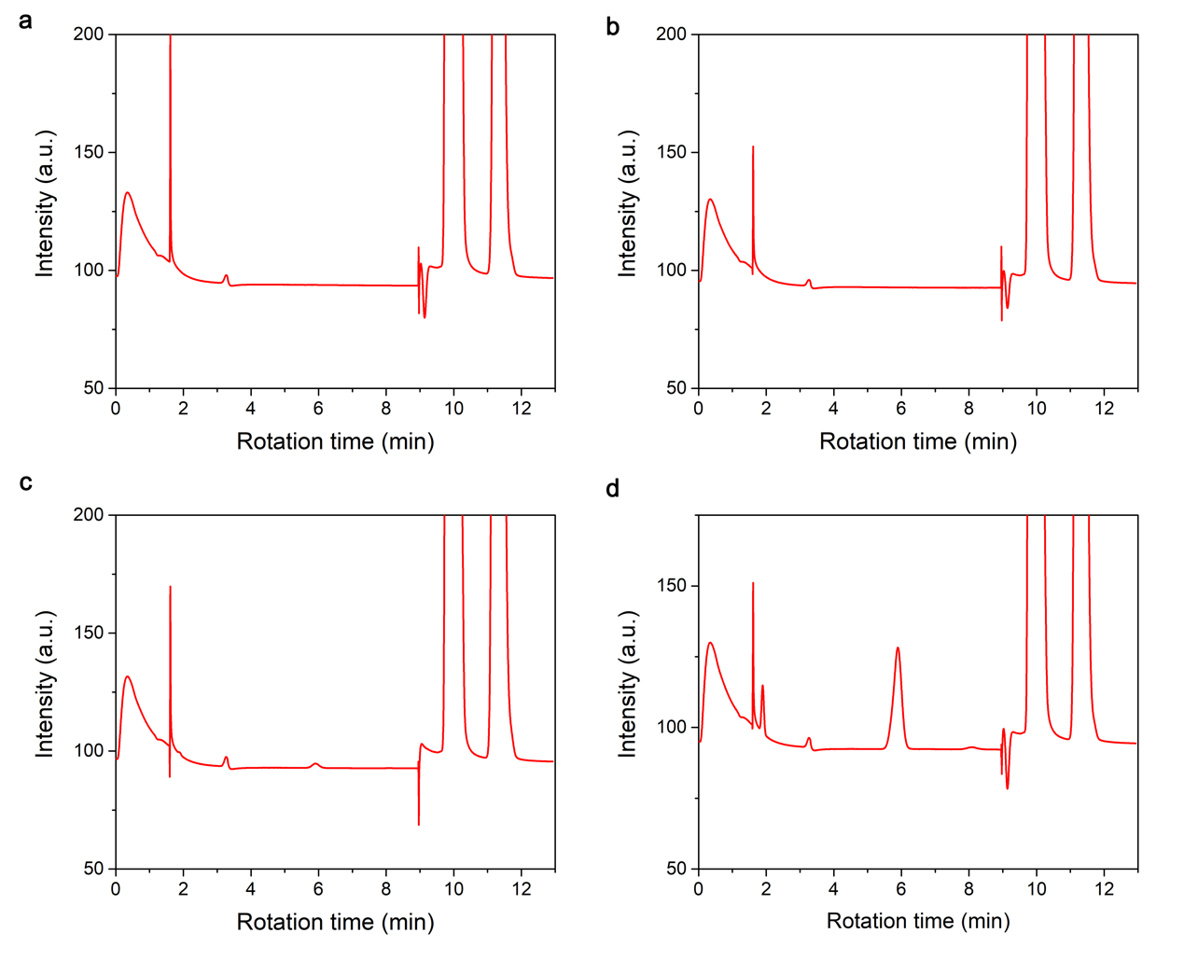
Supplementary Figure 8. (a) The GC-MS curve of gas in the air-tight bottle containing pure Li foil after water (0.5 mL) injection. (b) The GC-MS curve of gas in the air-tight bottle containing Li foil and biphenyl/THF (8 mL) after water (2.0 mL) injection. (c) The GC-MS curve of gas in the air-tight bottle containing biphenyl/THF (with 10 wt.% of biphenyl) solution of Li after water (2.0 mL) injection. (d) The GC-MS curve of the gas in the air-tight bottle containing cycled LMA after water (2.0 mL) injection.

Additional discussions:
The gas in the air-tight bottle after the reaction of pure Li with water was directly characterized by GC-MS. Figure S8a shows that the main components in the gas are argon (rotation time of 9.844 min) and hydrogen (rotation time of 9.174 min). But there are still trace amount of N₂ (rotation time of 11.278 min) and CO₂ (rotation time of 3.290 min), which may be resulted from the air filled in the empty space of the syringe tip during the gas-transport procedures. The existence of biphenyl/THF and Li-biphenyl/THF liquid doesn’t interfere the gas characterizations as shown in Figure S8b and c. The results demonstrate that the reaction between water and Li-biphenyl/THF generates LiOH instead of releasing hydrogen. Thus, during the lateral H₂-GCT process, the residual Li-biphenyl/THF wouldn’t interfere the quantification for hydrogen. As shown in Figure S8d, cycled LMA with SEI layer will release additional gases when reacted with water, including CH₄ (rotation time of ~1.9 min), C₂H₄ (rotation time of ~5.8 min) and C₂H₆ (rotation time of ~8.0 min), which is quite different to the results of pure Li foil.

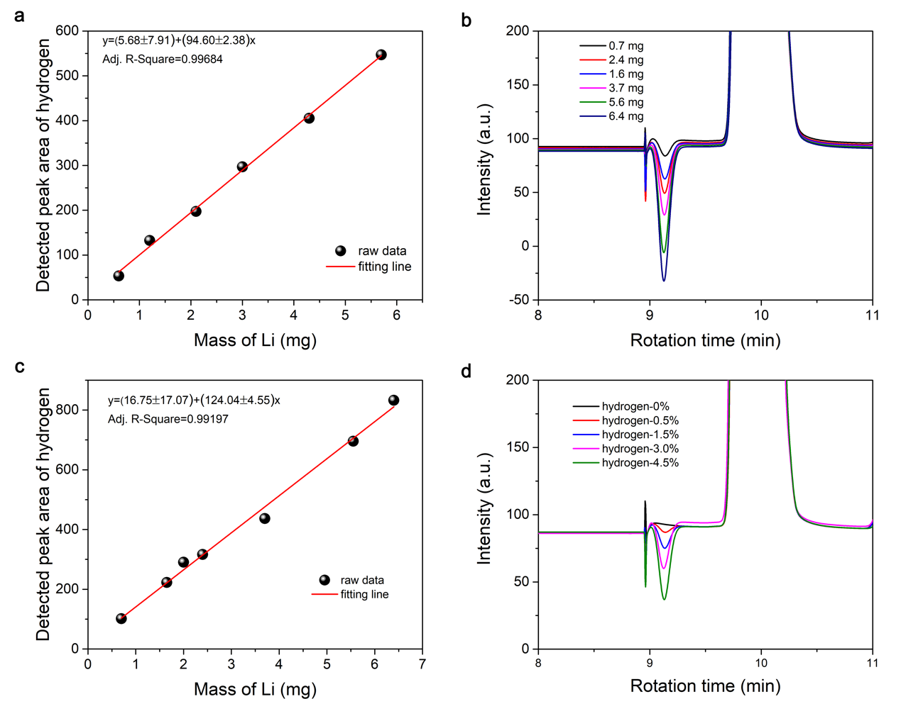
Supplementary Figure 9. (a) The calibration curve established by pure Li without THF solution. (b) The GC-MS curves of gas in the air-tight bottle containing THF (8 mL) and Li foils with different masses after water injection. (c) The relationship between the actual mass of Li foils and peak areas of hydrogen from GC-MS. (d) GC curves of different calibrating gases.

Supplementary Table 5. The components of calibrating gases having different ratios of hydrogen, nitrogen and argon, and the corresponding peak areas.
Sample ID | Hydrogen (molar ratio) | Peak area of hydrogen | Nitrogen (molar ratio) | Argon (molar ratio) | Peak area of Argon
Calibrating gas 1 | 3.01 | 222.632 | 11.01 | 85.98 | 186319.145
Calibrating gas 2 | 1.51 | 111.541 | 14.5 | 83.99 | 182587
Calibrating gas 3 | 0 | 0 | 15 | 18 | 185902
Calibrating gas 4 | 0.502 | 36.044 | 10.5 | 88.998 | 181102
Calibrating gas 5 | 4.52 | 362.344 | 10 | 85.48 | 187788
Additional discussions:
The linear relationship (Figure S9a) between the balance-measured mass of pure Li foils without THF and peak areas of GC-MS confirms the accuracy of GC-MS. The fitting line has a very good linear relationship with the R² of 0.99684. However, inactive Li were characterized in circumstances of Li-biphenyl/THF solution, the calibration curve based on liquid circumstance is also tested by using pure THF of 8 mL. The GC curves of pure Li foils in THF and fully dissolved Li foils in biphenyl/THF are shown in Figure S8. As shown in Figure S9b, pristine Li foils with different masses in THF show different integral areas of H₂ peak, which is the criteria for the quantification of H₂. The masses of Li foils and the related integral peaks’ areas of H₂ are shown in Figure S9c. The fitting line as the calibration curve has a very good linear relationship with the R² of 0.99197, which demonstrate the accuracy and availability of these procedures for H₂-GCT method in the solution circumstance.
When thick SEI layer contacts with water, additional gas (CO₂, CH₄, C₂H₄, C₂H₆) will be released in the air-tight bottle (Figure S8d). As a result, the relative molar proportion of hydrogen will be depressed, thereby affecting the peak areas of hydrogen in GC curves. And the calibration curve established by pure Li can’t determine the content of hydrogen accurately. To eliminate the interference of additional gas, argon with constant content in the entire procedures was taken as the calibration standard, thereby new calibration curve for quantifying hydrogen was proposed for H₂-GCT. The GC-curves of different calibrating gases (detailed information for the components is listed in Table S5) are shown in Figure S9d. This helps us to make sure that using the argon as constant calibration gas is reasonable and accurate to rectify the effluences of additional gases.

Part 8. Determination of pristine mass of Li foil
Supplementary Table 6. The measured masses of Li foils with thickness of 100 μm and diameter of 14 mm by using digital balance, ICP-AES and H₂-GCT.
Sample ID | Mass from balance (mg) | Mass from ICP-AES (mg) | Mass from H₂-GCT (mg)
1 | 8.3 | —— | 8.42
2 | 8.2 | —— | 8.35
3 | 8.3 | —— | 8.16
4 | 8.2 | —— | 8.12
5 | 8.4 | —— | 8.40
6 | 8.2 | 8.26 | ——
7 | 8.3 | 8.42 | ——
8 | 8.4 | 8.51 | ——
9 | 8.4 | 8.30 | ——
10 | 8.3 | 8.32 | ——

Additional discussions:
According to the method of ICP-AES and H₂-GCT, the mass of Li foil with thickness of 100 μm and diameter of 14 mm (the same size as the Li anode samples after cycling for quantitative analysis) is treated as 8.4 mg in this work. The mass is representative for the dash line in Figure 4b. And the value of $y_{0}$ used for mathematical relationship and fitting process in Methods is also 8.4 mg.

Part 9. The original data of quantitative analysis
Supplementary Table 7. The testing and assembling parameters of pouch cells for quantitative analysis.
Initial pressure (kPa) | Electrolyte | Cathode/  Areal Capacity (mAh/cm²) | Rate  (C) | Cycle number | Designed  capacity  (Ah) | Short name  (pressure-cathode-electrolyte -rate-cycle)
100 | Type 1 | NCM811/3.80 | 0.2 | 10 | 0.5 | 100-NCM-0.2-1-10
100 | Type 1 | NCM811/3.80 | 0.2 | 25 | 0.5 | 100-NCM-0.2-1-25
100 | Type 1 | NCM811/3.80 | 0.2 | 50 | 0.5 | 100-NCM-0.2-1-50
400 | Type 1 | NCM811/3.80 | 0.2 | 10 | 0.5 | 400-NCM-0.2-1-10
400 | Type 1 | NCM811/3.80 | 0.2 | 25 | 0.5 | 400-NCM-0.2-1-25
400 | Type 1 | NCM811/3.80 | 0.2 | 50 | 0.5 | 400-NCM-0.2-1-50
800 | Type 1 | NCM811/3.80 | 0.2 | 10 | 0.5 | 800-NCM-0.2-1-10
800 | Type 1 | NCM811/3.80 | 0.2 | 25 | 0.5 | 800-NCM-0.2-1-25
800 | Type 1 | NCM811/3.80 | 0.2 | 50 | 0.5 | 800-NCM-0.2-1-50
100 | Type 1 | LR-NCM/5.80 | 0.2 | 10 | 0.6 | 100-LR-0.2-1-10
100 | Type 1 | LR-NCM/5.80 | 0.2 | 20 | 0.6 | 100-LR-0.2-1-20
100 | Type 1 | LR-NCM/5.80 | 0.2 | 40 | 0.6 | 100-LR-0.2-1-40
100 | Type 1 | NCM811/3.80 | 0.5 | 10 | 0.5 | 100-NCM-0.5-1-10
100 | Type 1 | NCM811/3.80 | 0.5 | 15 | 0.5 | 100-NCM-0.5-1-15
100 | Type 1 | NCM811/3.80 | 0.5 | 25 | 0.5 | 100-NCM-0.5-1-25

Supplementary Table 8. The average results and corresponding STD. error of active Li and inactive Li in cycled LMBs obtained using Li-AEST and H₂-GCT. The original data is listed in detail in Table S9 for Li-AEST and Table S10 for H₂-GCT.
Short Sample ID | Average Mass of inactive Li (mg) | STD. error of inactive Li (mg) | Average Mass of active Li (mg) | STD. error of active Li (mg)
100-NCM-0.2-1-10 | 0.67 | 0.03 | 7.25 | 0.30
100-NCM-0.2-1-25 | 1.40 | 0.18 | 6.62 | 0.20
100-NCM-0.2-1-50 | 1.70 | 0.18 | 5.60 | 0.20
400-NCM-0.2-1-10 | 0.44 | 0.09 | 7.58 | 0.19
400-NCM-0.2-1-25 | 1.32 | 0.19 | 6.42 | 0.33
400-NCM-0.2-1-50 | 1.50 | 0.11 | 5.92 | 0.13
800-NCM-0.2-1-10 | 0.22 | 0.12 | 8.02 | 0.10
800-NCM-0.2-1-25 | 1.32 | 0.15 | 6.97 | 0.36
800-NCM-0.2-1-50 | 1.38 | 0.05 | 6.62 | 0.16
100-LR-0.2-1-10 | 1.15 | 0.19 | 7.15 | 0.27
100-LR-0.2-1-20 | 1.41 | 0.17 | 6.41 | 0.29
100-LR-0.2-1-40 | 2.02 | 0.15 | 5.00 | 0.14
100-NCM-0.5-1-10 | 1.82 | 0.22 | 7.53 | 0.31
100-NCM-0.5-1-15 | 2.82 | 0.51 | 5.47 | 0.50
100-NCM-0.5-1-25 | 4.69 | 0.60 | 2.44 | 0.59

Appendix: Supplementary Table 9-10 are listed at the end of this file.

Part 10. Detailed parameters for the fitting curves
Supplementary Table 11. Fitting results of all the parameters based on the equations and quantified results. Due to the irreversible plating of Li from the cathodes, quantitative data of active Li under C/2 can’t represent mass of active Li for now, so the fitting processes for active Li under C/2 aren’t performed here. The CE_{cell} for each sample is the average CE calculated from CEs of the 2nd to 50th cycle.
Sample ID | A_{IRL} | K_{IRL} | R² (K_{IRL}) | IRL_{Li,0} (%) | CE_{cell} (%) | R_{Li，0} (%) | K_{inactive} | R² (K_{inactive}) | IRL_{inactive Li,0} (%) | IRL_{SEI,0} (%)
100kPa-NCM811-C/5 | 1.09044 | 0.01966 | 0.9064 | 0.669 | 99.89 | 99.221 | 0.01686 | 0.7242 | 0.3945 | 0.2745
400kPa-NCM811-C/5 | 1.0643 | 0.01809 | 0.7670 | 0.601 | 99.95 | 99.349 | 0.01865 | 0.6447 | 0.3535 | 0.2505
800kPa-NCM811-C/5 | 0.6359 | 0.02368 | 0.6954 | 0.470 | 99.91 | 99.44 | 0.02145 | 0.5043 | 0.335 | 0.135
100kPa-LRNCM-C/5 | 1.09348 | 0.02931 | 0.9249 | 0.658 | 99.64 | 98.982 | 0.01849 | 0.8548 | 0.365 | 0.293
100kPa-NCM811-C/2 | —— |  |  |  |  |  | 0.06025 | 0.7534 | 2.01 | ——

Part 11. Reversibility/irreversibility analysis of 0.6 Ah Li/LR-NCM pouch cells
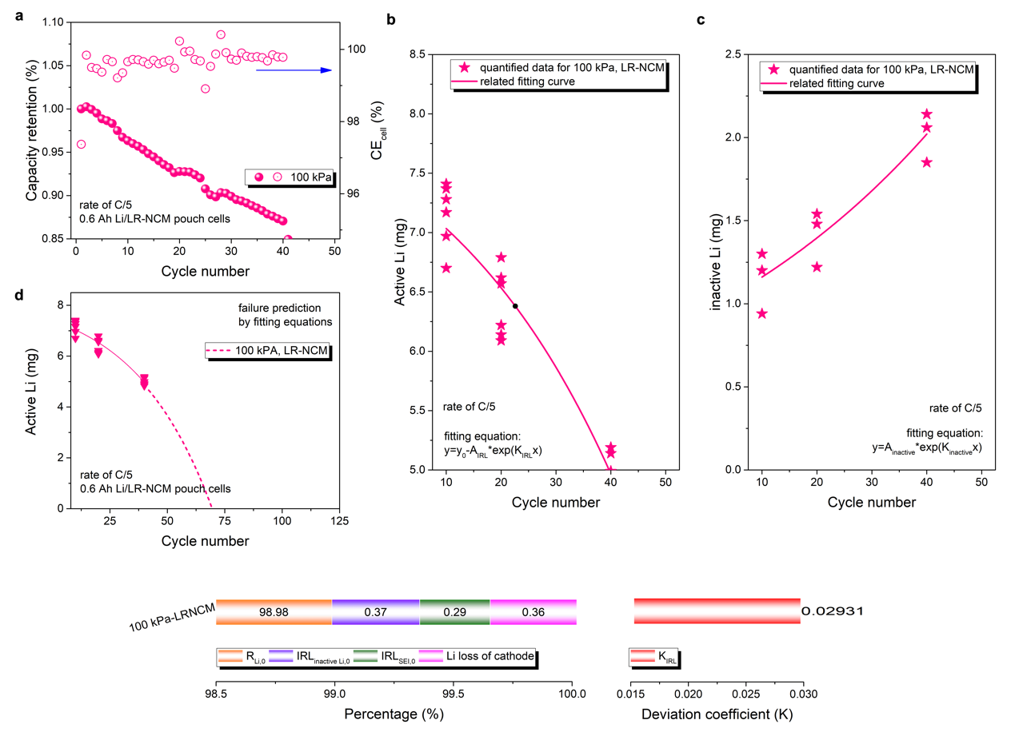
Supplementary Figure 10. (a) The capacity retention ratios and CE_{cell} of a practical 0.6 Ah Li/LR-NCM pouch cell under the rate of C/5. The first cycle which is used for the activation of the cell at C/20 isn’t included. (B) Exponential fitting curve between active Li and cycle number, and (c) exponential fitting curves between inactive Li and cycle number. The related parameters are listed at the bottom of the figure.

Additional discussions:
For comparison, high-capacity cathode (Li-rich layer oxide, LR-NCM) was employed in 0.6Ah Li/LR-NCM pouch cells (three cathode sheets) which were cycled under C/5 and 100 kPa (Fig. S10a). Capacity retention of the Li/LR-NCM cell is 85% after 40 cycles, and the average CE_{cell} is evidently lower than that of NCM811 cells. The cycling performance suggests large irreversibility of the LR-NCM cell, which may be caused by high areal capacity of Li stripped/plated and high charge-ended voltage of 4.6V. Both of them cause 0.36% of average Li loss of the cathode, while that of NCM811 cells is ~0.1%. Similarly, active/inactive Li are quantified to decouple the parameters about reversibility and irreversibility (Fig. S10b, c). Fitting results show that the proportion of R_{Li,0} is only 98.98% for the LR-NCM cells, meaning huge and continuous Li loss of LMA happens while cycling. The replacement of the NCM811 cathode by LR-NCM increases the increment parts (K_{IRL} = 0.02931) due to less stability of the electrolyte under 4.6 V and high absolute Li loss that induces worse “dead Li” layer.

Part 12. Cycling performance of 0.9Ah Li/NCM811 pouch cells
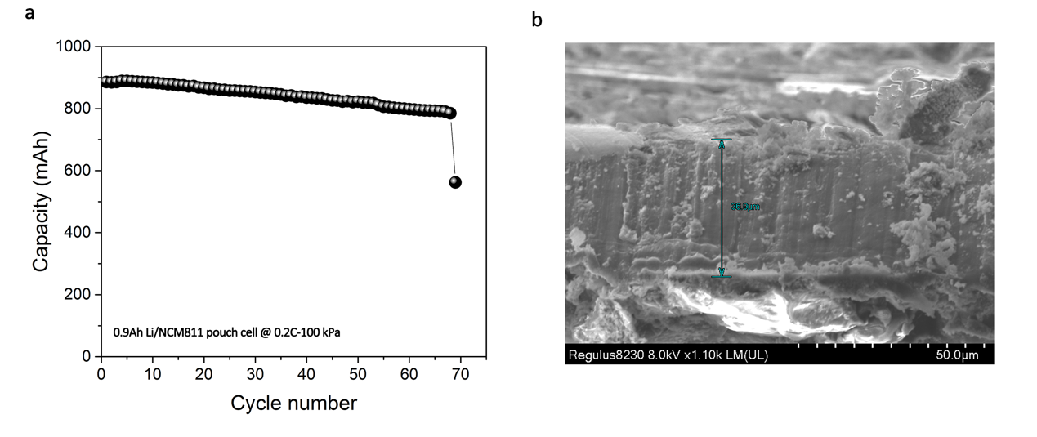
Supplementary Figure 11. (a) The cycle life of a 0.9 Ah Li/NCM811pouch cell with sudden capacity drop at the 69th cycle. (b) SEM image showing the thickness active Li (37 μm) in the Li anode after cycling, which indicates 37% (~3.0 mg) of active Li remained.

Part 13. Failure prediction of 0.5 Ah Li/NCM811 pouch cells
Supplementary Figure 12. Failure prediction of practical 0.5Ah Li/NCM811 pouch cells by applying quantified results.

Additional discussions:
As shown in Figure S12, incorporating the quantified data to the mathematical model, the lifetime of cells can be roughly estimated. The Y-axis of Figure S12 is different from that of Figure 3b. The residual amount of active Li, rather than cell capacity, is employed here to more evidently show the degradation of LMBs. Assuming that all active Li has been consumed, the total failure of all cells under different stack pressure is predicted to happen within the cycle number range of 100-125, which is in a good agreement with the practical results. High K_{IRL} and low R_{Li,0} for the cell under 100 kPa with no doubt induces the most serious failure process. It is interesting that, although the cell under 800 kPa demonstrates the highest R_{Li,0}, the high K_{IRL} still predicts that its lifetime maybe shorter than that under 400 kPa (lowest K_{IRL}).

Part 14. Degradation analysis of 0.5 Ah Li/NCM811 pouch cells under C/2
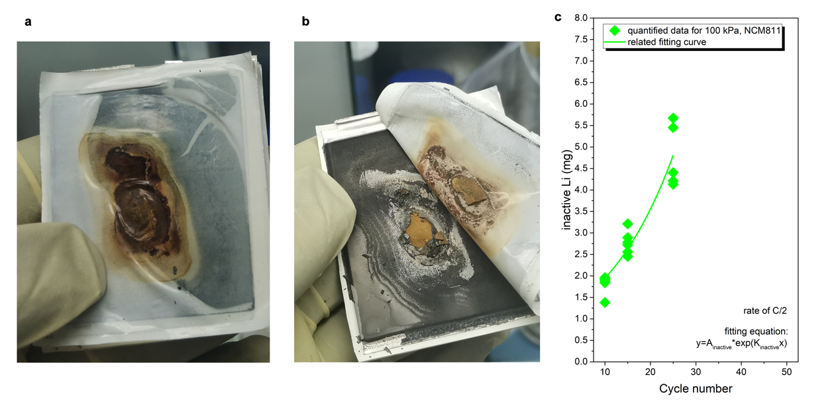
Supplementary Figure 13. (a, b) The digital photographs of cycled LMAs under 100 kPa-C/2 conditions after 25 cycles. It is obvious that uneven Li plating/stripping happened due to concentrated charge and temperature across the LMAs during high charging rate. (c) Fitting curves between inactive Li and cycle number.

Part 15. The morphology and Ar sorption characterizations of cycled LMAs.
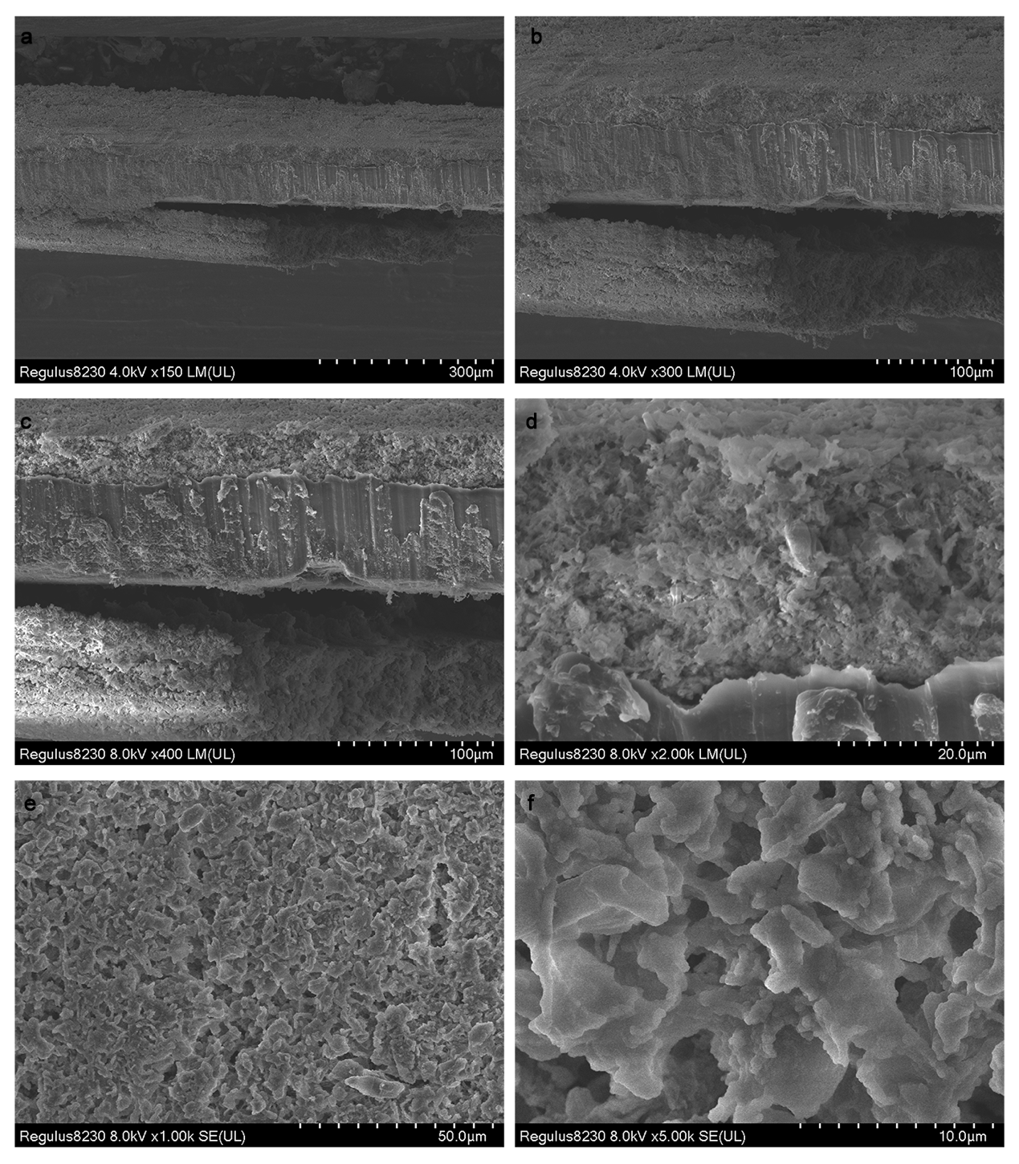
Supplementary Figure 14. The cross-sectional (a-d) and top-view (e-f) SEM images of the cycled LMA from the pouch cell tested under 100 kPa-C/5 for 10 cycles.

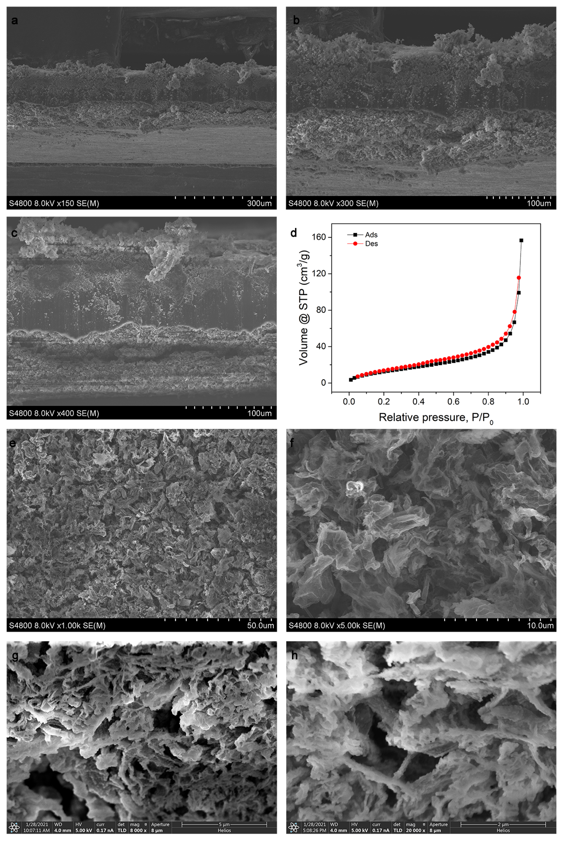
Supplementary Figure 15. The cross-sectional (a-c) and top-view (e-f) SEM images, FIB-SEM images (g, h) and Ar sorption isotherms (c) of the cycled LMA from the pouch cell tested under 100 kPa-C/5 for 25 cycles.
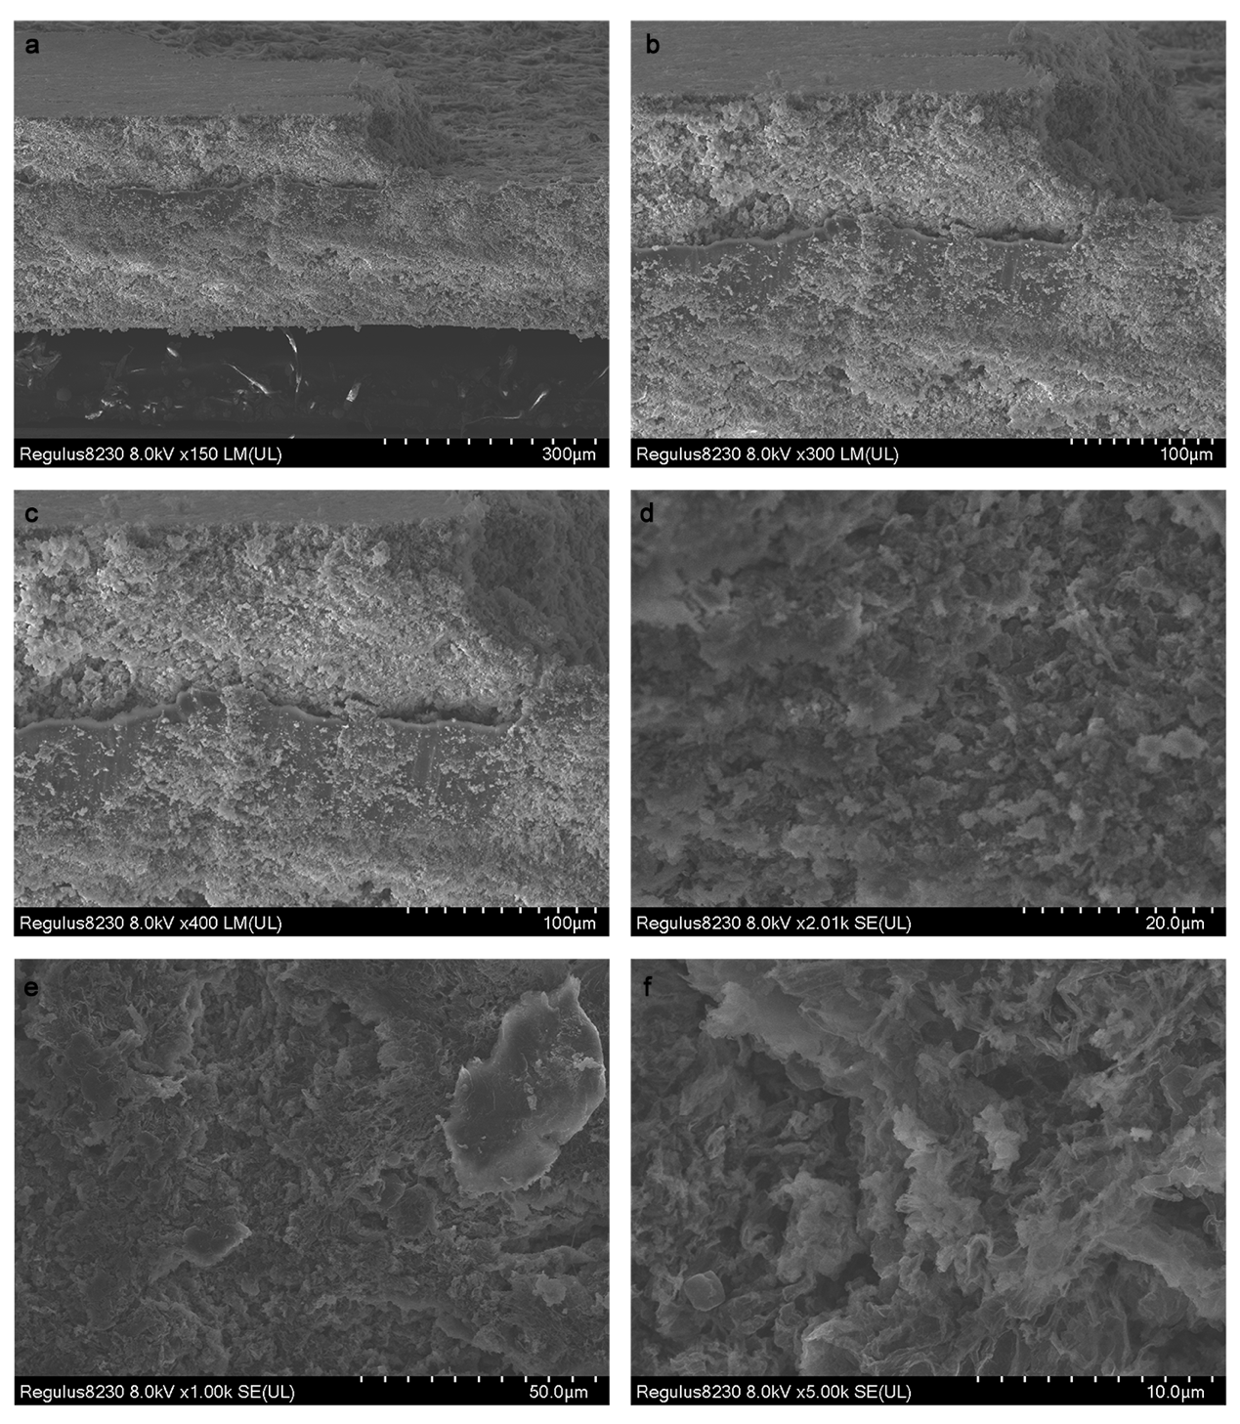
Supplementary Figure 16. The cross-sectional (a-d) and top-view (e-f) SEM images of the cycled LMA from the pouch cell tested under 100 kPa-C/5 for 50 cycles.

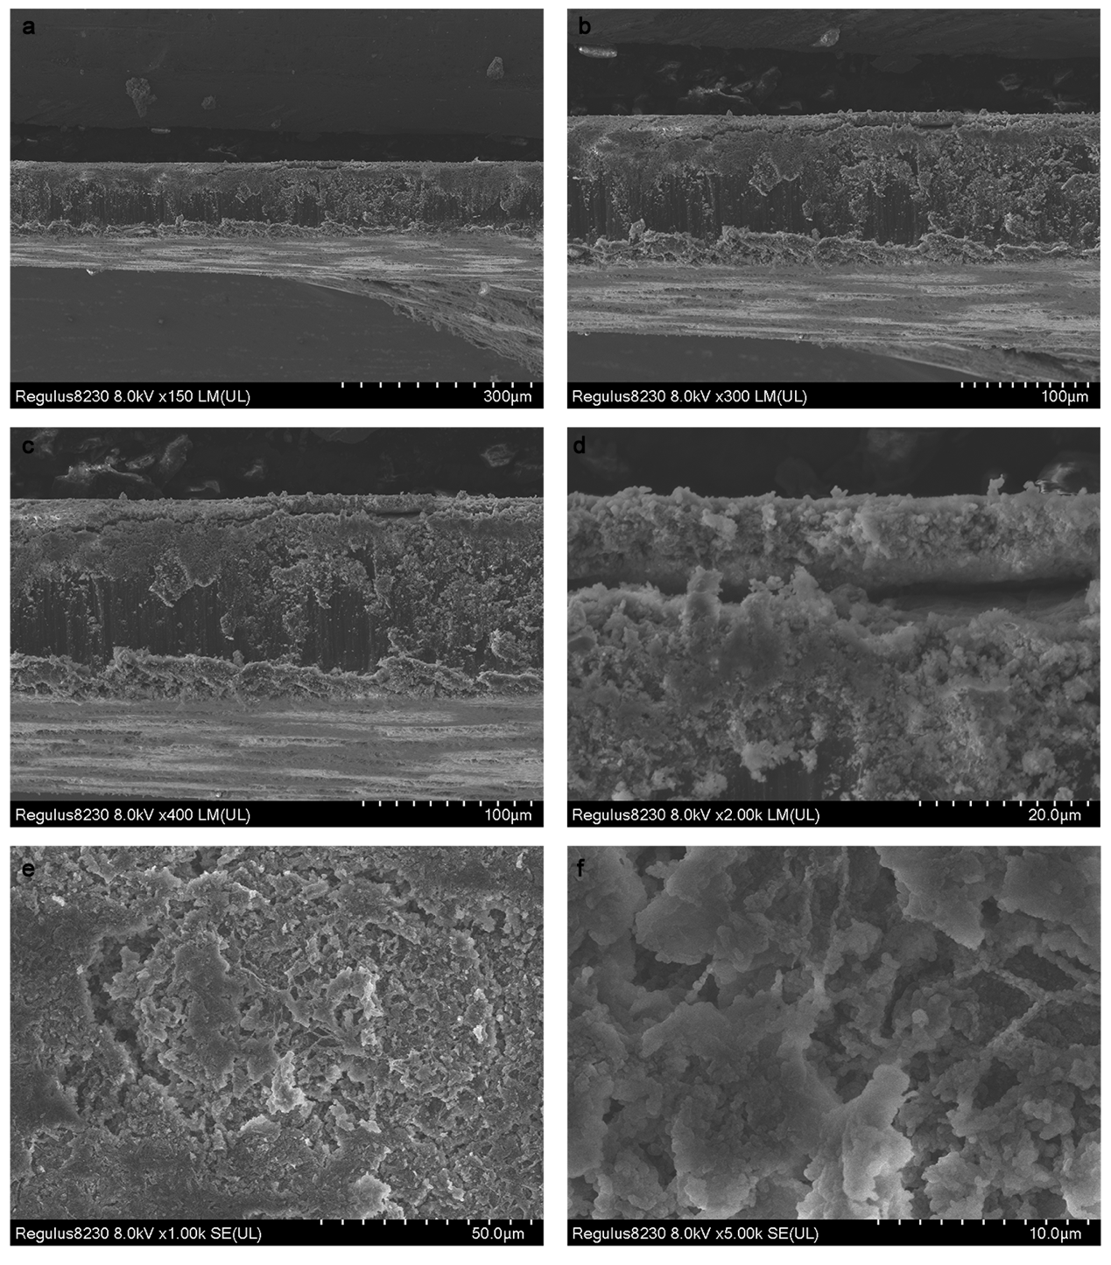
Supplementary Figure 17. The cross-sectional (a-d) and top-view (e-f) SEM images of the cycled LMA from the pouch cell tested under 800 kPa-C/5 for 10 cycles.

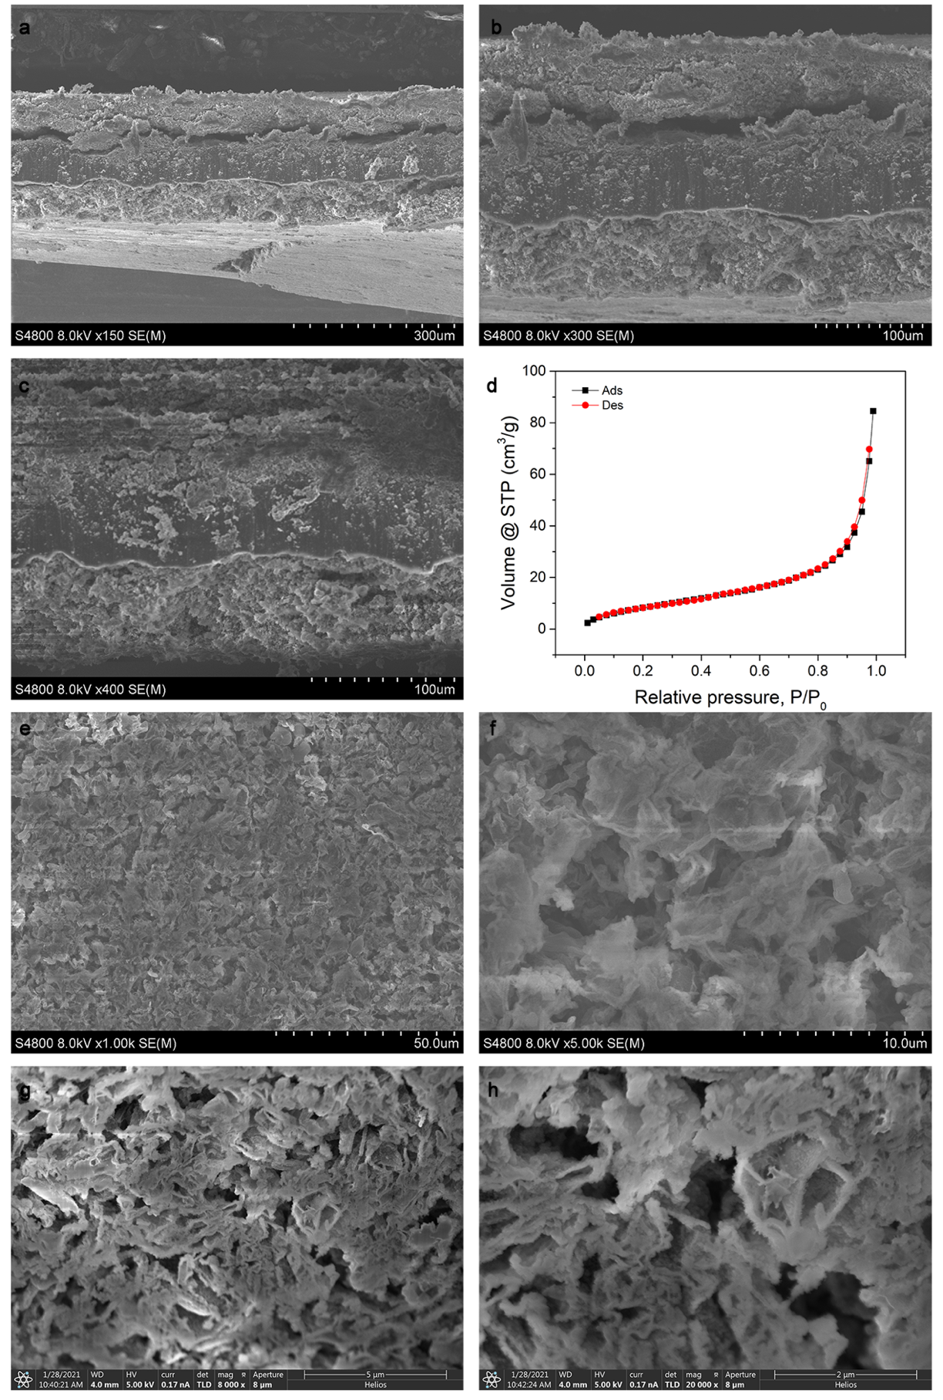
Supplementary Figure 18. The cross-sectional (a-c) and top-view (e-f) SEM images, FIB-SEM images (g, h) and Ar sorption isotherms (c) of the cycled LMA from the pouch cell tested under 800 kPa-C/5 for 25 cycles. The specific surface area of the cycled LMA is 29.95 m²/g.
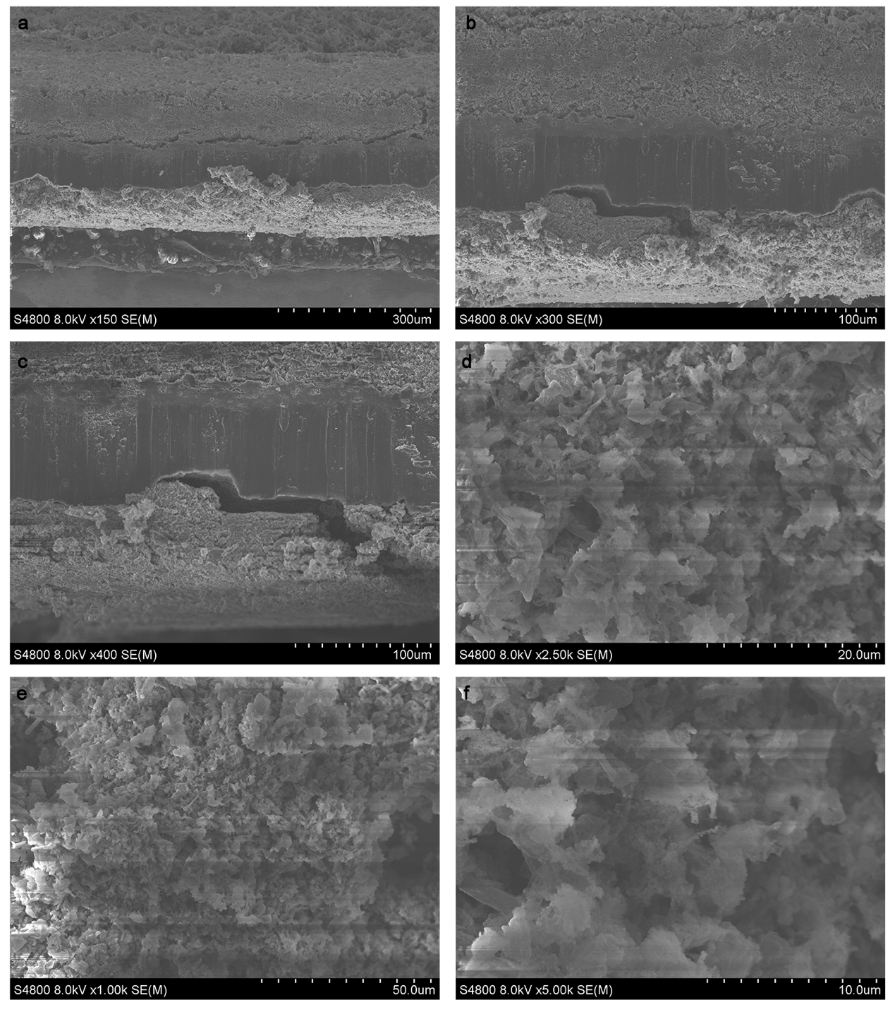
Supplementary Figure 19. The cross-sectional (a-d) and top-view (e-f) SEM images of the cycled LMA from the pouch cell tested under 100 kPa-C/2 for 10 cycles.

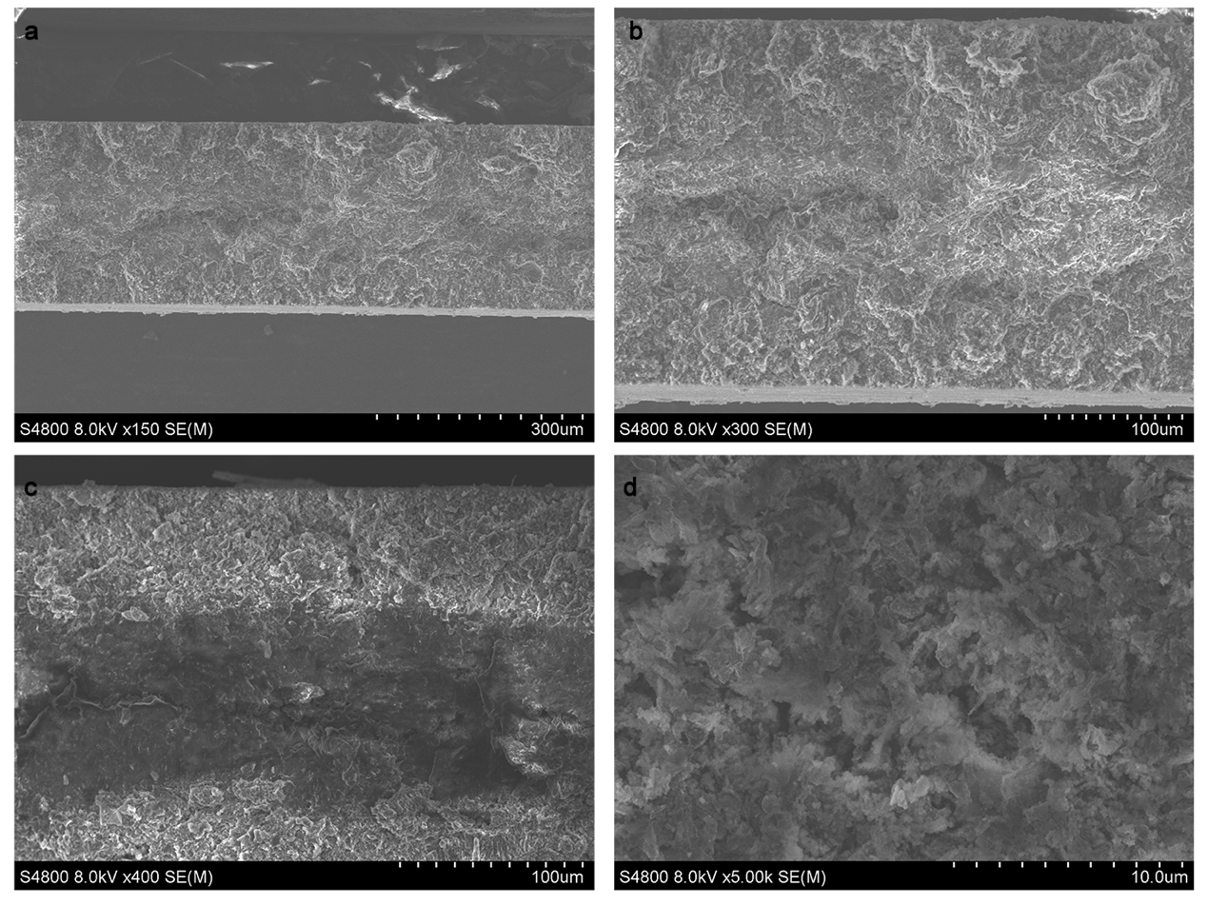
Supplementary Figure 20. The cross-sectional (a-d) and top-view (e-f) SEM images of the cycled LMA from the pouch cell tested under 100 kPa-C/2 for 15 cycles.

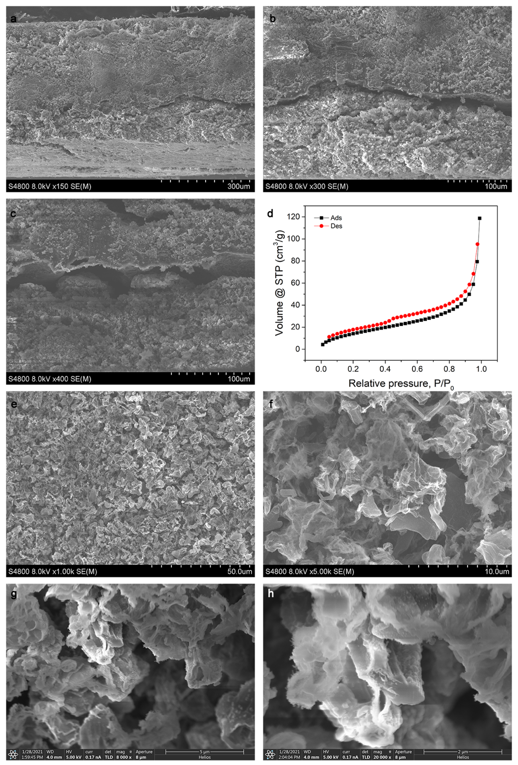
Supplementary Figure 21. The cross-sectional (a-c) and top-view (e-f) SEM images, FIB-SEM images (g, h) and Ar sorption isotherms (c) of the cycled LMA from the pouch cell tested under 100 kPa-C/2 for 25 cycles. Evident Li dendrites can be observed in Figure S21f, h, which is the direct evidence for the irreversible Li plating from the capacity losses of the cathode.

Part 16. Active Li thickness analysis for 0.5 Ah Li/NCM811 pouch cells under C/2 and C/5 rate
Supplementary Figure 22. The relationship between the thickness of active Li in cycled LMAs (measured by SEM) under different rates and the quantified mass of active Li using Li-AEST.

Additional discussions about degradation of LMAs:
For the condition of C/5:
Slow electron flux guarantees elongated Sand’s time and uniform local Li-ion distribution near the interface, which promises high possibility of dendrite-free Li plating. The CEs confirm that capacity losses of the cathodes are at a low level even after 50 cycles, therefore both quantified plots are located beneath the baseline mass of pristine Li foil. These results demonstrate that Li stripping/plating is more stable and uniform under the rate of C/5. Meanwhile, high stack pressure can suppress dendrite growth and flatten plated Li. The contents of inactive Li at 100 kPa is higher, which confirms the functions of high stack pressure on suppressing uneven Li protrusions to reduce the possibilities of SEI breakage. With no doubt, under the stack pressure of 100 kPa, the thickness of active Li will be gradually reduced, and expanded “dead Li” layers are responsible for the entire volume expansion of the cycled LMAs. More specifically, the volume expansion of “dead Li” layer is far more than the volume shrinkage of active Li whatever the pressure conditions are, but this phenomenon is depressed under the condition of 800 kPa-C/5.

For the condition of C/2:
In the condition of 100kPa-C/2, the elevated current density induces electron aggregation for unstable Li plating as the theory predicts, thus the dendritic morphology becomes the main deposition morphology, which is the main cause for the large irreversibly of the Li anode. It means that the consumption rate of active Li is extremely fast. Li loss of the cathode can’t be fully compensated by the large concentration polarization and cell resistance, because large “dead Li” particles loosely cumulate on bumpy LMA. Therefore, CEs of cells suffer dramatical decreasing only after 10 cycles.

Appendix: Original data for Li-AEST and H₂-GCT
Supplementary Table 9. The original data for detailed parameters of Li-AEST for quantifying active Li. The results about six parallel quantifications on cycled LMAs under ultra-mild conditions (100-NCM-0.2-1-50, 400-NCM-0.2-1-50) with low deviations in Table S9 and S10 confirm the accurate and coherence of the Li-AEST and H₂-GCT method. Therefore, we believe that the error values of each plots could qualitatively reflect the uniformity of Li components across the cycled LMAs.
Sample ID | $m_{target}$ (g) | $m_{dilute}$ (g) | $$m_{solution}$$  (g) | $m_{digestion}$ (g) | Volumetric flask (mL) | Results of ICP-AES (mg/L) | $C_{Li before digestion}$ (mg/kg) | $C_{Li target}$ (mg/kg) | Mass of active Li (mg)
100-NCM-0.2-1-10 | 8.7081 | 1.7977 | 3.4778 | 0.8591 | 25 | 13.862 | 403.387266 | 835.009959 | 7.27
100-NCM-0.2-1-10 | 8.7081 | 1.7977 | 3.4778 | 0.8557 | 25 | 13.805 | 403.324763 | 834.88058 | 7.27
100-NCM-0.2-1-10 | 8.6048 | 1.7922 | 3.5319 | 0.856 | 25 | 14.848 | 433.64486 | 880.376088 | 7.58
100-NCM-0.2-1-10 | 8.6048 | 1.7922 | 3.5319 | 0.8621 | 25 | 14.953 | 433.62139 | 880.328439 | 7.58
100-NCM-0.2-1-10 | 8.5390 | 1.8697 | 3.6465 | 0.8256 | 25 | 13.057 | 395.379118 | 811.430636 | 6.93
100-NCM-0.2-1-10 | 8.5390 | 1.8697 | 3.6465 | 0.8209 | 25 | 12.891 | 392.587404 | 805.701243 | 6.88
100-NCM-0.2-1-25 | 8.306 | 1.7203 | 3.4742 | 0.7702 | 25 | 12.786 | 415.022072 | 822.093439 | 6.83
100-NCM-0.2-1-25 | 8.306 | 1.7203 | 3.4742 | 0.803 | 25 | 13.329 | 414.975093 | 822.000382 | 6.83
100-NCM-0.2-1-25 | 8.3322 | 1.7277 | 3.4963 | 0.8002 | 25 | 12.508 | 390.777306 | 772.517638 | 6.44
100-NCM-0.2-1-25 | 8.3322 | 1.7277 | 3.4963 | 0.8104 | 25 | 13.272 | 409.427443 | 809.386616 | 6.74
100-NCM-0.2-1-25 | 8.4658 | 1.7469 | 2.8019 | 0.8156 | 25 | 9.367 | 287.119912 | 762.541498 | 6.46
100-NCM-0.2-1-25 | 8.4658 | 1.7469 | 2.8019 | 0.818 | 25 | 9.370 | 286.369193 | 760.547718 | 6.44
100-NCM-0.2-1-50  1st characterization | 8.3502 | 1.6988 | 2.9781 | 0.8053 | 25 | 9.602 | 298.087669 | 693.92237 | 5.79
100-NCM-0.2-1-50  1st characterization | 8.3502 | 1.6988 | 2.9781 | 0.823 | 25 | 9.340 | 283.718104 | 660.471263 | 5.52
100-NCM-0.2-1-50  1st characterization | 8.5418 | 1.8009 | 3.6141 | 0.823 | 25 | 10.224 | 310.571081 | 619.035377 | 5.29
100-NCM-0.2-1-50  1st characterization | 8.5418 | 1.8009 | 3.6141 | 0.8312 | 25 | 10.523 | 316.500241 | 630.853474 | 5.39
100-NCM-0.2-1-50  1st characterization | 8.5029 | 1.7449 | 3.5648 | 0.8357 | 25 | 11.802 | 353.057317 | 691.56477 | 5.88
100-NCM-0.2-1-50  1st characterization | 8.5029 | 1.7449 | 3.5648 | 0.8415 | 25 | 11.967 | 355.525847 | 696.400098 | 5.92
100-NCM-0.2-1-50  2nd characterization | 8.2437 | 1.7171 | 3.4705 | 0.8211 | 25 | 11.257 | 342.741444 | 678.387238 | 5.59
100-NCM-0.2-1-50  2nd characterization | 8.2437 | 1.7171 | 3.4705 | 0.8501 | 25 | 11.916 | 350.429361 | 693.603911 | 5.72
100-NCM-0.2-1-50  2nd characterization | 8.6876 | 1.7758 | 3.5155 | 0.8516 | 25 | 10.868 | 319.046501 | 644.713441 | 5.60
100-NCM-0.2-1-50  2nd characterization | 8.6876 | 1.7758 | 3.5155 | 0.8584 | 25 | 10.852 | 316.053122 | 638.664569 | 5.55
100-NCM-0.2-1-50  2nd characterization | 8.7951 | 1.8118 | 3.4179 | 0.8628 | 25 | 10.128 | 293.463143 | 624.511349 | 5.49
100-NCM-0.2-1-50  2nd characterization | 8.7951 | 1.8118 | 3.4179 | 0.858 | 25 | 9.937 | 289.539627 | 616.161815 | 5.42
800-NCM-0.2-1-10 | 8.8991 | 1.7816 | 3.5614 | 0.7963 | 25 | 14.075 | 441.88748 | 884.221862 | 7.87
800-NCM-0.2-1-10 | 8.8991 | 1.7816 | 3.5614 | 0.8002 | 25 | 14.345 | 448.169208 | 896.791671 | 7.98
800-NCM-0.2-1-10 | 8.618 | 1.797 | 3.3078 | 0.8165 | 25 | 13.985 | 428.199633 | 937.515717 | 8.08
800-NCM-0.2-1-10 | 8.618 | 1.797 | 3.3078 | 0.809 | 25 | 13.971 | 431.736712 | 945.259926 | 8.15
800-NCM-0.2-1-10 | 8.69 | 1.7919 | 3.5572 | 0.8269 | 25 | 15.325 | 463.326884 | 933.635297 | 8.11
800-NCM-0.2-1-10 | 8.69 | 1.7919 | 3.5572 | 0.8243 | 25 | 15.133 | 458.965183 | 924.846172 | 8.04
800-NCM-0.2-1-25 | 8.3267 | 1.7329 | 3.4882 | 0.8352 | 25 | 13.299 | 398.078305 | 791.076592 | 6.59
800-NCM-0.2-1-25 | 8.3267 | 1.7329 | 3.4882 | 0.8439 | 25 | 13.371 | 396.107359 | 787.159852 | 6.55
800-NCM-0.2-1-25 | 8.3774 | 1.7266 | 3.4573 | 0.8395 | 25 | 14.431 | 429.749851 | 858.481632 | 7.19
800-NCM-0.2-1-25 | 8.3774 | 1.7266 | 3.4573 | 0.8532 | 25 | 14.933 | 437.558603 | 874.080637 | 7.32
800-NCM-0.2-1-25 | 8.3642 | 1.7551 | 3.1676 | 0.8371 | 25 | 12.627 | 377.105483 | 845.677401 | 7.07
800-NCM-0.2-1-25 | 8.3642 | 1.7551 | 3.1676 | 0.8431 | 25 | 12.915 | 382.961689 | 858.810227 | 7.18
800-NCM-0.2-1-50 | 8.3454 | 1.6986 | 3.4398 | 0.7921 | 25 | 12.78 | 403.358162 | 796.847809 | 6.65
800-NCM-0.2-1-50 | 8.3454 | 1.6986 | 3.4398 | 0.7955 | 25 | 12.93 | 406.348209 | 802.754749 | 6.70
800-NCM-0.2-1-50 | 8.7184 | 1.9193 | 3.6675 | 0.8034 | 25 | 11.246 | 349.950212 | 734.150784 | 6.40
800-NCM-0.2-1-50 | 8.7184 | 1.9193 | 3.6675 | 0.8153 | 25 | 11.618 | 356.249233 | 747.365326 | 6.52
800-NCM-0.2-1-50 | 8.5933 | 1.6518 | 3.3754 | 0.8226 | 25 | 12.845 | 390.37807 | 764.494161 | 6.57
800-NCM-0.2-1-50 | 8.5933 | 1.6518 | 3.3754 | 0.8226 | 25 | 13.41 | 407.549234 | 798.121191 | 6.86
100-NCM-0.5-1-10  1st characterization | 8.6718 | 1.777 | 3.4662 | 0.8664 | 25 | 14.353 | 414.156279 | 849.839269 | 7.37
100-NCM-0.5-1-10  1st characterization | 8.6718 | 1.777 | 3.4662 | 0.8603 | 25 | 13.780 | 400.441706 | 821.697278 | 7.13
100-NCM-0.5-1-10  1st characterization | 8.7317 | 1.746 | 3.5003 | 0.8686 | 25 | 14.867 | 427.90122 | 853.777941 | 7.45
100-NCM-0.5-1-10  1st characterization | 8.7317 | 1.746 | 3.5003 | 0.8649 | 25 | 14.926 | 431.43716 | 860.833092 | 7.52
100-NCM-0.5-1-10  1st characterization | 8.651 | 1.7859 | 3.5048 | 0.8657 | 25 | 14.630 | 422.49047 | 861.44895 | 7.45
100-NCM-0.5-1-10  1st characterization | 8.651 | 1.7859 | 3.5048 | 0.8613 | 25 | 14.679 | 426.071055 | 868.749686 | 7.52
100-NCM-0.5-1-10  2nd characterization | 8.099 | 1.7243 | 3.1553 | 0.8545 | 25 | 13.891 | 406.407256 | 896.112379 | 7.26
100-NCM-0.5-1-10  2nd characterization | 8.099 | 1.7243 | 3.1553 | 0.8434 | 25 | 13.962 | 413.860564 | 912.546638 | 7.39
100-NCM-0.5-1-10  2nd characterization | 8.3518 | 1.7145 | 3.184 | 0.8505 | 25 | 14.456 | 424.926514 | 920.69821 | 7.69
100-NCM-0.5-1-10  2nd characterization | 8.3518 | 1.7145 | 3.184 | 0.8472 | 25 | 15.102 | 445.644476 | 965.588303 | 8.06
100-NCM-0.5-1-10  2nd characterization | 8.2662 | 1.7335 | 3.5451 | 0.8483 | 25 | 17.158 | 505.658376 | 989.517282 | 8.18
100-NCM-0.5-1-10  2nd characterization | 8.2662 | 1.7335 | 3.5451 | 0.8559 | 25 | 15.499 | 452.710597 | 885.904359 | 7.32
100-NCM-0.5-1-15 | 7.8068 | 1.6757 | 3.3899 | 1.0073 | 25 | 12.84 | 318.673682 | 630.190127 | 4.92
100-NCM-0.5-1-15 | 7.8068 | 1.6757 | 3.3899 | 0.7351 | 25 | 9.267 | 315.161203 | 623.244056 | 4.87
100-NCM-0.5-1-15 | 7.8759 | 1.7418 | 3.4908 | 0.8312 | 25 | 12.325 | 370.698989 | 739.871945 | 5.83
100-NCM-0.5-1-15 | 7.8759 | 1.7418 | 3.4908 | 0.8333 | 25 | 12.98 | 389.415577 | 777.22807 | 6.12
100-NCM-0.5-1-15 | 7.6199 | 1.7723 | 3.5243 | 0.8404 | 25 | 11.892 | 353.760114 | 711.619161 | 5.42
100-NCM-0.5-1-15 | 7.6199 | 1.7723 | 3.5243 | 0.8406 | 25 | 12.377 | 368.100167 | 740.465421 | 5.64
100-NCM-0.5-1-25 | 8.8021 | 1.7975 | 3.5781 | 0.8305 | 25 | 4.717 | 141.992775 | 285.33323 | 2.51
100-NCM-0.5-1-25 | 8.8021 | 1.7975 | 3.5781 | 0.8288 | 25 | 4.856 | 146.476834 | 294.343906 | 2.59
100-NCM-0.5-1-25 | 8.6978 | 1.7797 | 3.5674 | 0.8327 | 25 | 4.646 | 139.486009 | 278.347816 | 2.42
100-NCM-0.5-1-25 | 8.6978 | 1.7797 | 3.5674 | 0.8318 | 25 | 4.669 | 140.328204 | 280.028436 | 2.44
100-NCM-0.5-1-25 | 8.7387 | 1.7875 | 3.5435 | 0.8343 | 25 | 3.214 | 96.3082824 | 194.344191 | 1.70
100-NCM-0.5-1-25 | 8.7387 | 1.7875 | 3.5435 | 0.8312 | 25 | 3.355 | 100.908325 | 203.626794 | 1.78
100-LR-0.2-1-10 | 8.3032 | 1.7028 | 3.4009 | 0.7631 | 25 | 13.594 | 445.354475 | 891.941602 | 7.41
100-LR-0.2-1-10 | 8.3032 | 1.7028 | 3.4009 | 0.7869 | 25 | 13.194 | 419.176515 | 839.513227 | 6.97
100-LR-0.2-1-10 | 8.737 | 1.7366 | 3.4621 | 0.7817 | 25 | 12.795 | 409.204298 | 821.040974 | 7.17
100-LR-0.2-1-10 | 8.737 | 1.7366 | 3.4621 | 0.8039 | 25 | 12.297 | 382.416967 | 767.293992 | 6.70
100-LR-0.2-1-10 | 8.7155 | 1.7626 | 3.4795 | 0.8088 | 25 | 13.343 | 412.431998 | 835.842004 | 7.28
100-LR-0.2-1-10 | 8.7155 | 1.7626 | 3.4795 | 0.8135 | 25 | 13.579 | 417.301782 | 845.711196 | 7.37
100-LR-0.2-1-20 | 8.463 | 1.7306 | 3.4274 | 0.7932 | 25 | 12.295 | 387.512607 | 782.744407 | 6.62
100-LR-0.2-1-20 | 8.463 | 1.7306 | 3.4274 | 0.8148 | 25 | 12.953 | 397.428817 | 802.774356 | 6.79
100-LR-0.2-1-20 | 8.4737 | 2.4096 | 3.8531 | 0.817 | 25 | 9.488 | 290.330477 | 774.972194 | 6.57
100-LR-0.2-1-20 | 8.4737 | 2.4096 | 3.8531 | 0.8211 | 25 | 8.912 | 271.34332 | 724.290229 | 6.14
100-LR-0.2-1-20 | 8.4137 | 1.5041 | 3.2576 | 0.8264 | 25 | 13.147 | 397.719022 | 738.870537 | 6.22
100-LR-0.2-1-20 | 8.4137 | 1.5041 | 3.2576 | 0.8264 | 25 | 12.873 | 389.430058 | 723.471547 | 6.09
100-LR-0.2-1-40 | 8.3753 | 1.8395 | 3.591 | 0.8252 | 25 | 9.409 | 285.052109 | 584.42599 | 4.89
100-LR-0.2-1-40 | 8.3753 | 1.8395 | 3.591 | 0.8379 | 25 | 10.031 | 299.289891 | 613.6169 | 5.14
100-LR-0.2-1-40 | 8.4214 | 1.7687 | 3.5122 | 0.8385 | 25 | 9.863 | 294.066786 | 592.383921 | 4.99
100-LR-0.2-1-40 | 8.4214 | 1.7687 | 3.5122 | 0.8423 | 25 | 10.315 | 306.155764 | 616.736607 | 5.19
100-LR-0.2-1-40 | 8.3237 | 1.7705 | 3.522 | 0.8576 | 25 | 9.895 | 288.450326 | 580.029717 | 4.83
100-LR-0.2-1-40 | 8.3237 | 1.7705 | 3.522 | 0.8541 | 25 | 10.02 | 293.291184 | 589.763945 | 4.91
400-NCM-0.2-1-10 | 8.4714 | 1.7392 | 3.4503 | 0.78 | 25 | 13.914 | 445.961538 | 899.24674 | 7.62
400-NCM-0.2-1-10 | 8.4714 | 1.7392 | 3.4503 | 0.8417 | 25 | 14.612 | 434.002614 | 875.132499 | 7.41
400-NCM-0.2-1-10 | 8.4391 | 1.7447 | 3.4534 | 0.8496 | 25 | 15.327 | 451.006356 | 911.514806 | 7.69
400-NCM-0.2-1-10 | 8.4391 | 1.7447 | 3.4534 | 0.8417 | 25 | 15.316 | 454.912677 | 919.409749 | 7.76
400-NCM-0.2-1-10 | 8.5644 | 1.7441 | 3.448 | 0.8564 | 25 | 14.497 | 423.195936 | 856.376307 | 7.33
400-NCM-0.2-1-10 | 8.5644 | 1.7441 | 3.448 | 0.8472 | 25 | 14.756 | 435.434372 | 881.141918 | 7.55
400-NCM-0.2-1-25 | 8.4535 | 1.7343 | 3.4773 | 0.8215 | 25 | 12.006 | 365.368229 | 728.912761 | 6.16
400-NCM-0.2-1-25 | 8.4535 | 1.7343 | 3.4773 | 0.8131 | 25 | 12.248 | 376.583446 | 751.287216 | 6.35
400-NCM-0.2-1-25 | 8.4159 | 1.7289 | 3.4759 | 0.8283 | 25 | 11.922 | 359.833394 | 715.938691 | 6.03
400-NCM-0.2-1-25 | 8.4159 | 1.7289 | 3.4759 | 0.832 | 25 | 12.567 | 377.614183 | 751.316049 | 6.32
400-NCM-0.2-1-25 | 8.4023 | 1.807 | 3.555 | 0.8267 | 25 | 13.247 | 400.598766 | 814.718887 | 6.85
400-NCM-0.2-1-25 | 8.4023 | 1.807 | 3.555 | 0.8388 | 25 | 13.349 | 397.860038 | 809.148991 | 6.80
400-NCM-0.2-1-50  1st characterizations | 8.5327 | 1.6906 | 3.6555 | 0.8336 | 25 | 12.362 | 370.741363 | 689.727239 | 5.89
400-NCM-0.2-1-50  1st characterizations | 8.5327 | 1.6906 | 3.6555 | 0.841 | 25 | 12.655 | 376.189061 | 699.862136 | 5.97
400-NCM-0.2-1-50  1st characterizations | 8.4573 | 1.7301 | 3.5419 | 0.8477 | 25 | 12.189 | 359.472691 | 702.73558 | 5.94
400-NCM-0.2-1-50  1st characterizations | 8.4573 | 1.7301 | 3.5419 | 0.8457 | 25 | 11.952 | 353.316779 | 690.701346 | 5.84
400-NCM-0.2-1-50  1st characterizations | 8.5662 | 1.6987 | 3.499 | 0.8581 | 25 | 11.969 | 348.706444 | 677.733627 | 5.81
400-NCM-0.2-1-50  1st characterizations | 8.5662 | 1.6987 | 3.499 | 0.8521 | 25 | 12.169 | 357.029691 | 693.910398 | 5.94
400-NCM-0.2-1-50  2nd characterization | 8.7192 | 1.7514 | 3.5067 | 0.8649 | 25 | 11.465 | 331.396693 | 662.057075 | 5.77
400-NCM-0.2-1-50  2nd characterization | 8.7192 | 1.7514 | 3.5067 | 0.8583 | 25 | 11.436 | 333.100315 | 665.460533 | 5.80
400-NCM-0.2-1-50  2nd characterization | 8.7329 | 1.7577 | 3.496 | 0.8681 | 25 | 11.589 | 333.746112 | 671.216941 | 5.86
400-NCM-0.2-1-50  2nd characterization | 8.7329 | 1.7577 | 3.496 | 0.8645 | 25 | 12.144 | 351.185656 | 706.29066 | 6.17
400-NCM-0.2-1-50  2nd characterization | 8.6994 | 1.7693 | 3.5174 | 0.8714 | 25 | 11.676 | 334.978196 | 674.018824 | 5.86
400-NCM-0.2-1-50  2nd characterization | 8.6994 | 1.7693 | 3.5174 | 0.8547 | 25 | 12.069 | 353.018603 | 710.318422 | 6.18

Supplementary Table 10. The original data of H₂-GCT for quantifying inactive Li.
Sample ID | Peak area of hydrogen  $$S_{hydrogen-test}$$ | Peak area of Argon  $$S_{argon-test}$$ | Average slope value of H₂-GCT baseline | Mass of inactive Li (mg)
100-NCM-0.2-1-10 | 58.977 | 131744.023 | 1422 | 0.64
100-NCM-0.2-1-10 | 81.261 | 172888.155 | 1422 | 0.67
100-NCM-0.2-1-10 | 82.225 | 167410.277 | 1422 | 0.70
100-NCM-0.2-1-25 | 109.486 | 130082.125 | 1422 | 1.20
100-NCM-0.2-1-25 | 159.123 | 155796.854 | 1422 | 1.45
100-NCM-0.2-1-25 | 179.617 | 163967.906 | 1422 | 1.56
100-NCM-0.2-1-50  1st characterization | 182.396 | 161514.099 | 1422 | 1.61
100-NCM-0.2-1-50  1st characterization | 195.375 | 150081.848 | 1422 | 1.85
100-NCM-0.2-1-50  1st characterization | 163.208 | 156874.841 | 1422 | 1.48
100-NCM-0.2-1-50  2nd characterization | 177.139 | 154933.577 | 1422 | 1.63
100-NCM-0.2-1-50  2nd characterization | 183.081 | 157542.214 | 1422 | 1.65
100-NCM-0.2-1-50  2nd characterization | 214.675 | 153454.741 | 1422 | 1.99
800-NCM-0.2-1-10 | 14.589 | 158052.305 | 1422 | 0.13
800-NCM-0.2-1-10 | 17.347 | 145240.28 | 1422 | 0.17
800-NCM-0.2-1-10 | 40.211 | 161251.336 | 1422 | 0.35
800-NCM-0.2-1-25 | 134.733 | 164259.195 | 1422 | 1.17
800-NCM-0.2-1-25 | 171.22 | 165517.622 | 1422 | 1.47
800-NCM-0.2-1-25 | 153.556 | 167297.836 | 1422 | 1.31
800-NCM-0.2-1-50 | 139.25 | 140585.898 | 1422 | 1.41
800-NCM-0.2-1-50 | 154.706 | 160268.02 | 1422 | 1.37
800-NCM-0.2-1-50 | 143.591 | 154808.396 | 1422 | 1.32
800-NCM-0.2-1-50 | 160.838 | 161012.38 | 1422 | 1.42
100-NCM-0.5-1-10  1st characterization | 153.934 | 159118.868 | 1422 | 1.38
100-NCM-0.5-1-10  1st characterization | 217.578 | 159764.942 | 1422 | 1.94
100-NCM-0.5-1-10  1st characterization | 213.894 | 161575.143 | 1422 | 1.88
100-NCM-0.5-1-10  2nd characterization | 209.628 | 155464.175 | 1422 | 1.92
100-NCM-0.5-1-10  2nd characterization | 191.463 | 148290.907 | 1422 | 1.84
100-NCM-0.5-1-10  2nd characterization | 214.453 | 155209.04 | 1422 | 1.96
100-NCM-0.5-1-15 | 305.582 | 158386.193 | 1422 | 2.74
100-NCM-0.5-1-15 | 271.195 | 164030.229 | 1422 | 2.35
100-NCM-0.5-1-15 | 381.295 | 161279.634 | 1422 | 3.36
100-NCM-0.5-1-25 | 664.717 | 176653.304 | 1422 | 5.35
100-NCM-0.5-1-25 | 633.792 | 169127.314 | 1422 | 5.33
100-NCM-0.5-1-25 | 471.184 | 162094.935 | 1422 | 4.16
100-NCM-0.5-1-25 | 633.792 | 169127.314 | 1422 | 4.21
100-NCM-0.5-1-25 | 471.184 | 162094.935 | 1422 | 4.4
100-LR-0.2-1-10 | 133.346 | 157742.162 | 1422 | 1.20
100-LR-0.2-1-10 | 142.234 | 156057.946 | 1422 | 1.30
100-LR-0.2-1-10 | 103.816 | 156497.099 | 1422 | 0.94
100-LR-0.2-1-20 | 151.63 | 145672.888 | 1422 | 1.48
100-LR-0.2-1-20 | 167.612 | 158483.393 | 1422 | 1.54
100-LR-0.2-1-20 | 138.621 | 160922.386 | 1422 | 1.22
100-LR-0.2-1-40 | 203.902 | 156513 | 1422 | 1.85
100-LR-0.2-1-40 | 236.002 | 156589.566 | 1422 | 2.14
100-LR-0.2-1-40 | 222.641 | 153708.693 | 1422 | 2.06
400-NCM-0.2-1-10 | 51.246 | 172983.398 | 1422 | 0.42
400-NCM-0.2-1-10 | 43.597 | 171596.363 | 1422 | 0.36
400-NCM-0.2-1-10 | 64.58 | 169463.514 | 1422 | 0.54
400-NCM-0.2-1-25 | 156.968 | 159362.451 | 1422 | 1.4
400-NCM-0.2-1-25 | 165.105 | 158292.724 | 1422 | 1.48
400-NCM-0.2-1-25 | 124.121 | 164962.017 | 1422 | 1.07
400-NCM-0.2-1-50  1st characterization | 158.998 | 164223.93 | 1422 | 1.38
400-NCM-0.2-1-50  1st characterization | 155.254 | 156340.911 | 1422 | 1.41
400-NCM-0.2-1-50  1st characterization | 164.262 | 156623.6 | 1422 | 1.49
400-NCM-0.2-1-50  2nd characterization | 164.469 | 154774.268 | 1422 | 1.51
400-NCM-0.2-1-50  2nd characterization | 165.689 | 155230.368 | 1422 | 1.52
400-NCM-0.2-1-50  2nd characterization | 185.441 | 156849.53 | 1422 | 1.68

