Supplemental Table and Figures
Tumor stage | n | %
T1 | 29 | 7.40%
T2 | 112 | 28.57%
T3 | 99 | 25.26%
T4x | 21 | 5.36%
T4a | 114 | 29.08%
T4b | 2 | 0.51%
TX | 15 | 3.83%
Nodal stage
N0 | 146 | 37.24%
N1 | 54 | 13.78%
N2x | 9 | 2.30%
N2a | 7 | 1.79%
N2b | 74 | 18.88%
N2c | 34 | 8.67%
N3 | 3 | 0.77%
NX | 65 | 16.58%
Site
Oropharynx | 67 | 17.09%
Oral cavity | 228 | 58.16%
Larynx/Hypopharynx | 97 | 24.74%
HPV status
Positive | 63 | 16.07%
Negative | 329 | 83.93%

Supplemental Table 1. Tumor characteristics of the Head and Neck TCGA cohort.

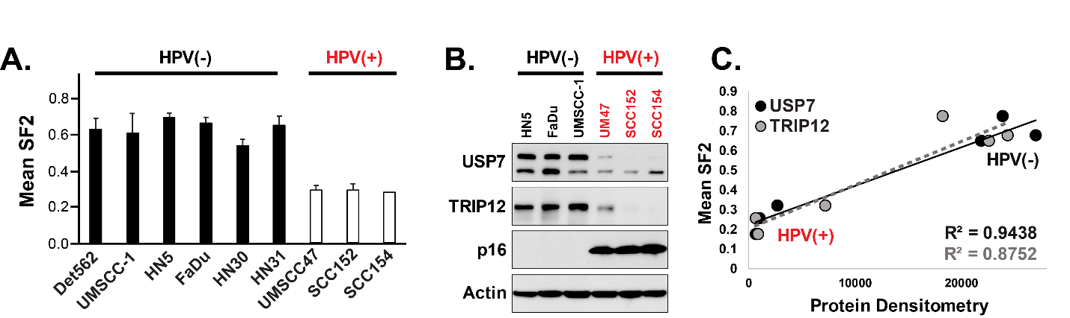
Supplemental Figure 1. Radiosensitivity in HNSCCs correlates with TRIP12 and USP7 expression and is HPV-status dependent. (A) Surviving fraction at 2 Gy (SF2) of representative HPV(-) and HPV(+) cells. (B) Immunoblots of USP7, TRIP12, p16 and Actin for selected HPV(-) and HPV(+) cells. (C) Correlation between SF2 and USP7 (black dots) or TRIP12 (grey dots) protein expression.

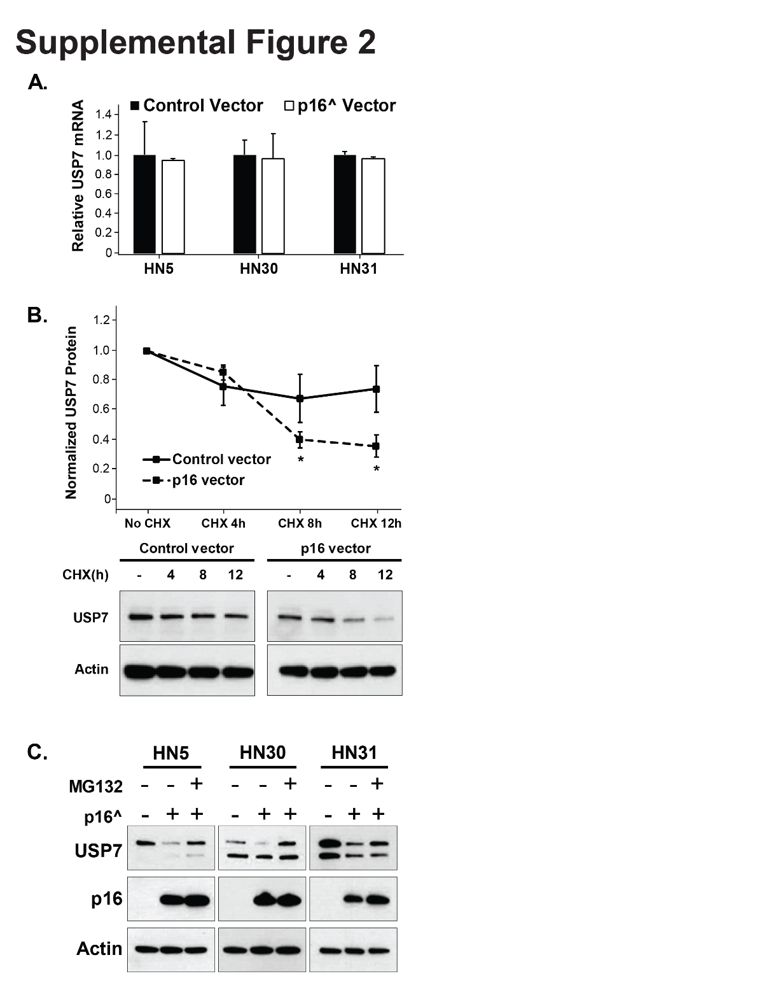
Supplemental Figure 2. A) USP7 mRNA expression in cells expressing either control vector or p16. B) Cycloheximide chase experiment in HN30 cells expressing control vector or p16. C) MG132 rescue experiment in several HPV(-)/p16(-) cell types (HN5, HN30 and HN31) expressing control vector or p16. * - p<0.05 versus control.
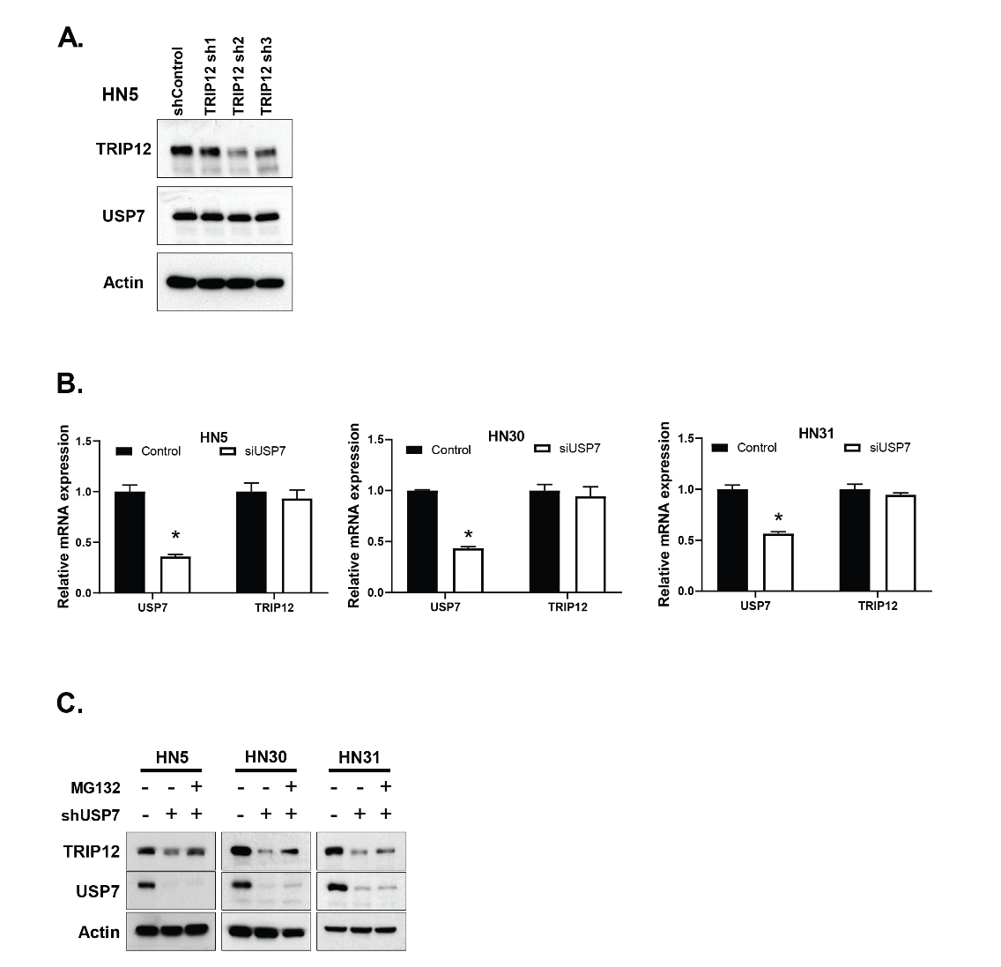
Supplemental Figure 3. A) Immunoblot in HN5 cells expressing control or shRNA to TRIP12. B) TRIP12 mRNA expression in cells expressing either mock or USP7 siRNA. C) MG132 rescue experiment in several HPV(-)/p16(-) cell types (HN5, HN30 and HN31) expressing control or shUSP7. * - p<0.05 versus control.

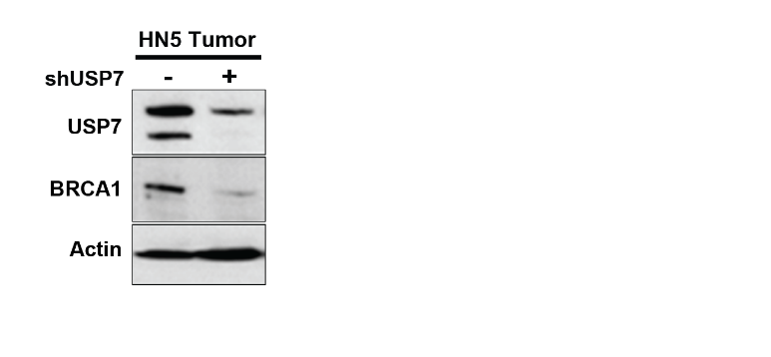
Supplemental Figure 4. Immunoblot of pooled tumors from in vivo experiment in Figure 4I.

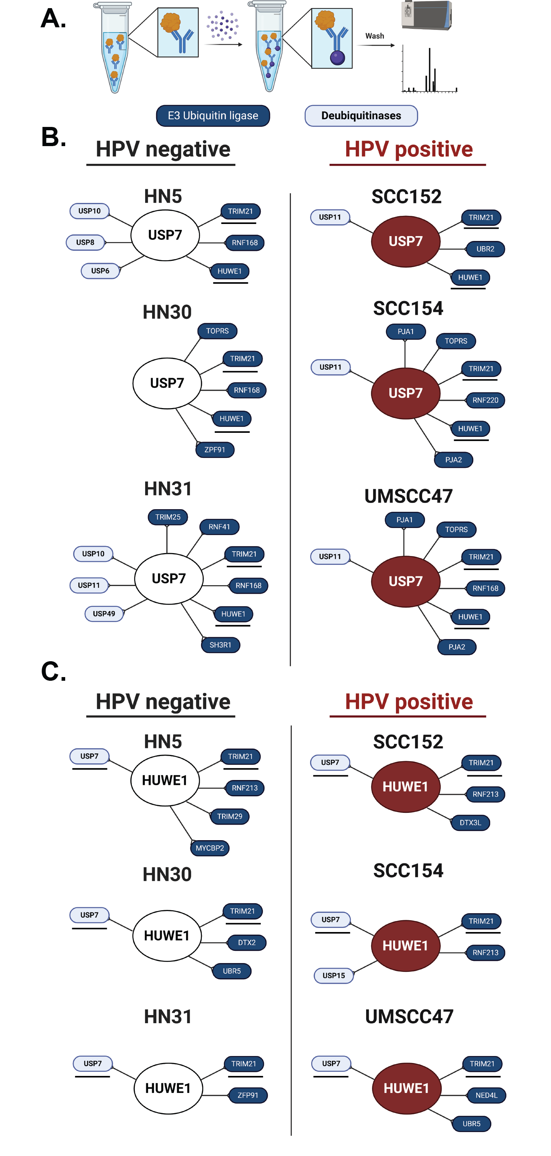
Supplemental Figure 5. A) Basic schema for the experiment, with lysate incubated with either USP7 or HUWE1 antibody, followed by incubation with Protein-A Sepharose beads. The beads were then washed, centrifuged and analyzed via mass spectrometry. B & C) E3 ubiquitin ligases (dark blue) and deubiquitinases identified by IP/MS following IP for either USP7 (B) or HUWE1 (C) in HPV (+) and HPV (-) cells are shown. Targets common to all cell lines examined are underlined in black.

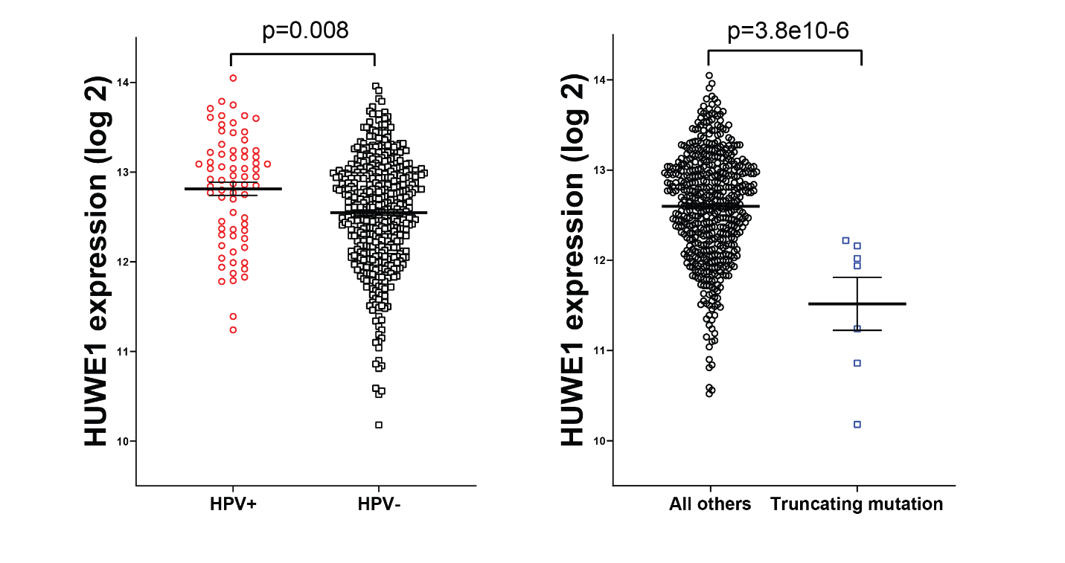
Supplemental Figure 6. Expression of HUWE1 in TCGA head and neck cohort stratified by HPV status or HUWE1 mutation. P-values are two-sided and determined via students t-test.
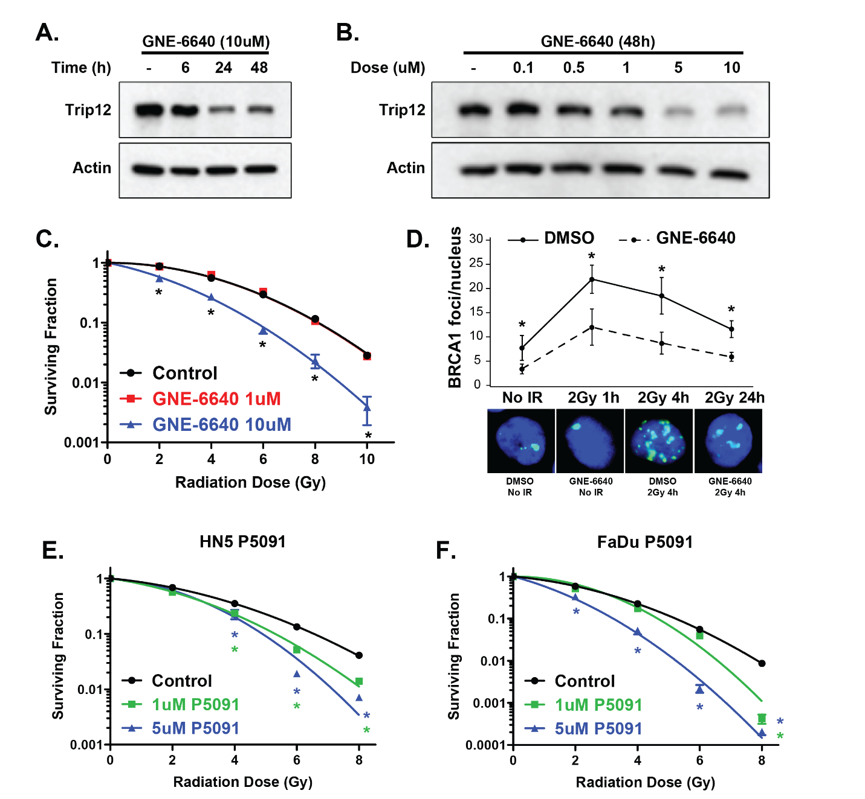Supplemental Figure 7. A-D) Immunoblot (A & B), clonogenic survival (C) and BRCA1 foci formation (D) in HN5 cells treated with the USP7 inhibitor GNE-6640. E-F) Clonogenic survival assay in HN5 cells (E) or FaDu cells (F) treated with P5091. Composite data are presented as mean ± SEM. * - p<0.05 versus control.

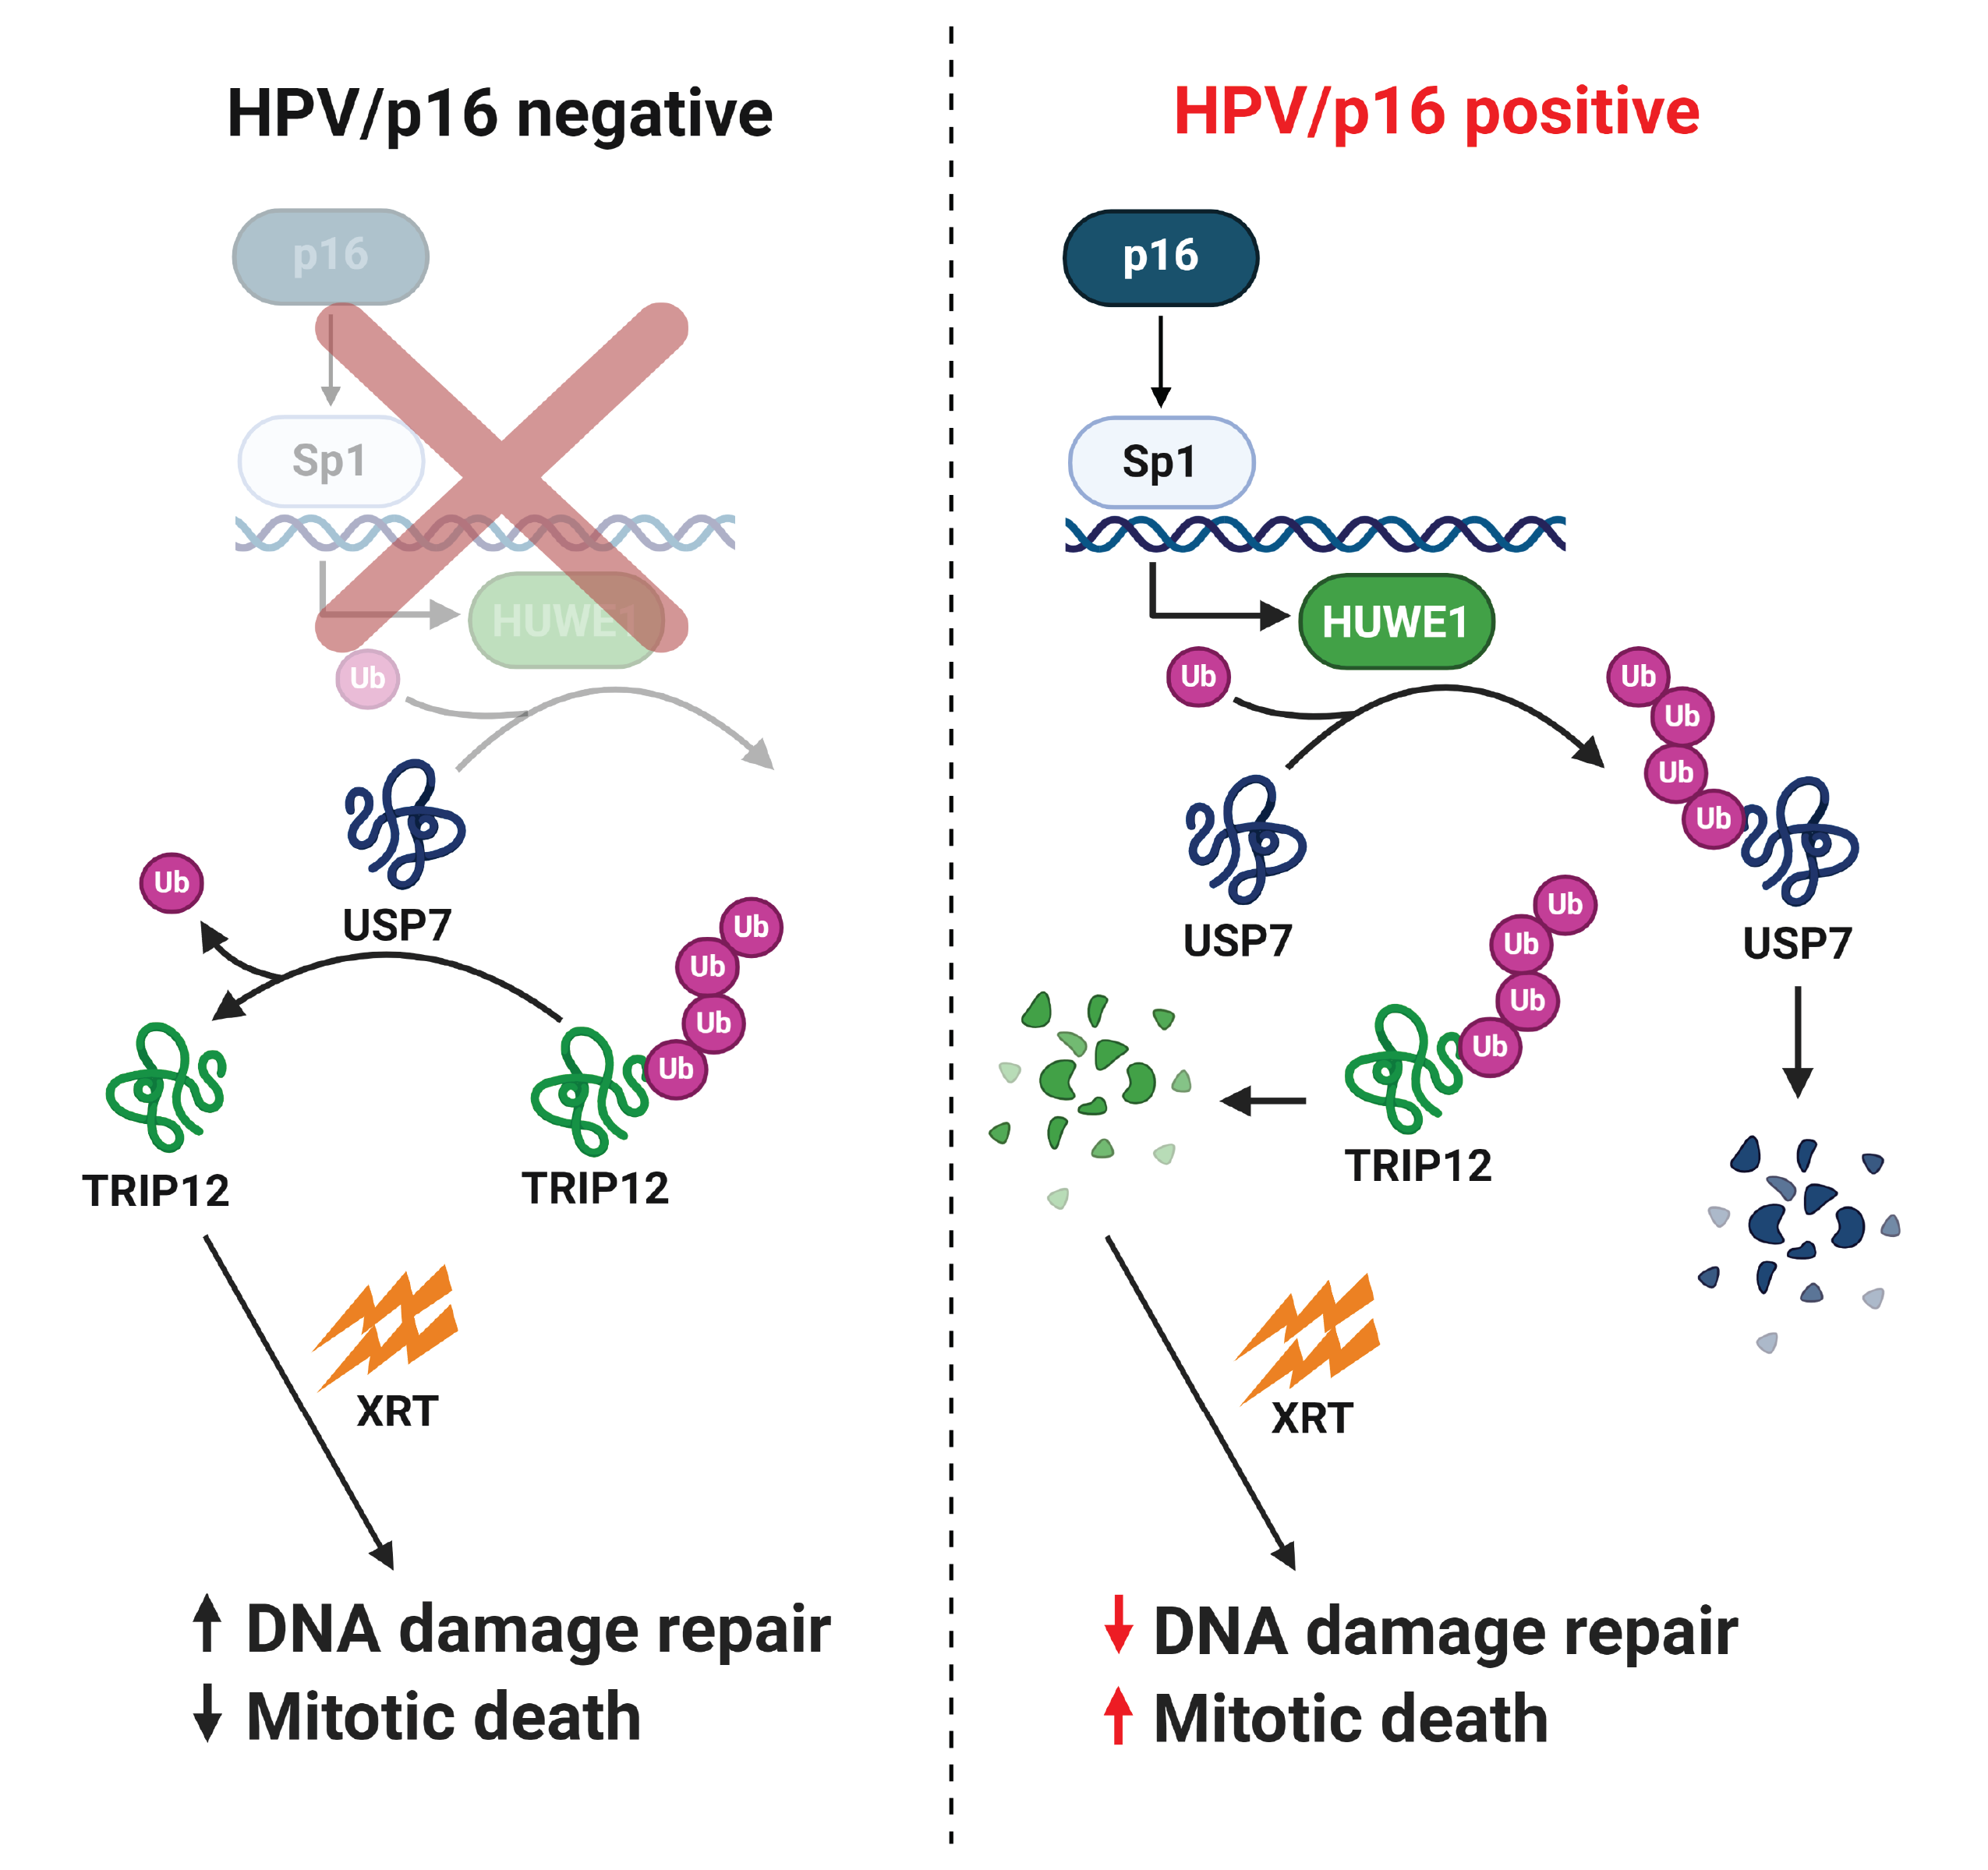Supplemental Figure 8. Potential pathway linking p16 to DNA damage repair via ubiquitin signaling.

