Supplemental Table and Figures
Tumor stage | n | %
T1 | 29 | 7.40%
T2 | 112 | 28.57%
T3 | 99 | 25.26%
T4x | 21 | 5.36%
T4a | 114 | 29.08%
T4b | 2 | 0.51%
TX | 15 | 3.83%
Nodal stage
N0 | 146 | 37.24%
N1 | 54 | 13.78%
N2x | 9 | 2.30%
N2a | 7 | 1.79%
N2b | 74 | 18.88%
N2c | 34 | 8.67%
N3 | 3 | 0.77%
NX | 65 | 16.58%
Site
Oropharynx | 67 | 17.09%
Oral cavity | 228 | 58.16%
Larynx/Hypopharynx | 97 | 24.74%
HPV status
Positive | 63 | 16.07%
Negative | 329 | 83.93%

Supplemental Table 1. Tumor characteristics of the Head and Neck TCGA cohort.

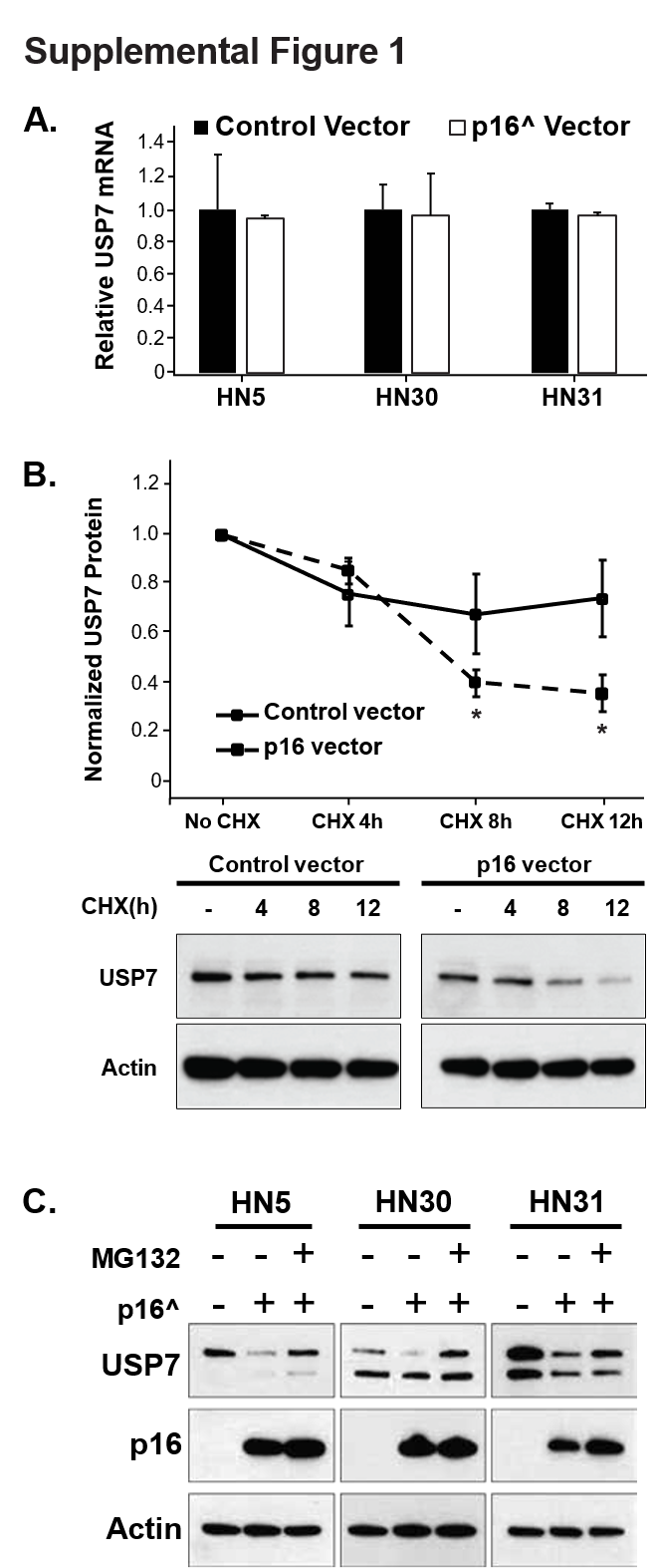
Supplemental Figure 1. A) USP7 mRNA expression in cells expressing either control vector or p16. B) Cycloheximide chase experiment in HN30 cells expressing control vector or p16. C) MG132 rescue experiment in several HPV(-)/p16(-) cell types (HN5, HN30 and HN31) expressing control vector or p16. * - p<0.05 versus control.
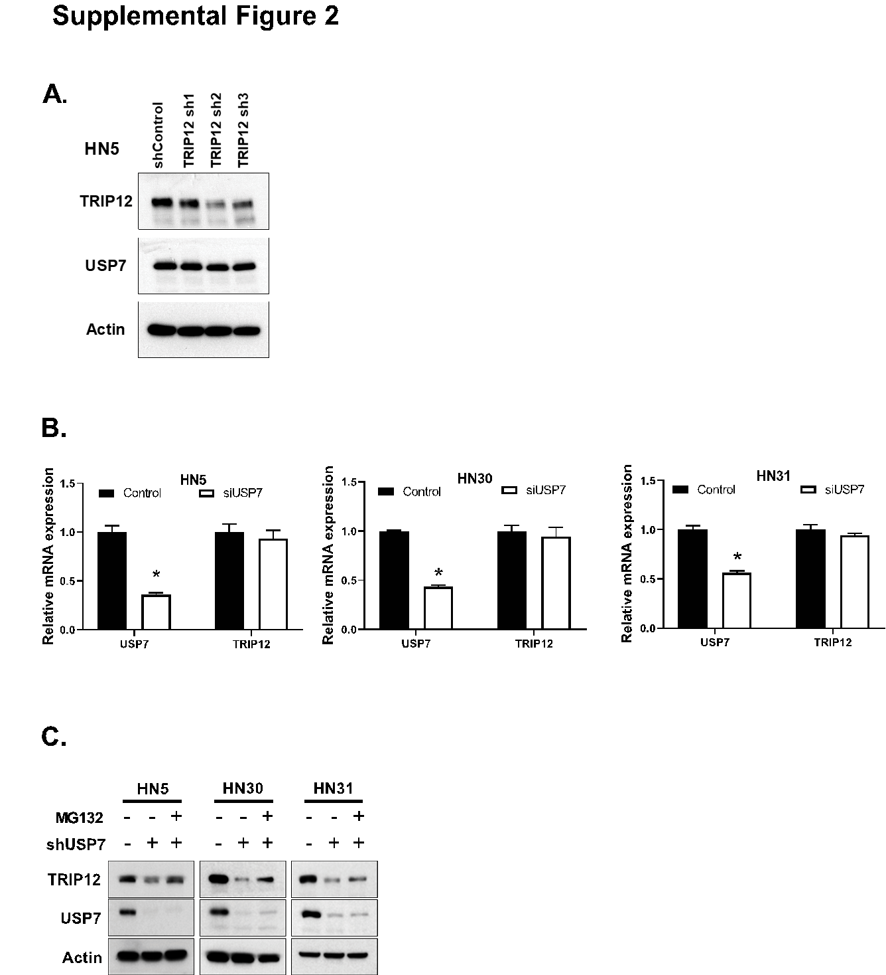Supplemental Figure 2. A) Immunoblot in HN5 cells expressing control or shRNA to TRIP12. B) TRIP12 mRNA expression in cells expressing either mock or USP7 siRNA. C) MG132 rescue experiment in several HPV(-)/p16(-) cell types (HN5, HN30 and HN31) expressing control or shUSP7. * - p<0.05 versus control.
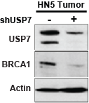
Supplemental Figure 3. Immunoblot of pooled tumors from in vivo experiment in Figure 4I.

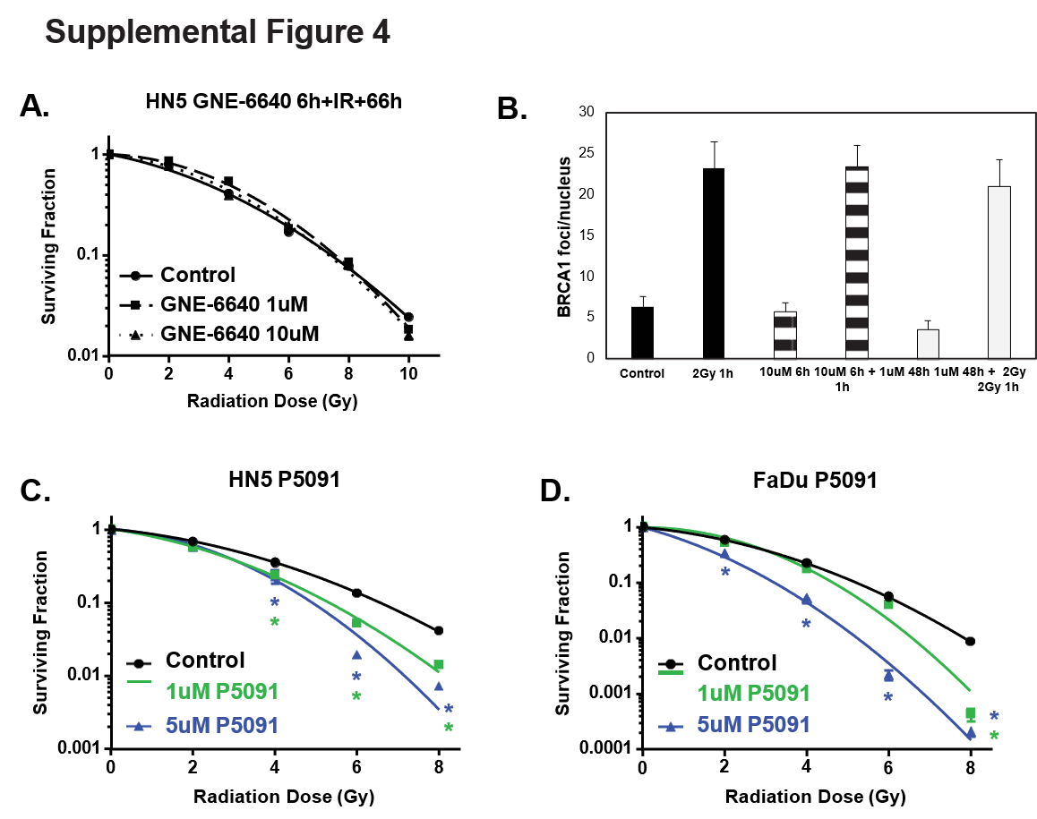Supplemental Figure 4. A) Clonogenic survival assay in HN5 cells treated with GNE-6640 for 6h before and 66h after irradiation. B) BRCA1 foci formation in HN5 cells treated with GNE-6640. C-D) Clonogenic survival assay in HN5 cells (C) or FaDu cells (D) treated with P5091.

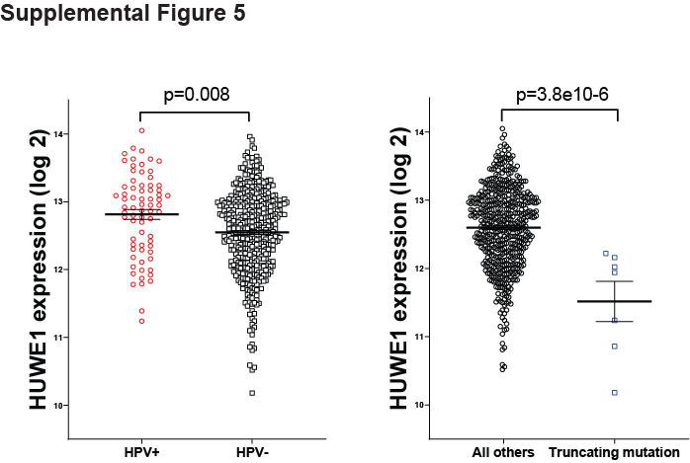
Supplemental Figure 5. Expression of HUWE1 in TCGA head and neck cohort stratified by HPV status or HUWE1 mutation. P-values are two-sided and determined via students t-test.

