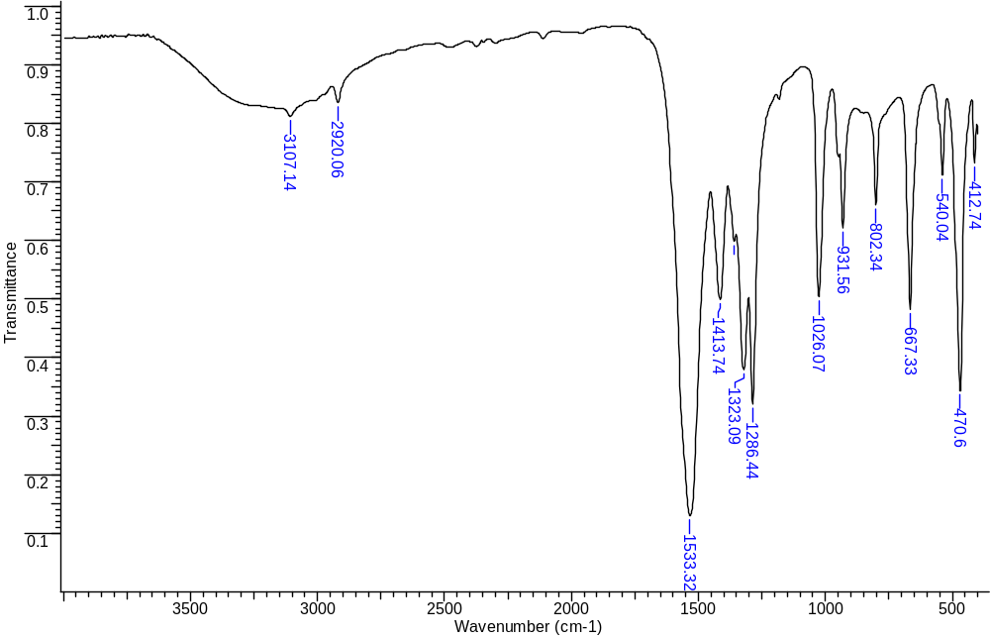
Fig. 1 FT-IR spectra of initial complex 1

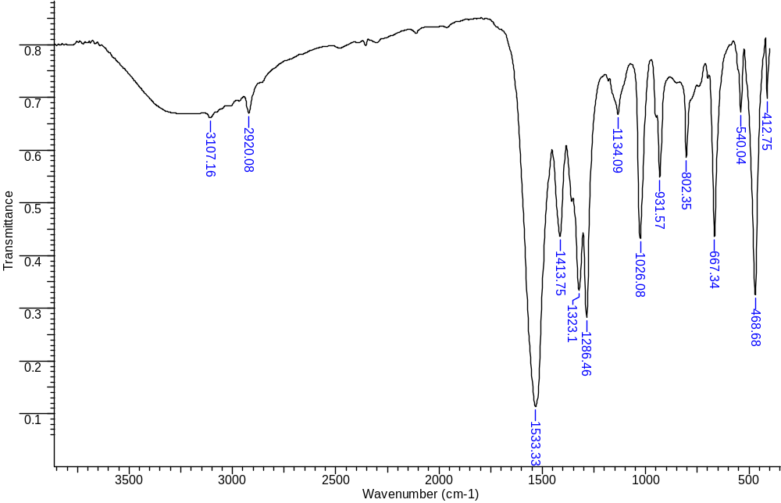
Fig. 2 FT-IR spectra of insoluble fraction 1.2

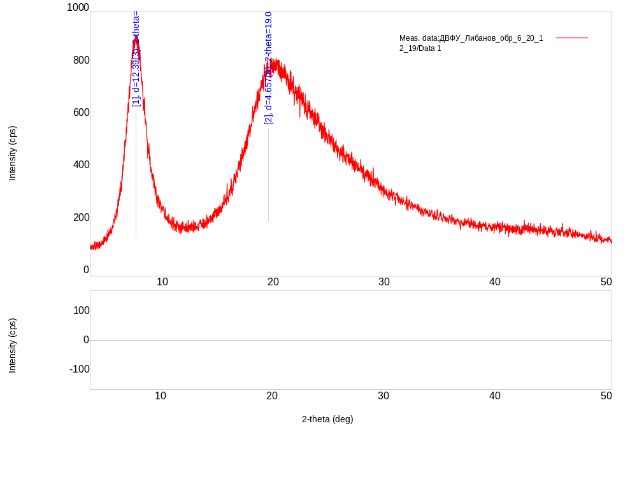Fig. 3 Diffraction pattern of fraction 2.1

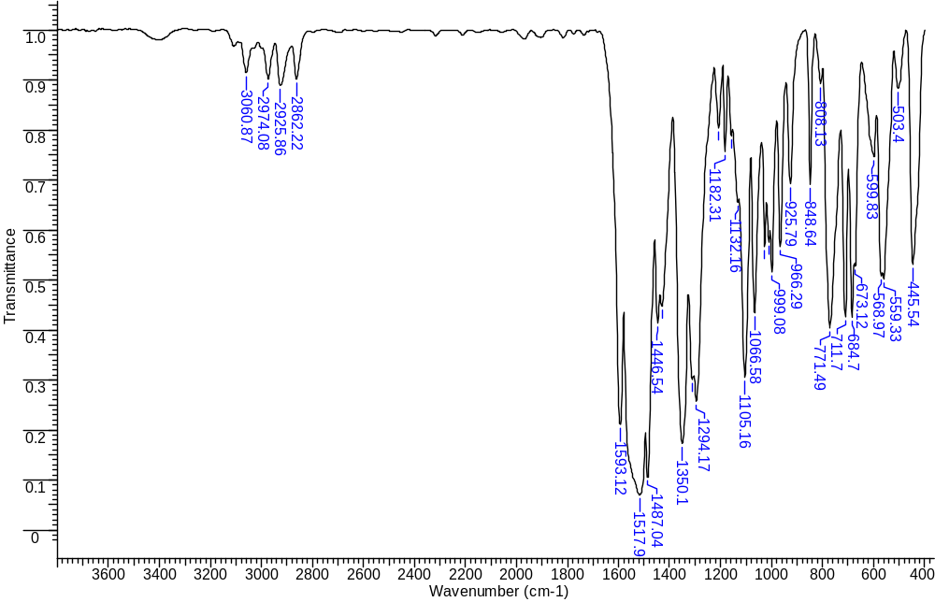
Fig. 4 FT-IR spectra of fraction 2.2

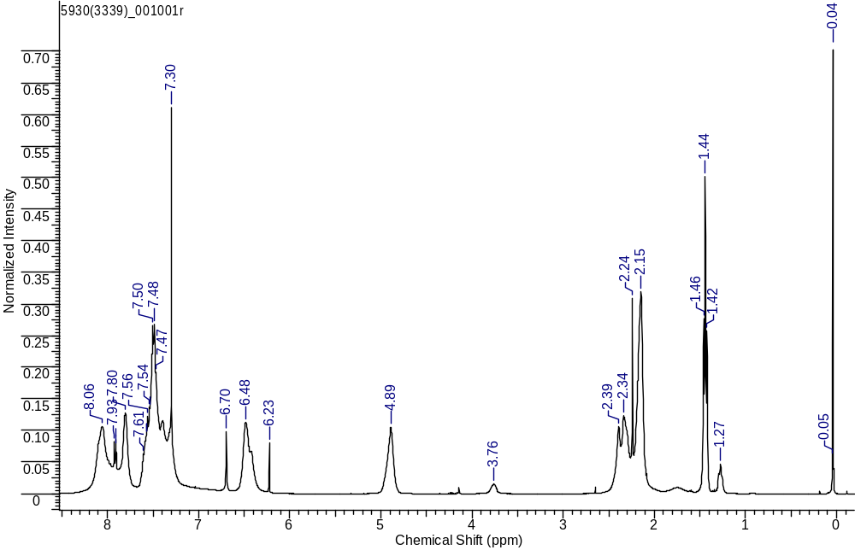
Fig. 5 ¹H NMR spectra of fraction 2.2

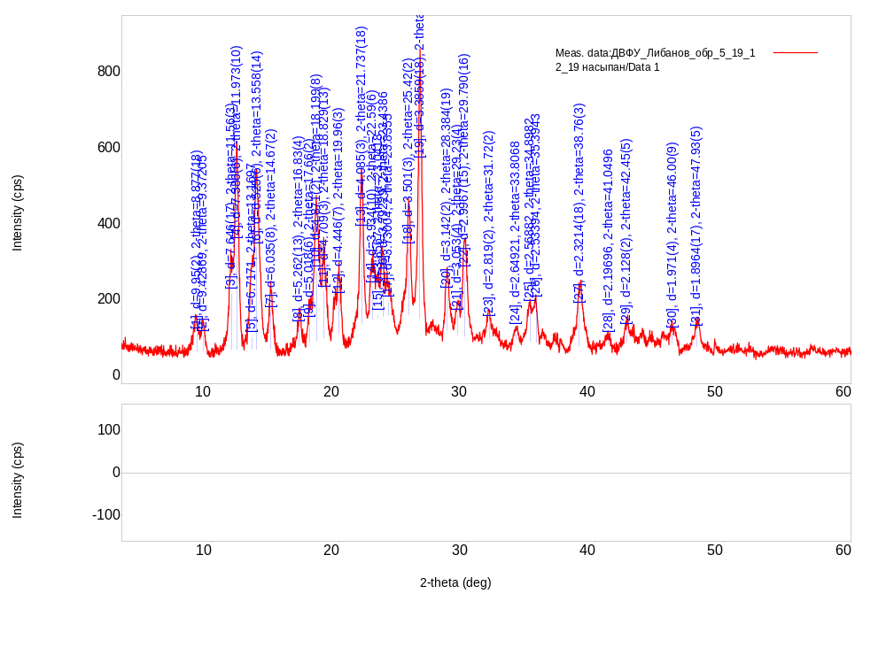
Fig. 6 Diffraction pattern of fraction 2.3

Table 1 Data of X-ray phase analysis of fractions 2.3
No. | 2-theta(deg) | d (A) | Height(cps) | Int. I(cps deg) | FWHM(deg) | Size
1 | 8.877(18) | 9.95(2) | 48(6) | 45(3) | 0.85(5) | 98(6)
2 | 9.37205 | 9.42869 | 41.1751 | 19.7154 | 0.448763 | 185.51
3 | 11.56(3) | 7.646(17) | 149(11) | 100(10) | 0.62(7) | 134(15)
4 | 11.973(10) | 7.386(6) | 281(15) | 91(11) | 0.300(15) | 278(14)
5 | 13.1697 | 6.7171 | 33.6237 | 16.1516 | 0.448763 | 186.117
6 | 13.558(14) | 6.525(6) | 267(15) | 203(4) | 0.697(14) | 120(2)
7 | 14.67(2) | 6.035(8) | 98(9) | 41(2) | 0.39(2) | 215(12)
8 | 16.83(4) | 5.262(13) | 51(7) | 18(2) | 0.32(4) | 262(34)
9 | 17.66(2) | 5.018(6) | 56(7) | 27(27) | 0.46(5) | 184(20)
10 | 18.199(8) | 4.871(2) | 184(12) | 64(13) | 0.327(17) | 257(13)
11 | 18.829(13) | 4.709(3) | 125(10) | 92(5) | 0.69(4) | 121(6)
12 | 19.96(3) | 4.446(7) | 93(9) | 45(3) | 0.45(3) | 188(14)
13 | 21.737(18) | 4.085(3) | 246(14) | 83(3) | 0.316(14) | 267(12)
14 | 22.59(6) | 3.934(10) | 87(9) | 101(5) | 1.08(6) | 78(5)
15 | 23.0418 | 3.8567 | 8.8975 | 3.77033 | 0.389152 | 217.595
16 | 23.4386 | 3.79229 | 97.868 | 41.5046 | 0.389152 | 217.75
17 | 23.8355 | 3.73004 | 36.2577 | 15.3888 | 0.389152 | 217.908
18 | 25.42(2) | 3.501(3) | 177(12) | 65(3) | 0.34(2) | 248(16)
19 | 26.299(14) | 3.3859(18) | 412(19) | 147(5) | 0.336(11) | 254(8)
20 | 28.384(19) | 3.142(2) | 101(9) | 37.6(16) | 0.335(18) | 255(14)
21 | 29.23(4) | 3.053(4) | 54(7) | 22(4) | 0.37(7) | 235(44)
22 | 29.790(16) | 2.9967(15) | 172(12) | 71(4) | 0.38(2) | 228(12)
23 | 31.72(2) | 2.819(2) | 47(6) | 19(2) | 0.31(3) | 278(31)
24 | 33.8068 | 2.64921 | 27.7558 | 12.0753 | 0.389152 | 222.839
25 | 34.8982 | 2.56882 | 92.6817 | 40.4522 | 0.389152 | 223.496
26 | 35.3943 | 2.53394 | 107.868 | 47.1514 | 0.389152 | 223.802
27 | 38.76(3) | 2.3214(18) | 104(9) | 67(3) | 0.55(3) | 161(8)
28 | 41.0496 | 2.19696 | 18.4261 | 8.206 | 0.389152 | 227.663
29 | 42.45(5) | 2.128(2) | 35(5) | 23(3) | 0.40(7) | 221(36)
30 | 46.00(9) | 1.971(4) | 29(5) | 18(2) | 0.43(10) | 211(48)
31 | 47.93(5) | 1.8964(17) | 42(6) | 21(2) | 0.46(4) | 196(15)

Ref.Code | Score | Compound Name | Scale Fac. | Chem. Formula
00-021-1932 | 73 | Titanium dichloro bis(1-phenyl-1,3-butanedione) | 0.406 | C20H18Cl2O4Ti
01-083-1949 | 40 | Silicon Oxide | 0.192 | SiO2

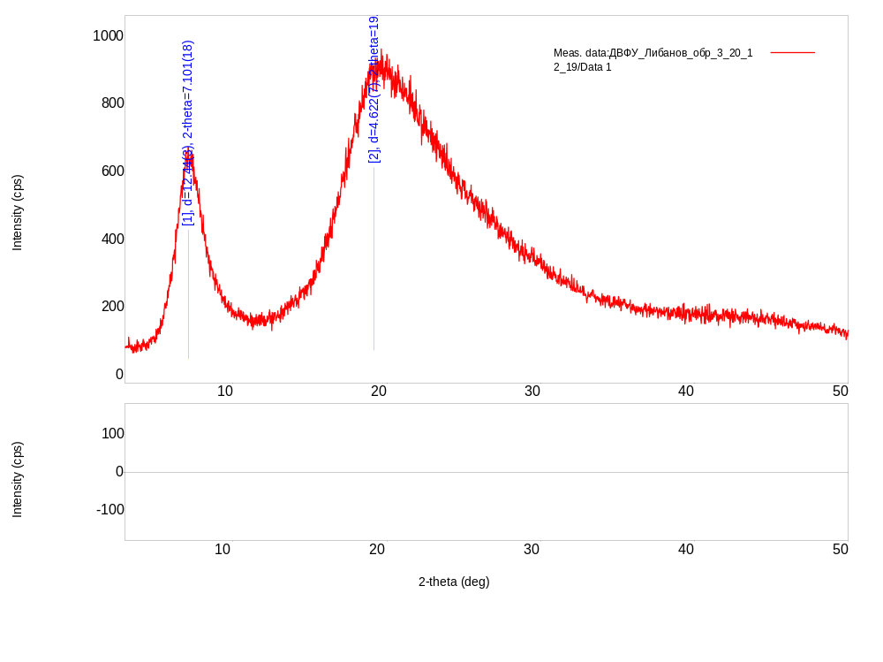
Fig. 7 Diffraction pattern of fraction 3.1

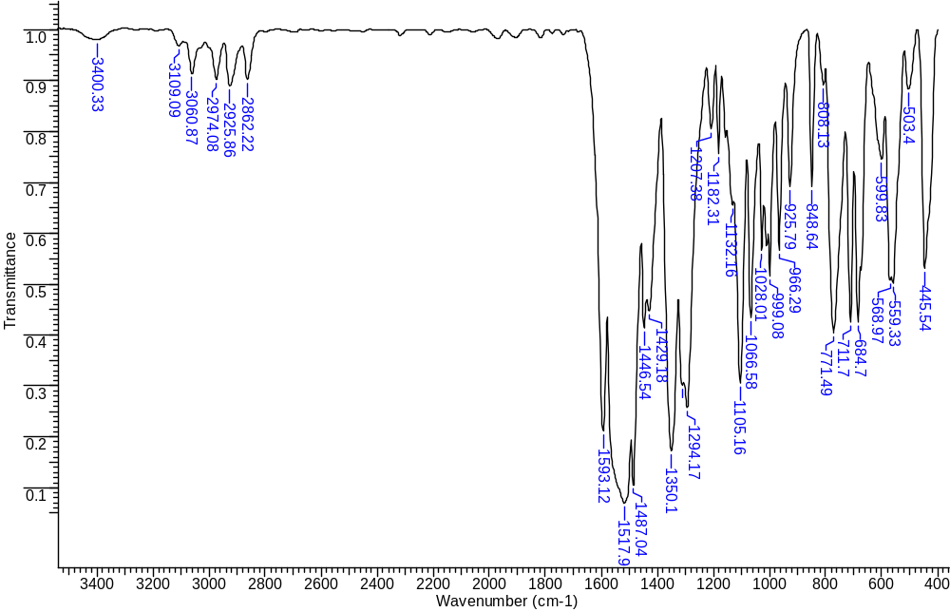
Fig. 8 FT-IR spectra of fraction 3.2

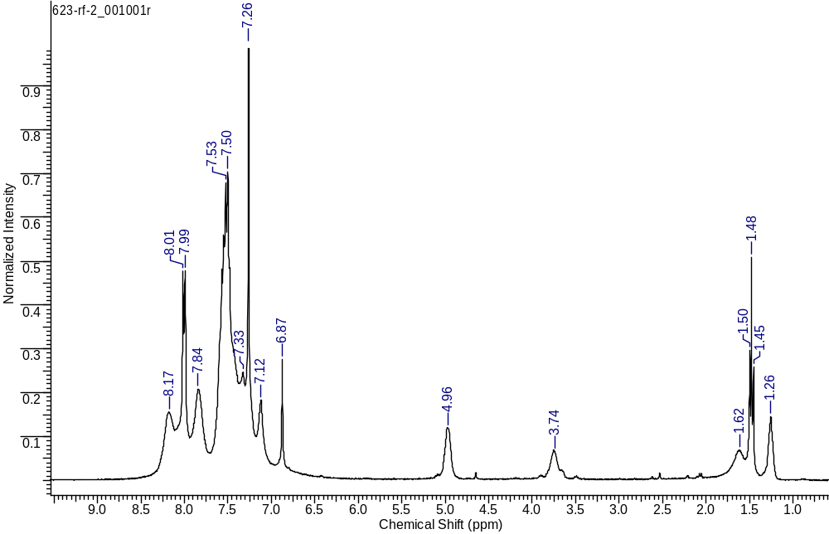
Fig. 9 ¹H NMR spectra of fraction 3.2

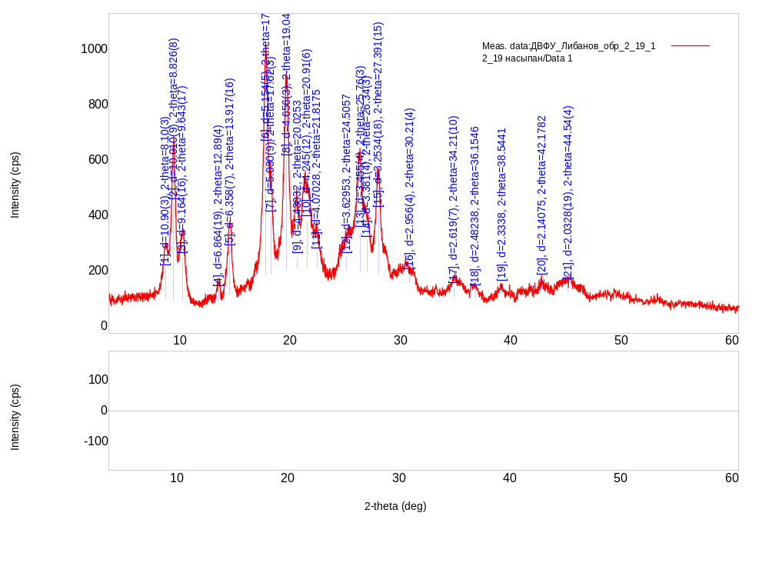
Fig. 10 Diffraction pattern of fraction 3.3

Table 2 Data of X-ray phase analysis of fractions 3.3
No. | 2-theta(deg) | d (A) | Height(cps) | Int. I(cps deg) | FWHM(deg) | Size
1 | 8.10(3) | 10.90(3) | 107(9) | 77(7) | 0.57(5) | 145(12)
2 | 8.826(8) | 10.010(9) | 351(17) | 181(7) | 0.407(13) | 204(7)
3 | 9.643(17) | 9.164(16) | 161(12) | 134(5) | 0.65(3) | 127(5)
4 | 12.89(4) | 6.864(19) | 38(6) | 13.2(14) | 0.31(4) | 272(33)
5 | 13.917(16) | 6.358(7) | 165(12) | 88(3) | 0.468(14) | 179(5)
6 | 17.191(17) | 5.154(5) | 474(20) | 242(42) | 0.43(3) | 197(14)
7 | 17.62(3) | 5.030(9) | 211(13) | 128(40) | 0.51(15) | 165(49)
8 | 19.047(14) | 4.656(3) | 399(18) | 200(6) | 0.443(12) | 190(5)
9 | 20.0253 | 4.43032 | 42.54 | 28.6293 | 0.57384 | 146.827
10 | 20.91(6) | 4.245(12) | 172(12) | 465(11) | 2.27(8) | 37.2(13)
11 | 21.8175 | 4.07028 | 55.5505 | 37.4265 | 0.57384 | 147.251
12 | 24.5057 | 3.62953 | 47.3043 | 31.9294 | 0.57384 | 147.961
13 | 25.76(3) | 3.455(4) | 145(11) | 136(41) | 0.75(4) | 114(6)
14 | 26.34(3) | 3.381(4) | 114(10) | 257(8) | 1.79(8) | 48(2)
15 | 27.391(15) | 3.2534(18) | 229(14) | 141(5) | 0.427(19) | 200(9)
16 | 30.21(4) | 2.956(4) | 36(5) | 40(4) | 0.90(11) | 95(11)
17 | 34.21(10) | 2.619(7) | 35(5) | 70(5) | 1.88(10) | 46(2)
18 | 36.1546 | 2.48238 | 27.907 | 25.3372 | 0.746503 | 116.918
19 | 38.5441 | 2.3338 | 34.3265 | 31.212 | 0.746503 | 117.745
20 | 42.1782 | 2.14075 | 40.4357 | 36.8586 | 0.746503 | 119.126
21 | 44.54(4) | 2.0328(19) | 28(5) | 51(5) | 1.48(13) | 61(5)

Ref.Code | Score | Compound Name | Scale Fac. | Chem. Formula
00-038-0197 | 64 | Silicon Oxide | 0.277 | SiO2
00-021-1931 | 49 | Titanium dichloro (1,3-diphenyl-1,3-propandione) | 0.271 | C30H22Cl2O4Ti

