Supplementary Materials
for

Cell chirality reversal through tilted balance between polymerization of radial fibers and clockwise-swirling of transverse arc

Hoi Kwan Kwong¹, Wengang Liu¹, Siying Wu¹, Cho Fan Chung¹, Lok Ting Chu¹, Hiu Lam Chow¹, Hogi Hartanto¹, Jiachen Wang¹, Miu Ling Lam² and Ting-Hsuan Chen¹*

¹Department of Biomedical Engineering, City University of Hong Kong, 83 Tat Chee Avenue, Hong Kong Special Administrative Region, China
²School of Creative Media, City University of Hong Kong, 18 Tat Hong Avenue, Hong Kong Special Administrative Region, China

*Corresponding author. Email: thchen@cityu.edu.hk

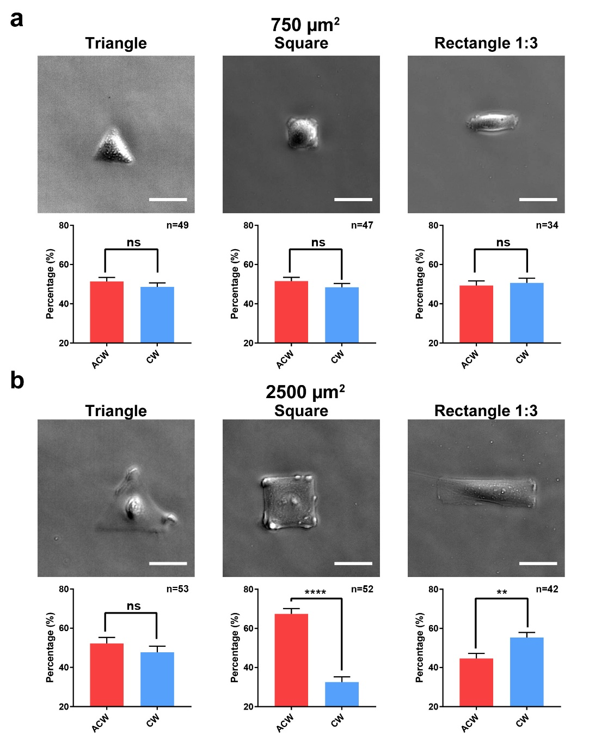

Supplementary Figure 1. Nucleus rotation on micro-islands with varied areas and shapes. a-b Phase contrast images of cells and the probability of ACW/CW rotation with areas of 750 μm² (a) and 2500 μm² (b). Data present the mean + SEM. Two-sample equal variance two-tailed t-test was used. Scale bar, 20 μm.

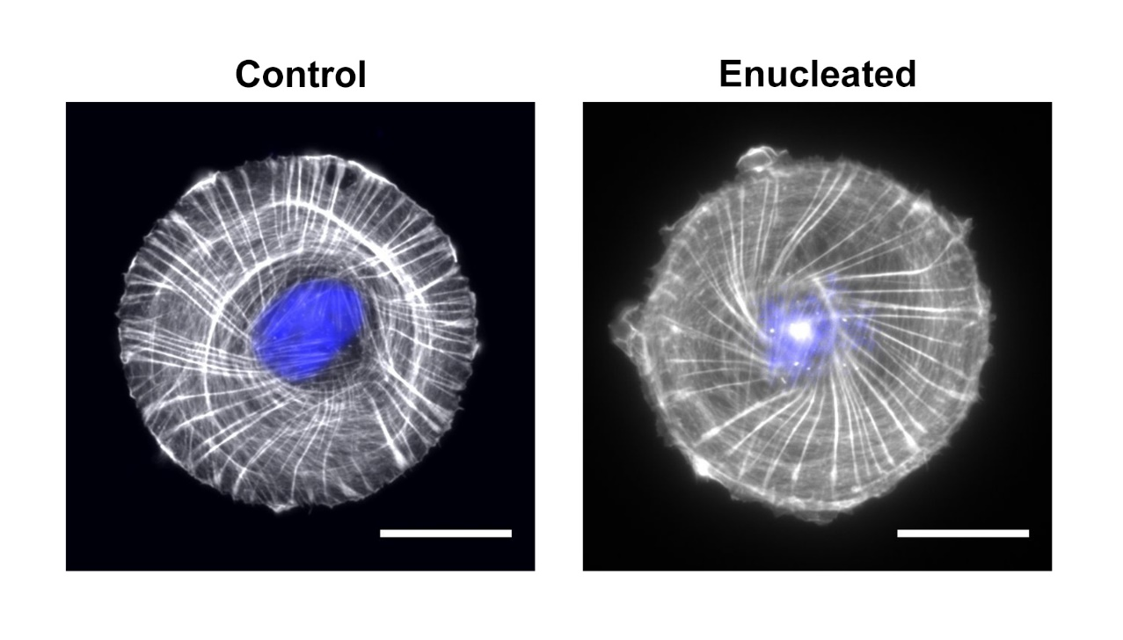

Supplementary Figure 2. Immunofluorescent image of actin distribution of untreated control and enucleated cell on micro-island with area of 2500 μm². Scale bar, 20 μm.

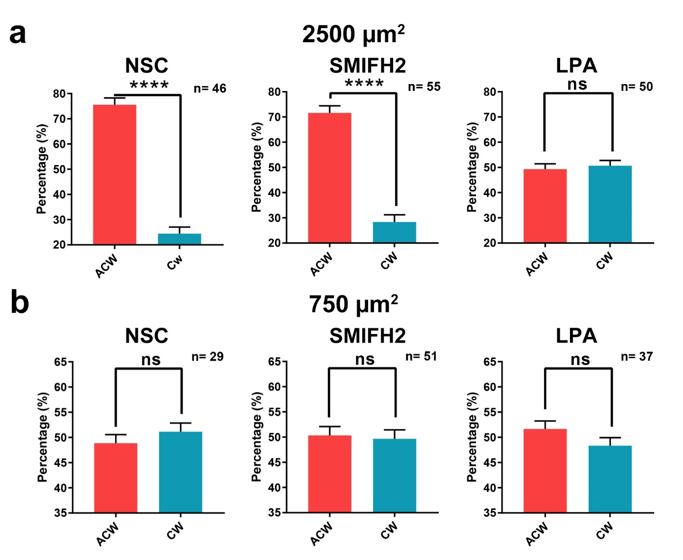

Supplementary Figure 3. Rotational bias of cell nucleus with actin-related inhibitors on HFF-1. Probability of ACW/CW rotation on a 2500 μm² and b 750 μm² micro-islands with cytoskeleton inhibitor, NSC (left), SIMFH2 (middle) and LPA (right). Data present the mean + SEM. Two-sample equal variance two-tailed t-test was used.
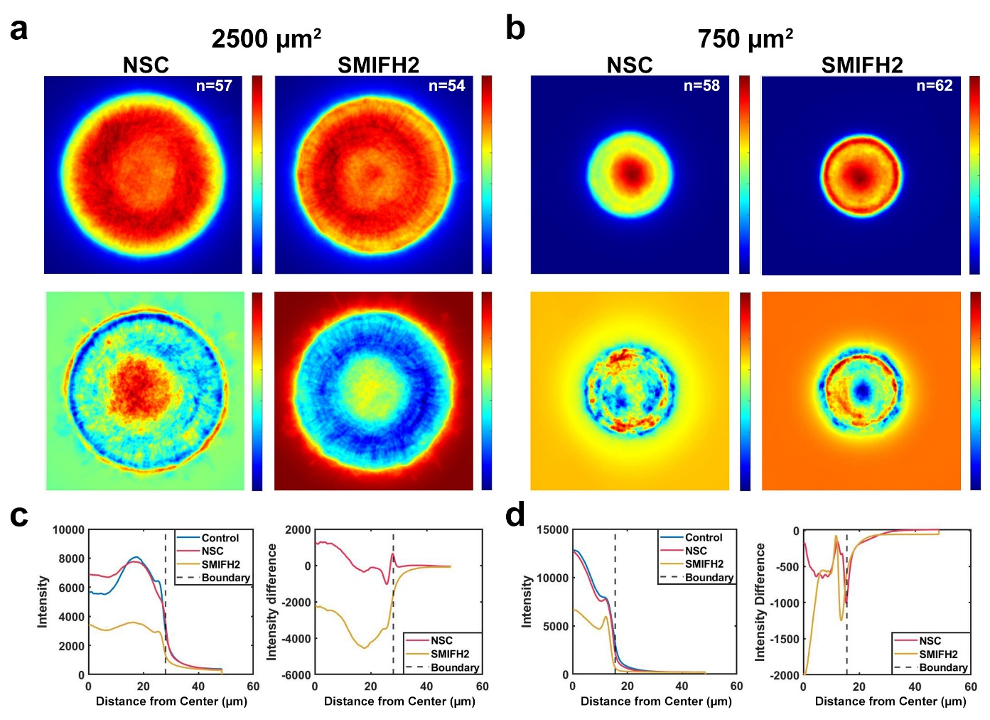

Supplementary Figure 4. Actin distribution with actin-related inhibitors on HFF-1. a-b Stacked image of actin showing heatmap distribution (upper) and intensity difference (lower) of actin comparing cells treated with NSC and SMIFH2 to untreated control on a 2500 µm² and b 750 µm² island. c-d Curves of actin intensity from cell center to boundary (left) and differential actin intensity (right) comparing cells treated with NSC and SMIFH2 to untreated control on 2500 µm² (c) and 750 µm² (d) island.

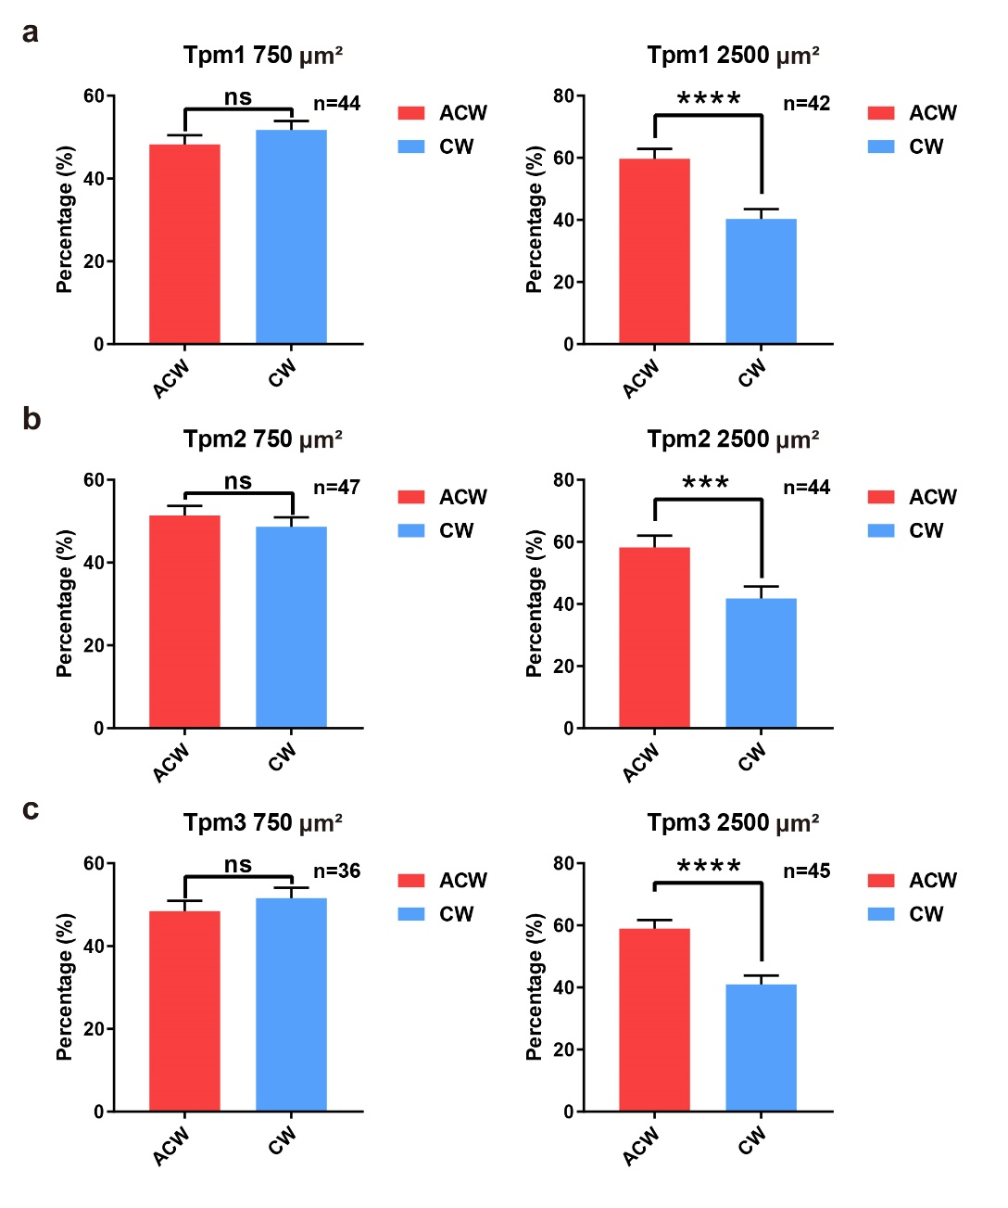
Supplementary Figure 5. Nucleus rotation with different tropomyosin siRNA transfection. a-c Probability of nucleus rotational bias on small (left) and large pattern (right) with tropomyosin isoform, Tpm1 (a), Tpm2 (b) and Tpm3 (c). Data present the mean + SEM. Two-sample equal variance two-tailed t-test was used.

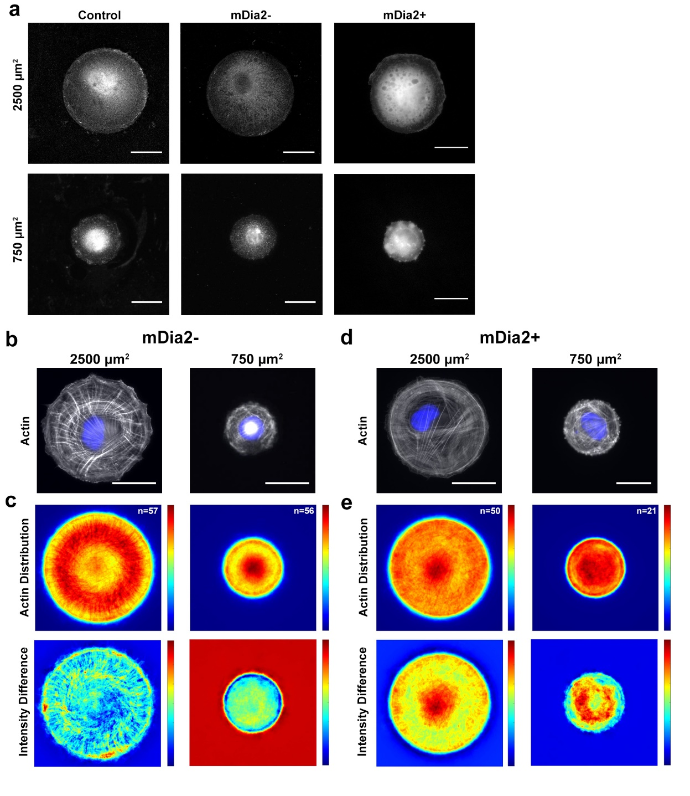

Supplementary Figure 6. Fluorescent images of mDia2 staining and actin distribution of mDia2 depletion or overexpression. a Fluorescence image of mDia2 distribution of in untreated control (left) and mDia2 silencing (middle), and overexpression of mDia2-GFP (right) on 2500 μm² (upper) and 750 μm² (lower). b Fluorescent staining of F-actin (white) by phalloidin and DAPI-stained nucleus (blue) of cells with mDia2 silencing on large (left) or small (right) pattern. c Stacked image of Supplementary Fig. 6b showing heatmap distribution of actin (upper) and differential actin intensity (lower) comparing mDia2 silencing treatment to untreated control on 2500 μm² (left) and 750 μm² (right). d Fluorescent staining of F-actin (white) by phalloidin and DAPI-stained nucleus (blue) of cells with mDia2 overexpressing on large (left) or small (right) pattern. c Stacked image of Supplementary Fig. 6d showing heatmap distribution of actin (upper) and differential actin intensity (lower) comparing mDia2 overexpressing treatment to untreated control on 2500 μm² (left) and 750 μm² (right). Scale bar, 20 μm.

Supplementary Table 1. siRNA sequence.
Gene | Part Number | ID | Sense | Antisense
mDia2 | AM16708 | 131029 | GCUACAAGCUUUUAAGUCUtt | AGACUUAAAAGCUUGUAGCtc
Tpm1 | AM51331 | 118354 | CGAUAUGACUUCCAUGUAAtt | UUACAUGGAAGUCAUAUCGtt
Tpm2 | AM51331 | 13058 | GGUGGAAAAGUAUUCUGAAtt | UUCAGAAUACUUUUCCACCtc
Tpm3 | AM16708 | 182242 | GGCCGAUAGGAAGUAUGAAtt | UUCAUACUUCCUAUCGGCCtc
Tpm4 | AM16708 | 118377 | GCAUACUUUCUUAAGACGGtt | CCGUCUUAAGAAAGUAUGCtt

Legend for Supplementary Movies

Movie S1. HFF-1 fibroblasts plated on cell culture dish with H33342 staining, showing the spreading and nucleus movement during the attachment. Time interval: 5 min; Total duration: 240 min. Frame rate of video, 15 fps.

Movie S2. HFF-1 fibroblasts transfected with Lifeact-mRuby on 2500 μm² showing rightward tilting of growing radial fibers which eventually drives an overall ACW rotation of entire cytoskeleton around cell nucleus. The images were acquired by 60X oil lens in Nikon Eclipse Ti2-E microscope with laser spinning disk confocal illuminator. Time interval: 1 min; Total duration, 90 min; Frame rate of final video, 15 fps.

Movie S3. HFF-1 fibroblasts transfected with Lifeact-GFP for actin and stained with H33342 to visualize the nucleus on 2500 μm² demonstrates that radial fibers could anchor on nucleus and promote ACW rotation of nucleus. The images were acquired by 40X oil lens in Nikon Eclipse Ti-E microscope with fluorescent light illuminator. Time interval: 3 min; Total duration, 200 min; Frame rate of final video, 15 fps.

Movie S4. Animation showing that incorporation of new actin monomer to the right-handed double helix would cause right-handed axial spinning as the barbed ends of actin filament is capped and tethered by formin.

Movie S5. HFF-1 fibroblasts transfected with Lifeact-mRuby for actin and stained with H33342 to visualize the nucleus on 750 μm² demonstrates the retrograde flow of transverse arc without apparent radial fibers. The images were acquired by 60X oil lens in Nikon Eclipse Ti2-E microscope with laser spinning disk confocal illuminator. To visualize layers of actin, the maximum intensity projection in Nikon Element was used after taking Z-stack images with step-size of 0.8 μm for total height of 3.5 μm. Time interval: 2 min; Total duration, 240 min; Frame rate of final video, 15 fps.

Movie S6. LatA treated HFF-1 fibroblasts transfected with Lifeact-mRuby for actin and stained with H33342 to visualize the nucleus on 2500 μm² demonstrates a CW swirling of transverse arc that approaches to the nucleus during the retrograde flow, eventually causing a CW rotational wrapping around the nucleus. The images were acquired by Nikon Eclipse Ti2-E microscope with laser spinning disk confocal illuminator with time interval of 1 min and total duration of 36 min. Frame rate of final video, 10 fps.

Movie S7. LatA treated HFF-1 fibroblasts transfected with Lifeact-GFP actin and stained with H33342 to visualize the nucleus on 2500 μm² shows a CW-bias of nucleus rotation occurs with this CW-bias swirling wrapping of transverse arc without distinct radial fibers. The images were acquired by Nikon Eclipse Ti-E microscope with fluorescent light illuminator with time interval of 3 min and total duration of 200 min. Frame rate of final video, 15 fps.

Movie S8. Animation showing how the myosin as left-handed motor glides on a double helix actin structure with a stepwise walking toward the barbed end of actin filament

Movie S9. Animation showing that when myosin II is tethered in connection between radial fibers and myosin-rich transverse arc, the original lefthanded, stepwise walking of myosin II could plausibly cause a lefthanded twirling, or axial spinning of radial fibers growing inward.

