Supporting information

Fig. S1 The sequences of wheat DREB genes. (a), (b) and (c) represent the nucleotide sequence and amino acid sequence of DREB2, DREB6 and Wdreb2, respectively. The box and underline denote nuclear localization signal and AP2/EREBP domain, respectively.
Fig. S2 Multiple alignment of wheat DREBs and its homologous sequences. (a), (b) and (c) are the alignment on some homologous sequences of wheat DREB2, DREB6 and Wdreb2, respectively. The underline denotes the AP2/EREBP domain.
Fig. S3 Prediction of CpG islands in the promoter regions of wheat DREB genes. (a), (b) and (c) represent the location of putative CpG islands in the promoter regions of DREB2, DREB6 and Wdreb2, respectively. The CpG island regions between two arrows below each diagram were examined using BSP, respectively.
Table S1 The cis-acting elements in the promoter of DREB2
Table S2 The cis-acting elements in the promoter of DREB6
Table S3 The cis-acting elements in the promoter of Wdreb2
Table S4 Correlation between promoter methylation and expression of DREB genes
Pearson’s r represents the relationship between expression levels of DREB2, DREB6, Wdreb2 in wheat leaves and methylation rates at CG, CHG or CHH sites in their promoter regions under the treatment of 15% PEG₆₀₀₀ solution. According to the expression level and methylation rate when wheat seedlings incubated in PEG₆₀₀₀ solution for 0 h, 2 h and 12 h, Pearson’s r analysis of DREB6 and Wdreb2 were performed, or were obtained for DREB2 after wheat seedlings stressed for 0 h, 2 h and10 h, respectively.
Table S5 Primers used in this study

(a) 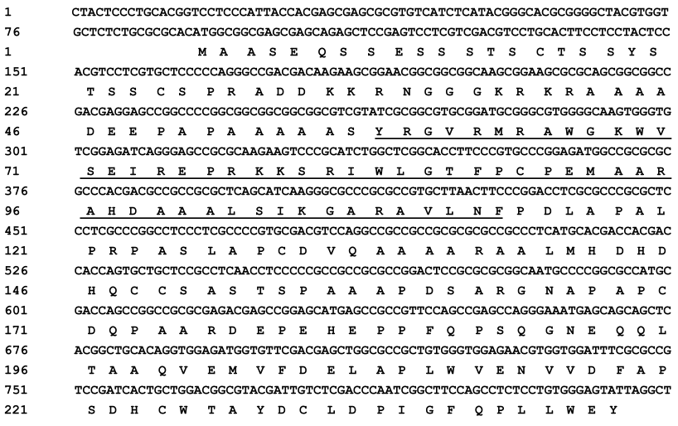
(b) 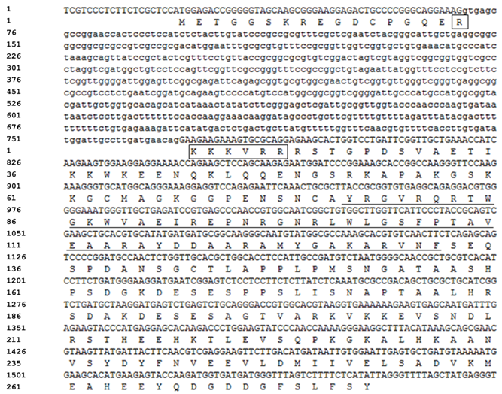

(c) 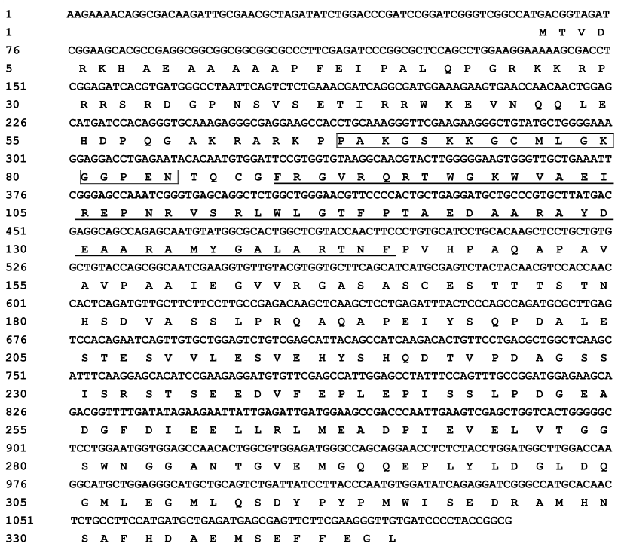

Fig. S1 The sequences of wheat DREB genes. (a), (b) and (c) represent the nucleotide sequence and amino acid sequence of DREB2, DREB6 and Wdreb2, respectively. The box and underline denote nuclear localization signal and AP2/EREBP domain, respectively.

(a) 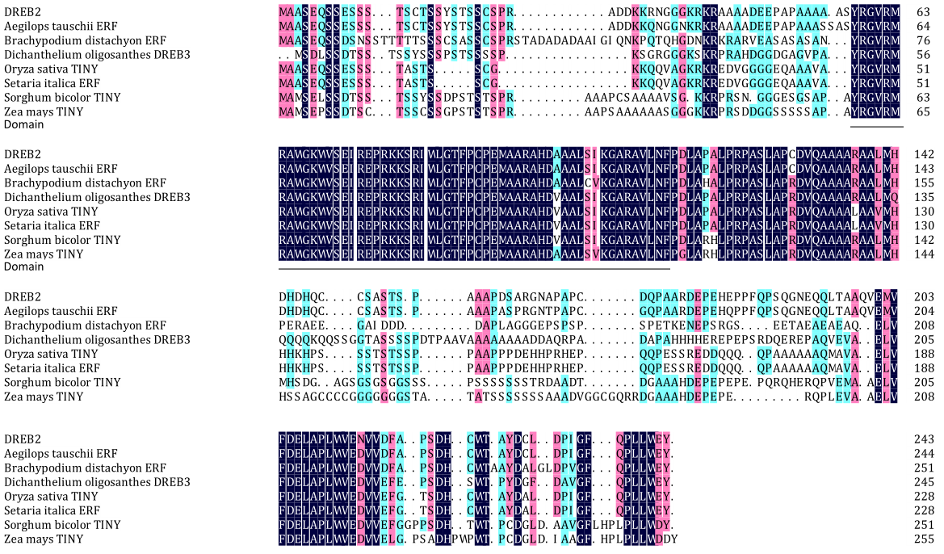
(b) 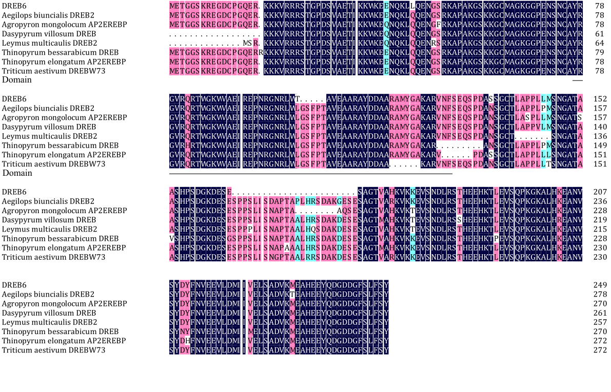

(c) 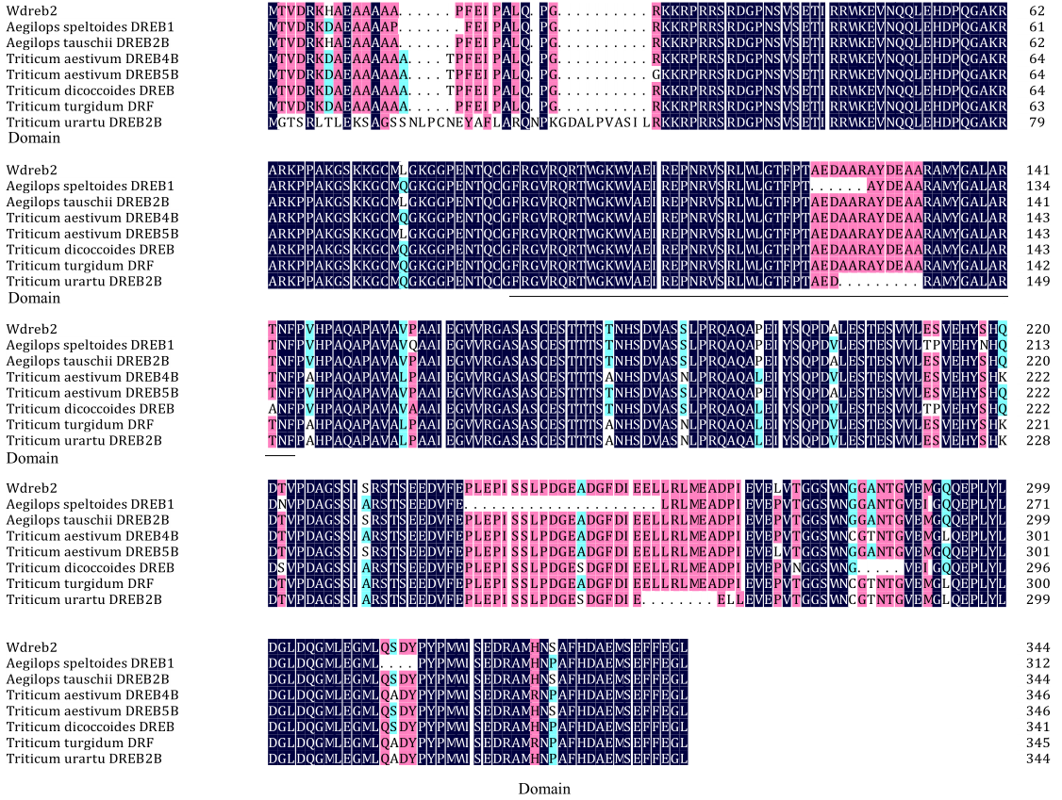
Fig. S2 Multiple alignment of wheat DREBs and its homologous sequences. (a), (b) and (c) are the alignment on some homologous sequences of wheat DREB2, DREB6 and Wdreb2, respectively. The underline denotes the AP2/EREBP domain.

(a) 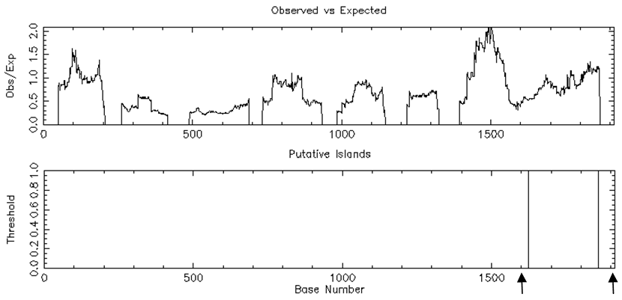
(b) 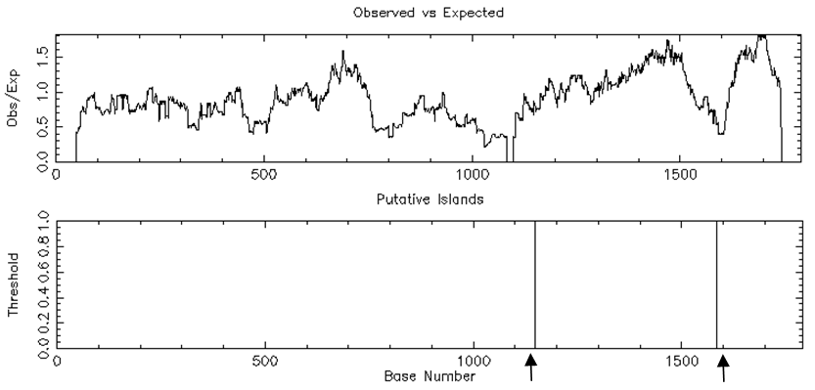
(c) 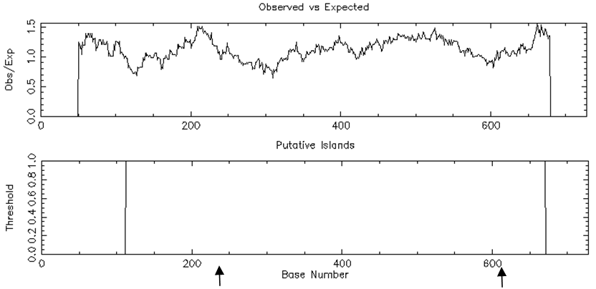
Fig. S3 Prediction of CpG islands in the promoter regions of wheat DREB genes. (a), (b) and (c) represent the location of putative CpG islands in the promoter regions of DREB2, DREB6 and Wdreb2, respectively. The CpG island regions between two arrows below each diagram were examined using BSP, respectively.

Table S1 The cis-acting elements in the promoter of DREB2
Element | Sequence | Function | Number
TATA-box | TATAWAW | Core promoter element around -30 of transcription start | 13
CAAT-box | CAAT | Common cis-acting element in promoter and enhancer regions | 34
ABRE | CGTACGTGCA | Cis-acting element involved in the abscisic acid responsiveness | 5
ACE | AAAACGTTTA | Cis-acting element involved in light responsiveness | 1
ARE | TGGTTT | Cis-acting regulatory element essential for the anaerobic induction | 3
MBS | CAACTG | MYB binding site involved in drought-inducibility | 2
LTR | CCGAAA | Cis-acting element involved in low-temperature responsiveness | 1
G-box | (T/C)ACGT(C/G/T) | Cis-acting regulatory element involved in light responsiveness | 6
C-repeat/DRE | TGGCCGAC | Regulatory element involved in cold- and dehydration-responsiveness | 1
EIER | TTCGACC | Elicitor responsive element | 1
TGACG-motif | TGACG | Cis-acting regulatory element involved in the MeJA-responsiveness | 1
Skn-1-motif | GTCAT | Cis-acting regulatory element required for endosperm expression | 1
SP1 | CC(G/A)CCC | Light responsive element | 4
GARE-motif | TCTGTTG | Gibberellin responsive element | 1
TCA-element | TCAGAAGAGG | Cis-acting element involved in salicylic acid responsiveness | 2
TGA-element | AACGAC | Auxin responsive element | 1
OCT | CGCGGATC | Cis-acting regulatory element related to meristem specific activation | 1
TATC-box | TATCCCA | Cis-acting element involved in gibberellins responsiveness | 1
Circadian | CAANNNNATC | Cis-acting regulatory element involved in circadian control | 1
MNF | GTGCCC(A/T) | Light responsive element | 1
HD-Zip | CAAT(A/T)ATTG | Element involved in differentiation of the palisade mesophyll cells | 1
GT1-motif | GGTTAAT | Light responsive element | 2
GC-motif | CCCCCG | Enhancer-like element involved in anoxic specific inducibility | 2
TATC-box | TATCCCA | Cis-acting element involved in gibberellins responsiveness | 1
P-box | CCTTTTG | Gibberellins responsive element | 1

Table S2 The cis-acting elements in the promoter of DREB6
Element | Sequence | Function | Number
TATA-box | TATAWAW | Core promoter element around -30 of transcription start | 10
CAAT-box | CAAT | Common cis-acting element in promoter and enhancer regions | 19
ABRE | CGTACGTGCA | Cis-acting element involved in the abscisic acid responsiveness | 10
ACE | AAAACGTTTA | Cis-acting element involved in light responsiveness | 2
ARE | TGGTTT1 | Cis-acting regulatory element essential for the anaerobic induction | 1
MBS | CAACTG | MYB binding site involved in drought-inducibility | 5
LTR | CCGAAA | Cis-acting element involved in low-temperature responsiveness | 1
AuxRR-core | GGTCCAT | Cis-acting regulatory element involved in auxin responsiveness | 1
TGA-element | AACGAC | Auxin responsive element | 1
TGACG-motif | TGACG | Cis-acting regulatory element involved in the MeJA-responsiveness | 4
CGTCA-motif | CGTCA | Cis-acting regulatory element involved in the MeJA-responsiveness | 3
CAT-box | GCCACT | Cis-acting regulatory element related to meristem expression | 2
G-box | (C/T)ACG(T/A)G | Cis-acting regulatory element involved in light responsiveness | 11
MBSI | aaAaaC(G/C)GTTA | MYB binding site involved in flavonoid biosynthetic genes regulation | 1
A-box | CCGTCC | Cis-acting regulatory element | 2
GARE-motif | AAACAGA | Gibberellin responsive element | 2
P-box | CCTTTTG | Gibberellin responsive element | 1
Circadian | CAANNNNATC | Cis-acting regulatory element involved in circadian control | 1
DRE/CRT | RCCGAC | Drought, high salt and cold-responsive element | 1
ERE | ATTTCAAA | Ethylene-responsive element | 1
SP1 | GGGCGG | Light responsive element | 6
Box I | TTTCAAA | Light responsive element | 1
GC-motif | CCCCCG | Enhancer-like element involved in anoxic specific inducibility | 1
W-box | TTGACC | Fungal elicitor responsive element | 1

Table S3 The cis-acting elements in the promoter of Wdreb2
Element | Sequence | Function | Number
5UTRpy-rich stretch | TTTCTTCTCT | Cis-acting element conferring high transcription levels | 1
TATA-box | TATAWAW | Core promoter element around -30 of transcription start | 5
CAAT-box | CAAT | Common cis-acting element in promoter and enhancer regions | 4
CAT-box | GCCACT | Cis-acting regulatory element related to meristem expression | 1
ABRE | CGTACGTGCA | Cis-acting element involved in the abscisic acid responsiveness | 8
ACE | AAAACGTTTA | Cis-acting element involved in light responsiveness | 1
O2-site | GATGACATGG | Cis-acting regulatory element involved in zein metabolism | 1
C-repeat/DRE | TGGCCGAC | Regulatory element involved in cold and dehydration responsiveness | 1
C-box | CTGACGTCAG | Cis-acting regulatory element involved in light responsiveness | 1
CE3 | GACGCGTGTC | Cis-acting element involved in ABA and VP1 responsiveness | 1
G-box | CACGT(G/C/T) | Cis-acting regulatory element involved in light responsiveness | 7
MRE | AACCTAA | MYB binding site involved in light responsiveness | 1
LTR | CCGAAA | Cis-acting element involved in low-temperature responsiveness | 1
TGACG-motif | TGACG | Cis-acting regulatory element involved in the MeJA-responsiveness | 2
GARE-motif | TCTGTTG | Gibberellin responsive element | 1
SP1 | CCGCCC | Light responsive element | 2
as1 | TGACGTCA | Cis-acting regulatory element involved in the root specificexpression | 1
CGTCA-motif | CGTCA | Cis-acting regulatory element involved in the MeJA-responsiveness | 2

Table S4 Correlation between promoter methylation and expression of DREB genes
Gene  Methylation type | Pearson’s r
Gene  Methylation type | DREB2 | DREB6 | Wdreb2
CG | -0.952 | -0.981 | -0.986
CHG | -0.327 | -0.950 | -0.973
CHH | -0.509 | 0.656 | -0.878

Pearson’s r represents the relationship between expression levels of DREB2, DREB6, Wdreb2 in wheat leaves and methylation rates at CG, CHG or CHH sites in their promoter regions under the treatment of 15% PEG₆₀₀₀ solution. According to the expression level and methylation rate when wheat seedlings incubated in PEG₆₀₀₀ solution for 0 h, 2 h and 12 h, Pearson’s r analysis of DREB6 and Wdreb2 were performed, or were obtained for DREB2 after wheat seedlings stressed for 0 h, 2 h and10 h, respectively.

Table S5 Primers used in this study
Experiment | Primer | Sequence（5’ to 3’）
Gene cloning | DREB2-F | CTACTCCCTGCACGGTCCT  GCCAAGCCTAATACTCCCAC
Gene cloning | DREB2-R | CTACTCCCTGCACGGTCCT  GCCAAGCCTAATACTCCCAC
 | DREB6-F | CGTCCCTCTTCTCGCTCCA CTAATATGAGAAAAGACTAAACCC
 | DREB6-R | CGTCCCTCTTCTCGCTCCA CTAATATGAGAAAAGACTAAACCC
 | Wdreb2-F | AAGAAAACAGGCGACAAGAT  ACGAAGCACAAAAAACTAGC
 | Wdreb2-R | AAGAAAACAGGCGACAAGAT  ACGAAGCACAAAAAACTAGC
qRT-PCR | β-Actin-F | CCAAGGCGGAGTACGATGAGTCT  TTCATACAGCAGGCAAGCACCAT
qRT-PCR | β-Actin-R | CCAAGGCGGAGTACGATGAGTCT  TTCATACAGCAGGCAAGCACCAT
 | DREB2-F | GCGTACAACACCTTGATTTCC  AAACTCAACTCACATCTAAGC
 | DREB2-R | GCGTACAACACCTTGATTTCC  AAACTCAACTCACATCTAAGC
 | DREB6-F | CGGCTGTGGCTTGGTTCATTC  CAGTTGCCCCATTAGACATC
 | DREB6-R | CGGCTGTGGCTTGGTTCATTC  CAGTTGCCCCATTAGACATC
 | Wdreb2-F | AGATGTTGCTTCTTCCTTGCC  GATGTGCTCCTTGAAATGCTTG
 | Wdreb2-R | AGATGTTGCTTCTTCCTTGCC  GATGTGCTCCTTGAAATGCTTG
Promoter cloning | DREB2-F | CCCAAGCTTGGTCGGCAGCACTACTATG  CATGCCATGGCATGTGCGCGCAGAGAGC
Promoter cloning | DREB2-R | CCCAAGCTTGGTCGGCAGCACTACTATG  CATGCCATGGCATGTGCGCGCAGAGAGC
 | DREB6-F | CCCAAGCTTTTCCCCACTAGAAGCATAAC  AACTGCAGCCAGTAAAGGCAAGTCGTAA
 | DREB6-R | CCCAAGCTTTTCCCCACTAGAAGCATAAC  AACTGCAGCCAGTAAAGGCAAGTCGTAA
 | Wdreb2-F | CCCAAGCTTATCCGTTCACATGGACAGC  AACTGCAGGATGGCCGACCCGATCCGGAT
 | Wdreb2-R | CCCAAGCTTATCCGTTCACATGGACAGC  AACTGCAGGATGGCCGACCCGATCCGGAT
BSP | DREB2-F | GTTTAGGTGTAGTAGGGTATGGAG  AAAAACACCACRTAACCC
BSP | DREB2-R | GTTTAGGTGTAGTAGGGTATGGAG  AAAAACACCACRTAACCC
 | DREB6-1-F | TTTATATTTATYGGGGAGTTTATA  AAAACCRATAATATAAATTCCTTC
 | DREB6-1-R | TTTATATTTATYGGGGAGTTTATA  AAAACCRATAATATAAATTCCTTC
 | DREB6-2-F | TGTTAGYGATGTTTTTGTTTAT  CAACATTTTTCRTATAATATTACCAC
 | DREB6-2-R | TGTTAGYGATGTTTTTGTTTAT  CAACATTTTTCRTATAATATTACCAC
 | Wdreb2-F | GTTATATGTAGAYGTATAYGTGGA  AAAACCCCAAAAACTCAC
 | Wdreb2-R | GTTATATGTAGAYGTATAYGTGGA  AAAACCCCAAAAACTCAC

