Efficient biodegradation of Di-(2-ethylhexyl) Phthalate by a novel strain Nocardia asteroides LMB-7 isolated from electronic waste soil
Tian-Tian Chang, Zhi-Wei Lin, Liu-Qing Zhang, Wei-Bing Liu*, Ying Zhou*, Bang-Ce Ye
Lab of Biosystems and Microanalysis, State Key Laboratory of Bioreactor Engineering, East China University of Science and Technology, Meilong RD 130, Shanghai, 200237, China;

*Corresponding authors:
E-mail: lwb@ecust.edu.cn, zhouying@ecust.edu.cn
Phone: (+) 00862164253832
Fax: (+) 00862164252094

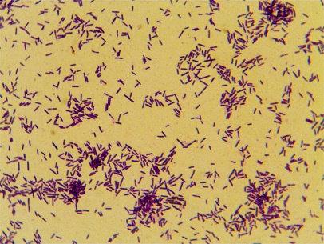
Fig. S1 Gram stain of LMB-7 strain

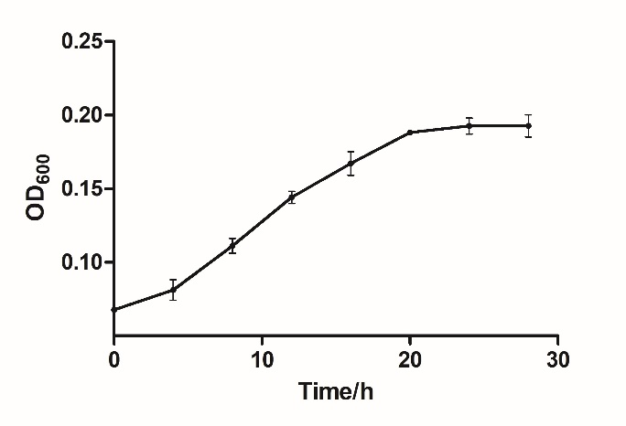
Fig. S2 Growth curve of LMB-7 in MSM medium.

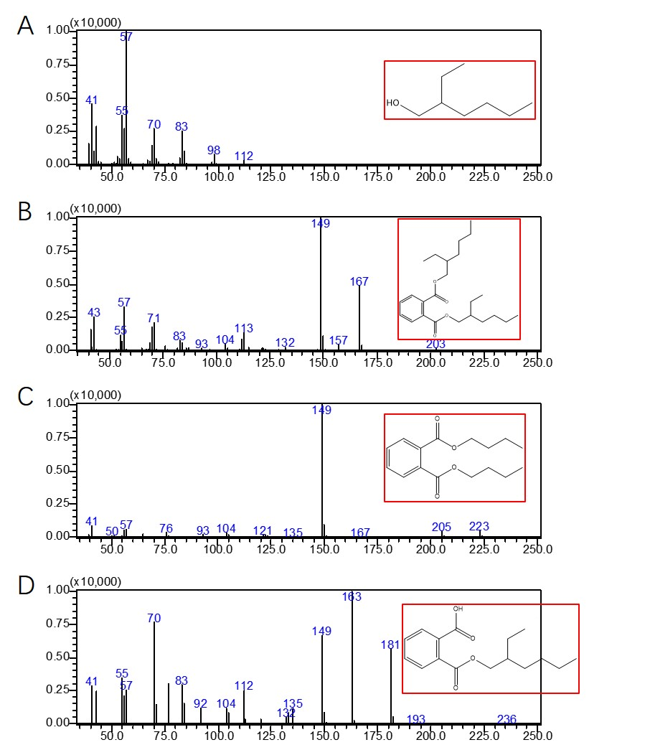
Fig. S3 Intermediate metabolites in the pathway of DEHP biodegradation were identified by GC-MS with A. MEHP, B. DBP, C. 2-EH, and D. PA.

