Additional file 1. GO analysis of the DEGs in chemotherapy-resistant breast cancer cells. A, up/downregulated GO enrichment terms of EPI-resistant cell lines (P < 0.05). B, up/downregulated KEGG enrichment terms of EPI-resistant cell lines (P < 0.05). C, GSEA of DEGs in EPI-resistant cell lines.
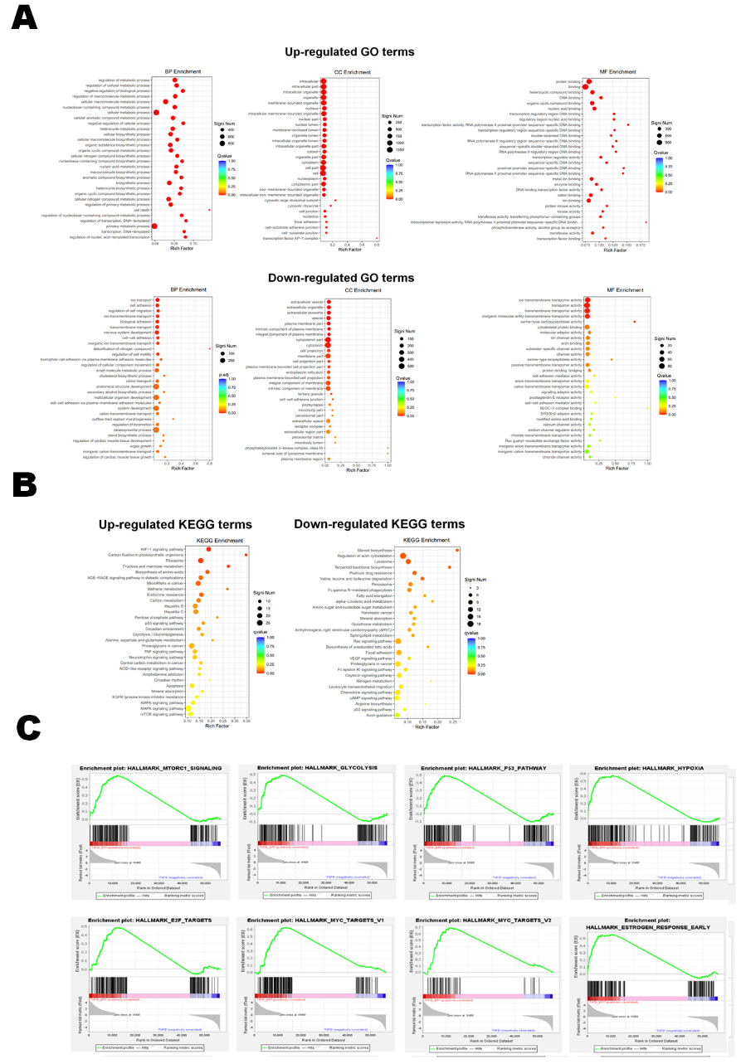

Additional file 2. Obtaining a risk model comprising the same 12 genes in the validation set. ROC analysis of the risk score in patients with breast cancer treated with neoadjuvant chemotherapy. All data are from the randomly selected patients in the GSE25066 dataset as the validation set.

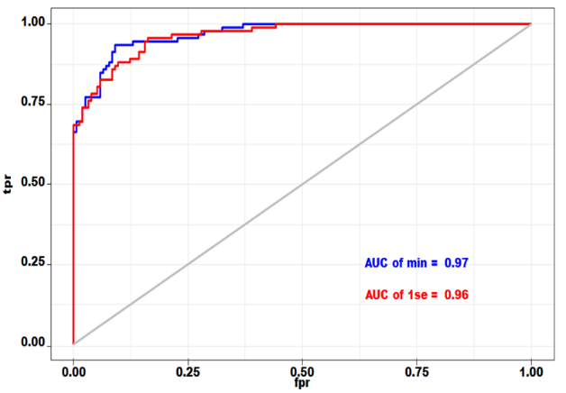

Additional file 3. A, the expression of twelve genes in tumor, normal tissues and tumor-adjacent tissues. B, Kaplan–Meier survival analysis of twelve genes. C, The calibration plots for predicting recurrence at 1, 3, and 5 years. The X-axis represents the predicted recurrence probability from the nomogram, and the y-axis represents the actual recurrence probability.
