Table 3: Salt repulsion percentage for the Henry problem
Run number |  |  | Values | Salt repulsion (%)
Run number | Protection method |  | Values | Sea side slope | Horizontal slope | Landside slope
1 | 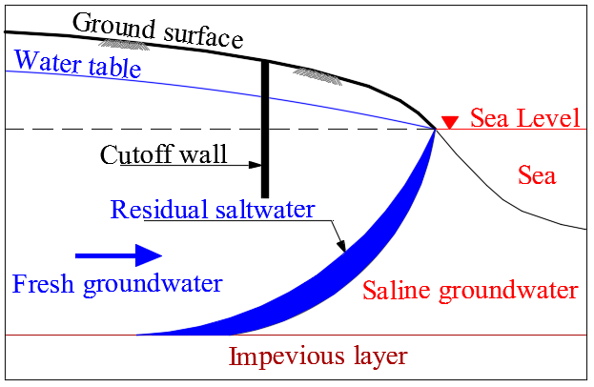 | Cutoff wall depths  (cm) | 15 | +6.23 | +9.97 | +-6.07
2 |  | Cutoff wall depths  (cm) | 30 | +19.38 | +24.74 | +19.58
2 |  | Cutoff wall depths  (cm) | 45 | +34.26 | +35.31 | +36.27
4 |  | Cutoff wall depths  (cm) | 60 | +47.64 | +50.34 | +52.71
 |  | Cutoff wall depths  (cm) | Average | +26.88 | +30.09 | +28.66
5 | 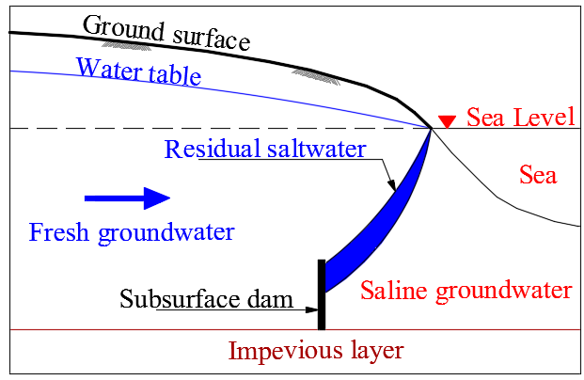 | Subsurface dam depths  (cm) | 15 | +3.56 | +3.44 | +3.21
6 |  | Subsurface dam depths  (cm) | 30 | +10.14 | +10.58 | +10.58
7 |  | Subsurface dam depths  (cm) | 45 | +13.43 | +17.12 | +18.52
8 |  | Subsurface dam depths  (cm) | 60 | +14.38 | +18.66 | +21.90
 |  | Subsurface dam depths  (cm) | Average | +10.38 | +12.45 | +13.55
9 | 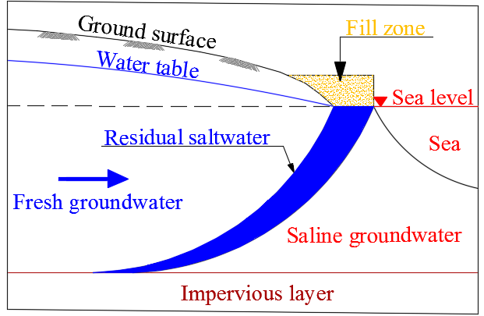 | Earth fill Permeability  (m day⁻¹) | 734.40 | +3.39 | +6.83 | +8.78
10 |  | Earth fill Permeability  (m day⁻¹) | 604.80 | +9.85 | +12.62 | +14.09
11 |  | Earth fill Permeability  (m day⁻¹) | 345.60 | +16.67 | +21.18 | +22.13
12 |  | Earth fill Permeability  (m day⁻¹) | 216 | +33.78 | +34.96 | +35.43
 |  | Earth fill Permeability  (m day⁻¹) | Average | +15.92 | +18.90 | +20.11
13 | 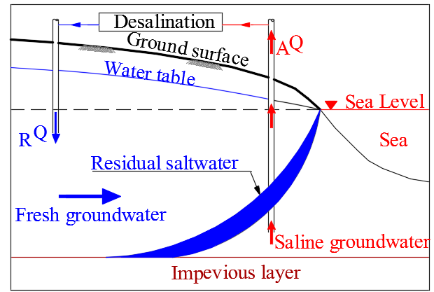 | Freshwater  recharge rates  (m³ day⁻¹) | 0.11404 | +14.38 | +14.17 | +14.05
14 |  | Freshwater  recharge rates  (m³ day⁻¹) | 0.22808 | +26.17 | +26.11 | +26.17
15 |  | Freshwater  recharge rates  (m³ day⁻¹) | 0.34212 | +35.92 | +36.17 | +36.59
16 |  | Freshwater  recharge rates  (m³ day⁻¹) | 0.45616 | +44.04 | +44.63 | +45.48
 |  |  | Average | +30.13 | +30.27 | +30.57
17 |  | Brackish water abstraction rates  (m³ day⁻¹) | 0.11404 | +3.05 | -2.69 | +2.44
18 |  | Brackish water abstraction rates  (m³ day⁻¹) | 0.22808 | +6.21 | -5.57 | +5.11
19 |  | Brackish water abstraction rates  (m³ day⁻¹) | 0.34212 | +9.26 | -8.45 | +7.85
20 |  | Brackish water abstraction rates  (m³ day⁻¹) | 0.45616 | +12.02 | -11.19 | +10.53
 |  |  | Average | +7.64 | -6.97 | +6.48
21 |  | Combine of two cases rates  (m³ day⁻¹) | 0.11404 | +17.51 | +17.00 | +16.65
22 |  | Combine of two cases rates  (m³ day⁻¹) | 0.22808 | +31.14 | +30.66 | +30.42
23 |  | Combine of two cases rates  (m³ day⁻¹) | 0.34212 | +41.24 | +41.12 | +41.25
24 |  | Combine of two cases rates  (m³ day⁻¹) | 0.45616 | +48.33 | +48.75 | +49.32
 |  |  | Average | +34.55 | +34.38 | +34.41
25 | 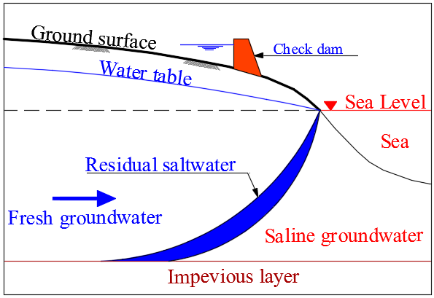 | Check dam heads  (cm) | 17.50 | +21.39 | +22.73 | +20.13
26 |  | Check dam heads  (cm) | 18 | +39.67 | +42.35 | +37.92
27 |  | Check dam heads  (cm) | 18.50 | +52.66 | +55.99 | +54.79
28 |  | Check dam heads  (cm) | 19 | +62.27 | +65.77 | +62.45
 |  |  | Average | +44.00 | +46.71 | +43.82

