Supplementary information
Tabel S1 Sequencing data quality control
Sample | Raw Datas | Clean Datas (%) | Adapter (%) | Low Quality (%) | Poly A (%) | N (%)
E12-1 | 111138084 | 110903154 (99.79%) | 49452 (0.04%) | 185478 (0.17%) | 0 (0.00%) | 0 (0.00%)
E12-2 | 81887432 | 81736844 (99.82%) | 31884 (0.04%) | 118704 (0.14%) | 0 (0.00%) | 0 (0.00%)
E12-3 | 73475458 | 73348018 (99.83%) | 25224 (0.03%) | 102216 (0.14%) | 0 (0.00%) | 0 (0.00%)
E16-1 | 81588884 | 81443096 (99.82%) | 26634 (0.03%) | 118302 (0.14%) | 0 (0.00%) | 852 (0.00%)
E16-2 | 148553196 | 148217264 (99.77%) | 72928 (0.05%) | 263004 (0.18%) | 0 (0.00%) | 0 (0.00%)
E16-3 | 129602476 | 129311716 (99.78%) | 58592 (0.05%) | 232168 (0.18%) | 0 (0.00%) | 0 (0.00%)
E19-1 | 115473662 | 115228718 (99.79%) | 53256 (0.05%) | 191688 (0.17%) | 0 (0.00%) | 0 (0.00%)
E19-2 | 130835344 | 130511036 (99.75%) | 75888 (0.06%) | 248420 (0.19%) | 0 (0.00%) | 0 (0.00%)
E19-3 | 116795024 | 116559114 (99.80%) | 53360 (0.05%) | 182550 (0.16%) | 0 (0.00%) | 0 (0.00%)
E21-1 | 90746886 | 90495818 (99.72%) | 52240 (0.06%) | 196780 (0.22%) | 0 (0.00%) | 2048 (0.00%)
E21-2 | 143859724 | 143497618 (99.75%) | 90398 (0.06%) | 271708 (0.19%) | 0 (0.00%) | 0 (0.00%)
E21-3 | 113579642 | 113256828 (99.72%) | 84164 (0.07%) | 238650 (0.21%) | 0 (0.00%) | 0 (0.00%)

Table S2 Statistics of clean reads at 4 different time points of chicken muscle embryo
Sample | Raw Data(bp) | BF_Q20 (%) | BF_Q30 (%) | BF_N (%) | BF_GC (%) | Clean Data(bp)
E12-1 | 16670712600 | 16369376179 (98.19%) | 15778459580 (94.65%) | 80126 (0.00%) | 7418552738 (44.50%) | 16539027690
E12-2 | 12283114800 | 12062039721 (98.20%) | 11623537943 (94.63%) | 58570 (0.00%) | 5335917603 (43.44%) | 12192468046
E12-3 | 11021318700 | 10828008658 (98.25%) | 10445457718 (94.78%) | 52718 (0.00%) | 4821916644 (43.75%) | 10933881477
E16-1 | 12238332600 | 11995202940 (98.01%) | 11525840071 (94.18%) | 178914 (0.00%) | 5646637710 (46.14%) | 12119516139
E16-2 | 22282979400 | 21895574481 (98.26%) | 21140462839 (94.87%) | 107225 (0.00%) | 10174430973 (45.66%) | 22083287013
E16-3 | 19440371400 | 19102687098 (98.26%) | 18440843014 (94.86%) | 92847 (0.00%) | 8867771358 (45.62%) | 19287927739
E19-1 | 17321049300 | 17049986003 (98.44%) | 16507817064 (95.30%) | 83394 (0.00%) | 7944467506 (45.87%) | 17176296312
E19-2 | 19625301600 | 19284208118 (98.26%) | 18620658960 (94.88%) | 93659 (0.00%) | 9068964453 (46.21%) | 19432225822
E19-3 | 17519253600 | 17224697285 (98.32%) | 16640239062 (94.98%) | 83476 (0.00%) | 7888244061 (45.03%) | 17369110202
E21-1 | 13612032900 | 13368698410 (98.21%) | 12894998730 (94.73%) | 458456 (0.00%) | 6362052827 (46.74%) | 13459454090
E21-2 | 21578958600 | 21169692812 (98.10%) | 20392956165 (94.50%) | 103383 (0.00%) | 10160445031 (47.08%) | 21335307637
E21-3 | 17036946300 | 16691402277 (97.97%) | 16045116538 (94.18%) | 81130 (0.00%) | 7886297608 (46.29%) | 16820690764

Table S3 Comparison of reference area statistics
sample | exon | intron | intergenic
E12-1 | 53819240 (51.10%) | 43253127 (41.07%) | 8252195 (7.84%)
E12-2 | 33029680 (42.56%) | 38453945 (49.55%) | 6115224 (7.88%)
E12-3 | 30766495 (44.23%) | 33446216 (48.09%) | 5339798 (7.68%)
E16-1 | 41594550 (53.65%) | 27699930 (35.73%) | 8227888 (10.61%)
E16-2 | 71609233 (51.07%) | 54224380 (38.67%) | 14382595 (10.26%)
E16-3 | 58979650 (48.31%) | 50320090 (41.22%) | 12774960 (10.46%)
E19-1 | 54425652 (50.39%) | 39089957 (36.19%) | 14489227 (13.42%)
E19-2 | 67524805 (55.01%) | 39509202 (32.19%) | 15717147 (12.80%)
E19-3 | 54739534 (49.93%) | 41223524 (37.60%) | 13668790 (12.47%)
E21-1 | 48288728 (57.60%) | 25308972 (30.19%) | 10231492 (12.21%)
E21-2 | 77050019 (58.95%) | 35350630 (27.05%) | 18303448 (14.00%)
E21-3 | 53152818 (51.92%) | 32551357 (31.79%) | 16675156 (16.29%)

Table S4 Alignment of reference genome
Sample | Total | Unmapped (%) | Unique_ Mapped (%) | Multiple_ Mapped (%) | Total_ Mapped (%)
E12-1 | 110098734 | 4774172 (4.34%) | 103518818 (94.02%) | 1805744 (1.64%) | 105324562 (95.66%)
E12-2 | 81283742 | 3684893 (4.53%) | 76525584  (94.15%) | 1073265 (1.32%) | 77598849  (95.47%)
E12-3 | 72787674 | 3235165 (4.44%) | 68424374  (94.01%) | 1128135 (1.55%) | 69552509  (95.56%)
E16-1 | 80878246 | 3355878 (4.15%) | 75258271  (93.05%) | 2264097 (2.80%) | 77522368  (95.85%)
E16-2 | 146786694 | 6570486 (4.48%) | 136725643  (93.15%) | 3490565 (2.38%) | 140216208 (95.52%)
E16-3 | 128160934 | 6086234 (4.75%) | 118883524  (92.76%) | 3191176 (2.49%) | 122074700 (95.25%)
E19-1 | 113707428 | 5702592 (5.02%) | 105229511  (92.54%) | 2775325 (2.44%) | 108004836 (94.98%)
E19-2 | 129016962 | 6265808 (4.86%) | 119112620  (92.32%) | 3638534 (2.82%) | 122751154 (95.14%)
E19-3 | 115085998 | 5454150 (4.74%) | 107226141  (93.17%) | 2405707 (2.09%) | 109631848 (95.26%)
E21-1 | 89152220 | 5323028 (5.97%) | 81273589  (91.16%) | 2555603 (2.87%) | 83829192  (94.03%)
E21-2 | 139382784 | 8678687 (6.23%) | 126071082  (90.45%) | 4633015 (3.32%) | 130704097 (93.77%)
E21-3 | 108925286 | 6545955 (6.01%) | 99465020  (91.31%) | 2914311 (2.68%) | 102379331 (93.99%)
Tabel S5 Primer sequencing in this study
Gene | Forward primer(5’-3’) | Reverse primer(3’-5’)
VASH2 | GCAATGGCCGGTATGGATCACTG | AGGTCGCTCAGAGTTCGGTAAGTC
MYH1F-F | TGCCTCAGGTCACACTTTAGC | AGCTGTCCAATGTCAACCTTTCC
TUBAL3-F | TGAGATCCGAACTGGCACCTACC | AGTTGTTGGCAGCATCCTCCTTG
HADHB-F | CCACAGGCATAGGTTTGATAG | CAGTTCCATAGGGCTTGACA
SLC25A12-F | GGTTCCATTCCACTCCCTG | CCTGTAGTAATTTCTCCCGCTA
STMN1 | GATCCTTGGTCCCCGCTCAAAAG | GCGTCTCTCTTCTGCTGCTTCC
ACTB | CTGTGCCCATCTATGAAGGCTA | ATTTCTCTCTCGGCTGTGGTG

Figure legends
Figure S1. Gene coverage of different samples. Sample gene coverage distribution (1) E12-1; (2) E12-2; (3) E12-3; (4) E16-1; (5) E16-2; (6); E16-3; (7) E19-1; (8) E19-2; (9) E19-3; (10) E21-1; (11) E21-2; (12) E21-3.Replace different gene coverage ratios with different colors.
Figure S2. Sample randomness distribution. Random distribution of samples in different periods (a) E12-1; (b) E12-2; (c) E12-3; (d) E16-1; (e) E16-2; (f); E16-3; (g) E19-1; (h) E19-2; (i) E19-3; (j) E21-1; (k) E21-2; (l) E21-3.
Figure S3. Volcano plot of differentially expressed genes. Comparison of embryo development at different time points.(A) E12vsE16; (B) E12vsE19; (C) E12vsE21; (D) E16vs19; (E) E16vsE21; (F) E19vsE21.

Figure S1

Figure S2
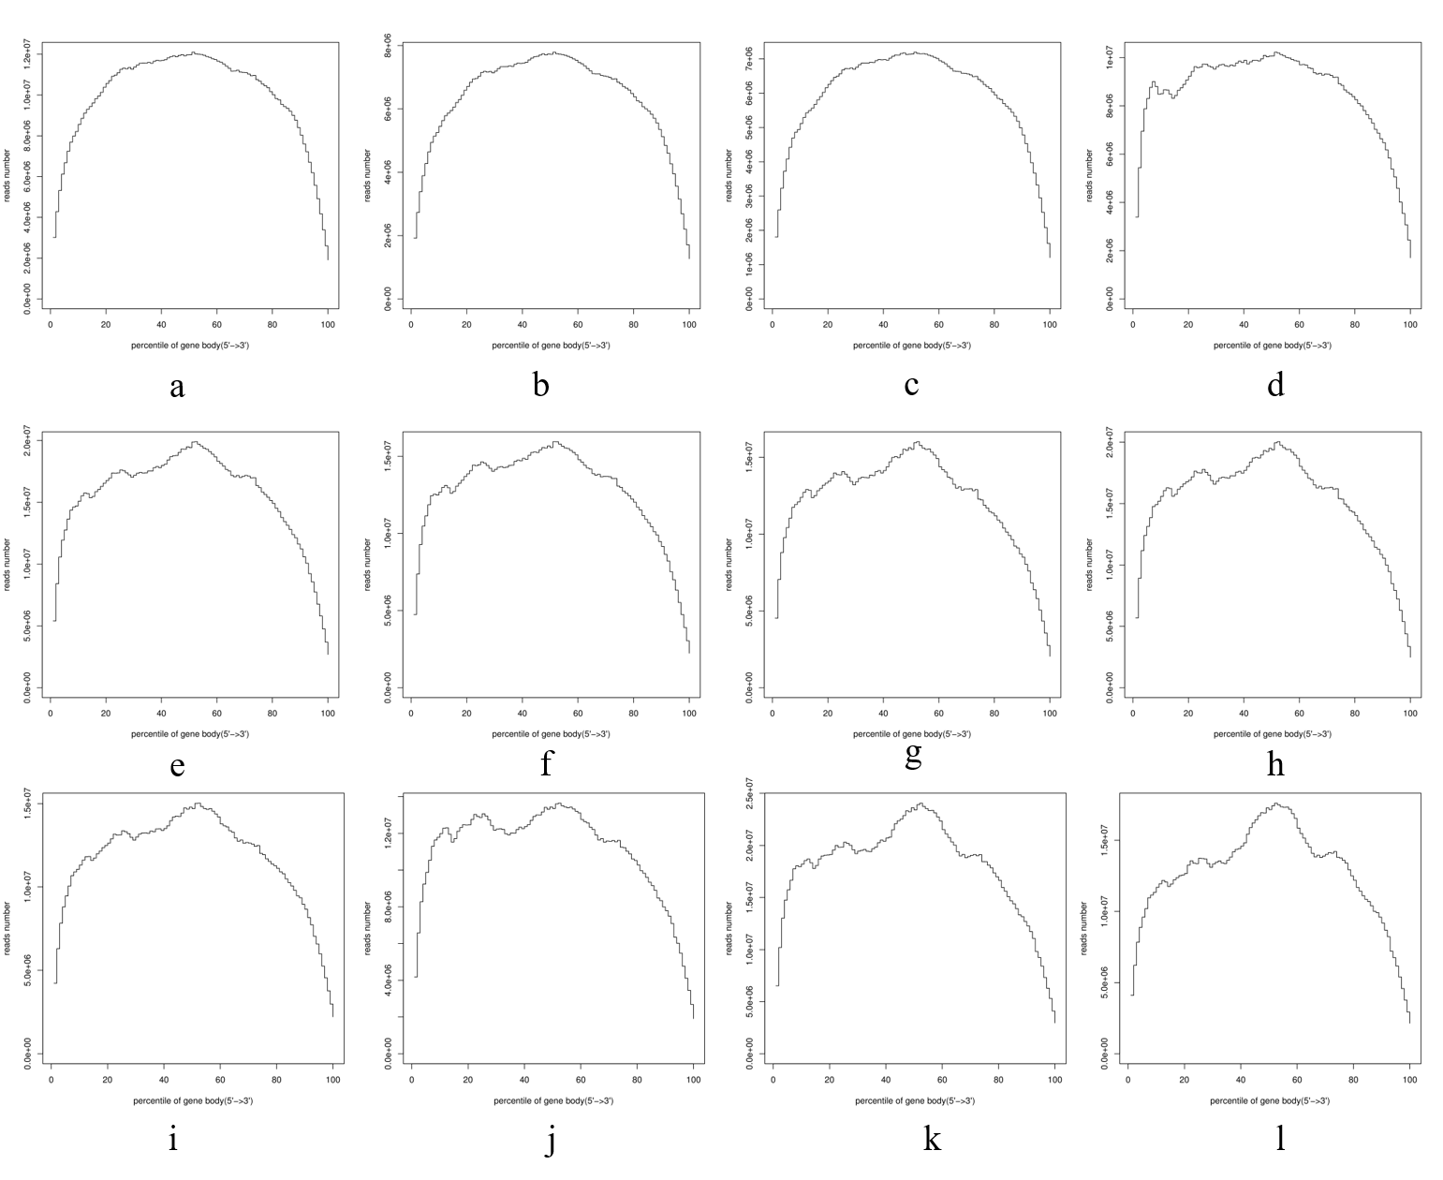

Figure S3
