STable1 Sequences of primer pairs for quantitative real-time RT-PCR assay
Target genes | Primers F/R (5’→3’) | Product size (bp)
Chalcone synthase (CHI) | F: TGGGTACTGAAACGGTTATG  R: TAGGACAGCTCCAGGTTTA | 203
Dihydroflavonol 4-reductase (DFR) | F: TGCGAGACCCAGAGAATA  R: CCGTTTATCGTTGGCTTTATC | 211
Flavanone 3-hydroxylase (F3H) | F: GGCGGCTTCATTGTCTC  R: TGGCTTCCGATAACACCT | 205
BpMYB15 | F: AGGACCACCATCACCAC  R: CGAGCCACCAGCAGATC | 103
BpMYB21 | F: TGAAATCAAGAACTACTGGAA  R: C GTCGGATGTTGCTTCTGT | 126
α-tubulin (TU) | F: TCAACCGCCTTGTCTCTCAGG  R: TGGCTCGAATGCACTGTTGG | 159

STable 2 Correlation coefficient between R2R3-MYB transcription factor and key enzyme genes of flavonoid synthesis pathway in Betula platyphylla
 | BpMYB12 |  |  | BpMYB15 |  | BpMYB21 |  | BpMYB36 |  | BpMYB37
 | WT | GSNOR-RNAi | WT |  | GSNOR-RNAi | WT | GSNOR-RNAi | WT | GSNOR-RNAi | WT | GSNOR-RNAi
PAL1 | 1.00 | 0.26 | -0.30 |  | 0.99 | 0.04 | 0.96 | 0.42 | -0.42 | 0.98 | 0.85
PAL2 | 0.95 | 0.11 | 0.56 |  | 1.00 | -0.33 | 0.99 | -0.14 | -0.55 | -0.89 | 0.76
4CL1 | 1.00 | 0.12 | 0.22 |  | 1.00 | 0.04 | 0.99 | -0.50 | -0.55 | -0.99 | 0.76
4CL2 | 0.77 | 0.20 | 0.83 |  | 1.00 | -0.66 | 0.97 | 0.25 | -0.48 | -0.64 | 0.82
CHS | 0.33 | 0.06 | 1.00 |  | 1.00 | -0.95 | 1.00 | 0.71 | -0.60 | -0.15 | 0.72
CHI1 | 0.61 | 0.05 | 0.93 |  | 0.99 | -0.81 | 1.00 | 0.45 | -0.61 | -0.46 | 0.72
CHI2 | 0.07 | 0.08 | 0.98 |  | 1.00 | -1.00 | 0.99 | 0.87 | -0.58 | 0.11 | 0.74
FLS1 | -0.02 | 0.55 | 0.95 |  | -0.74 | -1.00 | -0.86 | 0.91 | 0.96 | 0.20 | -0.17
FLS2 | 0.98 | 0.86 | 0.09 |  | 0.64 | 0.17 | 0.48 | -0.60 | 0.33 | -1.00 | 0.98
DFR1 | 0.18 | 0.07 | -0.89 |  | 1.00 | 0.98 | 1.00 | -0.97 | -0.59 | -0.35 | 0.73
DFR2 | 0.26 | 0.15 | 1.00 |  | 1.00 | -0.97 | 0.98 | 0.76 | -0.52 | -0.09 | 0.79
DFR3 | 0.35 | 0.94 | 1.00 |  | 0.49 | -0.95 | 0.31 | 0.69 | 0.50 | -0.18 | 0.92

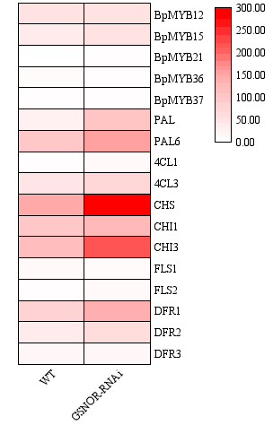
SFig.1 Heat map of the gene expression of the R2R3-MYBs and key enzymes in the flavonoid synthesis pathway

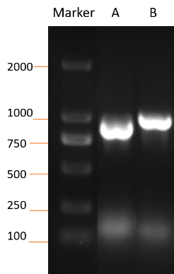
SFig.2 Electrophoresis chart of PCR products of BpMYB15 and BpMYB21
Note: A, BpMYB15；B, BpMYB21

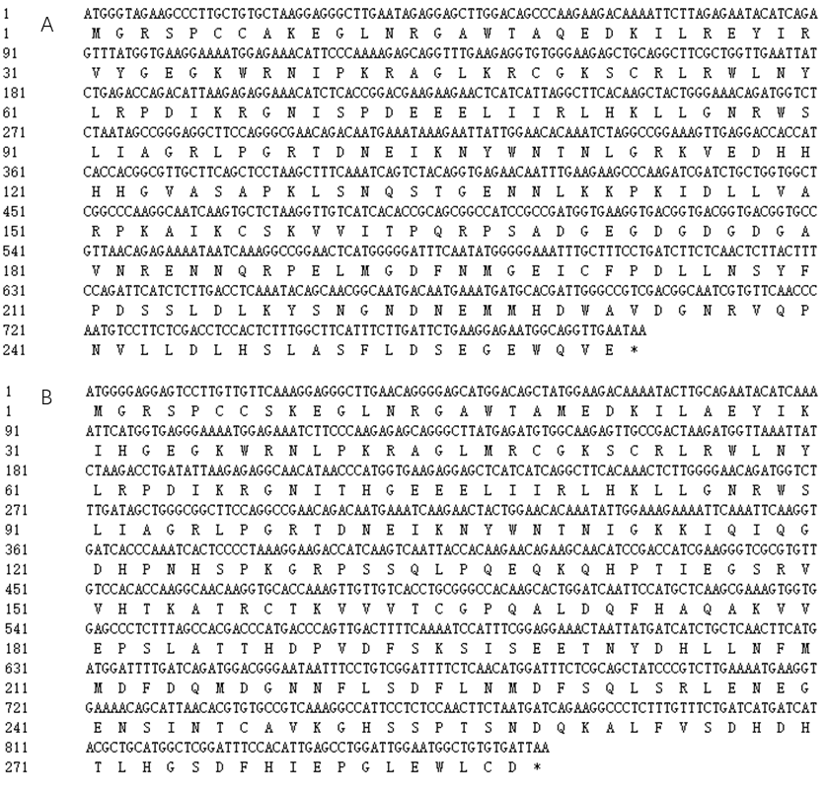
SFig.3 Amino acid sequences of BpMYB15 and BpMYB21
Note: A, BpMYB15；B, BpMYB21

S Table3 BpR2R3-MYBs clustered into one clade distributed on the same chromosome
genes | chromosome
BpMYB11, BpMYB29 |  | 2
BpMYB22, BpMYB43 |  | 3
BpMYB9, BpMYB38 |  | 5
BpMYB5, BpMYB21 |  | 6
BpMYB8, BpMYB13 |  | 8
BpMYB26, BpMYB18 |  | 11
BpMYB4, BpMYB35 |  | 11
BpMYB10, BpMYB39, BpMYB24 |  | 12
BpMYB2, BpMYB42 |  | 13
BpMYB14, BpMYB17 |  | 14
BpMYB16, BpMYB40 |  | 14

