Table 1
The Chemical Structures of Thiazole Derivatives

S.No. | Code | Structure | IC₅₀ | pIC₅₀ | S.No. | Code | Structure | IC₅₀ | pIC₅₀
 | 5b | 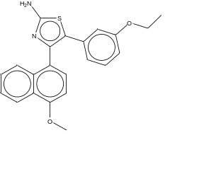 | 0.48 | 5.744727 | 28 | 1c | 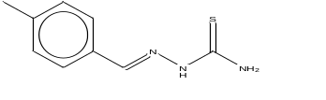 | 24.7 | 4.607303
 | 6l | 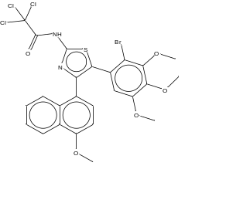 | 0.61 | 6.21467 | 29 | 11 | 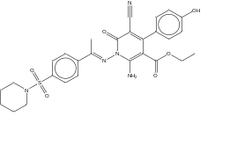 | 25.5 | 4.59346
 | 6d | 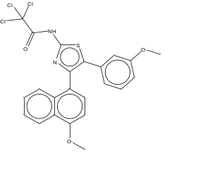 | 1.03 | 5.987163 | 30 | 4a | 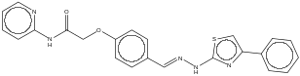 | 25.78 | 4.588717
 | 5a | 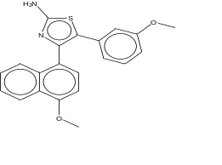 | 1.80 | 5.744727 | 31 | 10 | 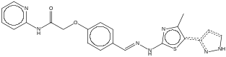 | 26.90 | 4.570248
 | 6a | 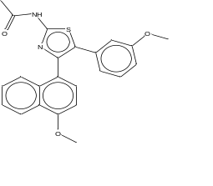 | 2.16 | 4.507938 | 32 | 9 | 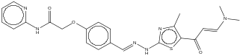 | 27.26 | 4.564474
 | 1b | 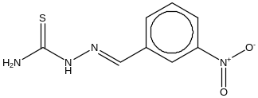 | 2.6 | 5.585027 | 33 | 1d | 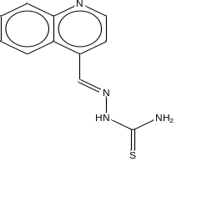 | 28.9 | 4.539102
 | 2c | 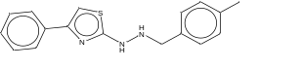 | 4.3 | 5.366532 | 34 | 5c | 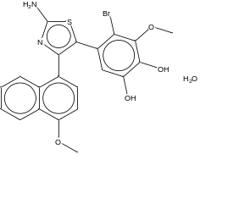 | 31.05 | 6.318759
 | 6f | 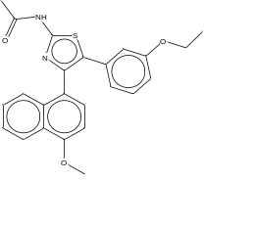 | 5.49 | 5.260428 | 35 | 3 | 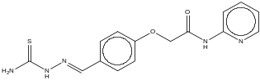 | 33.21 | 4.478731
 | 6h | 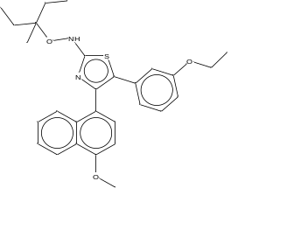 | 7.18 | 5.143876 | 36 | 2b | 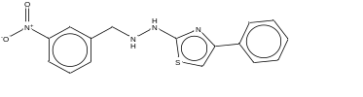 | 33.5 | 4.474955
 | 6i | 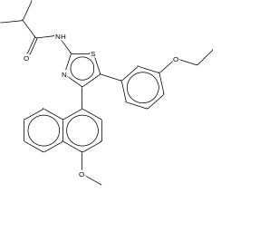 | 7.69 | 5.114074 | 37 | 14 | 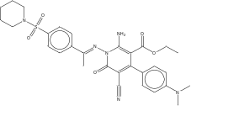 | 34.4 | 4.463442
 | 1a | 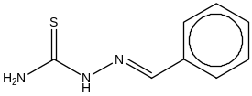 | 8.5 | 5.070581 | 38 | 16 | 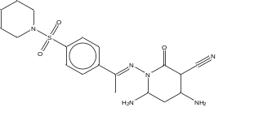 | 36.4 | 4.438899
 | 6g | 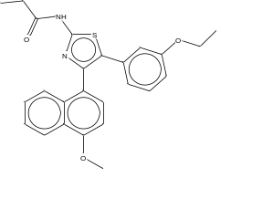 | 9.61 | 5.017277 | 39 | 10 | 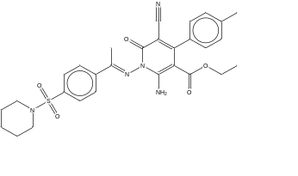 | 37.9 | 4.421361
 | 6c | 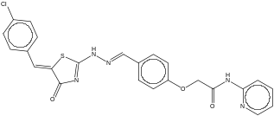 | 10.63 | 4.973467 | 40 | 13 | 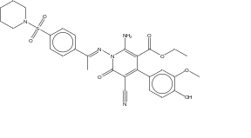 | 38.7 | 4.412289
 | 1e | 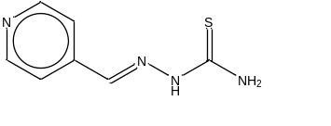 | 10.9 | 4.962574 | 41 | 2g | 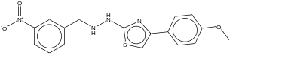 | 39.6 | 4.402305
 | 1f | 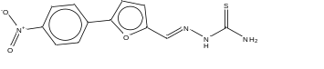 | 11.0 | 4.958607 | 42 | 2 | 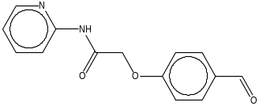 | 42.95 | 4.367037
 | 6e | 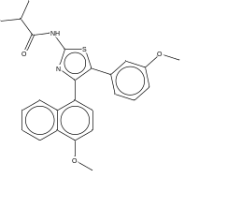 | 12.27 | 4.911155 | 43 | 3 | 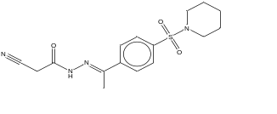 | 44.2 | 4.354578
 | 6b | 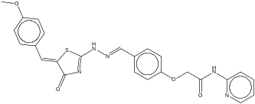 | 12.68 | 4.896881 | 44 | 2e | 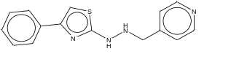 | 44.9 | 4.347754
 | 6n | 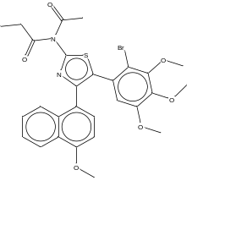 | 13.49 | 4.869988 | 45 | 18 | 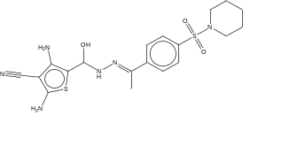 | 49.3 | 4.307153
 | 2i | 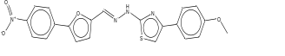 | 13.8 | 4.860121 | 46 | 2f | 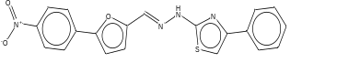 | 50.6 | 4.295849
 | 6b | 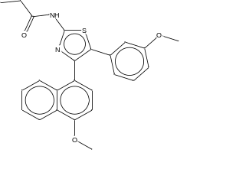 | 14.75 | 5.665546 | 47 | 12 | 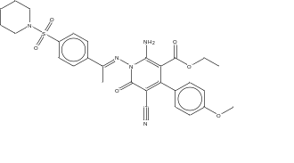 | 51.2 | 4.29073
 | 6c | 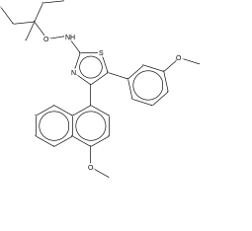 | 14.90 | 4.831208 | 48 | 2d | 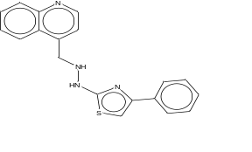 | 56.1 | 4.251037
 | 6a | 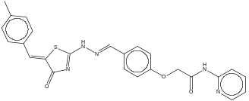 | 15.42 | 4.811916 | 49 | 2h | 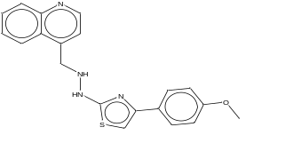 | 58.7 | 4.231362
 | 5 | 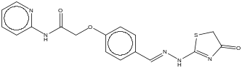 | 18.51 | 4.732594 | 50 | 22 | 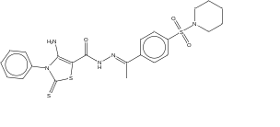 | 60.1 | 4.221126
 | 2a | 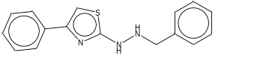 | 19.3 | 4.714443 | 51 | 17 | 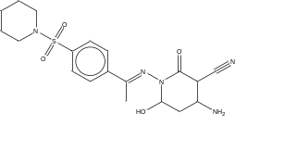 | 74.6 | 4.127261
 | 15 | 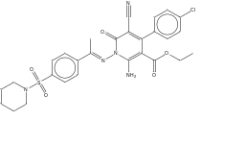 | 20.6 | 4.686133 | 52 | 20 | 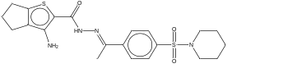 | 75.3 | 4.123205
 | 4b | 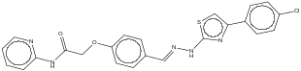 | 22.84 |  | 53 | 21 | 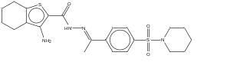 | 87.8 | 4.056505
 | 8 | 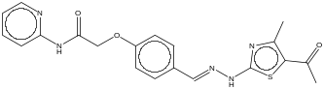 | 23.19 | 4.634699

