Appendix A. Comparison of the weights of the selected neural network models

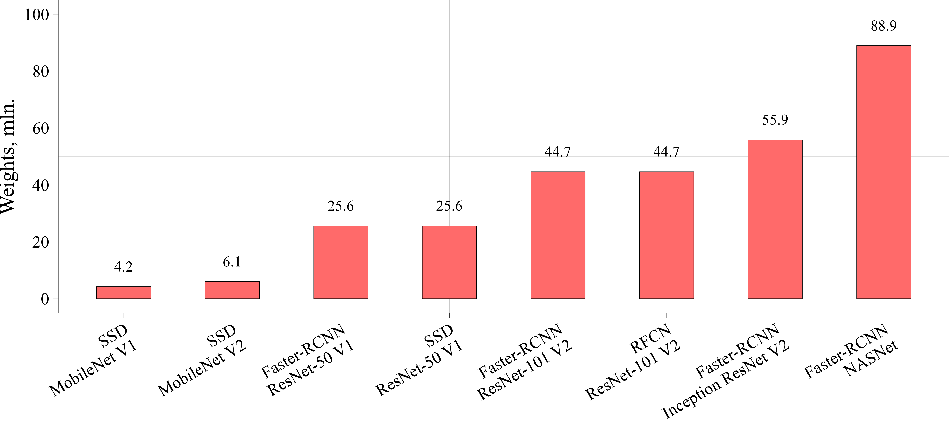
(а) Absolute number of weights
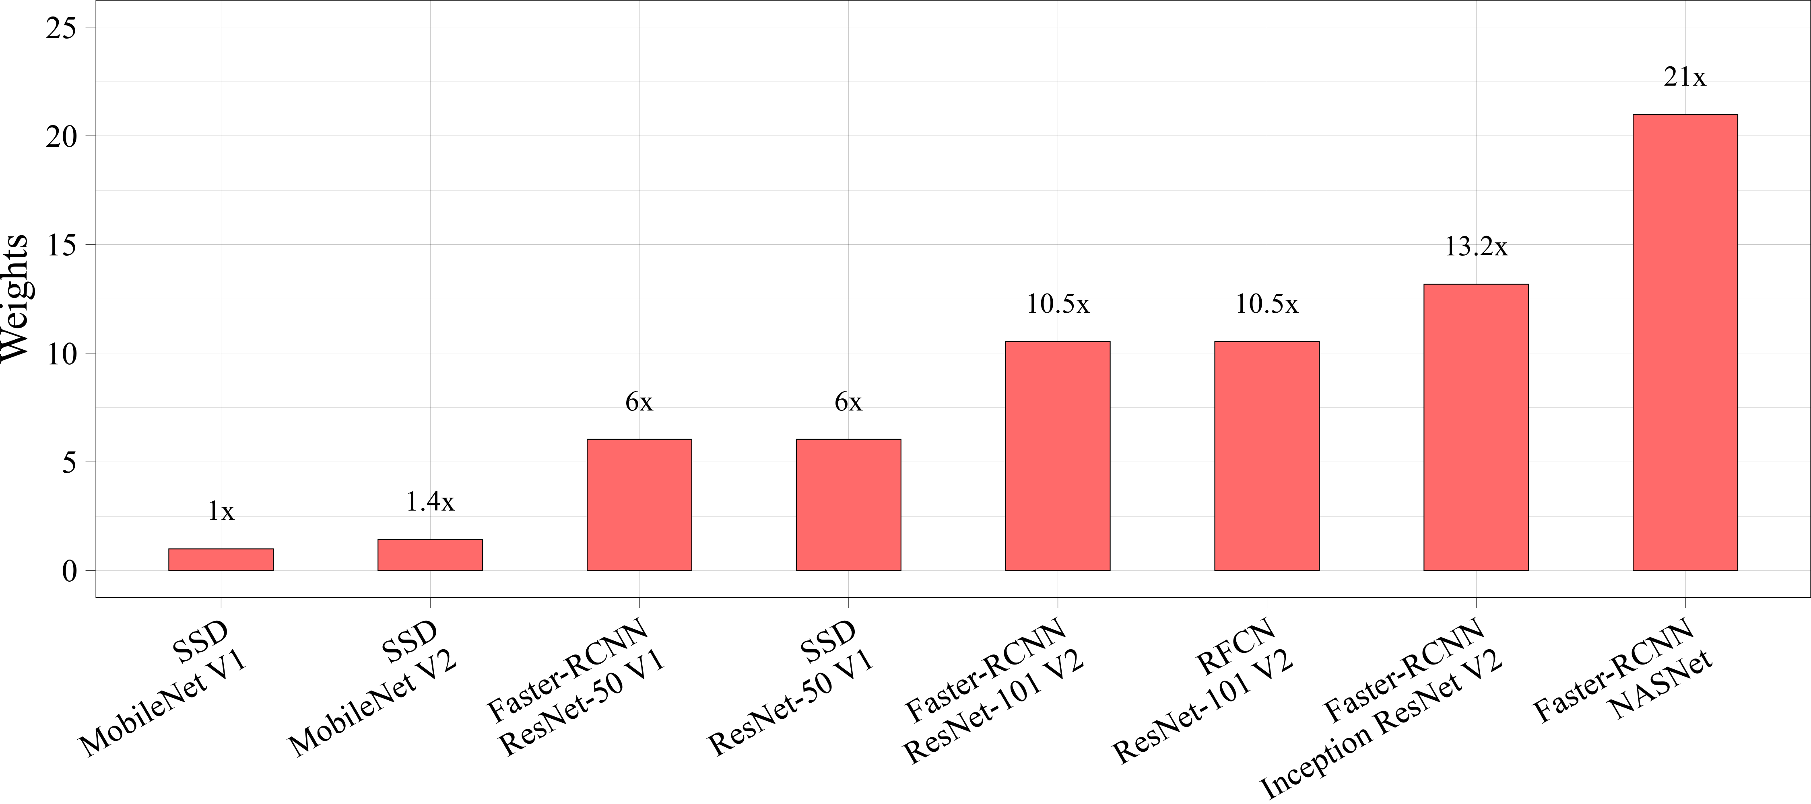
(b) Relative number of weights

Appendix B. Comparison of the training time of the selected neural network models
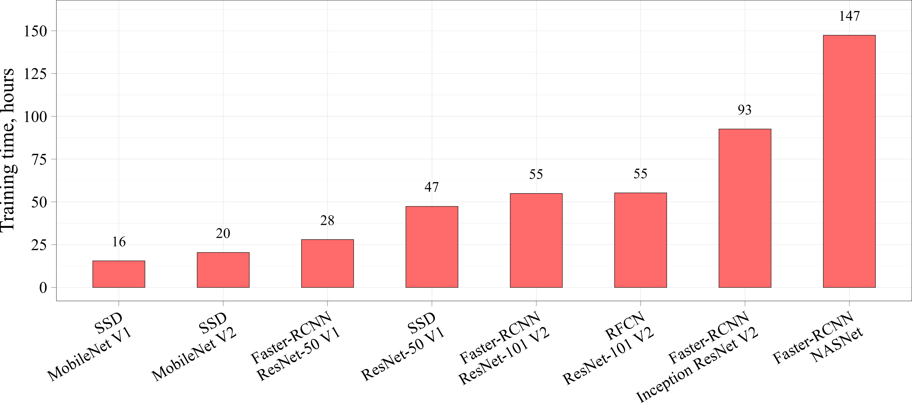
(а) Absolute values of the training time
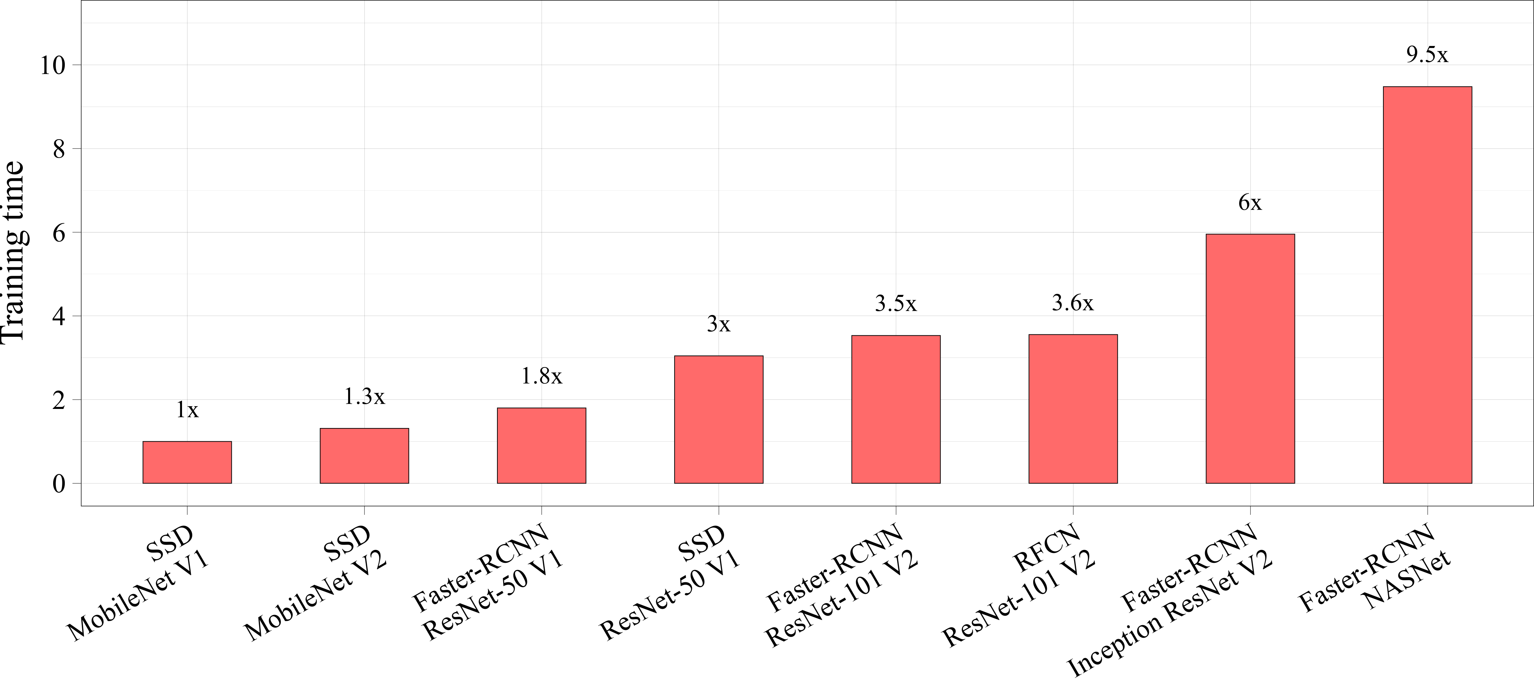
(b) Relative values of the training time

Appendix C. Comparison of the inference time of the selected neural network models
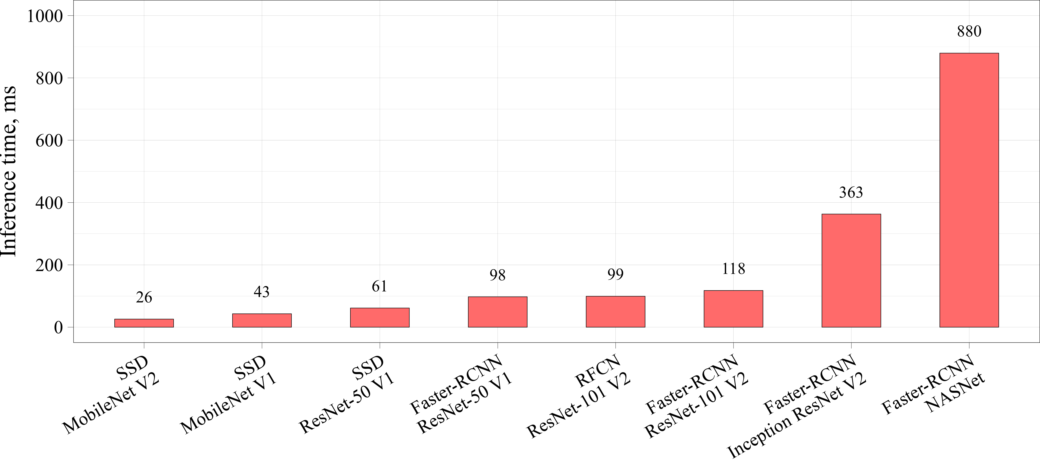
(а) Absolute values of the inference time
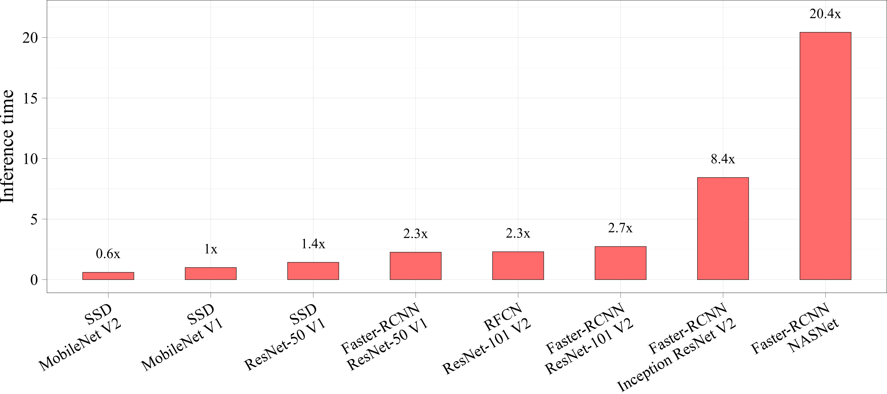
(b) Relative values of the inference time

Appendix D. Comparison of the mAP metric of the selected neural network models
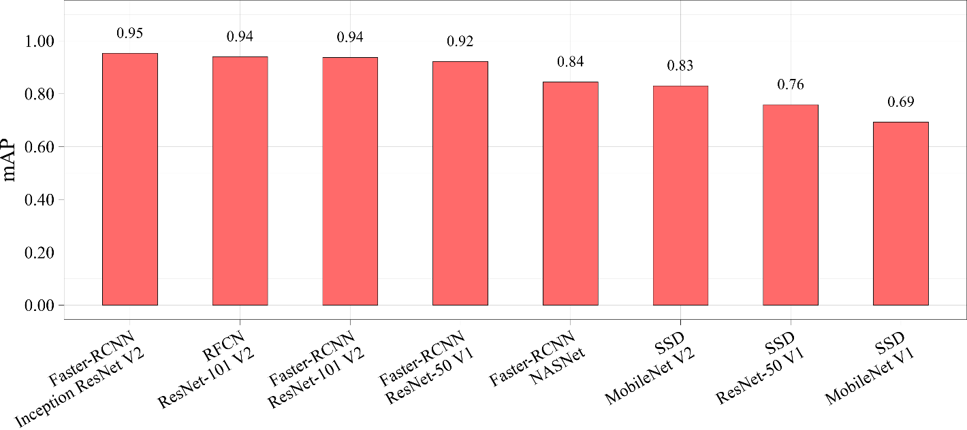
(а) Absolute values of mAP
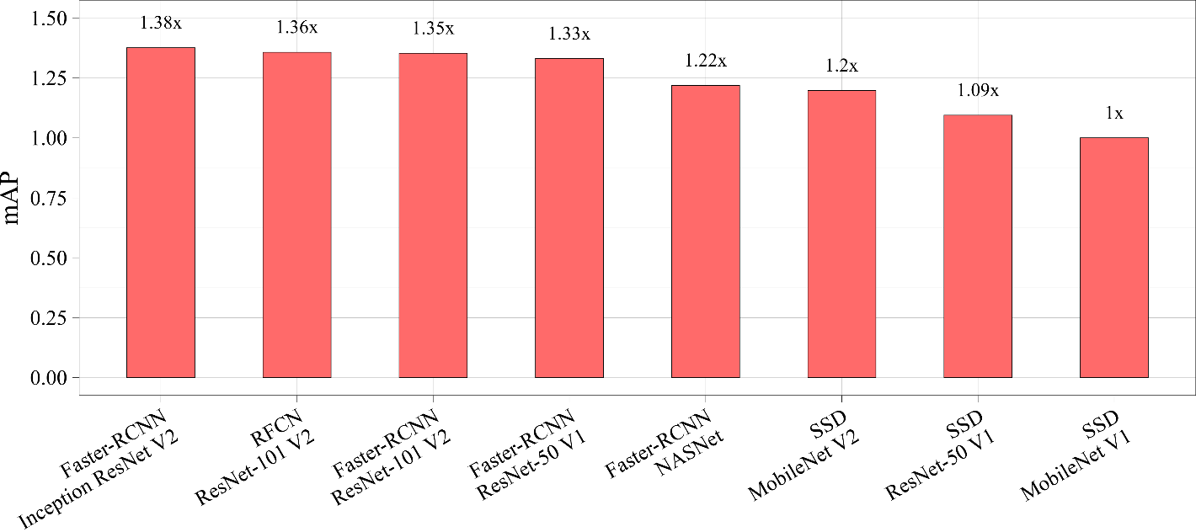
(b) Relative values of mAP

Appendix E. An example of new data prediction in patient 1 using all tested networks
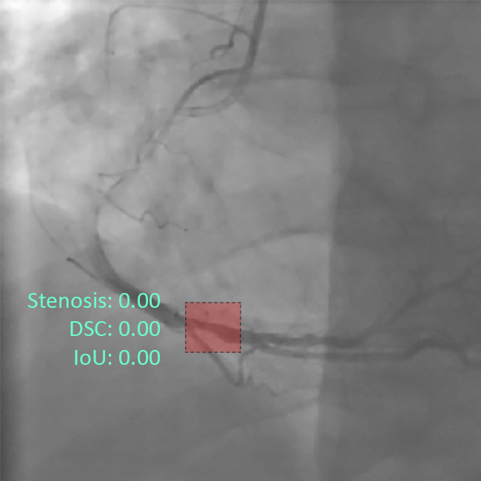 | 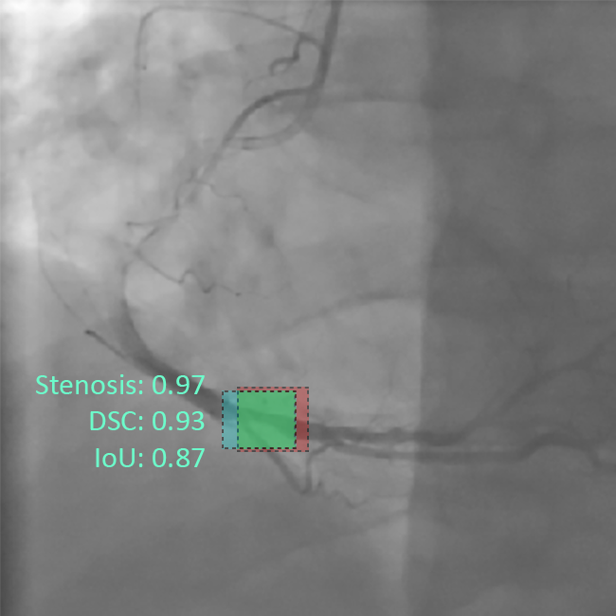
(a) SSD MobileNet V1 | (b) SSD MobileNet V2
 | 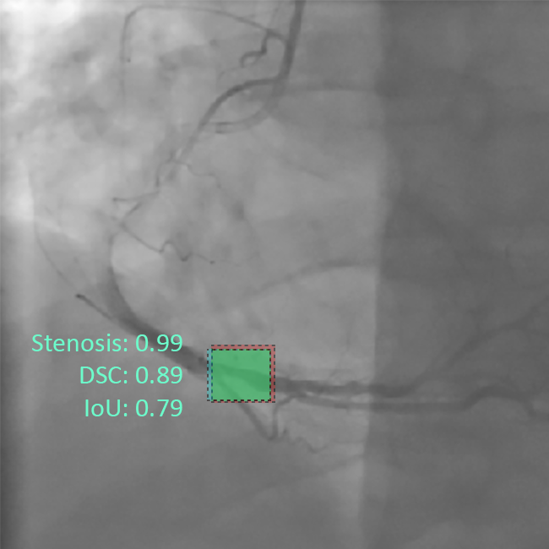
(c) SSD ResNet-50 V1 | (d) Faster-RCNN ResNet-50 V1
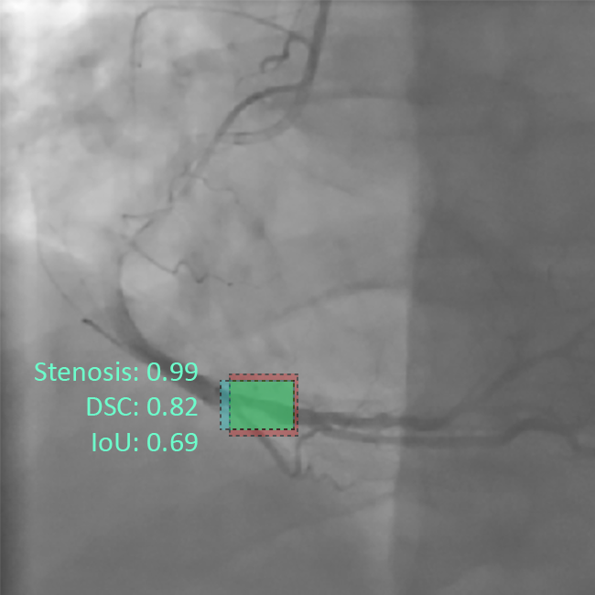 | 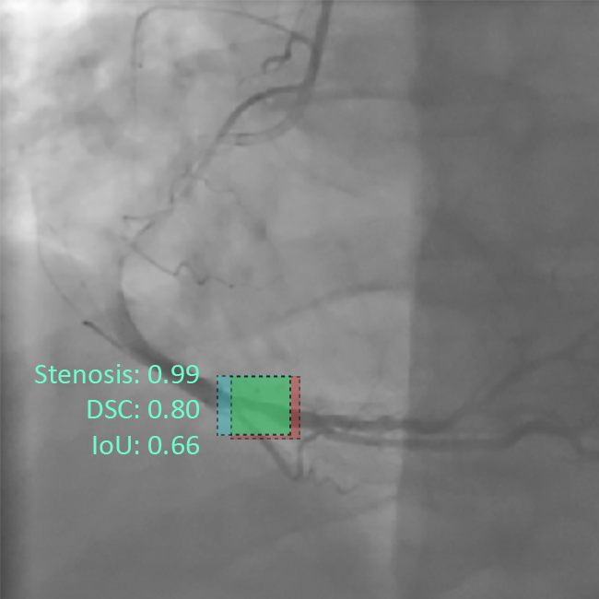
(e) RFCN ResNet-101 V2 | (f) Faster-RCNN ResNet-101 V2
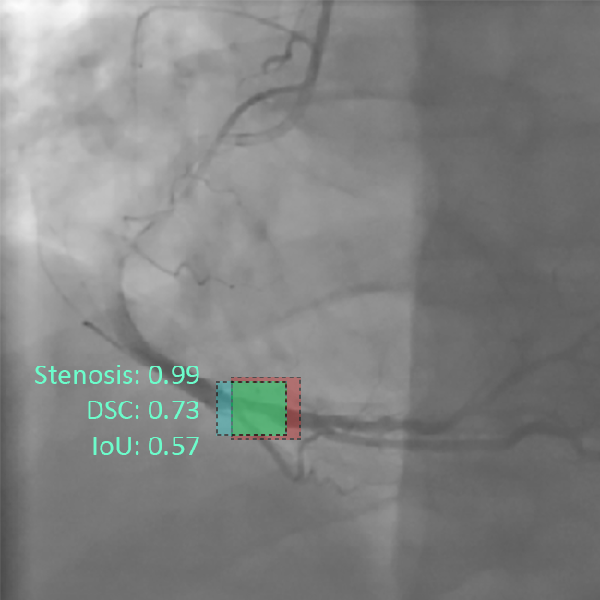 | 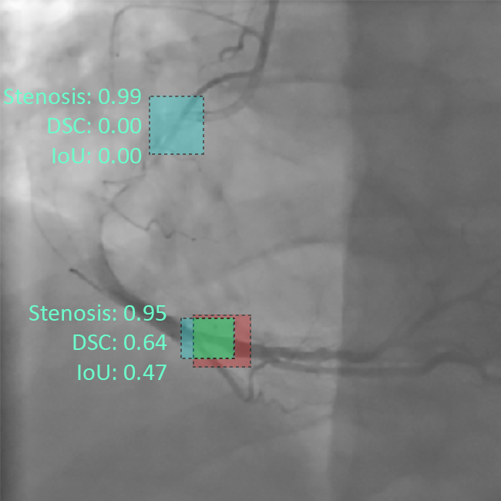
(g) Faster-RCNN Inception ResNet V2 | (h) Faster-RCNN NASNet
Appendix F. An example of new data prediction in patient 2 using all tested networks
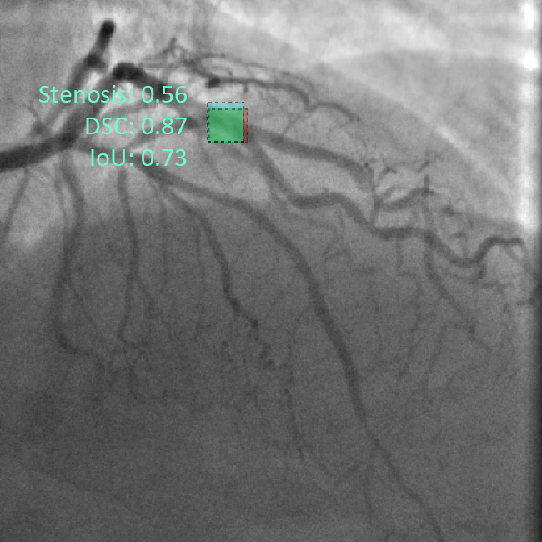 | 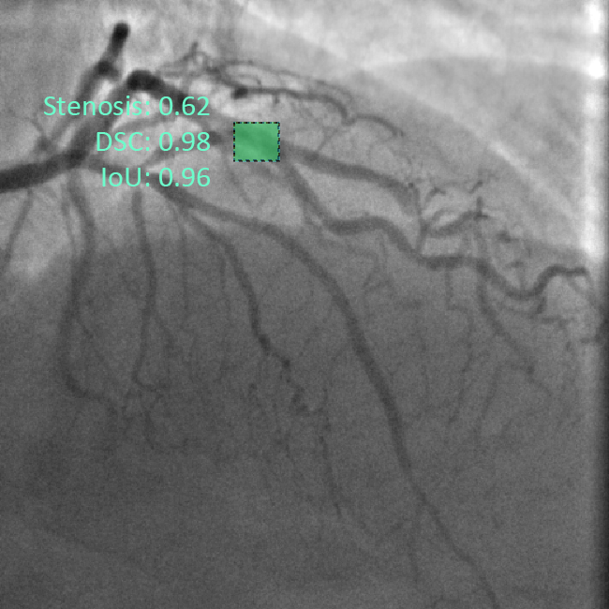
(a) SSD MobileNet V1 | (b) SSD MobileNet V2
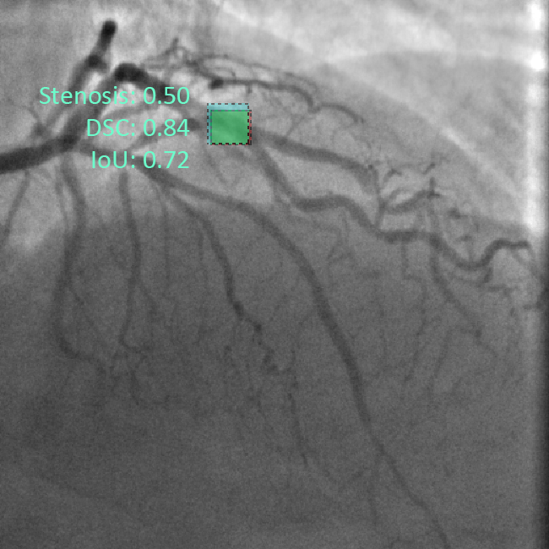 | 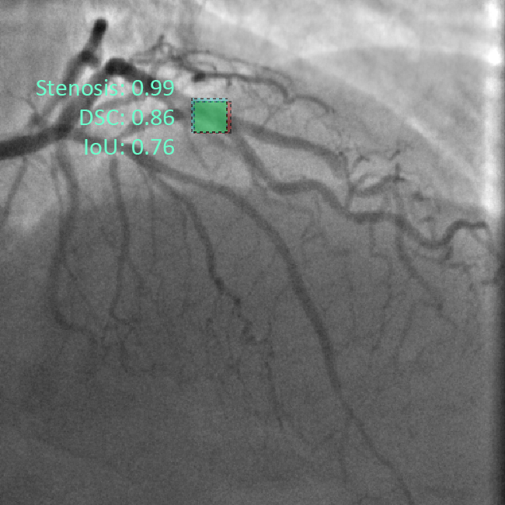
(c) SSD ResNet-50 V1 | (d) Faster-RCNN ResNet-50 V1
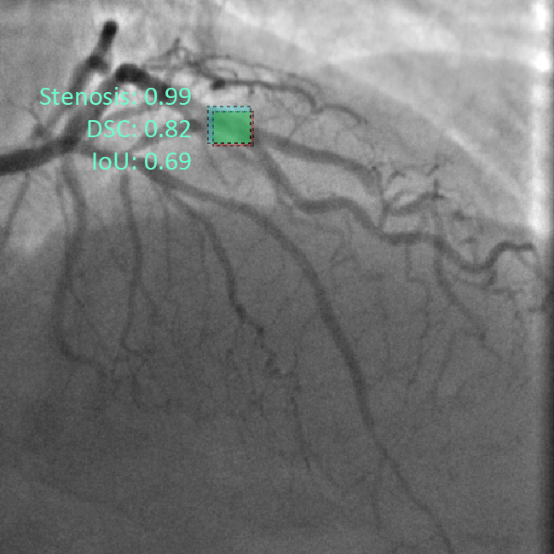 | 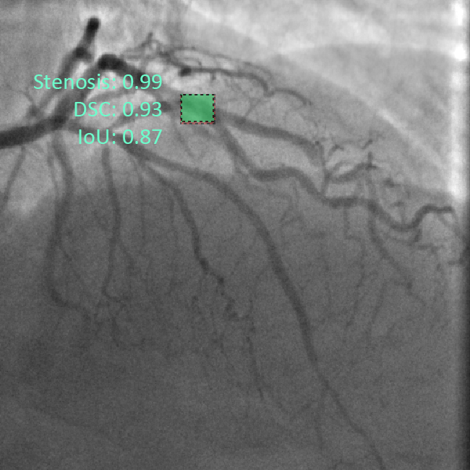
(e) RFCN ResNet-101 V2 | (f) Faster-RCNN ResNet-101 V2
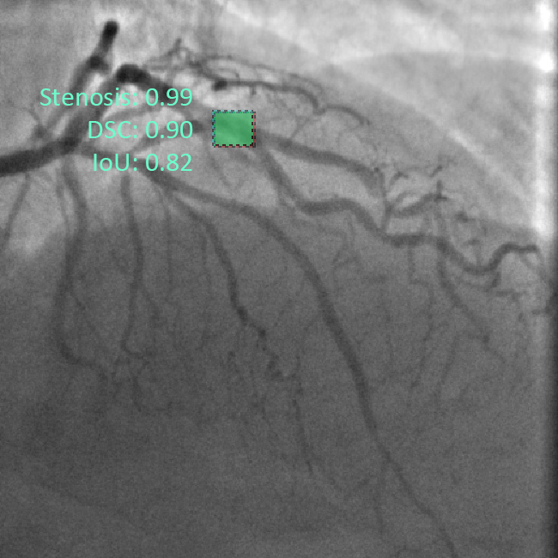 | 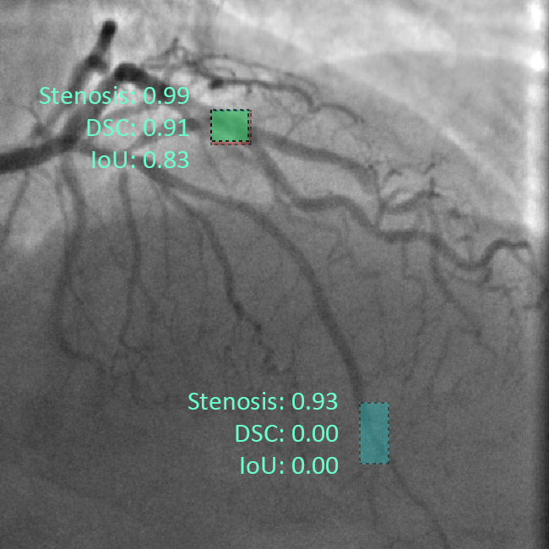
(g) Faster-RCNN Inception ResNet V2 | (h) Faster-RCNN NASNet
Appendix G. An example of new data prediction in patient 3 using all tested networks
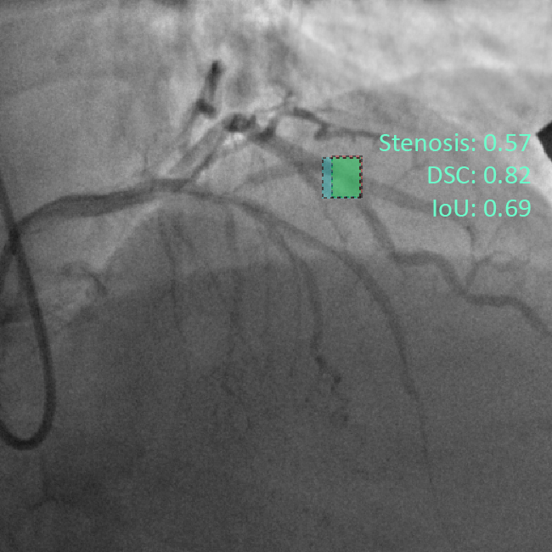 | 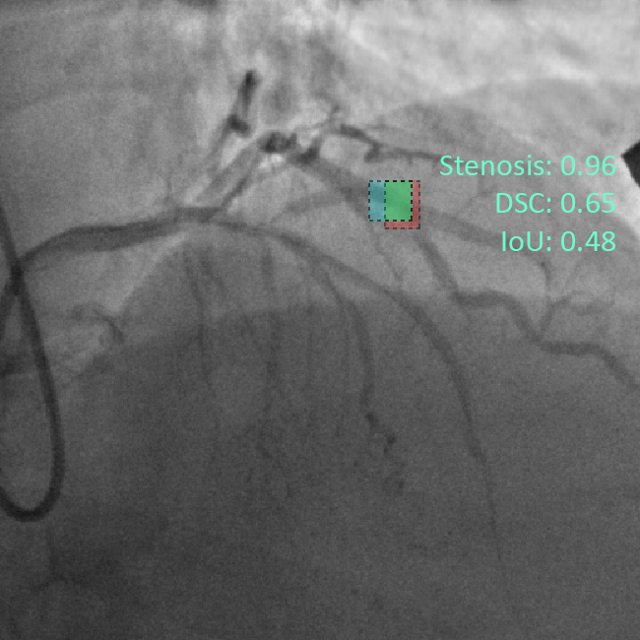
(a) SSD MobileNet V1 | (b) SSD MobileNet V2
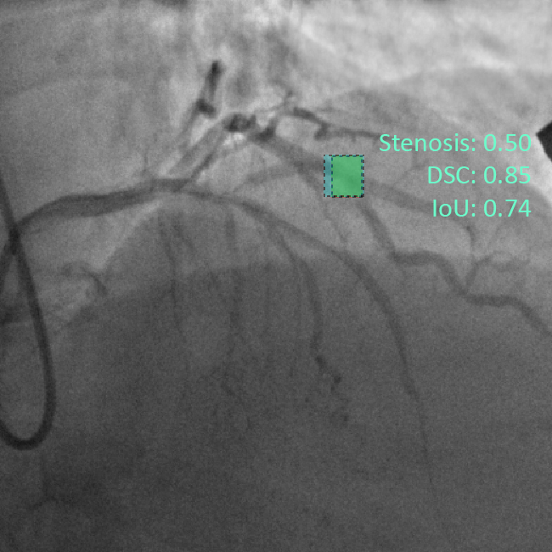 | 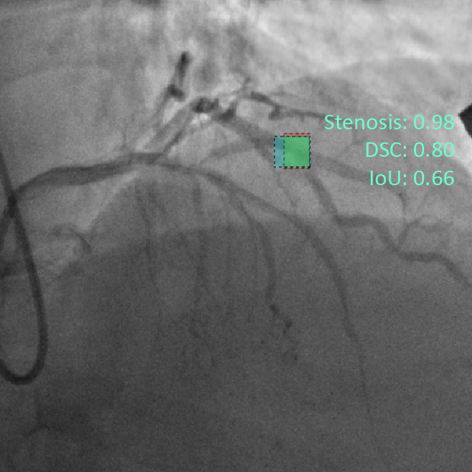
(c) SSD ResNet-50 V1 | (d) Faster-RCNN ResNet-50 V1
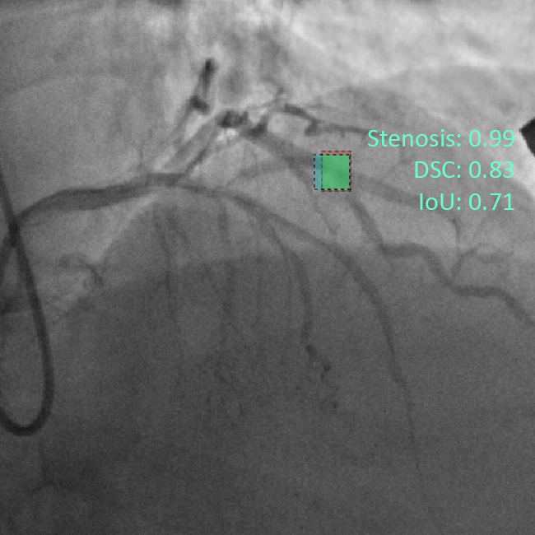 | 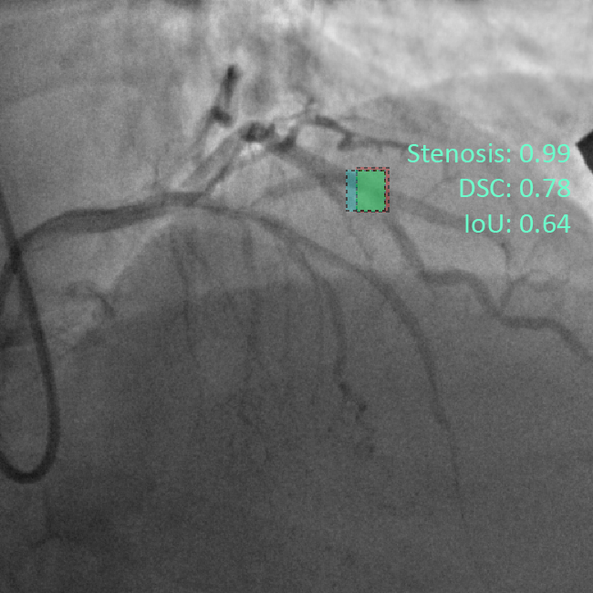
(e) RFCN ResNet-101 V2 | (f) Faster-RCNN ResNet-101 V2
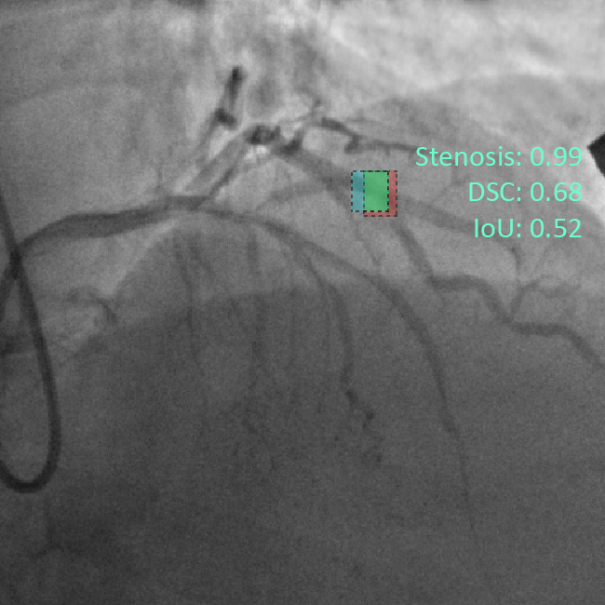 | 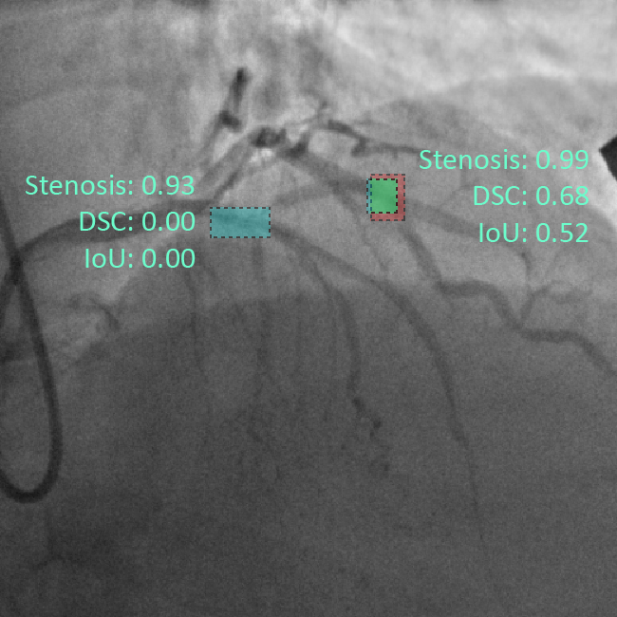
(g) Faster-RCNN Inception ResNet V2 | (h) Faster-RCNN NASNet

