Appendix for: The add-on effects of Danhong injection among patients with ischemic stroke receiving western medicines: A systematic review and
meta-analysis

Appendix 2 Supplementary figures

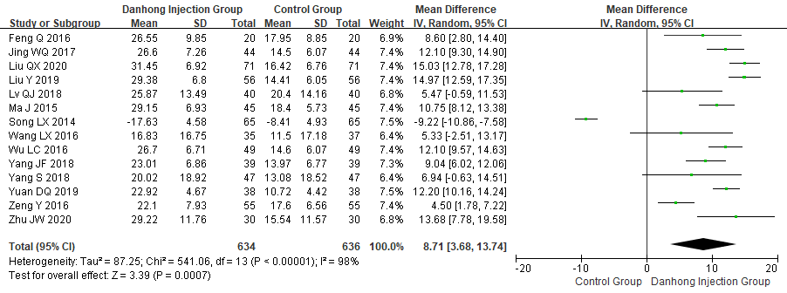
Figure S1. Meta-analysis of Barthel index between DHI+WM and WM in patients with Ischemic Stroke

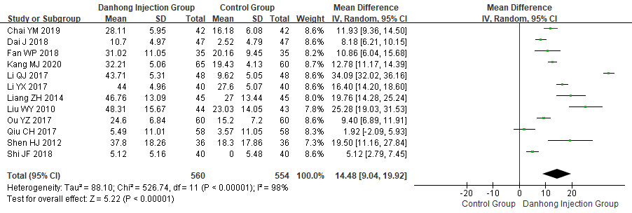
Figure S2. Meta-analysis of ADL between DHI+WM and WM in patients with Ischemic Stroke

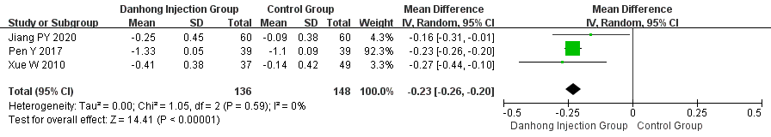
Figure S3. Meta-analysis of IMT between DHI+WM and WM in patients with Ischemic Stroke

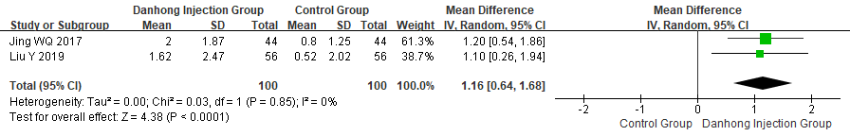
Figure S4. Meta-analysis of Cerebral Blood Flow between DHI+WM and WM in patients with Ischemic Stroke

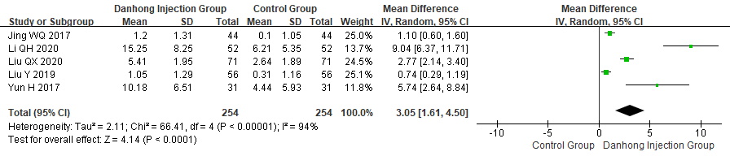
Figure S5. Meta-analysis of Average Cerebral Blood Flow Rate between DHI+WM and WM in patients with Ischemic Stroke

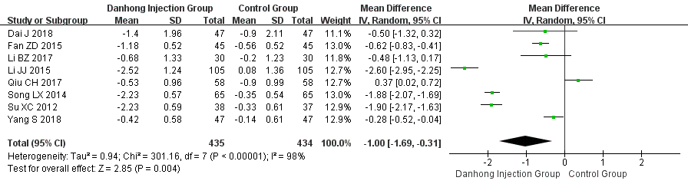
Figure S6. Meta-analysis of triglycerides between DHI+WM and WM in patients with Ischemic Stroke

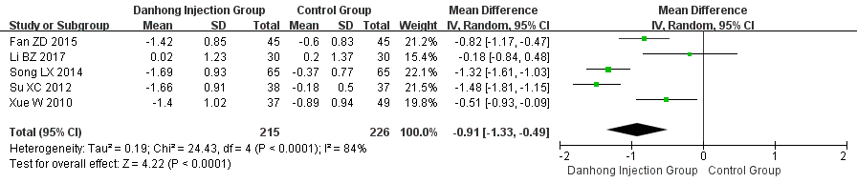
Figure S7. Meta-analysis of LDL between DHI+WM and WM in patients with Ischemic Stroke

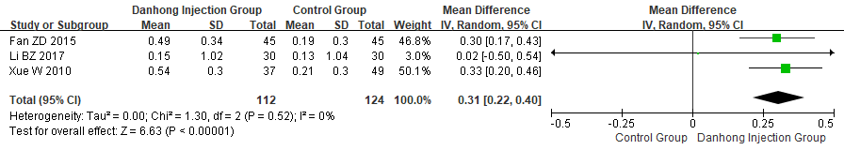
Figure S8. Meta-analysis of HDL between DHI+WM and WM in patients with Ischemic Stroke

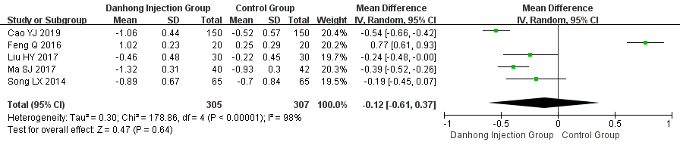
Figure S9. Meta-analysis of D-dimer between DHI+WM and WM in patients with Ischemic Stroke
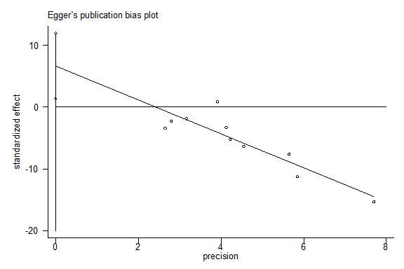
Figure S10. Egger’s publication bias plot of total cholesterol

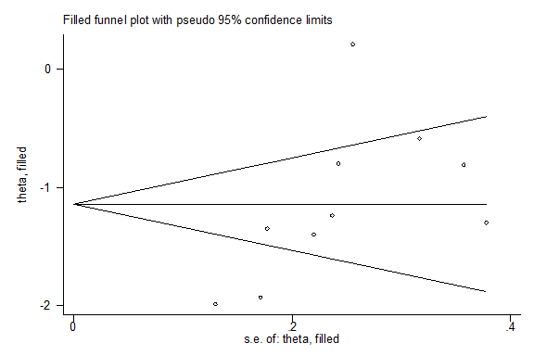
Figure S11. Filled funnel plot of total cholesterol from studies that investigated the association between the efficacy of DHI and WM. The circles are real studies and the trim-and-fill analysis estimating there were no possible missing studies. The horizontal line represents the summary effect estimates, and the diagonal lines represent pseudo-95% CI limits

