Chemometric approach to evaluate the chemical behavior of rainwater at high altitude in Shaune Garang catchment, Western Himalaya

Ramesh Kumar^{1*}, Rajesh Kumar¹, Atar Singh¹, Mohammad Arif², Pankaj Kumar³, Anupma Kumari⁴
¹Department of Environmental Science, School of Earth sciences, Central University of Rajasthan, Bandar Seendri, Ajmer, India.
²Directorate of Green India Mission, Ministry of Environment, Forest and Climate Change, New Delhi, India
³Integrated Regional Office, Ministry of Environment, Forest & Climate Change (MoEFCC), Govt. of India, Saifabad, Hyderabad, Telangana, 500004, India
⁴Environmental Biology Laboratory, Department of Zoology, Patna University, Patna, India.
*Corresponding Author: rameshkumar9234@gmail.com
b
a
Figure S1: Diurnal variation of in situ water parameters a) pH, b) Specific conductivity during the study period 2017 in Shaune Garang catchment.

Figure S2: Linear regression analysis between rainfall (mm) and H⁺ (Hydrogen Ion Concentration (µeq/l).

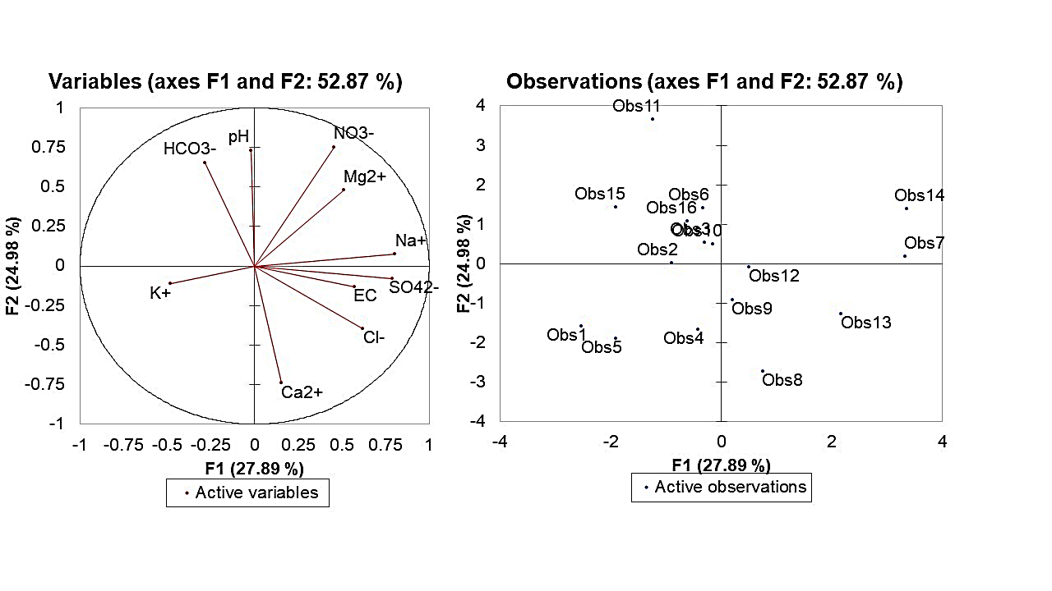
a.
b.
Figure S3: a. Loadings of the chemical constituent of the first two factors. b. Score plot of the first two scores.
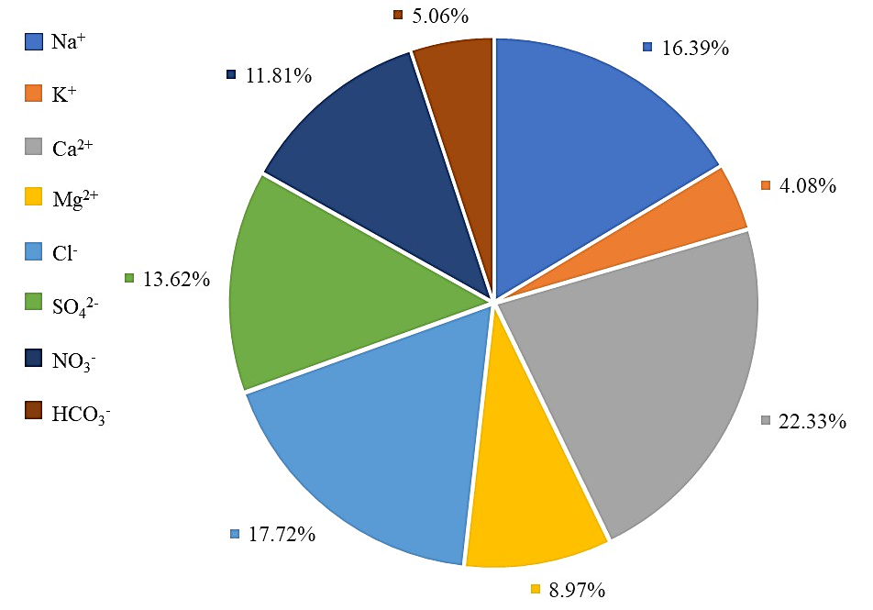
Figure S4: Percentage contribution of measured ionic species in rainwater in Shaune Garang catchment.

Table S1. Concentration (μeq/l) of ionic species of rainwater during the summer monsoon season of the year 2017.
Parameters | Min | Max | Avg. | SD | VWM
pH | 4.59 | 6.73 | 5.47 | 0.72 | 5.56
Na⁺ | 15.23 | 56.45 | 27.66 | 10.66 | 27.35
K⁺ | 2.31 | 12.98 | 6.56 | 3.25 | 6.86
Ca²⁺ | 18.92 | 56 | 37.13 | 12.23 | 35.7
Mg² | 3.65 | 21.45 | 13.98 | 4.57 | 17.61
Cl⁻ | 11.26 | 56.21 | 31.28 | 16.59 | 29.47
SO₄²⁻ | 11.51 | 48.29 | 23.83 | 11.98 | 22.32
NO₃⁻ | 3.65 | 36.17 | 18.75 | 8.75 | 20.61
HCO₃⁻ | 2.36 | 18.26 | 8.09 | 3.64 | 7.71
NH₄ | 3.14 | 30.0 | 14.87 | 5.95 | 14.56

Table S2: The ionic ratio of the observed ionic concentration in the rainwater from Shaune Garang catchment (unit in µeq/l).
Parameters | Minimum | Maximum | Average | STD
H⁺/ NO₃⁻ + SO₄²⁻ | 0.02 | 0.17 | 0.07 | 0.04
NO₃⁻ / SO₄²⁻ | 0.24 | 2.47 | 0.97 | 0.60
NH₄⁺ / NO₃⁻ | 0.42 | 1.00 | 0.81 | 0.21
NH₄⁺ / SO₄²⁻ | 0.21 | 1.46 | 0.73 | 0.38
Ca²⁺ + NH₄⁺ / NO₃⁻ + SO₄²⁻ | 0.48 | 2.75 | 1.34 | 0.51
NO₃⁻ + Cl⁻ / SO₄²⁻ | 1.08 | 4.60 | 2.38 | 0.91
NO₃⁻ + SO₄²⁻ / Ca²⁺ + Mg²⁺ | 0.36 | 2.07 | 0.87 | 0.39

Table S3: Neutralization factors (NF) for selected chemical parameters of Shaune Garang catchment compared with some previous studies in India.
Studies | K⁺ | Na⁺ | Ca²⁺ | Mg²⁺ | NH₄ | References
Shaune Garang, Himachal Pradesh | 0.15 | 0.63 | 0.85 | 0.34 | 0.39 | Present study
Kothi, Himachal Pradesh | 0.12 | 0.5 | 0.71 | 0.24 | 0.31 | Tiwari et al., 2012
Manora Peak, Nainital, Uttarakhand | 1.28 | 1.63 | 4.08 | 1.42 | 0.32 | Bisht et al., 2017
Singhagad, Western Ghat | 0.06 | 0.77 | 0.74 | 0.38 | 0.11 | Budhavant et al., 2014
Mahabaleshwar | 0.13 | 1.45 | 1.86 | 0.65 | 0.24 | Waghmare et al., 2021
Pune, Southwest India | 0.08 | - | 1.4 | 0.29 | 0.29 | Rao et al., 2016
Delhi, Northern India | 0.04 | - | 1.4 | 0.49 | 0.17 | Rao et al., 2016
Brahmaputra Valley, Tezpur 2012-18 | 0.39 | 0.5 | 1.01 | 0.28 | 1.02 | Ahmed et al., 2021

Table S4: Comparison of equivalent concentration ratios of various ionic species concerning sodium ion (Na⁺) along with seawater ratio, sea salt, and non-sea salt (nss) fractions (%) at Shaune Garang catchment.
 | Cl⁻/ Na⁺ | Mg²⁺/ Na⁺ | K⁺/ Na⁺ | Ca²⁺/ Na⁺ | SO₄²⁻/ Na⁺
Seawater Ratio | 1.16 | 0.22 | 0.02 | 0.04 | 0.12
Shaune Garang | 1.14 | 0.54 | 0.24 | 1.35 | 0.87
SSF | 98.27 | 40.74 | 8.33 | 2.96 | 13.79
NSSF | 1.73 | 59.26 | 91.67 | 97.04 | 86.21

Table S5: Enrichment factors (EF) of chemical parameters in rainwater of Shaune Garang catchment and comparison with previous studies.
Enrichment Factor | Cl⁻ | Mg²⁺ | K⁺ | Ca²⁺ | SO₄²⁻ | References
Shaune Garang, Himachal Pradesh | 0.98 | 2.45 | 12.0 | 33.75 | 7.25 | Present Study
Kothi, Himachal Pradesh | 1.05 | 1.98 | 10.9 | 32.23 | 9.32 | Tiwari et al., 2012
Monera Park Nainital, Uttarakhand | 1.18 | 3.79 | 38.07 | 61.73 | 3.28 | Bisht et al., 2017
Panipat, Haryana | 1.08 | 7.84 | 46.79 | 142.6 | 51.12 | Tiwari et al., 2008
NTPC Dadri, Uttar Pradesh | 1.02 | 6.5 | 2.61 | 11.26 | 3.64 | Salve et al., 2011
Lucknow, Uttar Pradesh | 1.10 | 17.8 | 1.04 | 106.4 | 12.10 | Khare et al., 2004
New Delhi | 1.70 | 1.76 | - | 50.34 | 184.7 | Kulshrestha et al., 1995
Bhubaneswar, Odisha | 0.9 | 9.08 | - | 5.81 | 4.15 | Das et al., 2010
Sinhagad, Western Ghats | 1.03 | 1.49 | 2.72 | 15.68 | 7.94 | Budhavant et al., 2009
Panipat, Haryana | 1.08 | 7.84 | 46.79 | 142.6 | 51.12 | Tiwari et al., 2008
Rameswaram, Tamil Nadu | 1.07 | 4.14 | 2.61 | 5.44 | 1.61 | Salve et al., 2011

Table S6: The correlation coefficient among the measured ionic constituents.
Variables | pH | EC | Na⁺ | K⁺ | Ca²⁺ | Mg²⁺ | Cl⁻ | SO₄²⁻ | NO₃⁻ | HCO₃⁻
pH | 1
EC | -0.031 | 1
Na⁺ | -0.045 | 0.422 | 1
K⁺ | -0.084 | -0.529 | -0.297 | 1
Ca²⁺ | -0.563 | 0.097 | -0.122 | 0.121 | 1
Mg²⁺ | 0.295 | -0.090 | 0.072 | -0.224 | -0.481 | 1
Cl⁻ | -0.117 | 0.152 | 0.562 | 0.007 | 0.507 | 0.016 | 1
SO₄²⁻ | 0.006 | 0.365 | 0.688 | -0.068 | 0.275 | -0.009 | 0.502 | 1
NO₃⁻ | 0.519 | 0.225 | 0.121 | -0.042 | -0.444 | 0.673 | -0.088 | 0.678 | 1
HCO₃⁻ | 0.405 | -0.206 | -0.181 | 0.278 | -0.220 | 0.045 | -0.410 | -0.068 | 0.536 | 1

