Supplementary figures
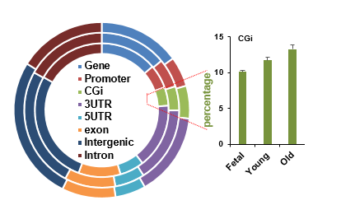
S Figure 1. Genome-wide methylation profiles of RRBS. Genomic distribution of differentially methylated regions (DMRs) according to the genomic features in the Reduced Representation Bisulfite Sequencing (RRBS) data in different ages of MSCs.

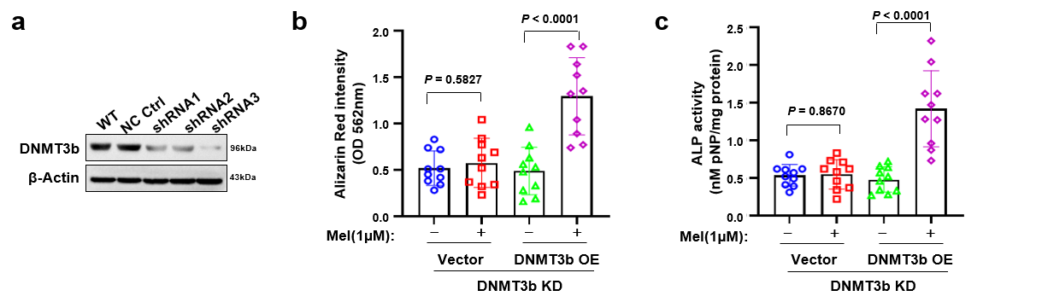
S Figure 2. Quantification for osteogenesis of the DNMT3b knockdown MSCs. (a) Efficacy of DNMT3b knockdown by lentivirus carrying shRNA after 72 hours. Quantification of Alizarin Red S staining (b) and ALP staining (c) of the DNMT3b-knockdown MSCs with or without DNMT3b overexpression and then treated with DMSO or 1 µM melatonin (n = 10). The values represent mean ± standard error of the mean (SEM) (n = 3 with each detection triplicated). All Western blot results are representative examples of three independently performed studies, each yielding similar results.

