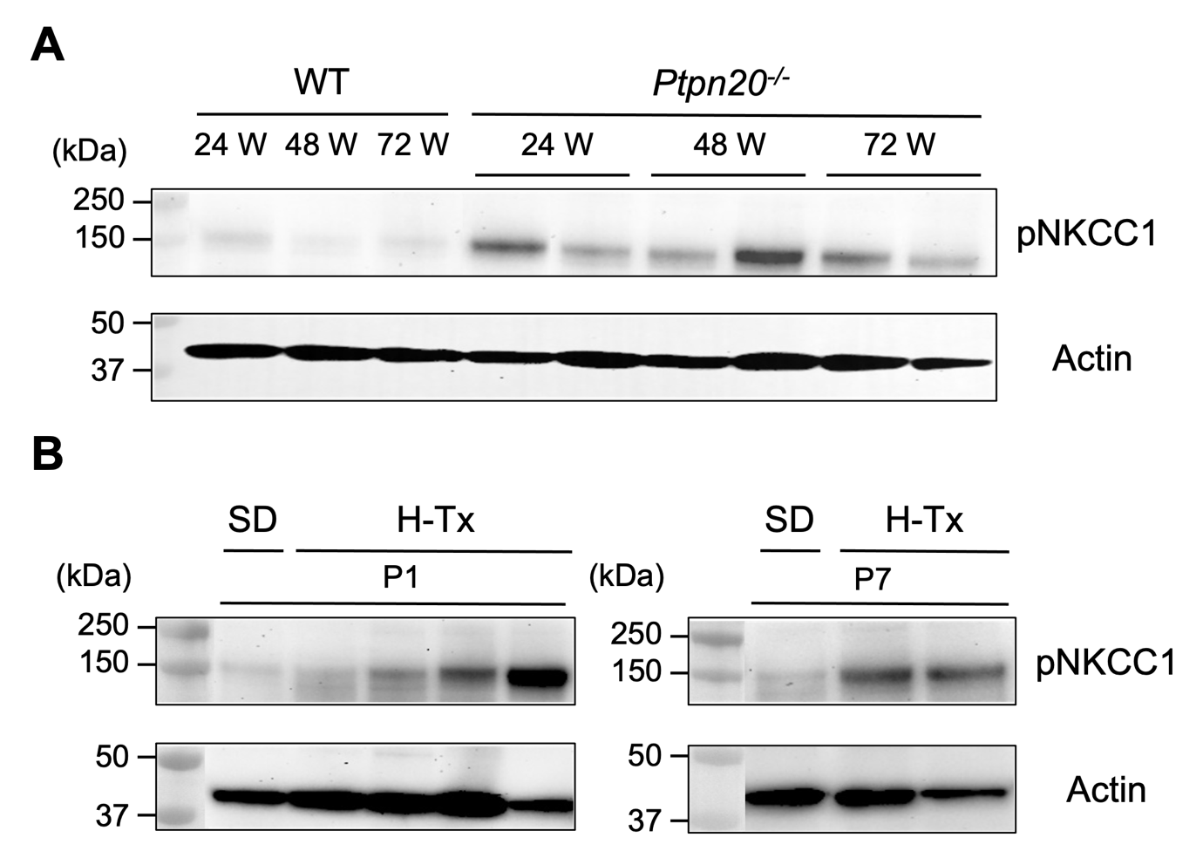
Figure S3. Immunoblotting of pNKCC1 protein expression in aged Ptpn20^{-/-} mice and H-Tx rats.
A. Immunoblotting of pNKCC1 protein expression in the choroid plexus (CP) of wild-type (WT) and Ptpn20^{-/-} mouse at 24, 48 and 72 weeks (W). The level of pNKCC1 remained elevated for a longer period in Ptpn20^{-/-} mice than in WT.
B. Immunoblotting of pNKCC1 protein expression in the CP of SD and H-Tx rats at P1 and P7. Expression of pNKCC1 is higher in the CP of most H-Tx rats than in SD rats. Actin is used as the loading control.

