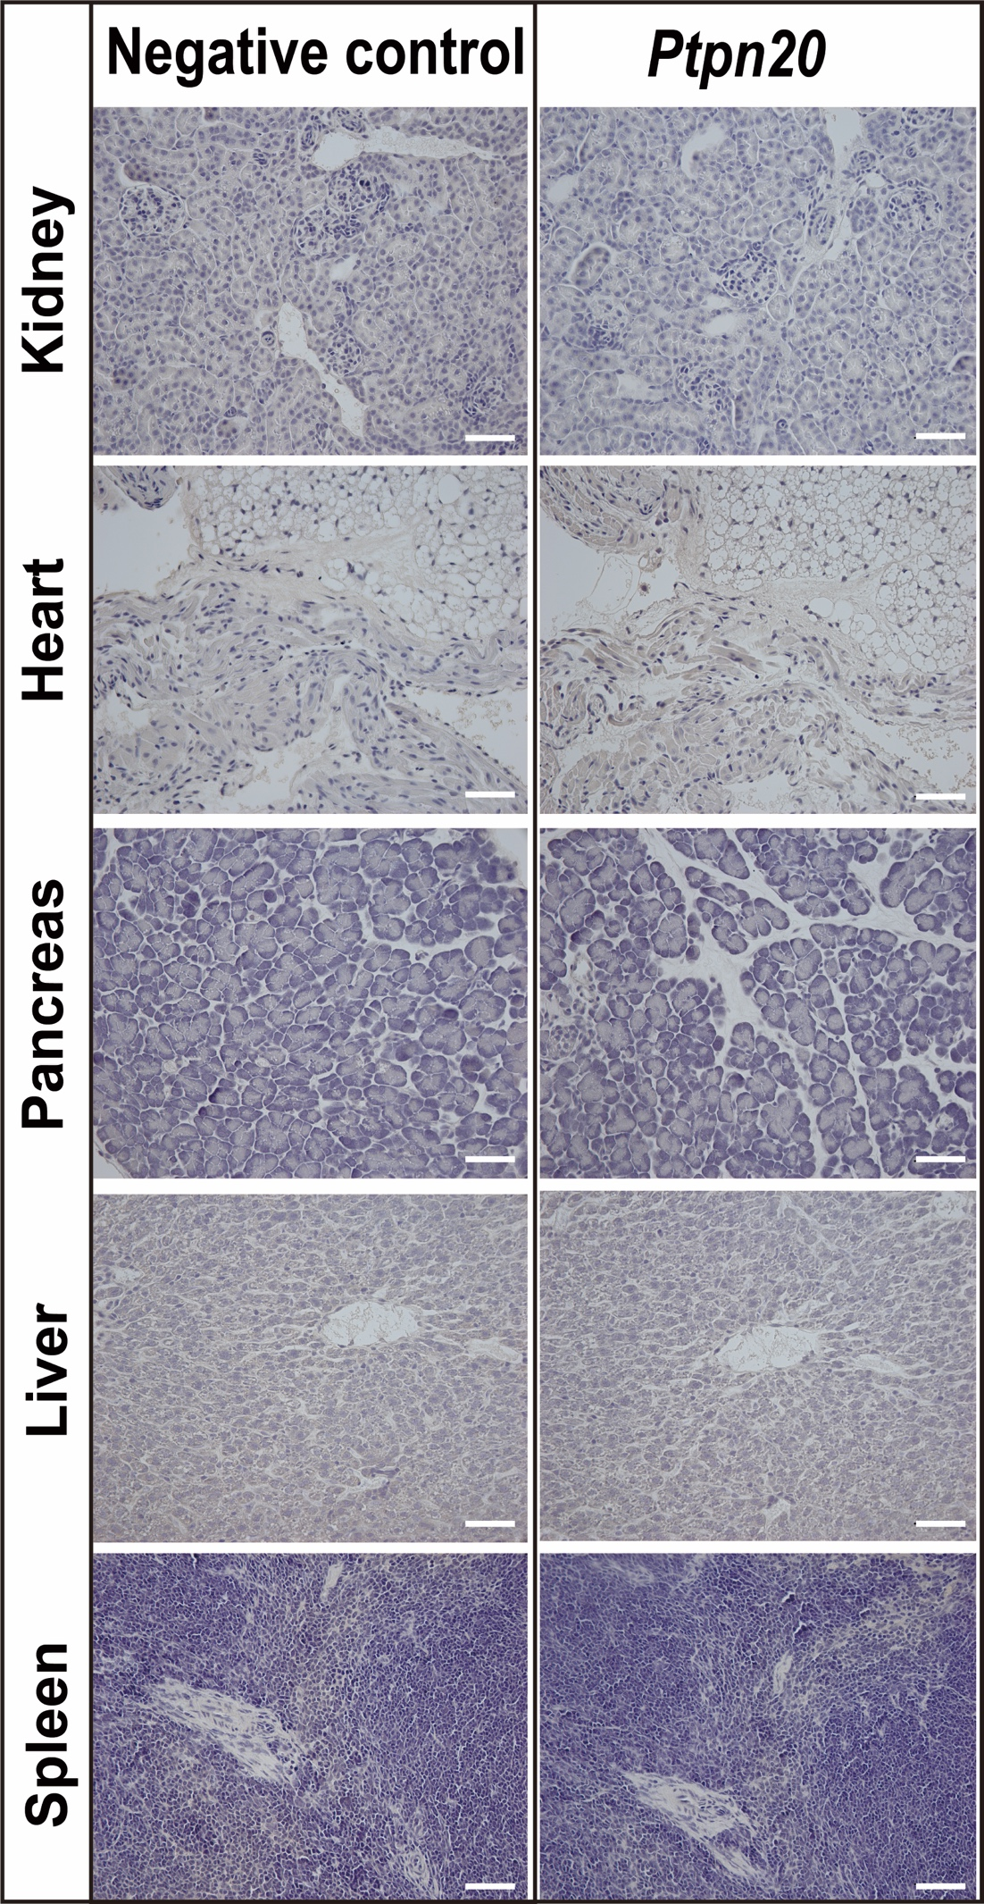
Figure S2. Ptpn20 expression in the tissues of mice.
Representative photomicrographs of immunohistochemistry staining with anti-Ptpn20 antibody in the heart, lung, spleen, pancreas, and liver from 4-week-old C57BL/6J mice. Scale bar = 50 µm.

