Supplementary material

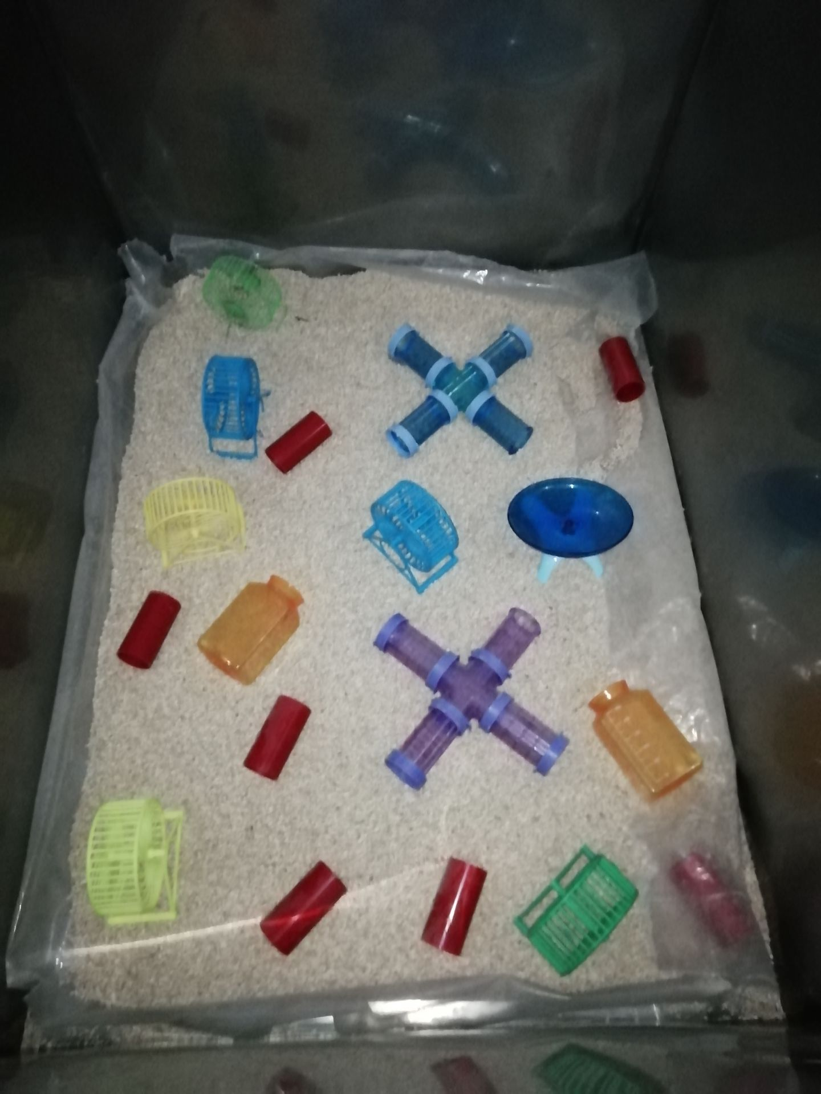

Supplementary Fig. 1

Supplementary Fig. 1 and Supplementary Videos 1-3. Enriched environment (EE) housing conditions. The EE contained two modified cages, running wheels, igloos with saucer wheels, plastic tubing, and other toys. Six to eight mice were exposed to an EE for 6 h/day every day from 8:00 am to 2:00 pm. The toys were replaced and rearranged into a new configuration every day to stimulate the exploratory behavior of the mouse. Video 1 shows mouse activity in an EE setting on day 7 after intracerebral hemorrhage (ICH). Some mice exercise on running wheels or igloos with saucer wheels, and others move back and forth through a maze of plastic tubing-videos 2, 3 show how the fore-limb and hind-limb tests were detected.

Supplementary Fig. 2
Supplementary Fig. 2. The overall mortality of mice in the sham group, only with intracerebral hemorrhage (ICH), and the ICH group exposed to an enriched environment (EE). No mice died in the sham group; the overall mortality was 6.3% (5 out of 79) in the ICH-only group and 6.6% (5 out of 76) in the ICH+EE group.

Supplementary Fig. 3
Supplementary Fig. 3. There is no difference in the forced swim test (FST), the light/dark transition test, the open-field test (OFT), and the novel object recognition (NOR) test on day 28 among the control, sham, and control + EE group. (A) FST test. (B) Distance in the center area of the open field. (C) Time in the center area of the open field. (D) The time of the lightbox in the light/dark transition test. (E) The time of the black box in the light/dark transition test. (G) The discrimination index in the NOR test. n=6-9 mice/group; Data are expressed as mean ± SD.
Abbreviation：con: control

Supplementary Fig. 4
Supplementary Fig. 4. The volume of liquid consumed in the sucrose preference test. The total liquid consumed, including sucrose and water, did not differ among the sham group, the intracerebral hemorrhage (ICH) group, and the ICH group exposed to an enriched environment (EE). n=8 mice/group.

Supplementary Fig. 5. Raw imaging of Western blots shown in Figs. 6A-B. Western blot analysis of Nrf2 and BDNF expression in perihematomal tissue on day 28 after intracerebral hemorrhage (ICH). EE exposure significantly increased Nrf2 and BDNF expression. n=6 mice/group.

