Supplementary Information

Multi-nozzle electrospray method for high-throughput uniform superhydrophobic coating
Md. Abu Mosa^{1, 2}, Se Hyun Kim², Kye-Si Kwon^{1,2*}

¹Department of Electronic Materials and Devices Engineering, Soonchunhyang University,
22, Soonchunhyang-ro, Asan city, Chungnam, 31538, South Korea,
²Department of Physics, European University of Bangladesh, Dhaka-1216, Bangladesh,
³Department of Mechanical Engineering, Soonchunhyang University, 22, Soonchunhyang-ro, Asan city, Chungnam, 31538, South Korea

*Corresponding author: Prof. Kye-Si Kwon, Ph. D.
Department of Electronic Materials and Devices Engineering, Soonchunhyang University, 22, Soonchunhyang-ro, Asan city, Chungnam, 31538, South Korea
Email: kskwon@sch.ac.kr
This PDF file includes:
Supplementary Information Text
Figures S1 to S7

Other Supplementary data for this manuscript include the following:
Movie S1 to Movie S7

Supplementary information text
S1. Cross talk behaviors according to nozzle-to-nozzle distance
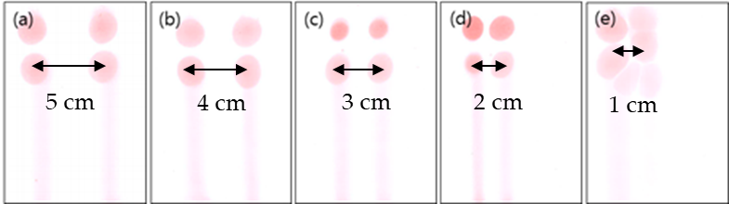
Figure S1. Spray deposition behaviors of two nozzle spray according to nozzle-to-nozzle distance.
The electric field interference (crosstalk) between two nozzles depends on the nozzle-to-nozzle distance. For better observation of spray deposition behaviors, colored ink (XL30 fluid-red, Fujifilm, USA) was used. Electrospray deposition on paper was performed by adjusting the nozzle spacing from 1 to 5 cm. The experimental results are shown in Figure S1. As the nozzle spacing decreased, the deposition shapes could be affected accordingly. When the nozzle-to-nozzle distance was as close as 1 cm, the multi-jet was observed due to the crosstalk.
S2. Plasma treatment
To improve the adhesion properties of the surface, plasma pre-treatment was performed at atmospheric pressure using a RF-driven argon and oxygen mixed plasma source (REX-300, RF Power Tech, South Korea). Figure S2 shows the schematic of the atmospheric pressure plasma treatment process. The mixing ratio of argon and oxygen gas and plasma power were 7 slpm (standard liter per minute) and 10 sccm (standard cubic centimeter per minute), respectively. The intensity of the plasma was controlled by adjusting the moving speed of the plasma head and the distance between the plasma head and substrates.
The plasma treatment could lead to better wettability condition on substrates. To roughly estimate plasma effects, 20 µL of water was dropped on (PCB) substrate to measure the droplet diameter. A micropipette was used to control the amount of water. The diameter before and after plasma treatment is shown in Figure S3(a) and S3(b).
There are two main parameters for plasma treatment: 1) plasma scanning speed and 2) distance between plasma head and substrates.
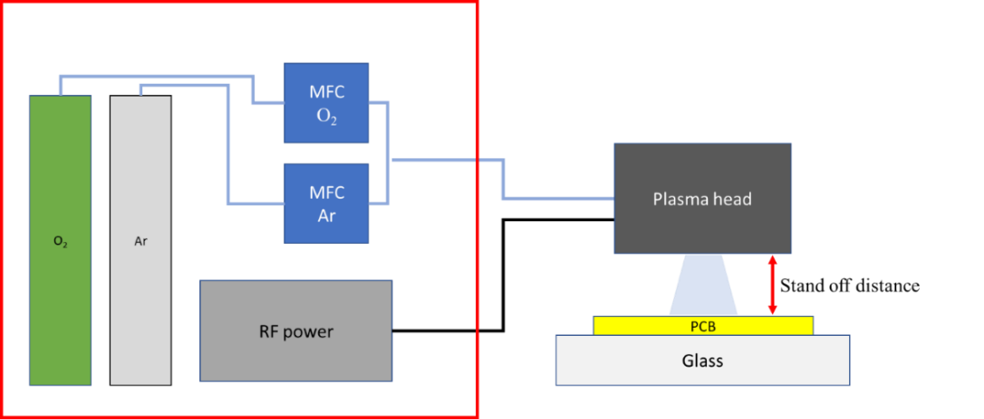
Figure S2. Schematic of the plasma treatment.
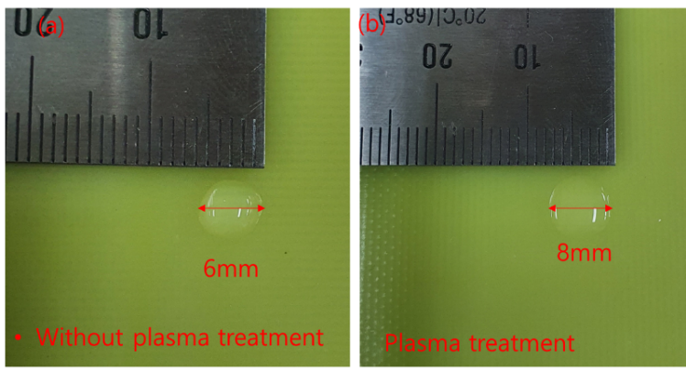
Figure S3. Comparison of the droplet size of 20 µL water droplet on a PCB substrate (a) without and (b) with plasma treatment.
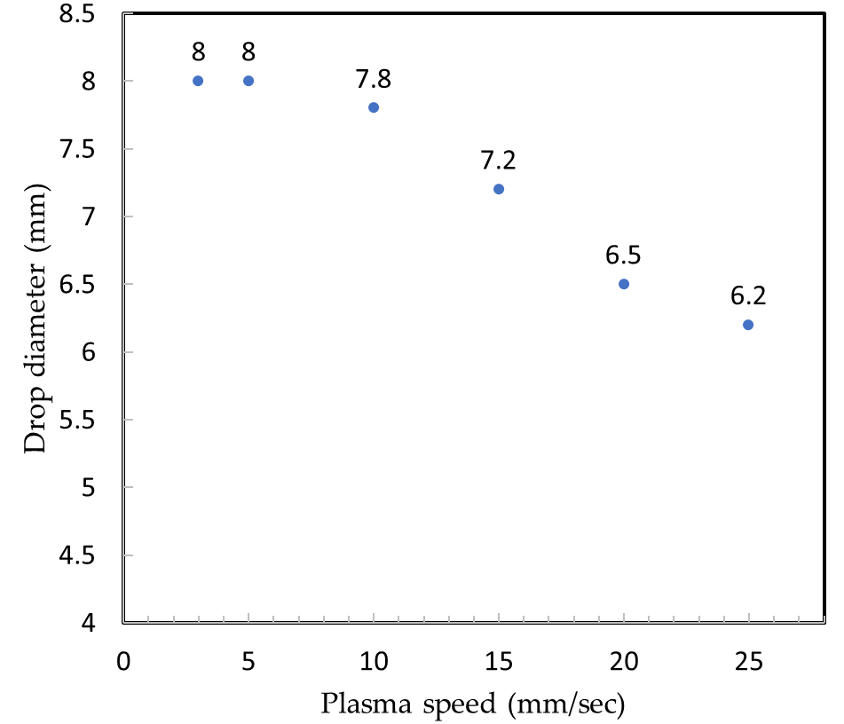
Figure S4. Plasma effect on spreading with respect to plasma head movement speed (distance between plasma head and substrate is 3 mm): 20 µL water droplet diameter was measured after plasma treatment.
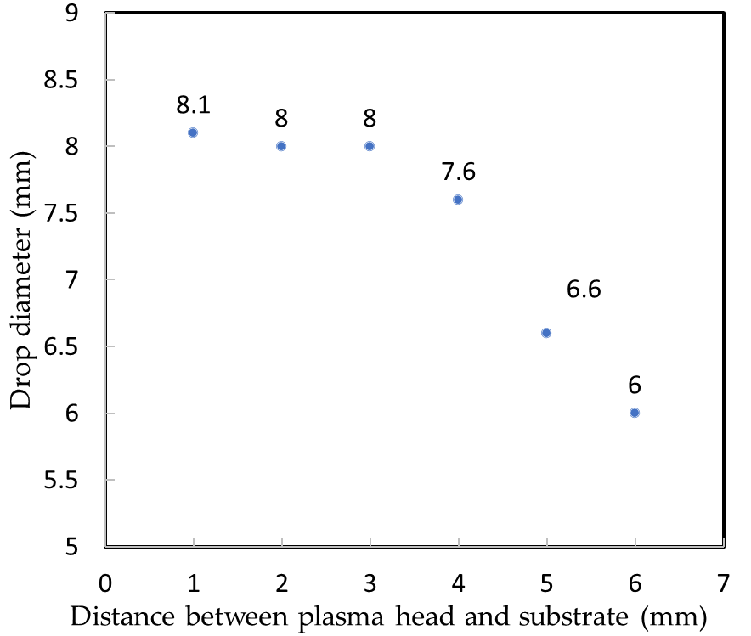
Figure S5. Plasma effect graph with respect to the distance (D) between the plasma head and the substrate (scanning speed 5 mm/s).
Figure S4 shows the scanning speed effect on spreading when the distance between the plasma head and the substrate was maintained to 3 mm. The wettability was significantly reduced according to the plasma head moving speed because the effective irradiation time reduces with increasing speed. If the scanning speed became more than 25 mm/s, the diameter of the droplet was almost the same (about 6.2 cm) as that of a non-treated substrate (6 cm). From the experimental results, we selected 5 mm/s for scanning speed, which can maximize the wettability. To investigate the stand-off distance effects on wettability, drop sizes on the substrate are measured when different distance is used for plasma scanning. As shown in Figure S5, when the distance (D) as short as 1-3 mm, the spreading size could be largest.
Based on the experimental results, the distance from the plasma head to the substrate was set to 3 mm and the plasma head movement speed was set to 5 mm/s.

S3. Photo of the hot blower and flow duct
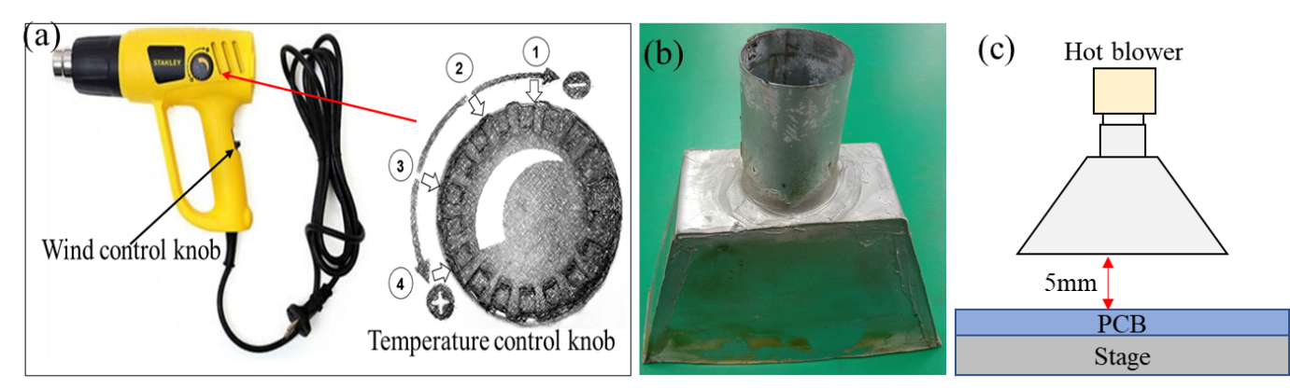
Figure S6. (a) Photo of the hot blower with temperature and wind control knob [There are two levels adjustment for wind speed and four level adjustment for power (temperature adjustment)], (b) photo of the flow duct and (c) schematic of the heating unit: hot blower is combined with the flow duct.
S4. Surface roughness

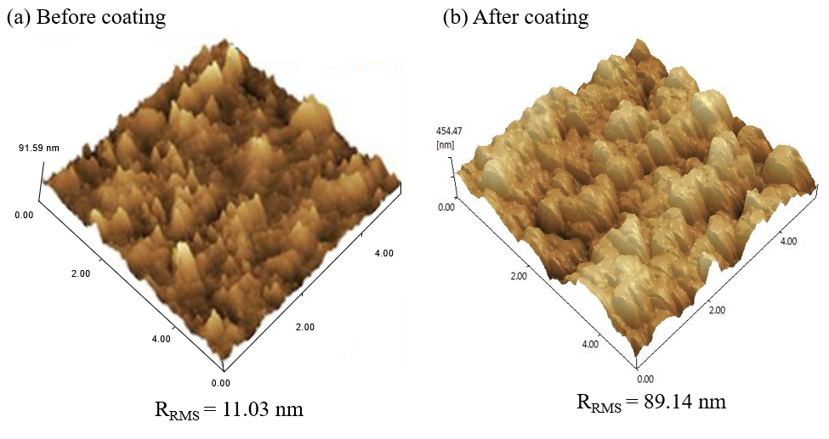
Figure S7. Atomic force microscopy (AFM): 3D image of the silica-coated PCB surface using electrospray method (a) before coating and (b) after coating.
The contact angles of coated layers according to the hot blower distance (D) are shown in Figure 7 (main text), which explains that the D should be more than 90 mm in order to ensure super-hydrophobicity with contact angles more than 150 degrees. The superhydrophobic surface is caused by micro/nano hierarchical roughness. We measured the roughness of the coated and uncoated samples in terms of the root means square roughness (R_{RMS}) with specified scan area ($5μm ×5 μm).$ Figure S7 shows AFM image of the PCB substrate before and after coating. The surface roughness of the uncoated PCB film was 11.03 nm. Using the AC-based multi-nozzle electrospray, the surface roughness (R_{RMS}) increased to 89.14 nm.

