Inhibition of DDR1 and DDR2 receptors: The potential therapeutic option to treat pancreatic fibrosis demonstrated in experimental chronic pancreatitis model
Sapana Bansod, Mohd Aslam Saifi, Chandraiah Godugu*

Department of Regulatory Toxicology, National Institute of Pharmaceutical Education and Research (NIPER), Balanagar, Hyderabad, Telangana, India

Running Head: DDRs receptors: a promising target for chronic pancreatitis

*Correspondence:
Dr. Chandraiah Godugu, Assistant Professor,
Department of Regulatory Toxicology,
National Institute of Pharmaceutical Education and Research (NIPER),
Balanagar, Hyderabad,
Telangana State, India-500037
Telephone: 040-23073741 Fax: 040-23073751
E-mail: chandragodugu@gmail.com, chandra.niperhyd@gov.in

Materials and Methods
Statement
Animals were kept in well-controlled housing facilities at temperature (25 ± 2°C) and 12/12 hr light/dark cycle with free access to water as ad libitum and pellet food. The Animal experiments were designed, conducted and reported as per the ARRIVE guidelines [18]. Specifically, all the animal experiments were performed according to the Committee for the Purpose of Control and Supervision of Experiments on Animals (CPCSEA), which is the approval body for animal experimentation in India. The CPCSEA certified Institutional Animal Ethical Committee (IAEC) of National Institute of Pharmaceutical Education and Research (NIPER)-Hyderabad, has reviewed the animal protocol and approved it (IAEC Protocol Approval No.: NIP/01/2019/RT/365).
Male Swiss albino mice (age: 6–8 weeks, body weight 25-30 g) were purchased from Palamur Biosciences Pvt. Ltd, Mahabubnagar, India. Mice were randomly divided into 6 groups (7 mice per group, n = 42).
Supplementary Figure 2
Original western blots for the images shown in Figure 2. The cropped images are shown here.
Actin
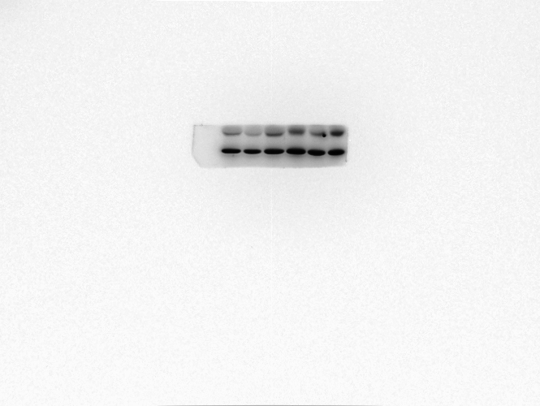
DDR1
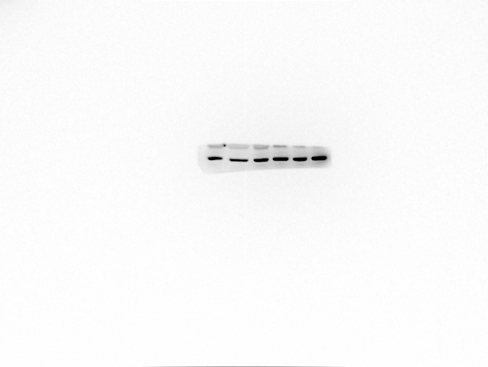

pDDR1

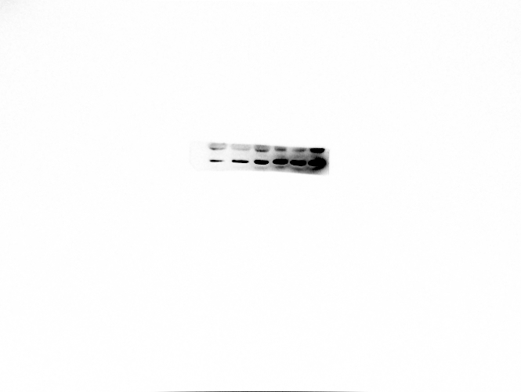

DDR2
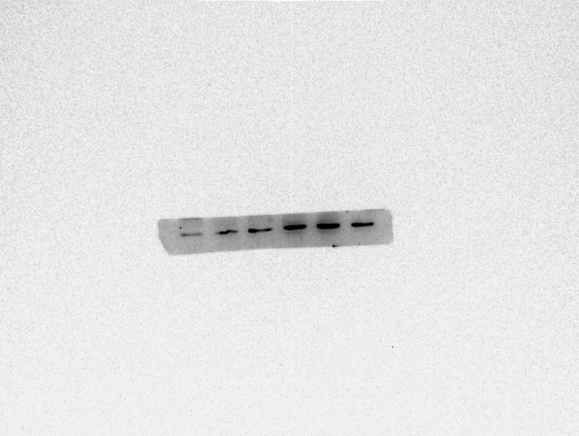

Collagen 1a
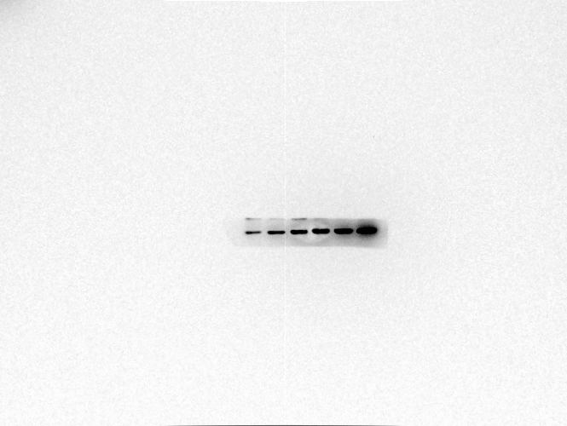

Supplementary Figure 3
Original western blots for the images shown in Figure 2. The cropped images are shown here.

Actin
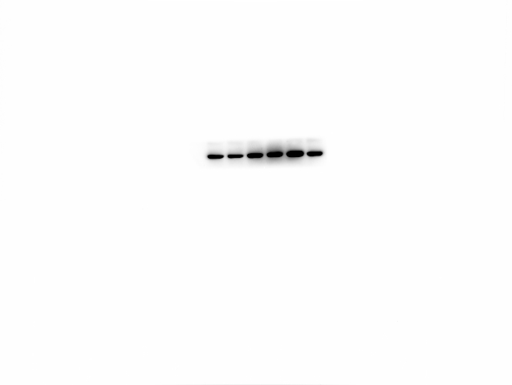

DDR2
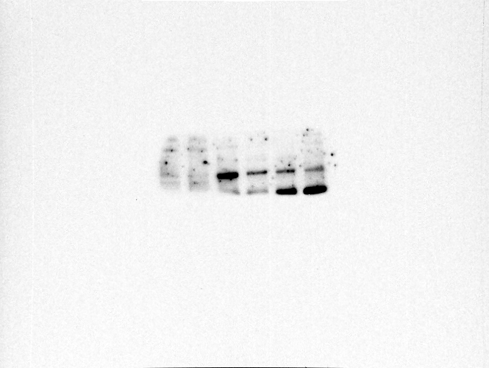
DDR1
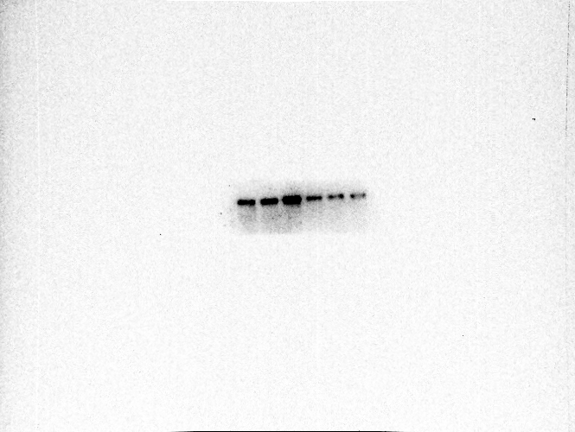

pDDR1
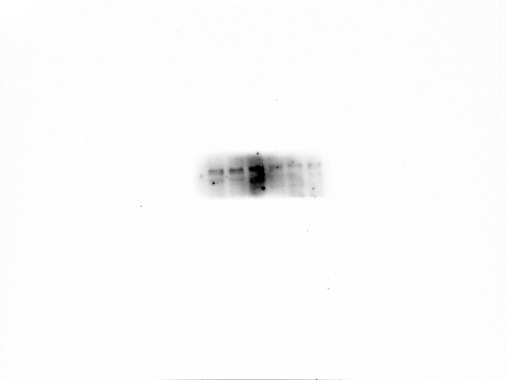
Collagen3a
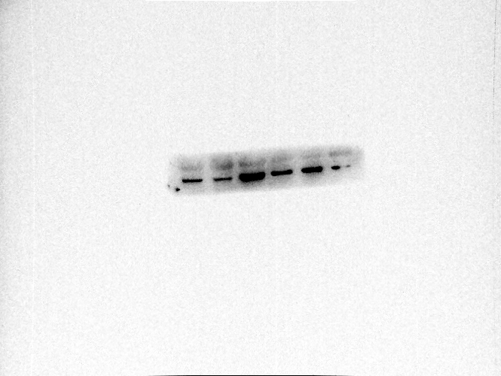

Collagen1a
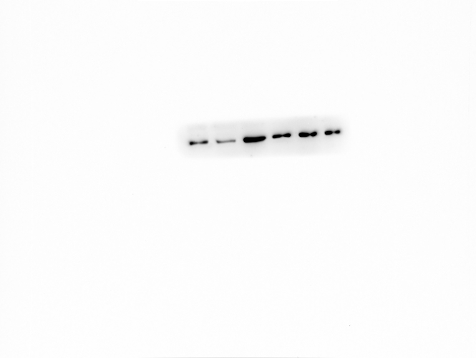

Supplementary Figure 5
Original western blots for the images shown in Figure 2. The cropped images are shown here.
Actin
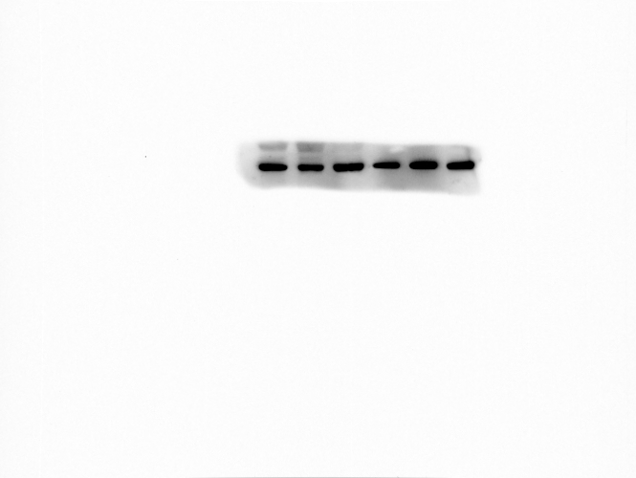

NF-κB
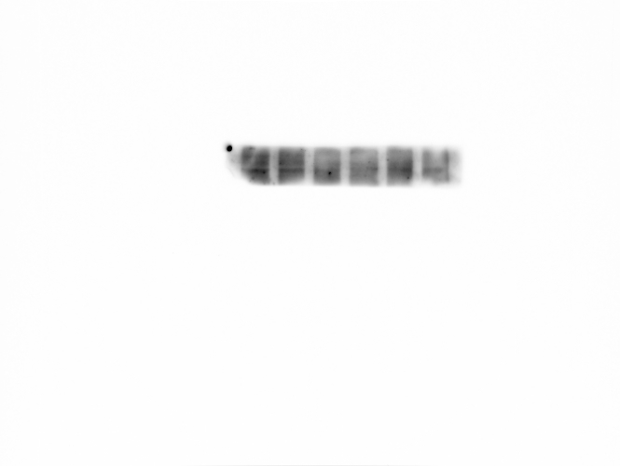
pNF-κB
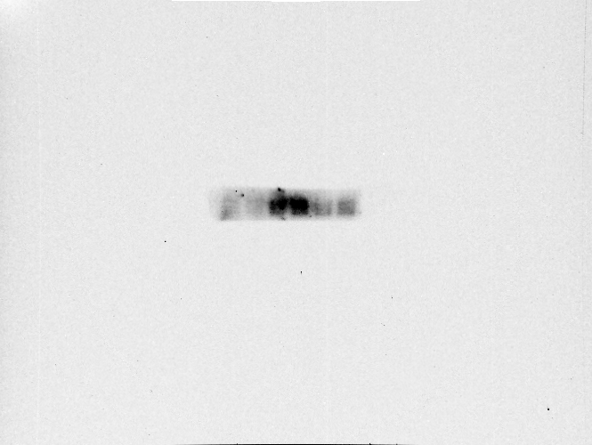

Supplementary Figure 6
Original western blots for the images shown in Figure 2. The cropped images are shown here.
Actin
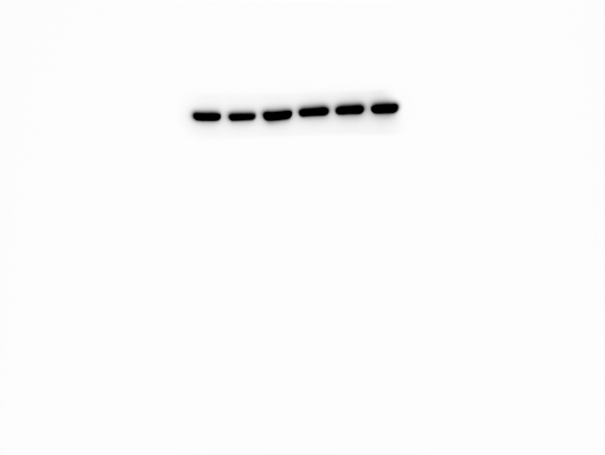

α-SMA

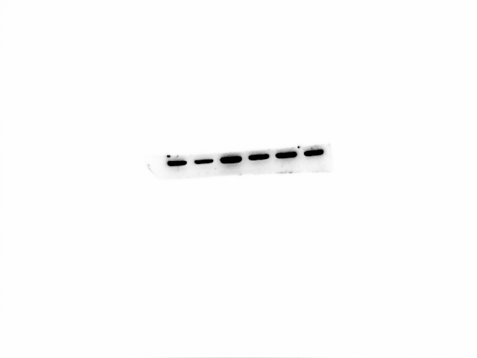

Supplementary Figure 7
Original western blots for the images shown in Figure 2. The cropped images are shown here.
Actin
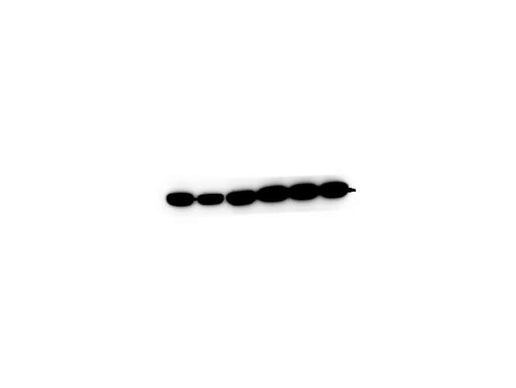
CTGF
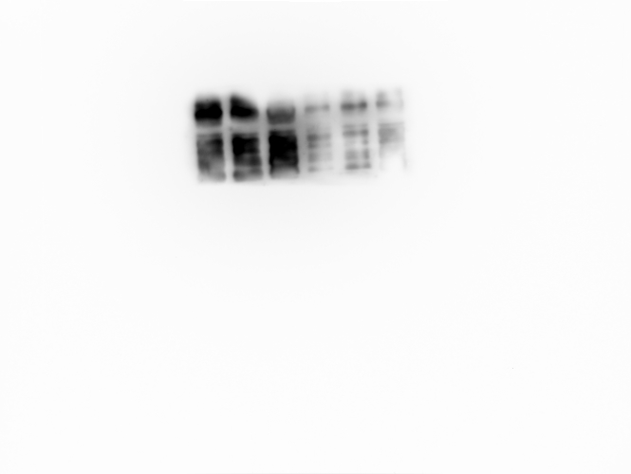

Smad2/3
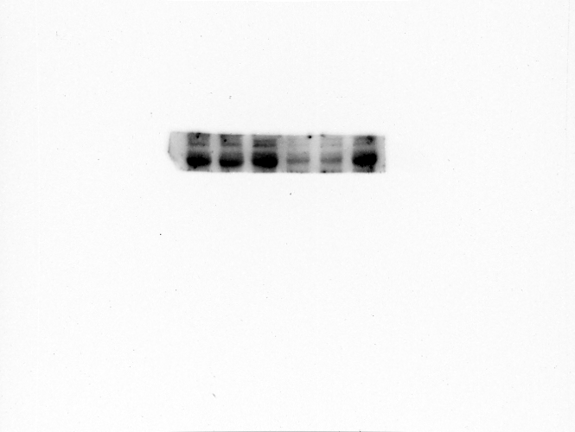

pSmad2/3
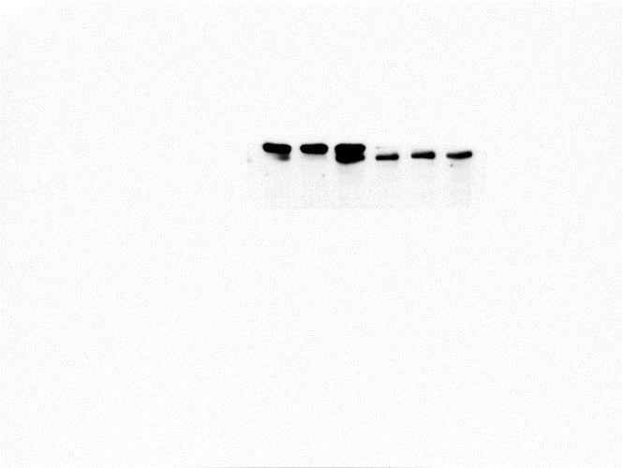

TGF-β1
