The Impact of Atmospheric Rivers on Rainfall in New Zealand
Jingxiang Shu¹, Asaad Y. Shamseldin¹, Evan Weller²

Supplementary Figures

Four supplementary figures with captions showing similar information as Figure 1-4 in the main manuscript but the outputs from the AR detection algorithm based on ERA-5.
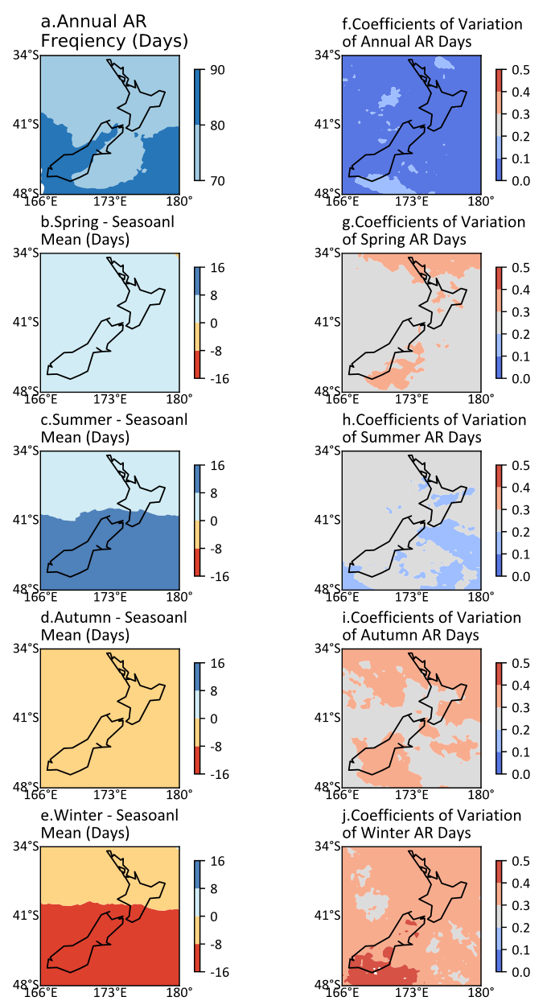
Figure 1. The climatology of AR frequency over New Zealand. a Annual frequency of AR days on each grid cell per year. b-e The difference between seasonal AR frequency and its seasonal mean frequency on each grid cell per year. f-j Annual and seasonal coefficients of variation of AR frequency for each grid cell.
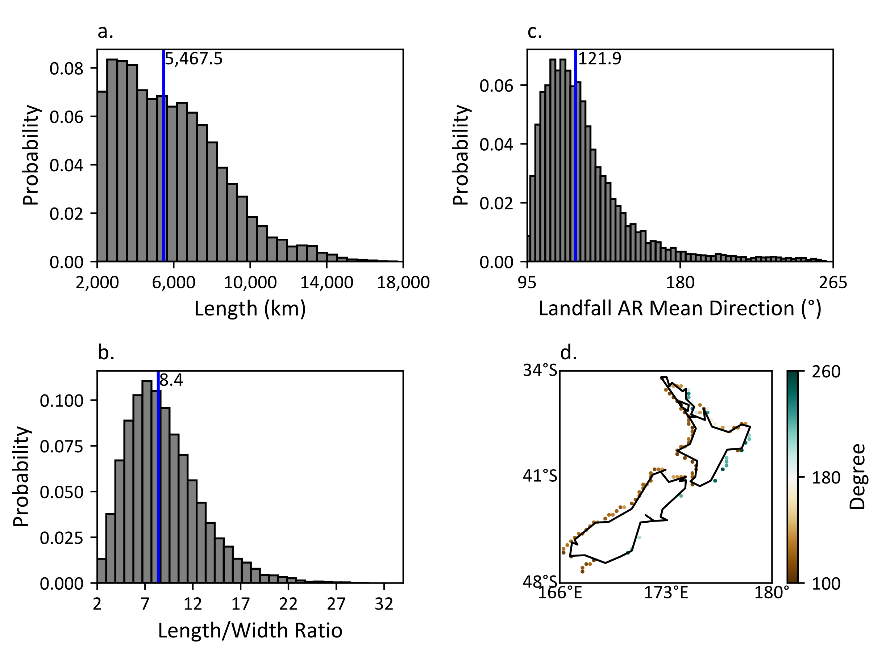
Figure 2. Histograms of geometric characteristics of detected landfalling ARs and a map of the landfalling ARs mean direction at their corresponding landfalling locations over New Zealand, the blue vertical lines indicate the median value in each histogram. a Length. b Length/width ratio. c Landfalling AR mean direction. d Landfalling AR mean direction at corresponding landfall locations.
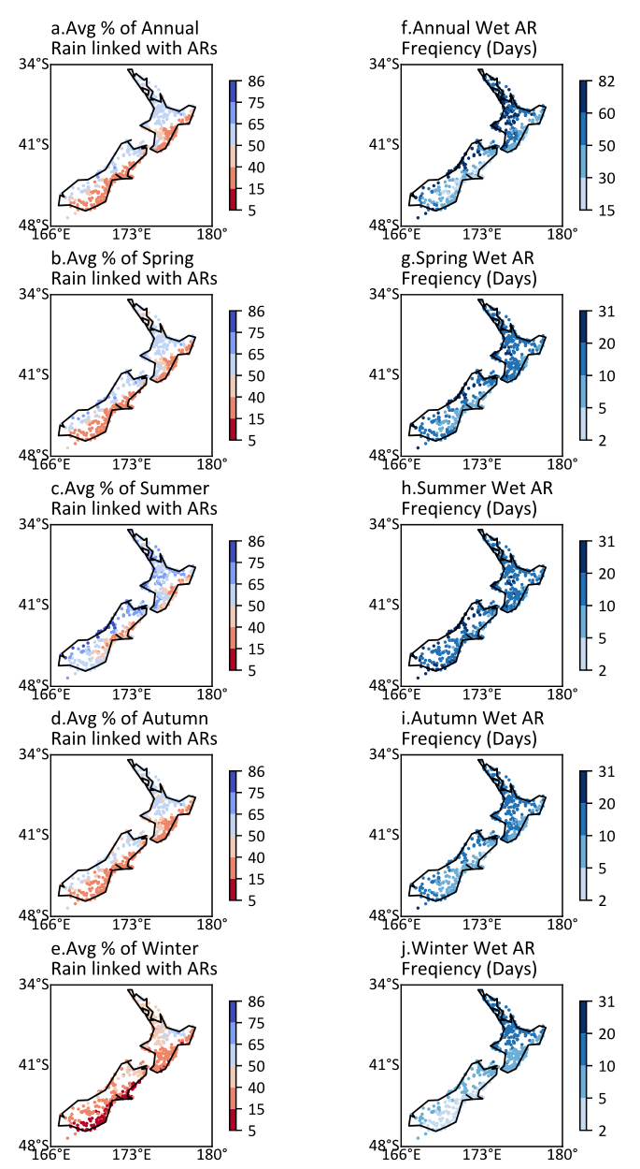
Figure 3. Maps of the annual and seasonal percentage of rain totals linked with ARs and the frequency wet AR days frequency per year for each site. a-e Annual and seasonal average percentages of rain totals linked with ARs. f-j Annual and seasonal frequency of wet AR days per year.
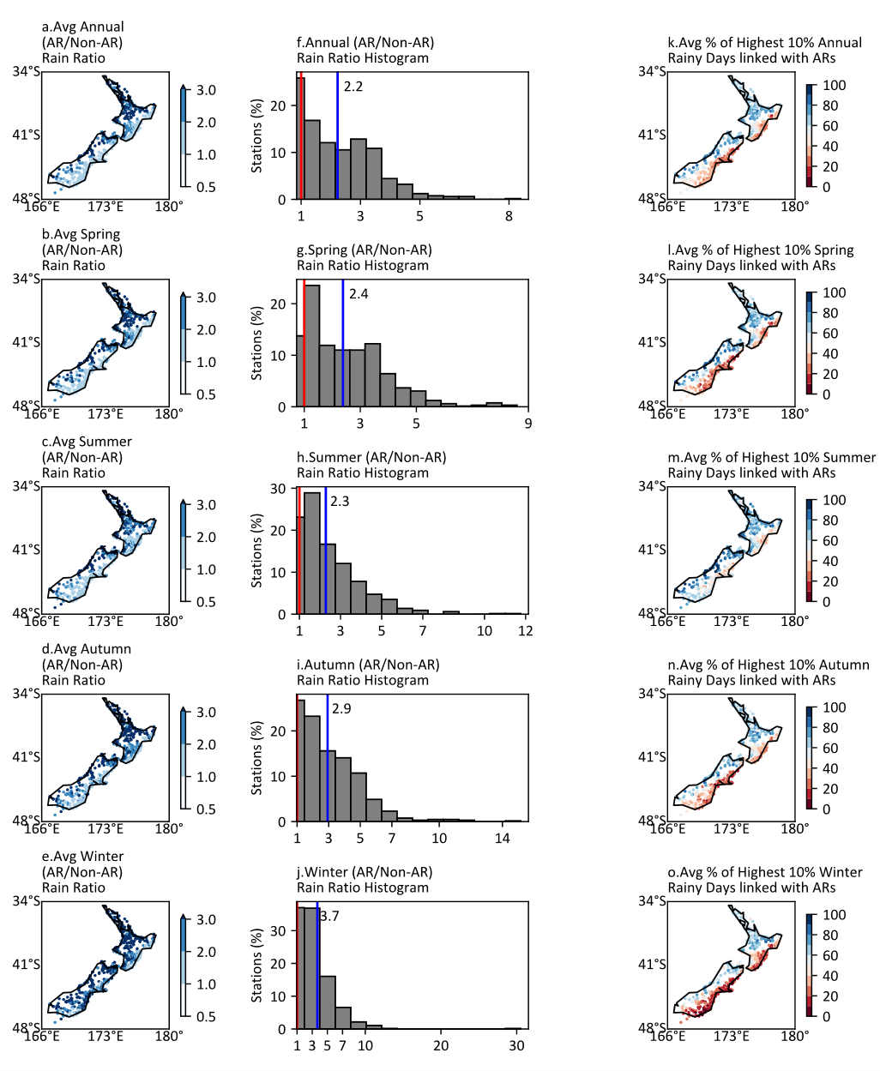
Figure 4. Maps of the average annual and seasonal AR/Non-AR rain ratio and the average percentage of the highest 10% rainy days linked with ARs, and histograms of AR/Non-AR rain ratio. The red vertical lines in histograms locate the ratio 1, and the blue vertical lines indicate the median values. a-e Annual and the seasonal mean ratio of AR/Non-AR daily rainfall totals for each site. f-j Histograms of the annual and seasonal mean ratio of AR/Non-AR daily rainfall totals. k-o The annual and seasonal average percentage of highest 10% rainy days linked with ARs.

