Electronic Supplementary Information
High-throughput low-cost DNA sequencing using surface-coating technology
Yanzhe Qin, Stephan Koehler, Shengming Zhao, Ruibin Mai, Zhuo Liu, Hao Lu,
Chengmei Xing
*correspondence to: yanzheqin@126.com

This PDF file includes:
Figures S1 to S6
Calculations
Captions for Simulations 1-3
Captions for Video clips 1 and 2
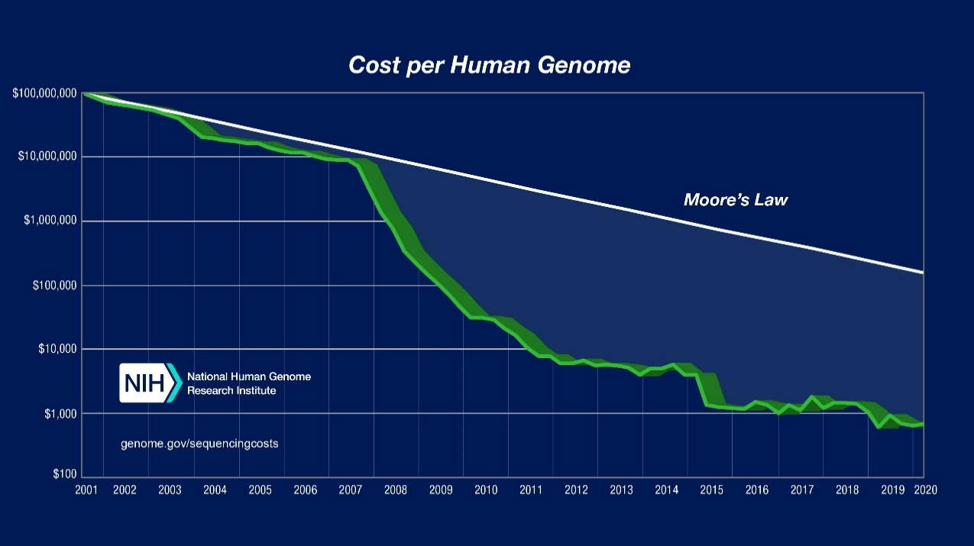
Supplemental figures
Fig. S1. Timeline for cost of whole genome sequencing. The next-generation sequencing (NGS) platform first released in the mid‑2000s resulted in a 1,000-fold drop within five years, much faster than Moore’s law. Currently more than 80% of the consumable cost arises from reagents. Courtesy: National Human Genome Research Institute, https://www.genome.gov/about-genomics/fact-sheets/DNA-Sequencing-Costs-Data.
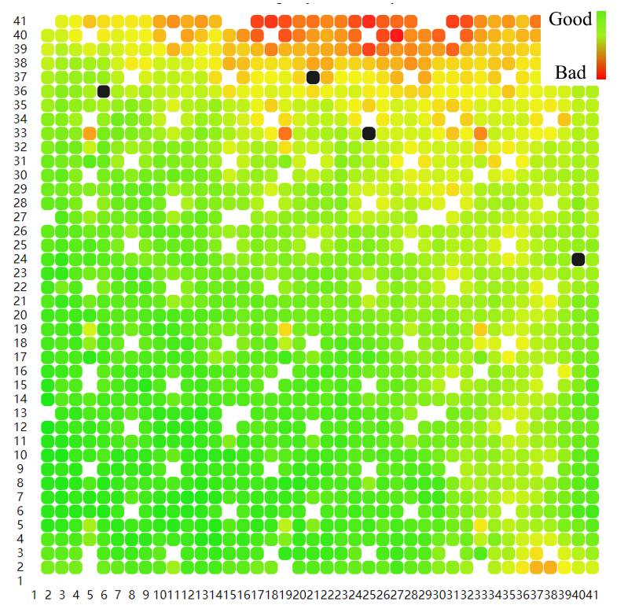
Fig. S2 Base calling information content (BIC) heatmap of a scaled-up 7 cm x 7 cm flow cell. Reagent transport is uneven, which results in incomplete biochemical reactions and loss of information. Every dot is a square field of view (FOV) of the objective and is colored according to its information quality.
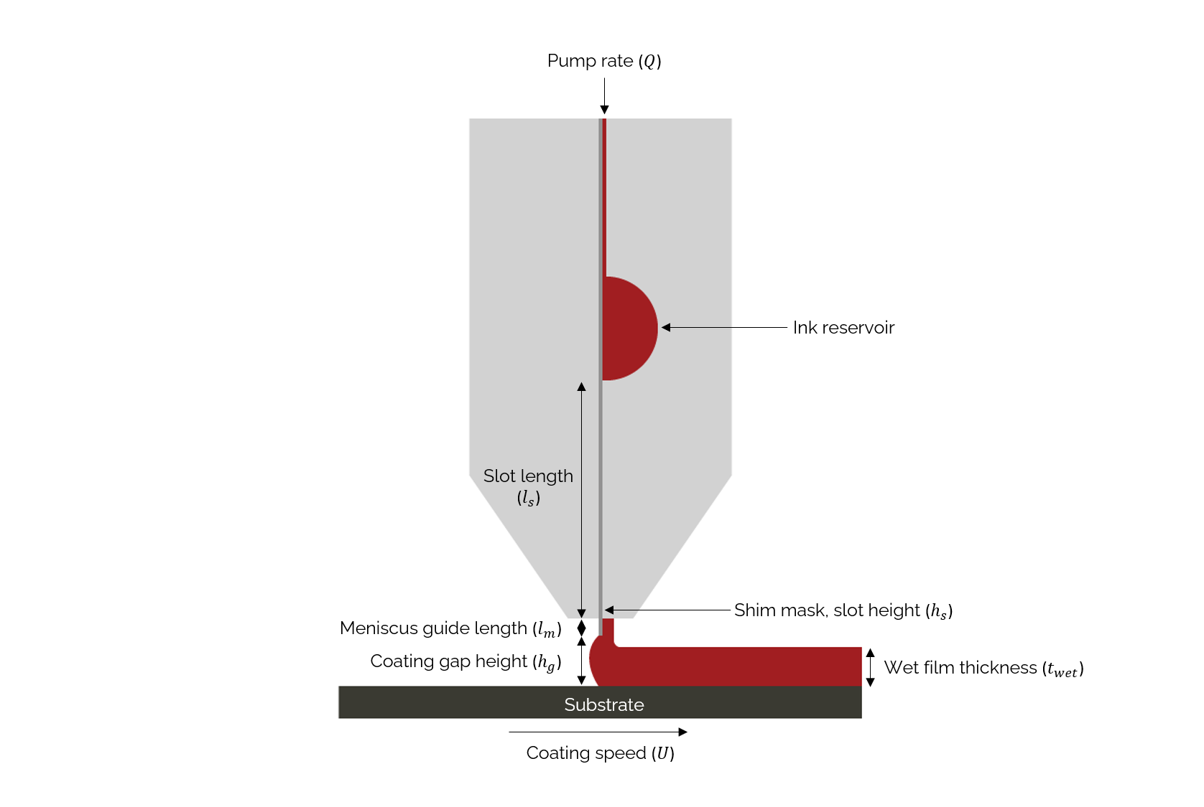
Fig. S3. The schematic of a die for thin-layer reagent coating. We set the film thickness to 20 um, the coating speed to 80 m/min. Courtesy: FOM Technologies, https://www.fomtechnologies.com/
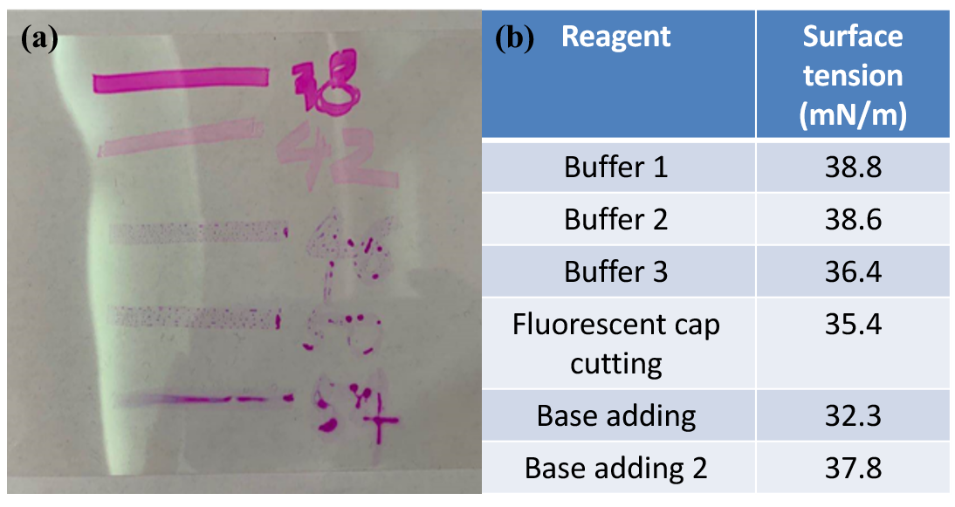Fig. S4. Matching surface properties. (a) Acrotest pens with surface tension less than 42 mN/m do not bead up on corona-pretreated PET strip. (b) Table of reagent surface tensions used in biochemical processes.
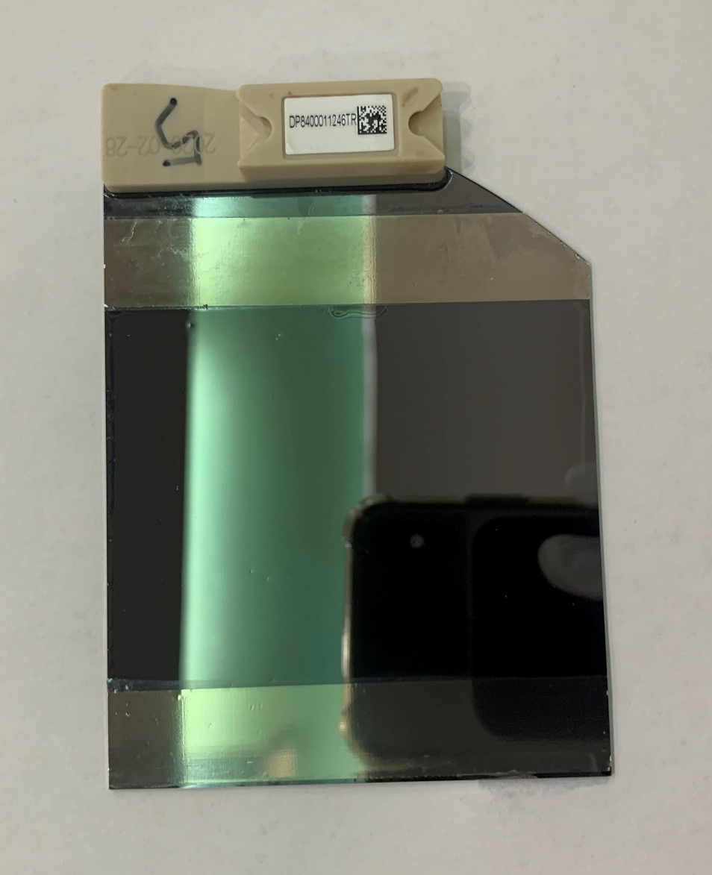
Fig. S5. Picture of a 7 cm x 7 cm sequencing biochip with two 20 μm thick tape strips that set the reagent layer thickness.
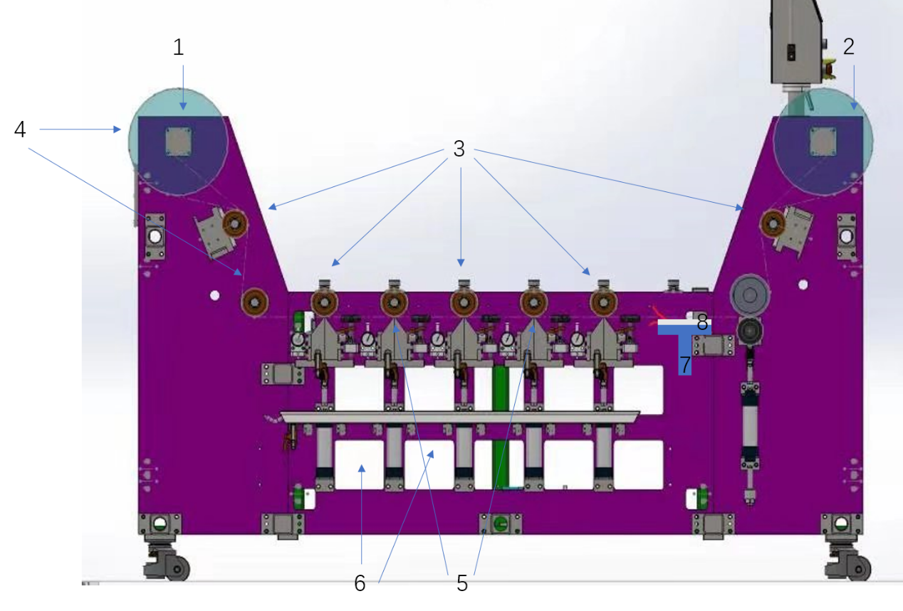Fig. S6 Schematic of SCT. The two ends of the machine are flexible film rolls, one is for unwinding, and the other is for winding (1, 2). The motor and other auxiliary equipment control the start and stop, speed and tension of the film roll. The clean substrate (4) is guided by the winding motor to move in one direction. When it passes through a die (5), one reagent in the storage container (6) are uniformly covered on part of the area of ​​the substrate with twice of the length of the chip with thickness of 20 µm.

Calculations of reagent usage
We compare typical reagent usage for a conventional NGS flow cell and our SCT prototype. Expensive reagents are the dNTP nucleotides (N stands for A, T, C, G) responsible for the biochemical reactions. Due to the need for fast reagent replacement, the flow cell thickness is limited to ~100 um, whereas for SCT much thinner layers can be quickly applied. This results in much larger reagent volumes for flow cells than for SCT.

We first calculate usage for a SCT biochip. The DNA nanoballs are patterned to form a square matrix with 700 nm separation.

In a biochemical cycle every DNB needs ~250 fluorescent nucleotides of each kind (A, C, T and G).

For a normal bioreaction, the working concertation of dNTP is 0.5 μmol/L for each kind of nucleotides.

Then, the minimum required reagent thickness is (2.5 x 10¹²) ÷ (5.88 x 10¹²) = 0.425 μm. To replace a reagent layer using SCT twice its volume is required, hence a layer of this thickness is only 50% efficient in terms of reagent usage.

The state-of-the-art flow-cell technique has a gap of 100 μm, assuming the buffer exchange rate is 5X, the effective thickness of dNTP reagent = 100 μm × 5 = 500 μm.

The usage of reagent in state-of-the-art flow cell technology= 0.425 μm ÷ 500 μm = 8.5x10⁻⁴ = 0.085 %

The reagent thickness of SCT is 20 μm and exchange ratio is 2X, then
the usage of reagent is 0. 425 μm ÷ (20 μm × 2) = 1.062 %

Assuming 2 μm SCT is viable, then the usage of reagent is 0. 425 μm ÷ (2 μm × 2) = 10.625 %

Captions for simulations and video clips

Simulation 1: Reagent replacement process for SCT, where the relative concentration at the biochip surface of the dNTP nucleotide is shown. The diffusion coefficient is 10⁻⁹ m²/sec, the gap between PET strip and biochip is 20 μm and lateral speed of the strip is 0.5 m/min. Thus at 18 seconds the PET strip has advanced a distance of 15 cm, the length of the biochip, whereas the advancing front has advanced only half that amount.

Simulation 2: Reagent replacement process for a single-lane flow cell, where the relative concentration of the dNTP nucleotide at the biochip’s surface is shown. The flow cell’s total volume passage time is one second, and the speed of the advancing front is half that which is similar the speed relationship for SCT shown in simulation 1.

Simulation 3: Reagent replacement process in a cylindrical tube, where the relative concentration profile along the central plane is shown. The tube’s total volume passage time is one second, whereas at the tube’s surface the boundary layer passage time is 5 seconds.

Video clip 1: Liquid layer coated onto PET strip by slot die moving onto the biochip. The pen mark indicates the wet-dry boundary on the PET strip. The biochip is completely wetted after the PET strip has advanced a distance twice the length of the biochip.

Video clip 2: Transfer of biochip from buffer storage to the DNBSEQ-T10 imaging system using a robotic arm.

