Extended Data Figures

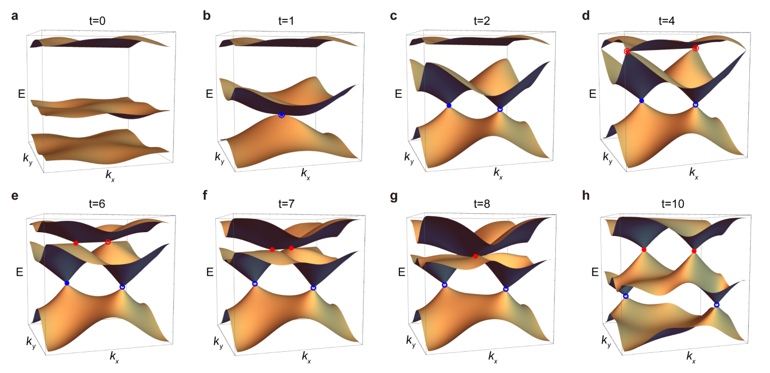
Extended Data Fig. 1 | Time evolution of the band nodes manifested by 2D full band structures. a-h, Band structures plotted in the full 2D BZ, which indicate the nontrivial nodal braiding in our main text. The whole process is very clean, which involves only two pairs of band nodes evolved along the HSLs of the square BZ. All results are calculated by the tight-binding model.

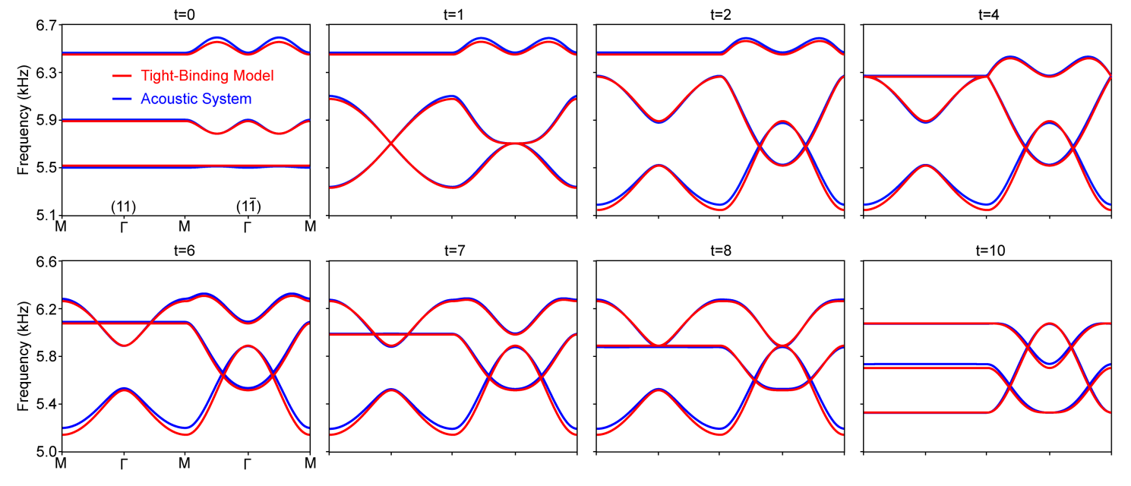
Extended Data Fig. 2 | Comparing the band structures between our acoustic system and tight-binding model. To fit the full-wave simulations, the coupling strength $κ=93.5 Hz$ and the onsite energy $ω_{0}=5702.9 Hz$ are consistently used in the tight-binding model.

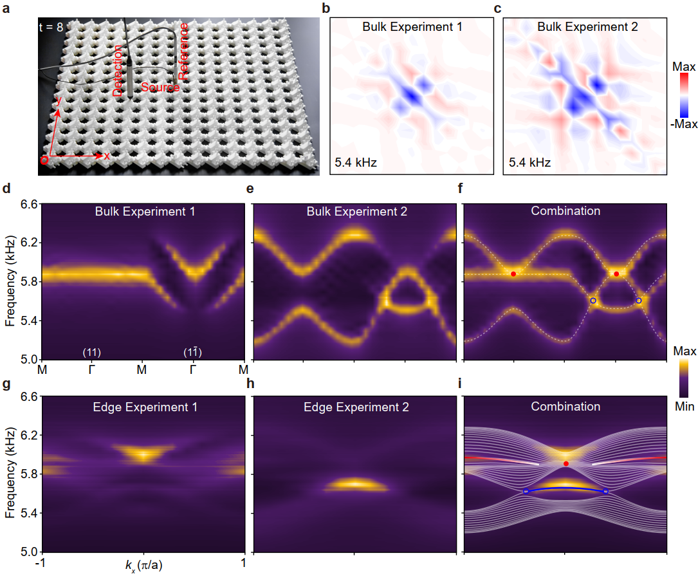
Extended Data Fig. 3 | Experimental measurements of the bulk and edge spectra (exemplified for $t=8$). a, Experimental setup for our bulk measurements. The sound source is positioned in the middle unitcell of the sample, together with a microphone fixed in the same cavity for the phase reference. The pressure distribution over the sample is scanned by a needle microphone. Small holes are perforated on the desired cavities for inserting the sound source and detector, which are sealed when not in use. b,c, Pressure distributions measured independently for the cavities 1 and 2. d,e, The corresponding bulk spectra (color scale) plotted along the HSLs of the square BZ, obtained by performing 2D Fourier transforms to the above real-space measurements. f, Combination of the two independent measurements. The bright color reproduces perfectly the numerical dispersion curves (white dashed lines). g-i, Similar to d-f, but for the edge spectra, where the sound source and the reference microphone are relocated in the middle unitcell of the lower sample edge.

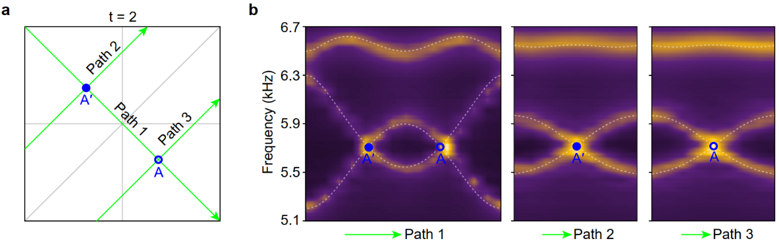
Extended Data Fig. 4 | Experimental characterization of the bilinear nodes (exemplified with $t=2$). a, Momentum paths (green solid lines) selected for plotting the dispersion curves that connect two band nodes at general HSL momenta. b, Measured (bright color) and simulated (white dashed lines) bulk band structures along the momentum paths crossing at the gap-I nodes $A$ and $A'$, which together exhibit clearly bilinear behavior around the two nontrivial nodes.

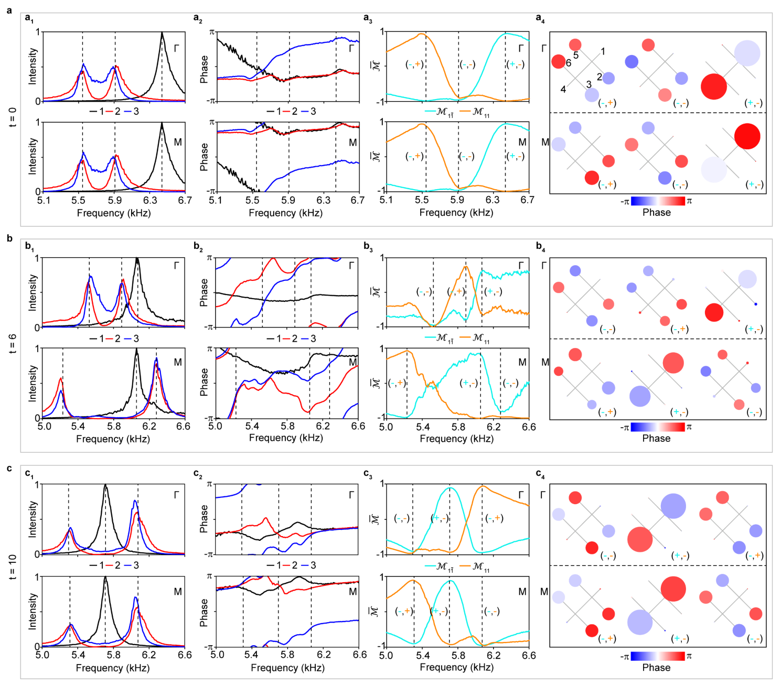
Extended Data Fig. 5 | Characterizing the HSP wavefunctions and their mirror symmetries. The experimental data in a-c correspond to three representative moments. a₁-c₁, Fourier intensity spectra extracted for the HSPs $Γ$ and $M$, which are peaked precisely at the predicted eigenfrequencies (vertical dashed lines). The intensity peaks of the orbitals 2 and 3 (aligned because of the mirror symmetry $M_{11}$) are misaligned with those of the orbital 1, which unveils the polarization nature of the HSP states. a₂-c₂, The corresponding phase spectra. a₃-c₃, Expectation value spectra of the mirror operators $M_{1\overline{1}}$ and $M_{11}$ measured for the wavefunctions at $Γ$ and $M$. The mirror expectation value around each intensity peak approaches $+1$ or $-1$, which captures the mirror eigenvalue $+1$ or $-1$ for the symmetric or antisymmetric eigenstates. a₄-c₄, Field distributions extracted for directly visualizing the mirror symmetry of the HSP states. The sizes and color of the circles characterize the sound energy densities and phases of the detecting points, respectively. The frequencies used are labeled successively in a₁-c₁ by the three dashed lines.

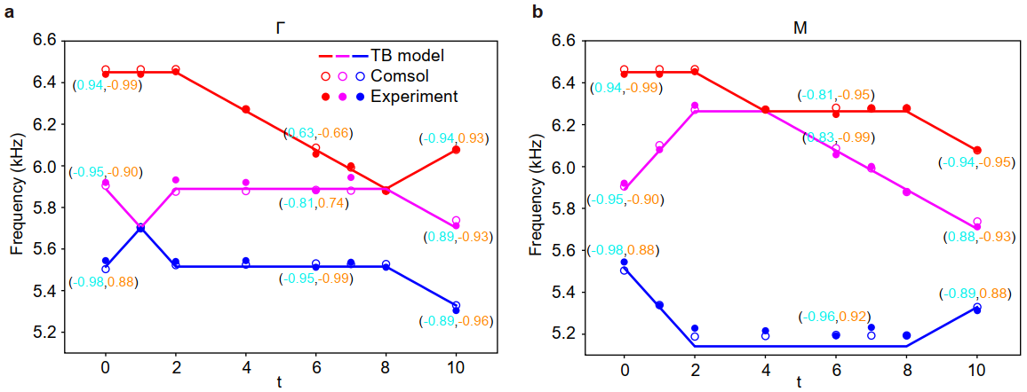
Extended Data Fig. 6 | Band inversions revealed by the time evolution of HSP states. a, Time involution of the $Γ$-point frequencies extracted from the experimentally measured (solid circles) band structures, together with the numerical (open circles) and theoretical (solid lines) results for comparisons. Mirror expectation values are labeled for the three moments $t=0$, $t=6$, and $t=10$. b, The same as a, but for the $M$ states. The band inversion, accompanying the evolution of bands with different mirror eigenvalues at the HSPs, is essential for changing the stability of the nodal pair in the same gap.

