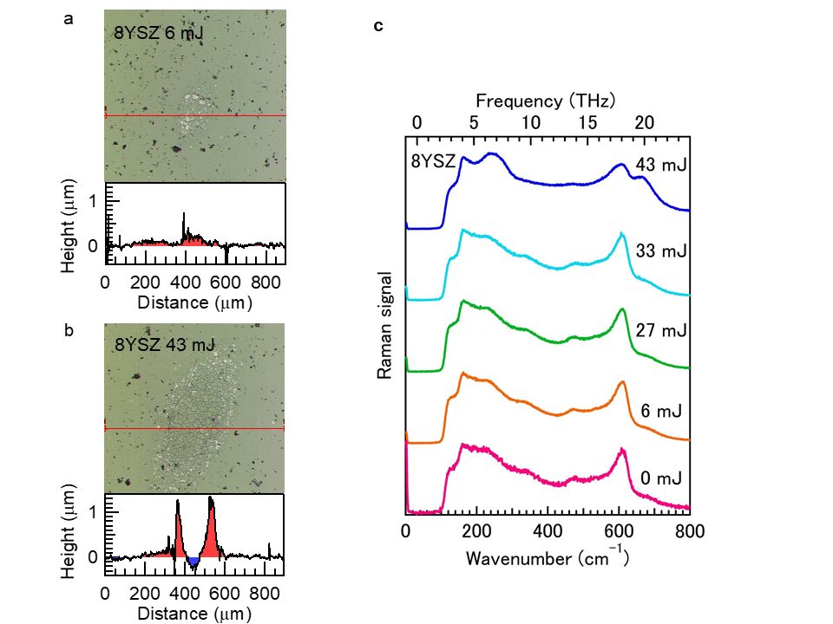

Extended Data Figure 1 | Characterization of the irradiation scar on the surface of a c-ZrO₂ sintered plate. a,b, The photographs of scars generated by a THz pulse on the surface of an 8-mol% Y₂O₃-stabilized zirconia sintered plate for low and high excitation pulse energies, respectively. The data below the photographs show the height profiles of the irradiation scar at the positions indicated by the red line. c, Raman spectra at the centre positions of irradiation scars for different macropulse energies.

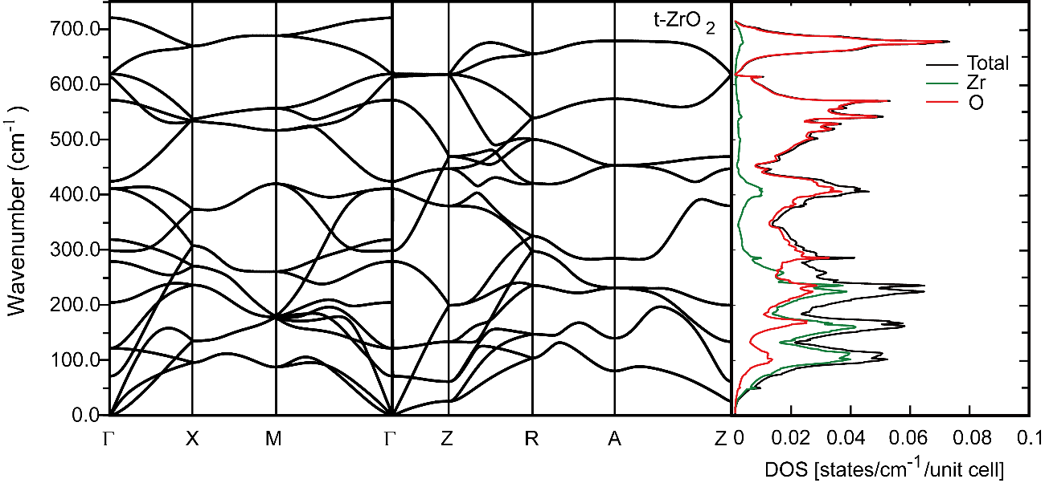

Extended Data Figure 2 | Calculated phonon dispersion curves of t-ZrO₂. The phonon branches are shown along symmetry directions. In the right panel, the total pDOS in t-ZrO₂ is given by the black line. The partial pDOS of the Zr and O atoms are given by the green and red lines, respectively.

