Terahertz-induced martensitic transformation in partially stabilized zirconia

Supplementary Information

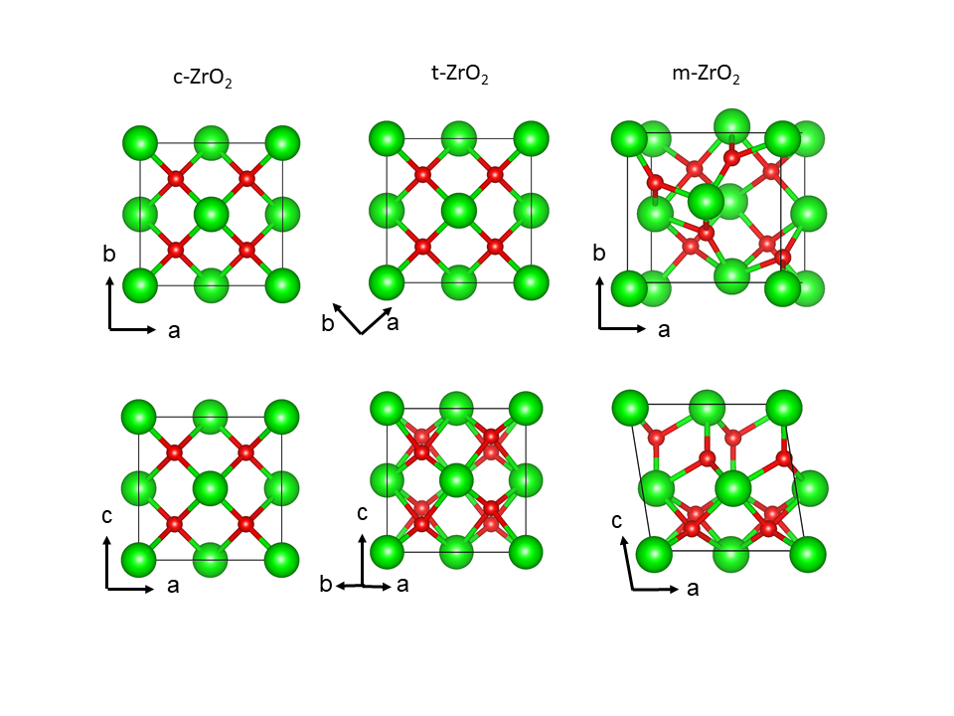
Figure S1 | Crystal structures of t-, c-, and m-ZrO₂. The green and red spheres correspond to Zr and O atoms, respectively. The major high-symmetry directions are indicated by the a-, b-, and c-axes.

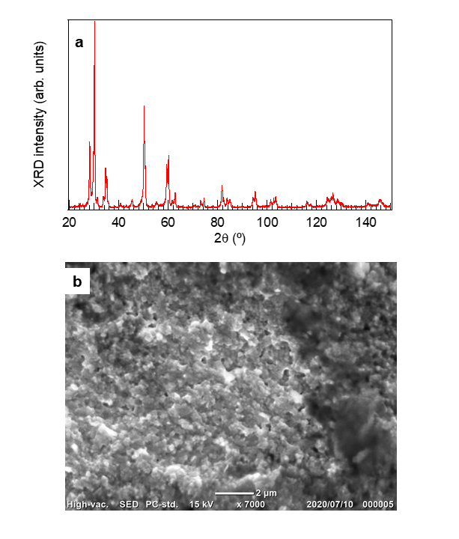

Figure S2 | Characterization of the partially stabilized zirconia plate. a, XRD pattern of the partially stabilized zirconia plate used in this work. b, The SEM image of the surface of the plate’s edge.
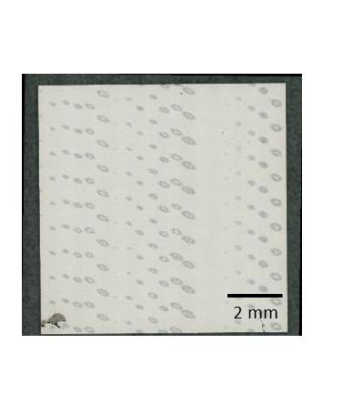
Figure S3 | Photograph of a partially stabilized zirconia plate after THz irradiation. Each irradiation scar on the surface is due to a single THz macropulse. There are three main columns, and each main column contains some subcolumns corresponding to different excitation intensities. The right side of the sample contains irradiation scars due to irradiation with a centre frequency of 3.7 THz, a macropulse width of 6 $μ$s, and a micropulse width of 2 ps. The irradiation scars obtained with a centre frequency of 5.2 THz, a macropulse width of 6 $μ$s, and a micropulse width of 2 ps are shown in the centre. The left side of the plate contains irradiation scars generated with a centre frequency of 5.2 THz, a macropulse width of 6 $μ$s, and a micropulse width of 10 ps.

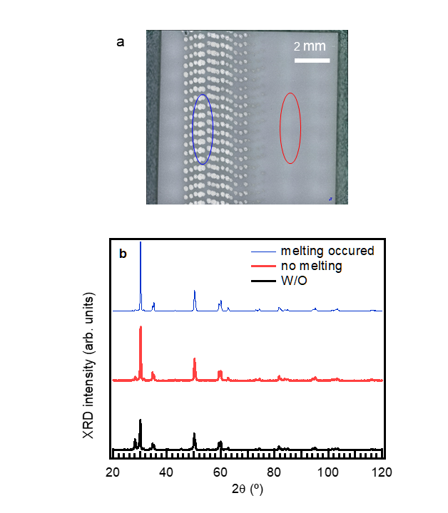

Figure S4 | Photograph of the partially stabilized zirconia plate used for the XRD measurements. a, An unpolished zirconia plate with different irradiation scars generated by a macropulse energy of 38 mJ but different irradiation spot sizes. Melting traces are apparent on the left side of the plate, where we used an irradiation spot size of 0.2 mm. No melting traces are apparent on the right side of the plate, where we used an irradiation spot size of 0.5 mm. The blue and red curves indicate the spot size of the X-ray beam on the sample. b, XRD patterns of the two areas indicated in Fig. S4a. The XRD pattern of a plate without irradiation is shown for reference (black curve). These data are the same as those in Fig. 3a.

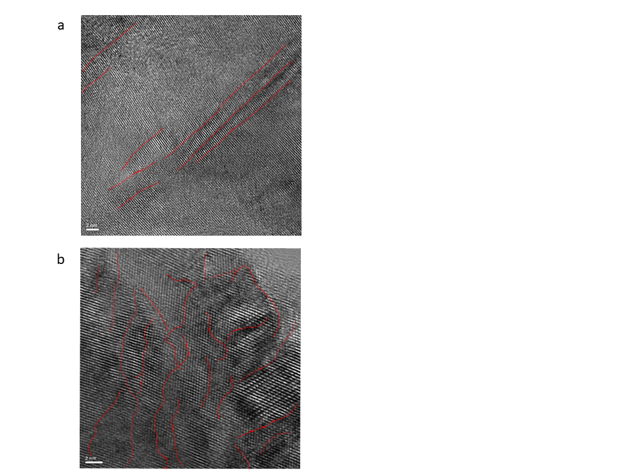

Figure S5 | TEM images of the partially stabilized zirconia. a, TEM image of the t-ZrO₂ sample with sheet-shaped m-ZrO₂. b, TEM image of the t-ZrO2 sample after irradiation with the THz pulse. Multiply twinned herringbone nanostructures can be observed. The red curves are guides to the eye to clarify the positions of phase boundaries.

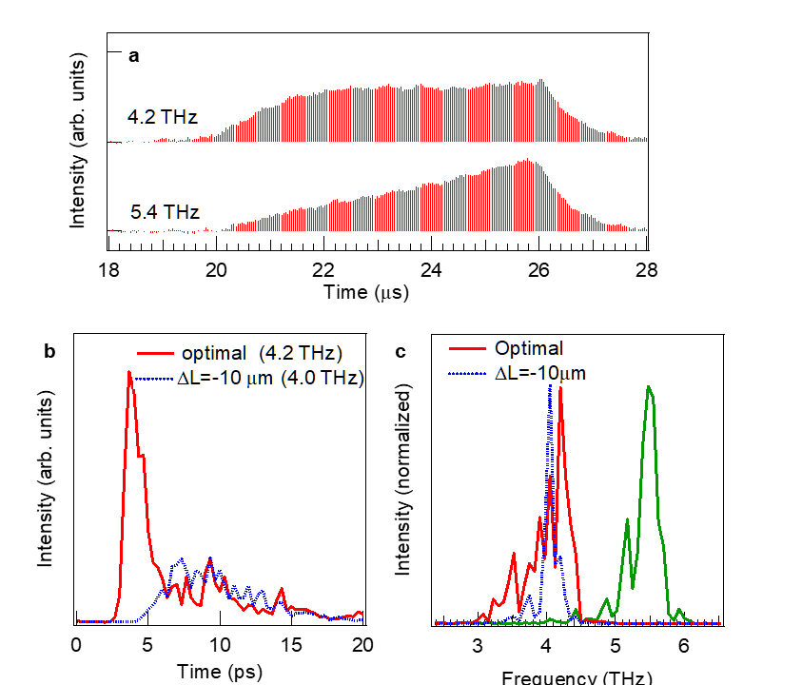

Figure S6 | Characterization of THz-FEL pulse. a, Temporal profiles of the macropulses consisting of a series of more than 200 micropulses (one micropulse every 37 ns). The profiles were measured at the optimal cavity length by a fast pyroelectric detector. The values 4.2 and 5.4 THz correspond to the peak frequencies of two pulses with different micropulse spectra. The sum of the micropulse intensities for each peak frequency is proportional to the macropulse energy. b, Typical temporal profiles of the THz-FEL micropulse and c, frequency spectra of the THz pulse measured by the electro-optic sampling method using a Ti:sapphire laser synchronized to the radio frequency of the L-band linear accelerator. The thick red curve shows a temporal profile of a THz-FEL micropulse obtained at the optimal optical cavity length. The dotted blue curve is that for a cavity length that is shorter by 10 μm, which is called the detuning length, -ΔL. For the optimal cavity length, the micropulse duration is less than 2 ps (full width at half-maximum) and its peak intensity is the highest, whereas the duration is approximately 10 ps and the peak intensity is approximately one fourth at ΔL = -10 μm. We changed the FEL properties (macropulse width, micropulse width, and center frequency) and confirmed no essential differences in the experimental results.

