Supplementary information for
Conversion of Chirality to Twisting via 1D-to-2D Growth of Graphene Spirals
Zhu-Jun Wang, Xiao Kong, Yuan Huang, Lihong Bao, Kecheng Cao, Yuxiong Hu, Jun Cai, Lifen Wang, Jun Li, Hui Chen, Fei Pang, Zhihai Cheng, Petr Babor, Miroslav Kolibal, Zhongkai Liu, Yulin Chen, Qiang Zhang, Yi Cui, Kaihui Liu, Haitao Yang, Xinhe Bao, Hong-Jun Gao, Zhi Liu, Wei Ji, Feng Ding, Marc-Georg Willinger

Content
Online Movie 1. In situ ESEM movie showing process of graphene Origami and Kirigami on the Pt surface during CVD growth condition from 1000°C up to 1400 °C……………………..…….…………….…………2
Online Movie 2. The illustration of graphene Origami and Kirigami………………………….…………….………..2
Online Movie 3. The growth and coalescence of graphene spirals…………………………….……………….…….2
Extended Data Fig. 1| Graphene-induced a variety of surface reconstruction on different Pt grain...3
Extended Data Fig. 2| Tubular edge structure……………………….………………………………………..….……….….4
Extended Data Fig. 3| Magnified region of yellow square in main text Figure 1d in situ showing the formation of sawtooth graphene edges………………………………………………………………………….……….........5
Extended Data Fig. 4| Opposite handedness of the adjacent graphene spiral and burger vector of screw core…………………………………………………………………………………………………………………………….…….....6
Extended Data Fig. 5| Graphene spiral structure……………………………………………………………………..….....7
Extended Data Fig. 6| Scanning tunnelling microscopy (STM) imaging of GS structures…………….…….8
Extended Data Fig. 7| Triggering spiral growth at the endpoints of wrinkle…………………………….…......9
Extended Data Fig. 8| 1D chirality to 2D twist-angle conversion........................................................10
Extended Data Fig. 9|Schematic representation of overlapping / coalescence of few layer graphene and graphene spiral…………………………………………………………………………………………………………………..…….11
Extended Data Fig. 10| Classifying the shape of twisted few-layer graphene by the orientations of fold-over wrinkles.................................................................................................................................12
Extended Data Fig. 11| Illustration of the transfer process of graphene from a Pt surface to TEM grid………………………………………………………………………………………………………………………………………………….13
Extended Data Fig. 12| Determining the twisted angle of coalesced graphene spirals in Figure 3……14
Extended Data Fig. 13| The shape of coalesced GSs…………………………………………………………………….…15
Extended Data Fig. 14| Reverse inference graphene spiral structure……………………………………………….16
Extended Data Fig. 15| The nodal point of spiral layout…………………………………………………………………..17
Supplementary Note………………………………………………………………………………………………………………………18
References…………………………………….………………………………………………………………………………………………..21

Online Movie 1. In situ ESEM movie showing process of graphene Origami and Kirigami on the Pt surface during CVD growth condition from 1000°C up to 1400 °C. With the rising temperature, restructuring of the surface and grain growth underneath growing flakes can be observed. The dark straps start to appear on the surface. They are due to folded over graphene on the Pt surface. Beyond 1000 °C the onset of Pt surface grain boundary migration and graphene overlayer Origami-Kirigami can be detected. Graphene evolution behaviour abstracted from this video is discussed in detail in the main manuscript.
Online Movie 2. The illustration of graphene origami and kirigami. In the front part of the movie, the analogic paper models show the formation process of wrinkles and subsequent folding, and tearing and cracking of single-layer graphene at different growth stages. In the latter part of the movie, the kinetic Monte Carlo simulations reproduce the growth process of the graphene spiral.
Online Movie 3. The growth and coalescence of graphene spirals. Upperside of the movie records pairwise graphene spirals evolution with opposite handedness showing the chirality conversion from 1D wrinkle to a twist angle of 3D stacking layers. Graphene evolution behaviour abstracted from this video is discussed in detail in the main manuscript. The corresponding coalescence behaviour of graphene spirals is simulated by KMC and presented on the lower side of the movie.
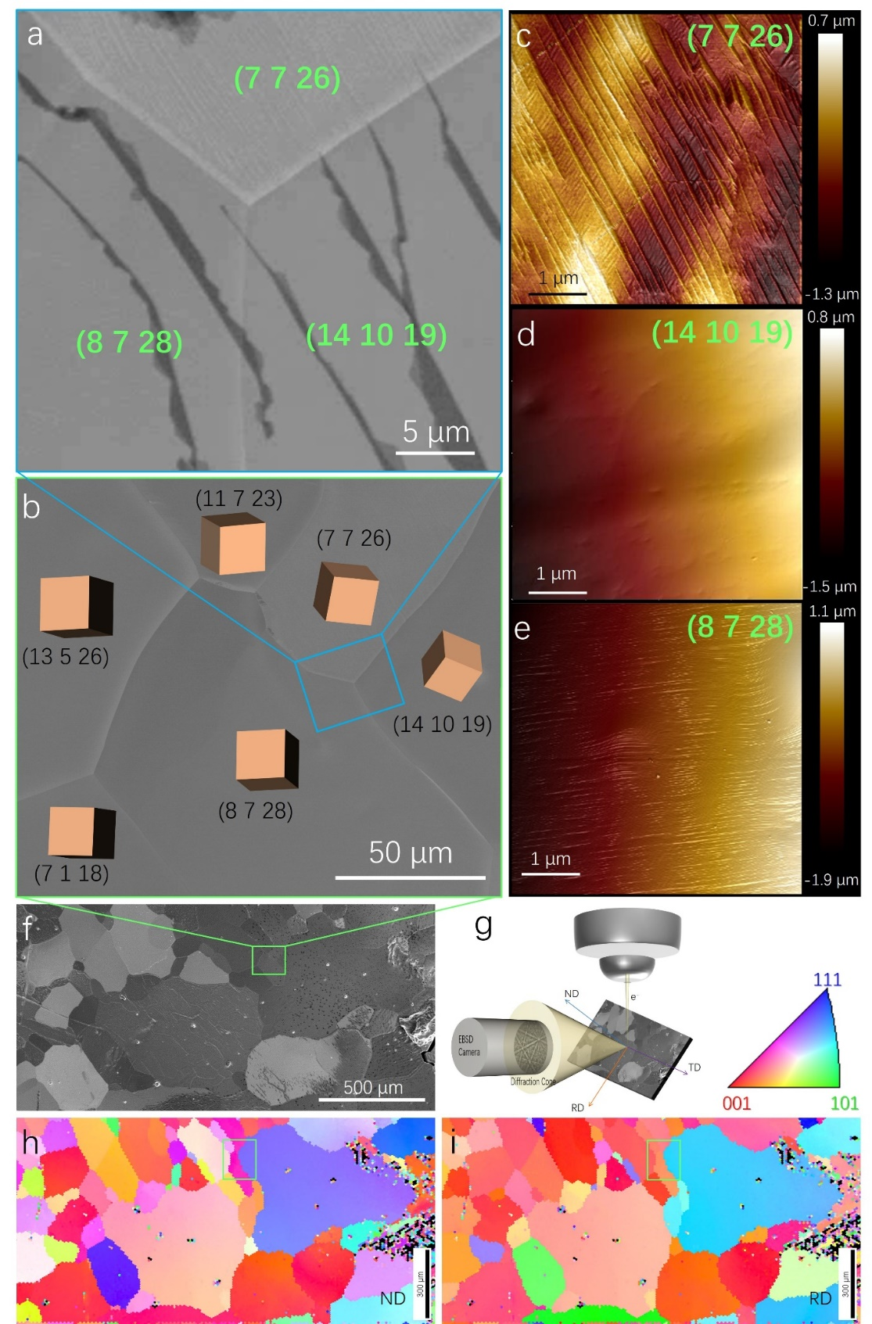
Extended Data Fig. 1 | Graphene-induced a variety of surface reconstruction on different Pt grain. (a) In situ ESEM images recorded the folded-over graphene wrinkle on Pt polycrystal surface at 1400°C, 25Pa. (b) Zoom-out SEM image showing wide-angle view of Pt substrate. (c-e) AFM images recorded from the same Pt grains imaged in (a). The graphene covered surfaces are characterized by graphene-induced Pt step bunching and surface reconstructions. (f) Global SEM image showing the overview morphology of Pt substrate. (g) Schematic of typical EBSD data collection showing the orientation of the crystal reference frame, from rolling (RD), transverse (TD) and normal (ND) orthogonal directions. The EBSD map recorded from a region in (f) is shown in (h) from ND, and in (i) from RD respectively. The different orientations of the cubic model represent the local orientation of Pt surface gains.

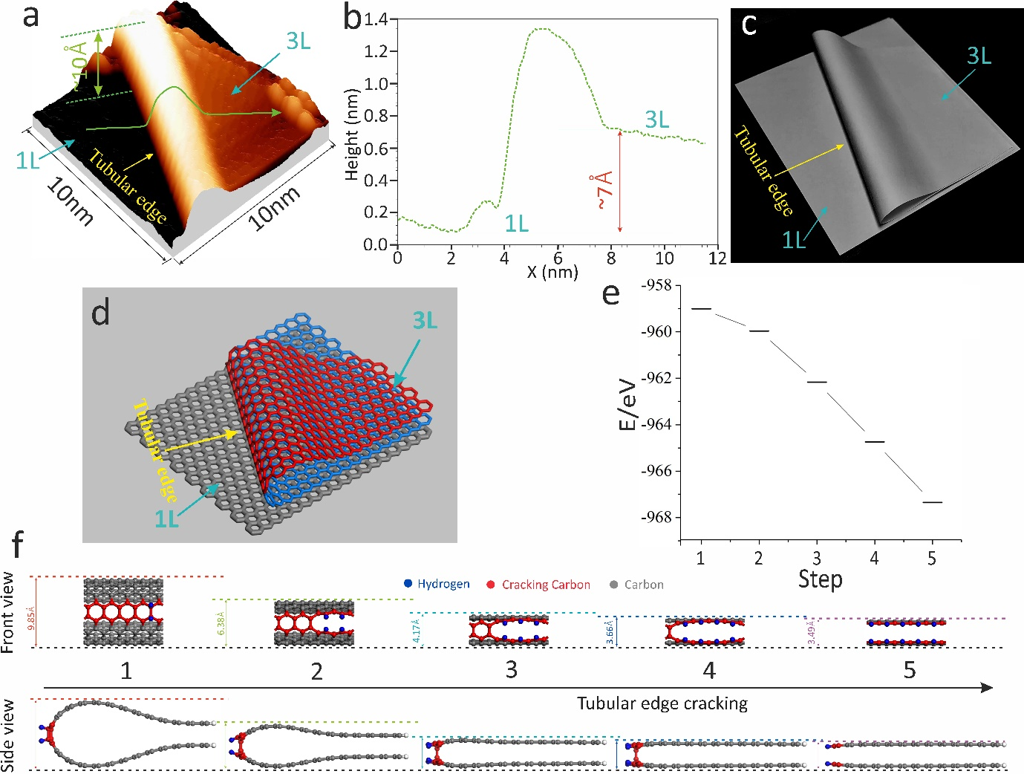
Extended Data Fig. 2 | Tubular edge structure. (a) Atomically resolved the curvature of tubular edge. (b) The height profile of the green line in (a). (c) Analogy with paper model for demonstration folded-over graphene wrinkle. (d) Schematic view showing folded-over graphene wrinkle. The cracking tubular edge energy profile as a function of the number of carbon atoms cracking is shown in (e). (f) The corresponding atomistic models used to calculate energies of the tubular edge cracking along zigzag direction (for details of the calculation, refer to the methods section). Note: The DFT calculations were carried out to model the graphene cracking step on the basis of experimentally obtained values for the curvature of the tubular edge (a, b). (f) shows the modelled hydrogen etching process, in which an H₂ molecule was attached at the point of the highest curvature; this attachment ultimately results in graphene cracking. The total energies of representative steps in the etching process (e) indicates the cracking is energetically favourable and further verifies the proposed graphene cracking mechanism.
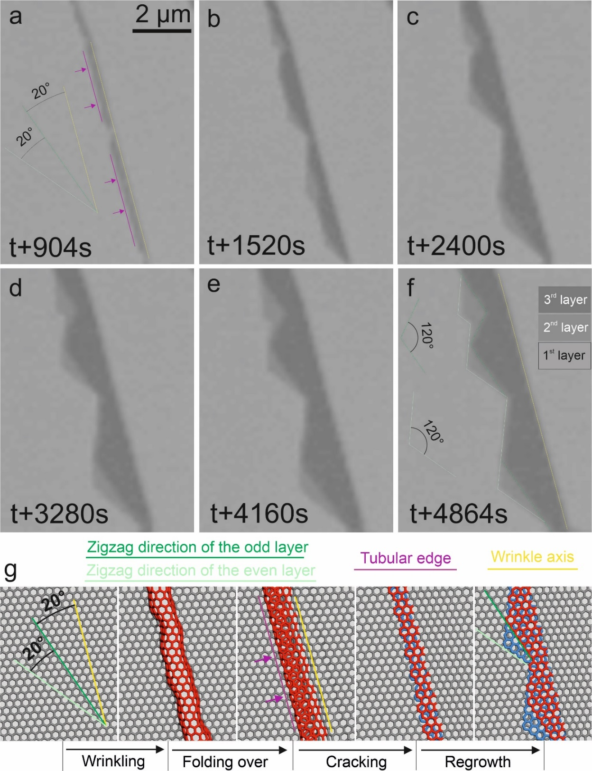
Extended Data Fig. 3 | Magnified region of yellow square in main text Figure 1d in situ showing the formation of sawtooth graphene edges. (a) The folded-over graphene wrinkle. The purple lines highlight the tubular edges of folding-over wrinkle. (b-f) shape evolution of the etching along the tubular edge creates two new growth fronts that will relatively fast re-establish the typical zigzag growth fronts. This will lead to the formation of sawtooth graphene edges unless the crack in the tubular edge is parallel to a zigzag edge. As shown in (f) the second layer and the third layer is finally terminated by zigzag edges with 120° corner. The corresponding formation steps (graphene wrinkling, folding over, cracking and regrowth) are demonstrated in the schematics of (g) using origami-like paper folding. Green and light-green lines highlight the zigzag direction of the odd and even layer, respectively. Yellow line indicates wrinkle axis of wrinkle.

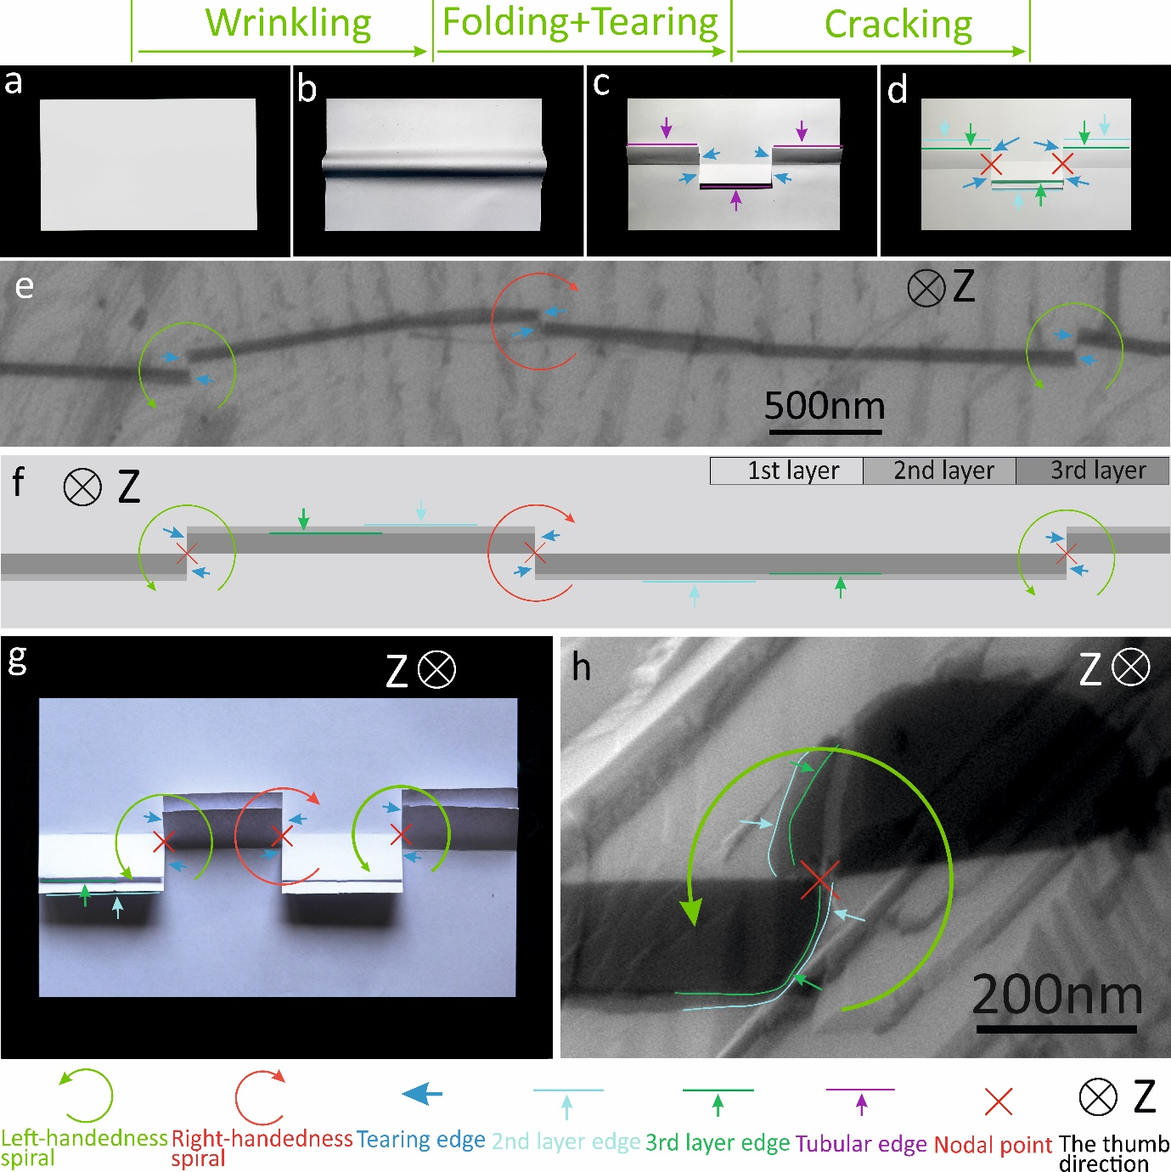
Extended Data Fig. 4| Opposite handedness of the adjacent graphene spiral and burger vector of screw core. (a-d) The analogy with paper model with two tearing nodal points (red crosses in d) was used to represent graphene origami-kirigami quadruplet (graphene wrinkling, folding, tearing and cracking). The folded wrinkles are easily detected in the ESEM imaging as elongated features of lower brightness, as shown in e (with a grey-level corresponding to 3-layer graphene), each of which contains one exposed layer edge (marked by green lines and arrows) and one buried layer edge (highlighted by light green lines and arrows). (f) Corresponding schematic view representing the contrast variation of SEM observation. (g), Origami-kirigami paper model representing the handedness of GSs at the nodal points of folding of collapsed wrinkle in (e). Note: The handedness of the resulting screw dislocation is defined by the sequence in which the wrinkle parts fold-over to the left or right along folding-axis. The tearing edges at a tearing point always have, as a consequence of the oppositely origami folding of wrinkles, reversed handedness to those at the two nearest adjacent tearing points, as marked by red and green curved arrows in (e–g). In situ ESEM images (h) recorded at 1400°C, 25Pa showing the two pair of tearing edges initializing the growth of two intertwined double spirals at the nodal point.

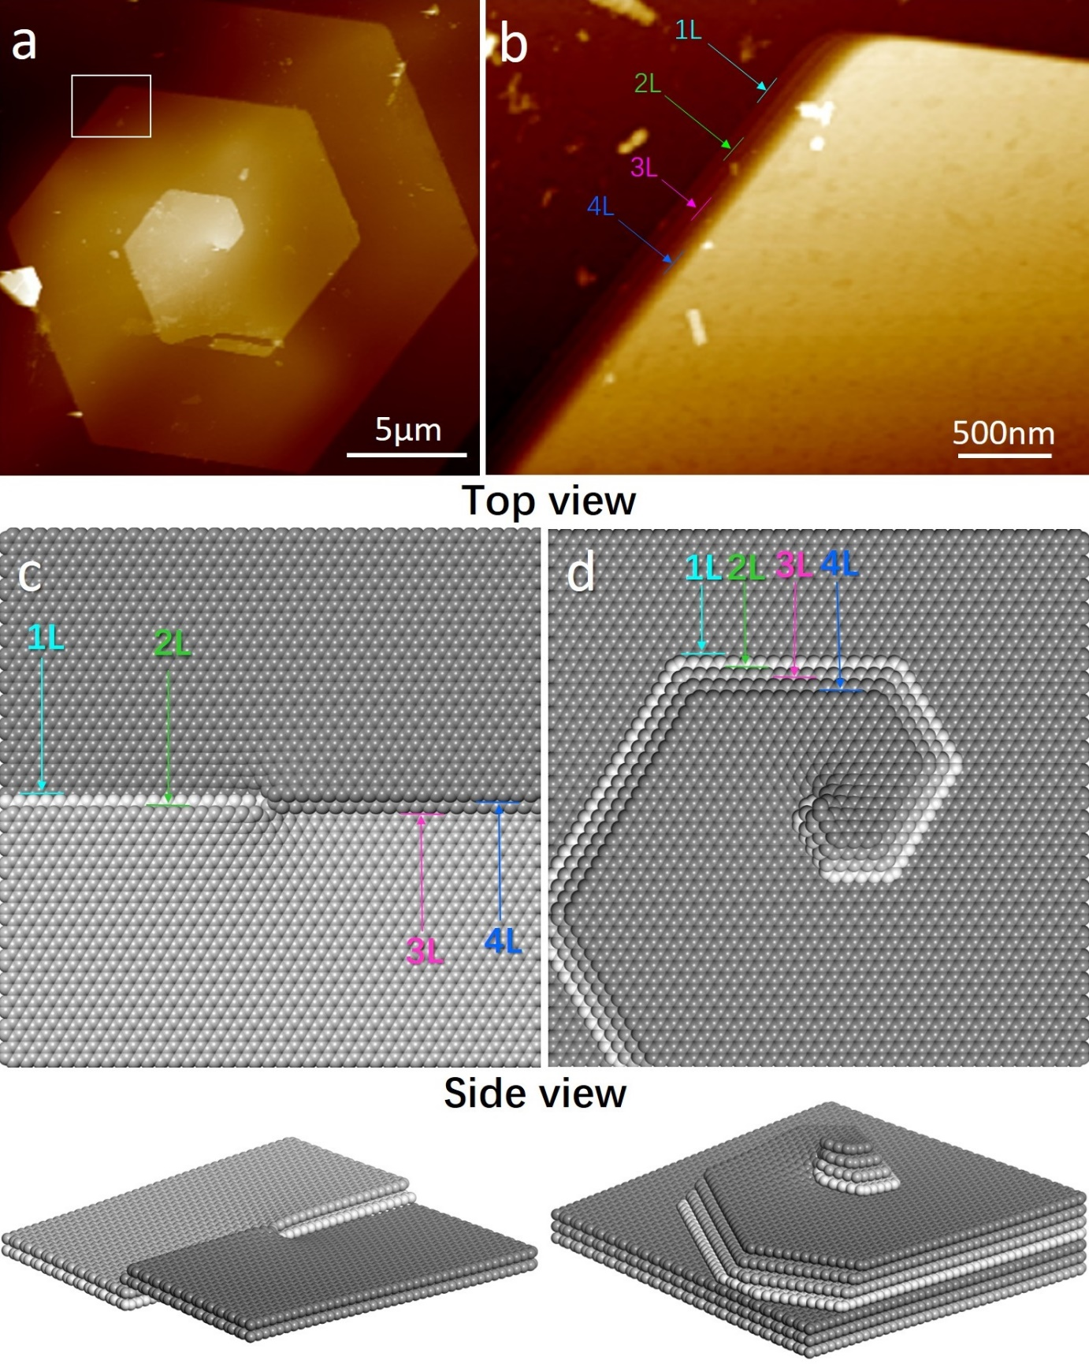
Extended Data Fig. 5| Graphene spiral structure. (a) Atomic force microscopy imaging of GS structures. (b) The zoom-in of topography over the region indicated by the white square in (a) showing four intertwined spirals structure. (c, d) Schematic representation of initial state and final structure of graphene spiral in (a).

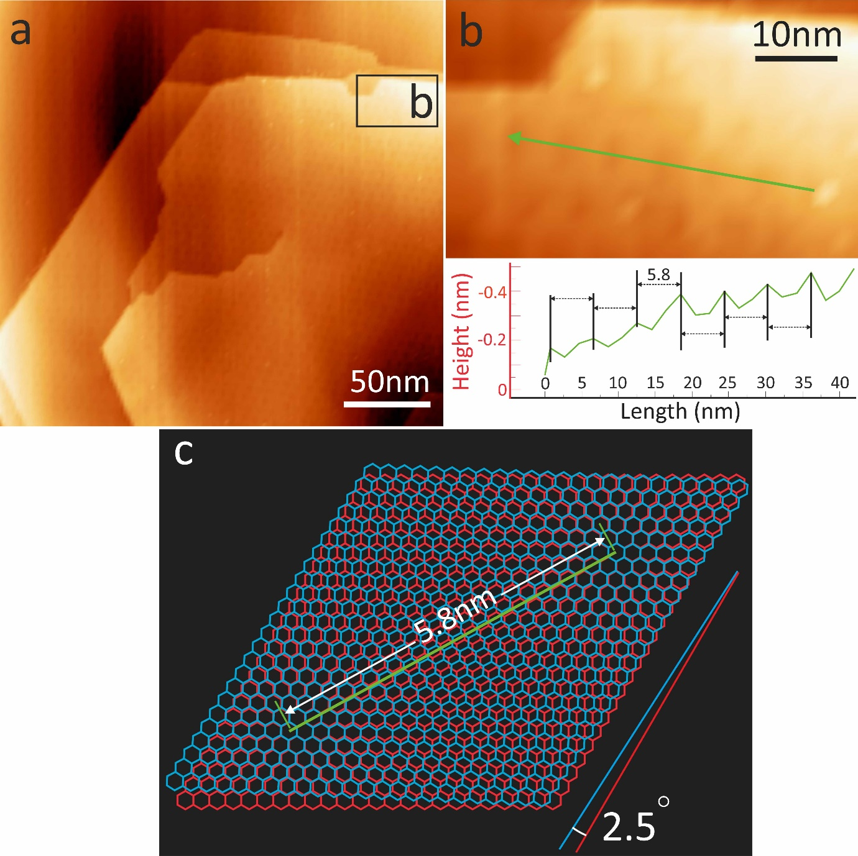
Extended Data Fig. 6| Scanning tunnelling microscopy (STM) imaging of GS structures. The screw dislocation cores are seen in the STM images (a), and (b) is a zoom-in of local topography over the region indicated by the black window in panel (a). Height profile along the green line in (b) showing the Moiré corrugation. (c) The corresponding atomistic models used to reduce twist angle of top and bottom layers.

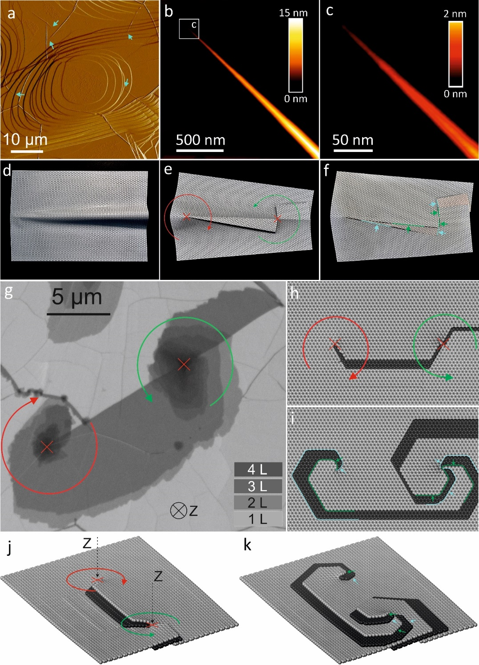
Extended Data Fig. 7| Triggering spiral growth at the endpoints of wrinkle. (a) Large-area AFM image of CVD grown graphene on Pt substrate showing topography of graphene wrinkles. The apices of wrinkles are marked by light blue arrows. (b) The details of a tail end of wrinkle represent half cone shape, and (c) is a zoom-in of local topography over the region indicated by the white box in panel (b). (d-f) Analogy with paper model for demonstration the cracking of the tubular edge up to the apex of a wrinkle. (g) In situ ESEM images of GSs at 1400 °C showing the GSs morphology at the endpoints of wrinkle and at the middle of wrinkle. The corresponding schematic representation of the formation of GSs at the endpoints of wrinkle and at the middle of wrinkle in in-plane view (h, i) and out-of-plane view (j, k). Note: The two growth fronts formed at the endpoint of cracked tubular edge initialize two spirals growth. The handedness is indicated by the red (right-handedness) and green (left-handedness) curved arrows (the thumb giving the direction of advance along the Z-axis). The tearing nodal points (screw dislocation cores) are highlighted by red ×. The light blue and green arrows in (f, i, k) highlight growth front of GSs at nodal points.

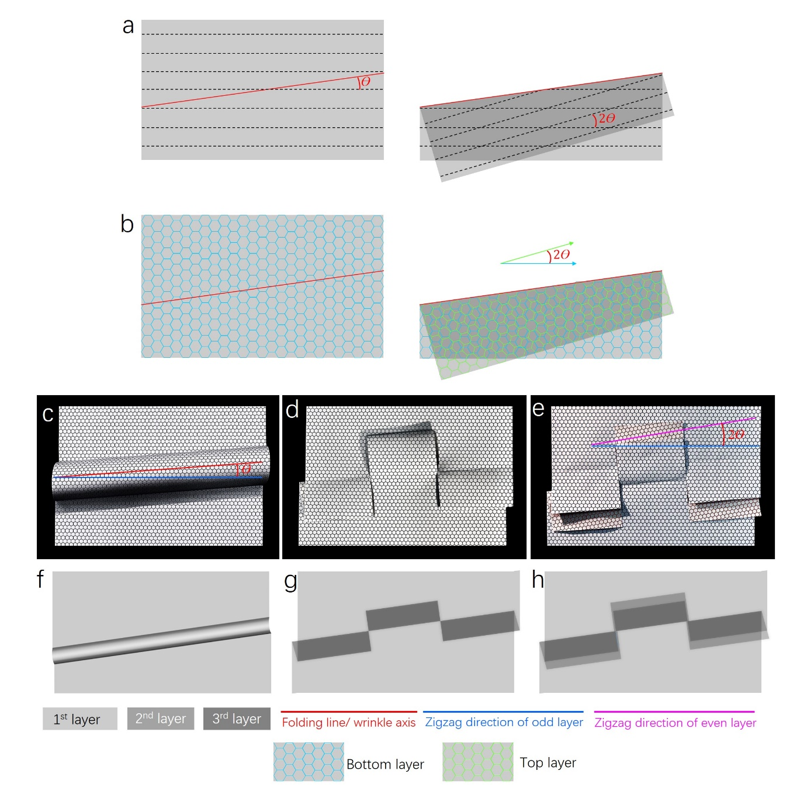
Extended Data Fig. 8|1D chirality to 2D twist-angle conversion. 1D chirality to 2D twist-angle conversion are demonstrated in the schematics of (a, b) using origami-like paper folding. (c-e) Analogy with paper model for demonstration the relation between the chirality of wrinkle and stacking order of FLG. The corresponding SEM contrast are demonstrated in the schematics of (f-h).

Extended Data Fig. 9|Schematic representation of overlapping / coalescence of few layer graphene and graphene spiral. Note: In the case of two few layer graphene domains layer-by-layer coalescence, the contrast of individual layers is homogenous in the merging region. In the case of pairwise GSs coalescence with opposite screw dislocation handedness, the contrast variation seems like a bridge (highlighted by yellow arrow), linking the GSs core, as a result of graphene wrinkle folding-over. The orange arrows highlight the 19° tilted edge.

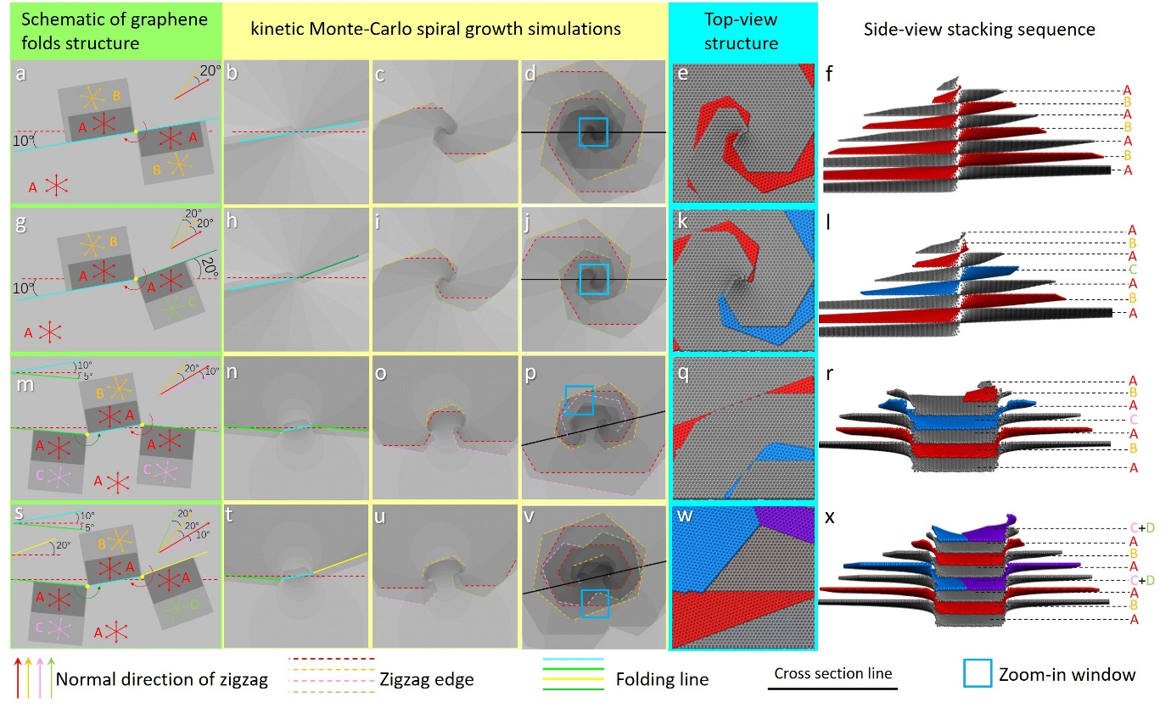
Extended Data Fig. 10| Classifying the shape of twisted few-layer graphene by the orientations of fold-over wrinkles. (a) Schematic of the case which has two segments of cracked wrinkle with (10°, 10°) orientation to zigzag direction of basal layer, the radial arrows indicate normal direction of zigzag edge in each layer. The layers with same orientation are labelled by same alphabet (A, B, …). (b-d) the snapshots in growth simulation of graphene corresponding to schematic (a). (e-f) Top view and side view of the final structure corresponding to schematic (a). (g) Schematic of the case which has two segments of wrinkle with (10°, 20°) orientation. (h-j) The snapshots in growth simulation of graphene corresponding to schematic (g); (k-l) top view and side view of the final structure corresponding to schematic (g). (m) Schematic of the case which has three segments of wrinkle with (-5°, 10°, -5°) orientation; (n-p) the snapshots in growth simulation of graphene corresponding to schematic (m); (k-l) top view and side view of the final structure corresponding to schematic (m). (s) Schematic of the case which has three segments of wrinkle with (-5°, 10°, 20°) orientation; (t-v) the snapshots in growth simulation of graphene corresponding to schematic (s); (w-x) Top view and side view of the final structure corresponding to schematic (s).

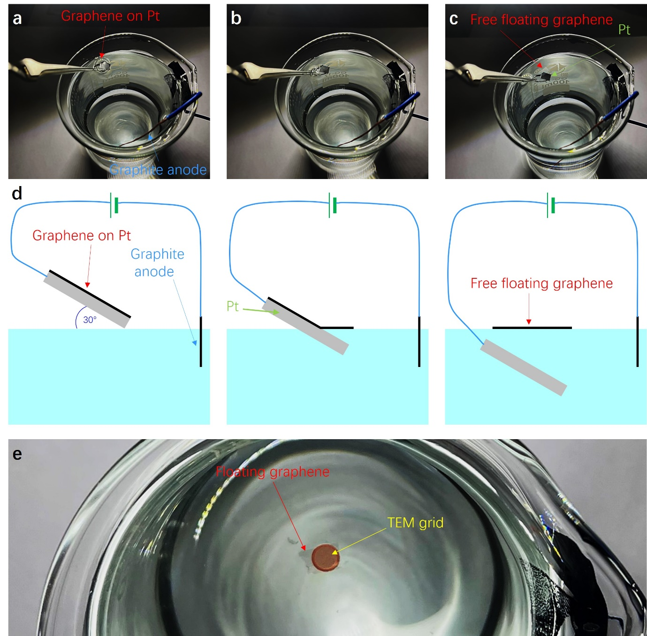
Extended Data Fig. 11| Illustration of the transfer process of graphene from a Pt surface to TEM grid. (a) A Pt foil with grown graphene inside the ESEM chamber was used as a cathode, and a graphite rod was used as an anode. (b) The graphene was peeled from the Pt surface driven by the H₂ produced after applying a constant current¹. (c) The completely separated graphene layer. (d) A schematic drawing of the transfer process of graphene from a Pt surface. (e) The free-floating graphene layer was fished by TEM grid. The free-floating graphene is indicated by a red arrow in (c), (d) and (e).

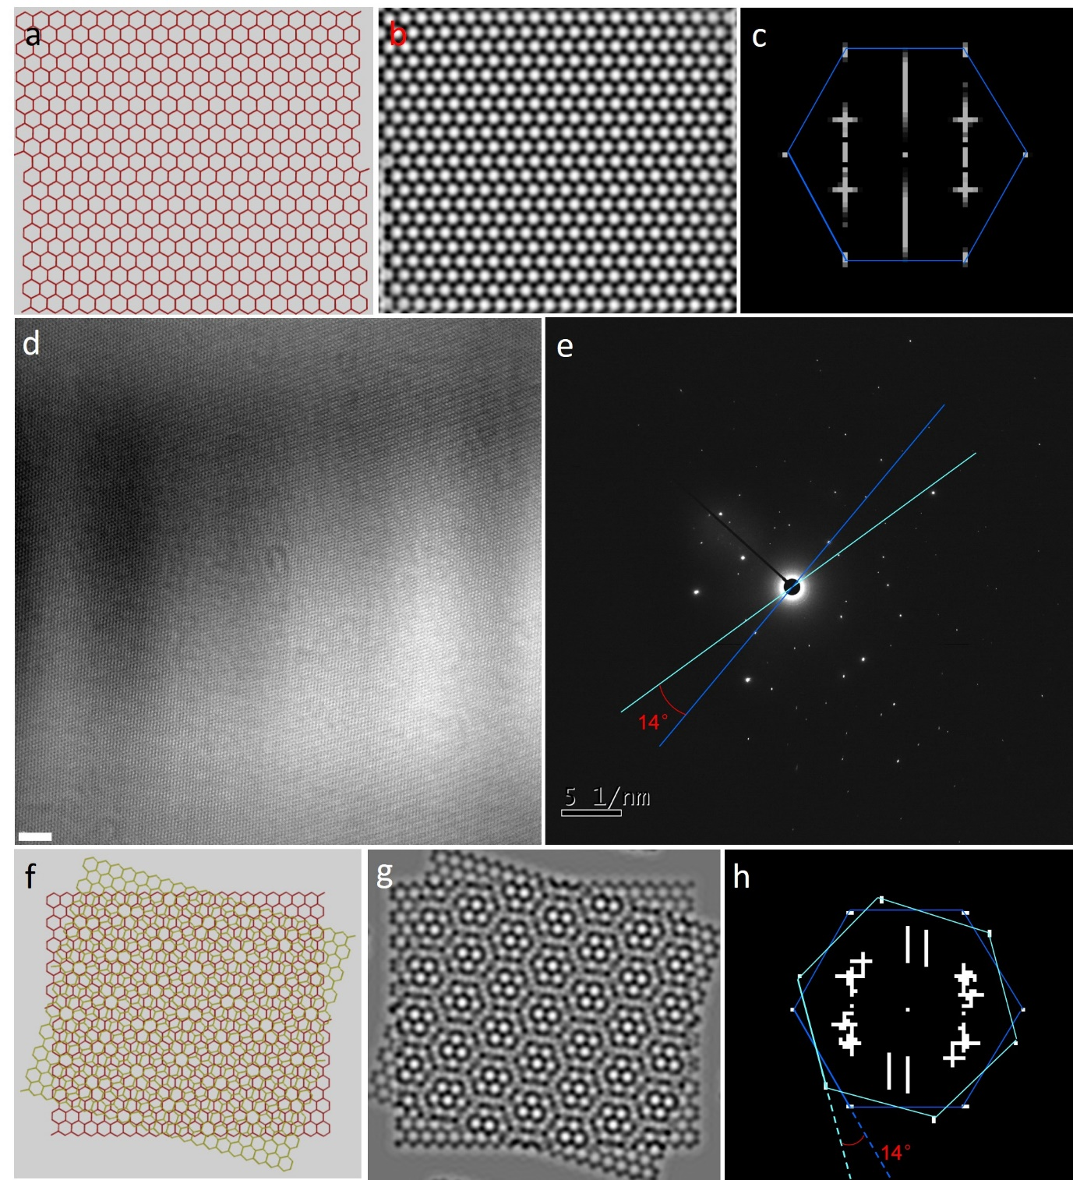
Extended Data Fig. 12| Determining the twisted angle of coalesced graphene spirals in Figure 3. (a) the structural model of monolayer graphene. (b) simulated TEM image (80 kV) corresponding to the structural model in a by QSTEM program. (c) FFT of the simulated TEM image in (b). (d) Raw HRTEM image of the coalesced graphene spirals in main text Figure 3. The scale bar measures 5nm in (d). (e) SEAD pattern of the coalesced graphene spirals, showing the 14° twisted angle. (f) The structural model of double-layered graphene with twisted angle of 14°. (g) Simulated TEM image (80 kV) corresponding to the structural model in f by QSTEM program. (h) FFT of the simulated TEM image in g with twisted angle highlighted.

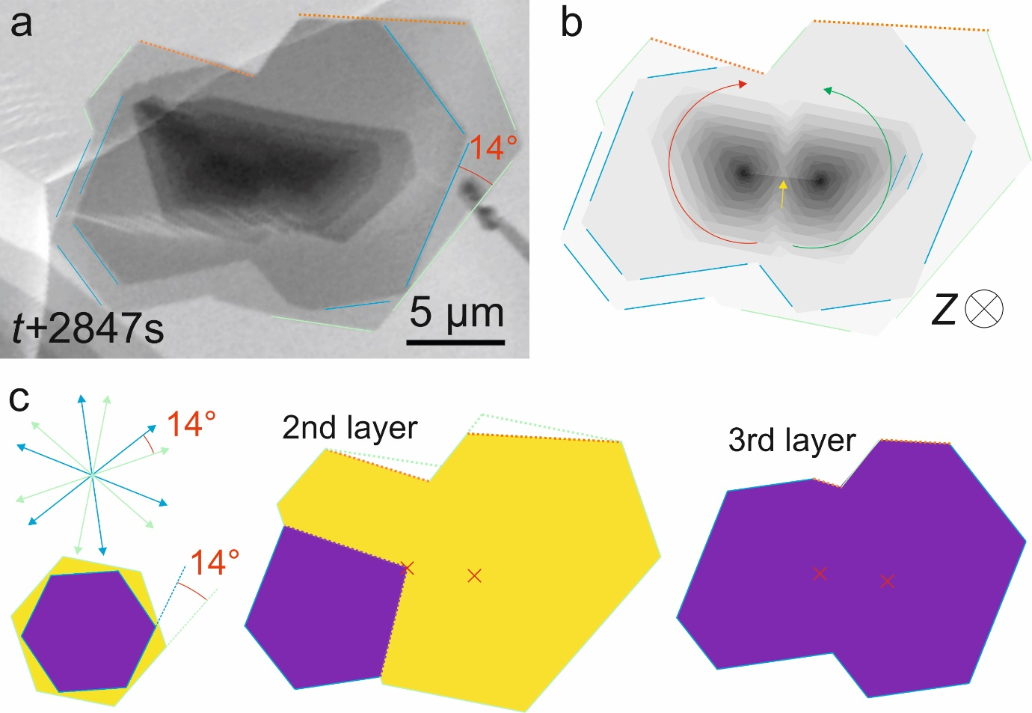
Extended Data Fig. 13| The shape of coalesced GSs. (a) In situ ESEM images of pairwise GSs coalescence with opposite screw dislocation handedness. (b) Schematic translation of SEM contrast. c, The decomposition map of 2nd and 3rd layers. Note: The slightly different shape of the 2nd layer between experimental observation and simulation indicates the existence of GB in polygonal domain. As shown in (a), the GB can be identified by the concave corner where the associated angle is not equal to 60°/120°. Due to the individual layer growth originating from screw dislocation core (tearing point), the location of GB can be predicted as the line connecting growth starting point and concave corner, as shown in (c)². This difference is only observed in the 2nd layer of system in comparison with theoretical simulation, and is thus caused by another type of growth defect that is not detectable in the images. The upper side of second and third layer (highlighted by orange dot line) does not appear intrinsic graphene shape (zigzag terminated edge) due to the out-of-plane growth fronts interactions and formation of bonded bilayer edges ³.
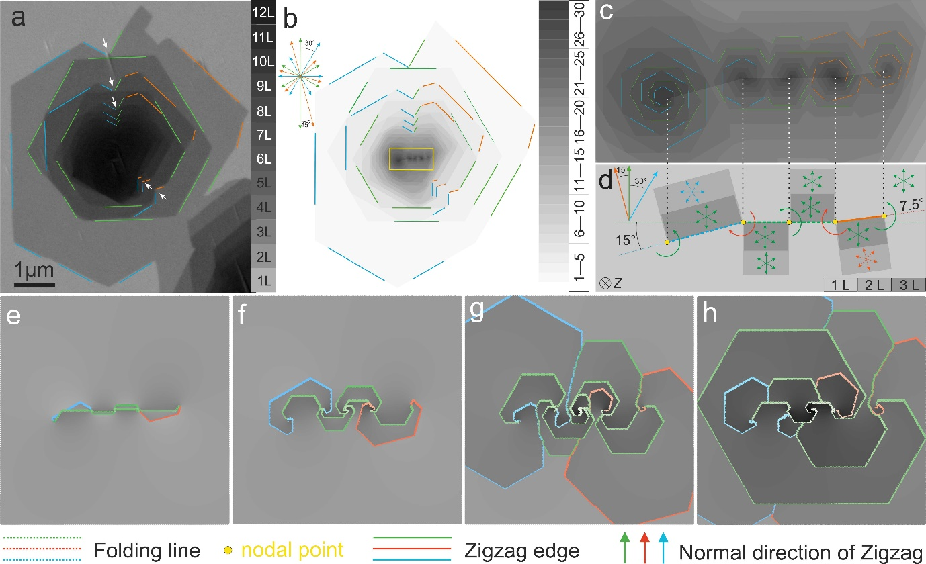
Extended Data Fig. 14︱ Reverse inference graphene spiral structure. The ESEM image (a) shows a complex shaped multi-layer graphene. The brightness in the secondary electron image changes with each additional layer. (b) Reproduced the shape of multi-layer graphene using GSs coalescence, and (c) is a zoom-in of local brightness topography over the region indicated by the yellow window in panel (a). (d) Schematic representation of initial state (c) using origami kirigami-like graphene folds. The number of layers can be abstracted by comparing the contrast in the images with the contrast legend in the (a，b). According layout of graphene folding in (c), the coalescence of GSs are simulated by KMC in (e-h) and represent apparent layer-by-layer growth behaviour.
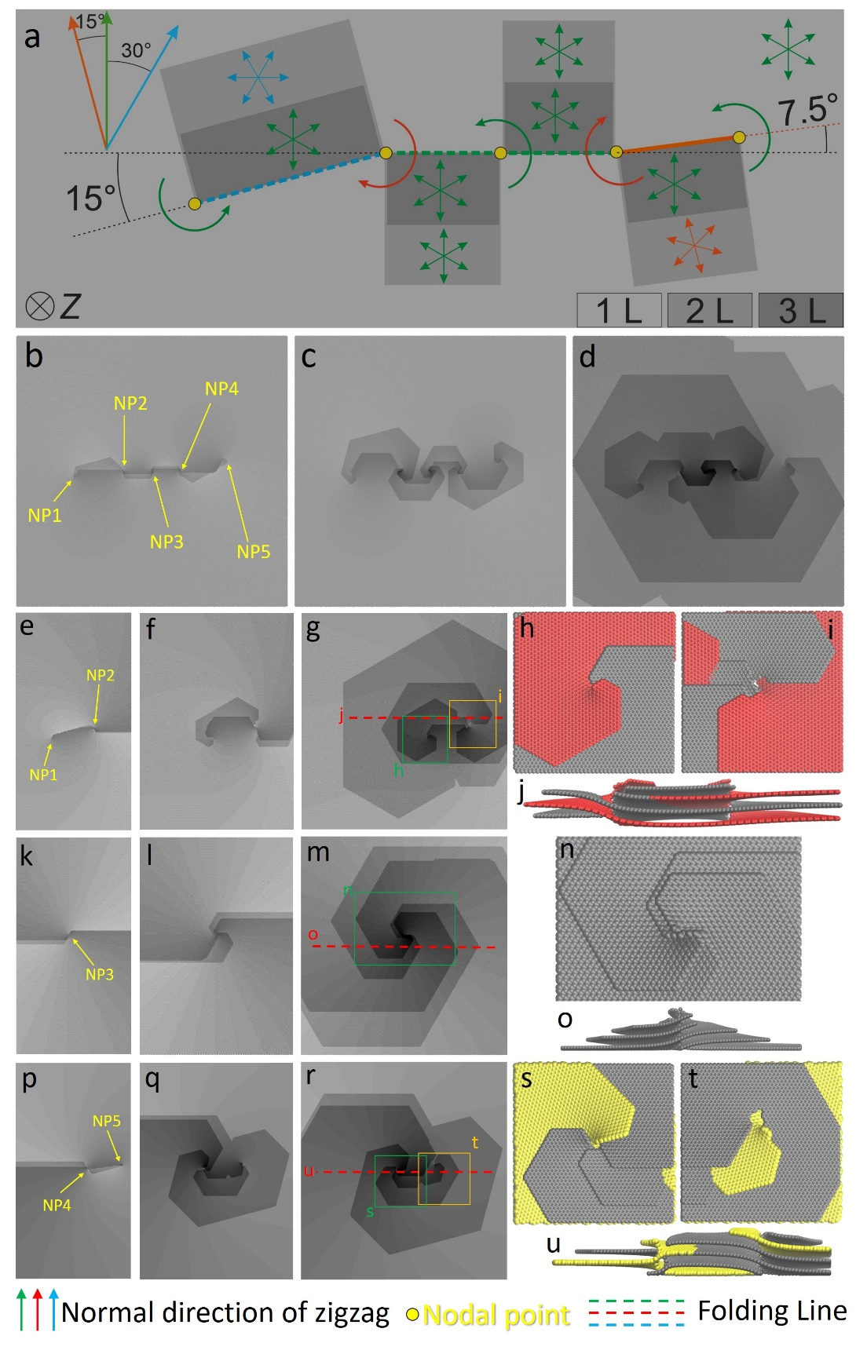
Extended Data Fig. 15︱ The nodal point of spiral layout and GSs structure. (a) Schematic representation of the initial state of folded over graphene using Origami-Kirigami model in brightness contrast. The coalescence of GSs are simulated by KMC in (b-d) and represent evolution behaviour. Each neighboring GS evolution are simulated in (e-u), showing the detail of GS structure.

Supplementary Note. Computational details:

Details of Density Function Theory (DFT) Calculations.
The Vienna ab inito simulation package (VASP) was employed for DFT calculations ^{4, 5}. The Perdew-Burke-Ernzerhof parameterization of generalized gradient approximation (GGA) was used for the exchange-correlation function ⁶. The ion-electron interactions were embodied in projector augmented wave method with a cutoff energy of $400eV$ ^{7, 8}. The Grimme DFT-D2 method was used for the corrections of the interlayer van der Waals interaction ⁹. To void the image interference, the supercell volumes are $40.0×12.3×25.0 Å^{3}$for closed edge graphene and $50.0×12.3×18.0 Å^{3}$ for flat graphene. Both cases are sampled by $1×3×1$ k-mesh using the Monkhorst−Pack method ¹⁰. The electronic self-consistency criterion is set to ${10}^{-4}eV$. For geometry relaxation, the force on atoms is converged below $0.01eV/Å$.

Stepwise energy calculation in etching fallen wrinkle.
The fallen wrinkle becomes two additional layers on primary graphene island, with a closed edge at termination. The closed edge contributes large bending energy to the system. Since there is a large pressure of hydrogen gas provided in experimental environment, the closed edge can be etched by adsorbing hydrogen molecules to reduce the bending energy. Here we calculated the free energy change during this process and compared it to flat monolayer etching. The results are shown in Extended Data Fig. 16 and stepwise structures are shown in Extended Data Fig. 17. For fallen wrinkle, we constructed five vertical carbon bonds along zigzag direction in one supercell. In each step, two hydrogen atoms are adsorbed to a carbon pair at closed edge. The chemical potential of hydrogen atoms is referring to the energy of them in hydrogen molecule ($E_{H_{2}}=-6.797eV$). According to the result, free energy rises a little in etching first carbon bond and then reduces step by step. The bending edge is relaxing during the process and finally turn into flat graphene bilayer with hydrogenated edge. The enhancement of interlayer interaction together with decrement of bending energy drive this process. The result supports the possibility of hydrogen etching fallen wrinkle to bilayer graphene. In the case of flat monolayer graphene, the supercell also contains five vertical bonds along zigzag direction. We considered that one atom of the adsorbed hydrogen molecule was flipping to bottom to reduce the total energy. According to calculation result, adsorbing hydrogen leads to an energy lifting except for the last carbon pair. The magnitudes of energy in two cases are renormalized to be compared. As shown in Extended Data Fig. 16, the change of free energy is always positive in second case, which implies there is no tendency in etching flat graphene during CVD at the chemical potential we considered. On the contrast, fallen wrinkle is tending to be etching by hydrogen molecules since the energy change is negative in most steps. The etched wrinkle then forms two additional layers on original layer.

Kinetic Monte Carlo simulation
In this work, we use an in-house developed kinetic Monte Carlo (KMC) simulation package to simulate the growth of graphene spirals. The method is introduced in Ref.¹¹ and has been implemented on studying the etching mechanisms of spiral 2D materials WSe₂ and WS₂ ^{11, 12}. In this work, the events were defined as completing a new hexagon on the edge of spiral graphene island. The probability of events was defined as $P_{i}=\exp\left(-\frac{E_{\left(m,n\right)}\left(r_{i}\right)}{k_{B}T}\right)$ and could not be larger than 1, where $k_{B}$ is the Boltzmann constant, and $T$ is the temperature. The energy was:
$$E_{\left(m,n\right)}\left(r\right)=E_{0}-α*m-β*n+ε\frac{b_{L}^{2}}{{\left({r_{i}}/{a_{0}}\right)}^{2}},$$
where $m$ and $n$ are the numbers of nearest and next-nearest neighbors, $b_{L}$ is the number of burger vector in unit of layer distance and ${r_{i}}/{a_{0}}$ is the distance from the center in unit of the lattice constant of graphene. The energy barriers of events are used from Ref.¹¹, which were fitted from DFT calculations on Pt (111) surface. A small energy barrier difference ($<=0.1 eV$) along different directions was also introduced to fit the anisotropic growth rate in experiments. $ε$ is the strain energy of screw dislocation. Naturally, $ε$ should be positive, which implies that the carbon atoms cannot attach to the central part of screw dislocations due to the high energy. However, due to the size limit of simulation, we use a small negative $ε=-0.1 eV$ to speed up the growth rate along z direction. This parameter narrows the distance between edges of two adjacent layers, but would not change the growth behaviour and the stacking orders, which are focused in this work. Additionally, we observed that the growth of a layer stopped at the edge of sublayer so that the possibility of an event at $\left(x, y,l\right)$ is $0$ if there is no graphene grain at $\left(x, y,l-1\right)$, where $x, y$ are Cartesian coordinates and $l$ is a reference number of layer. The model was put on a platform with screw dislocations,
$$z\left(θ\right)=z_{0}*\left(l+\frac{θ}{π}\right),$$
where $z_{0}≈3.4 Å$ is the layer distance, $l$ is the layer and $θ∈\left(-π,π\right)$ is the angle in $x$-$y$ plane. In the initial models, the first layer of graphene is filled to mimic the as-grown graphene on Pt, and the layers under the first layer is neglected.

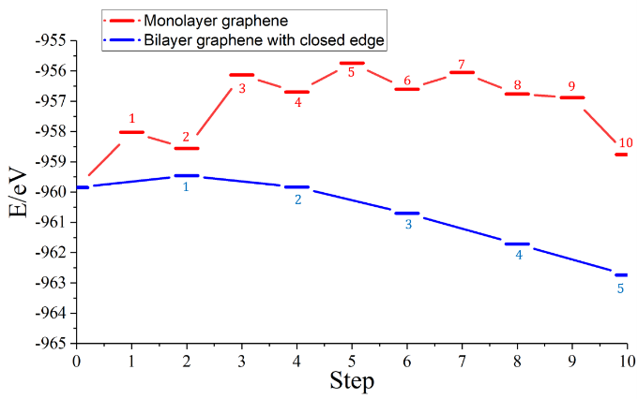
Extended Data Fig. 16| Free energy evolution during etching flat monolayer graphene (red) and closed edge bilayer graphene (blue). The energy of bilayer graphene is renormalized to compare with the monolayer one. The indexes near energy levels are corresponding to steps shown in Extended Data Fig. 17. The additional hydrogen atom energy refers to it in hydrogen molecule.
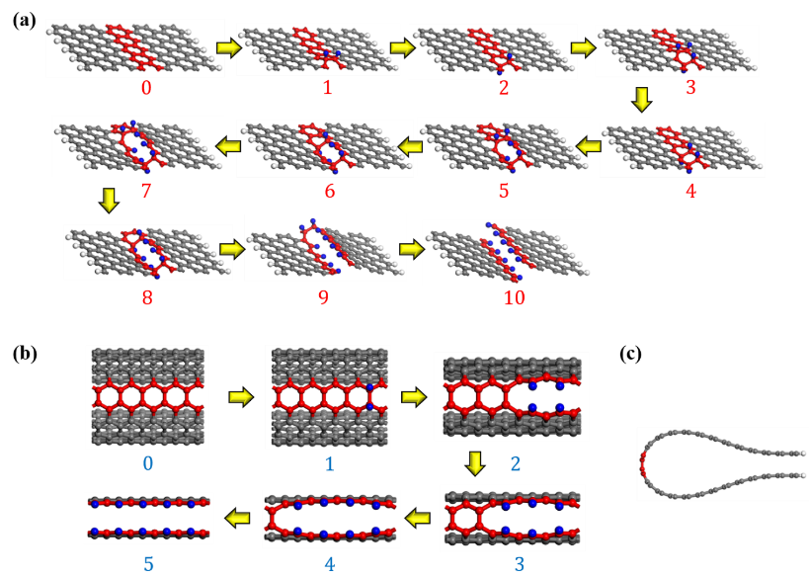
Extended Data Fig. 17| Optimized structures in stepwise etching graphene by hydrogen atoms. Carbon atoms are in gray and red; hydrogen atoms are in blue and white. The red and blue atoms localize near reaction region. (a) Etching flat monolayer graphene by hydrogen atoms. The etching process are in 10 steps. For odd step 2n-1, a pair of hydrogen atoms are adsorbed from hydrogen molecule; for even step 2n, one hydrogen atom flips to bottom to reduce the free energy. (b) Etching fallen wrinkle by hydrogen atoms. The process contains 5 steps and at each step two hydrogen atoms are adsorbed from hydrogen molecule. (c) A side view of fallen wrinkle.

References:
1. Gao, L. et al. Repeated growth and bubbling transfer of graphene with millimetre-size single-crystal grains using platinum. Nat. Commun. 3, 699 (2012).
2. Guo, W. et al. Governing Rule for Dynamic Formation of Grain Boundaries in Grown Graphene. ACS Nano 9, 5792-5798 (2015).
3. Huang, J.Y. et al. In situ observation of graphene sublimation and multi-layer edge reconstructions. Proceedings of the National Academy of Sciences 106, 10103 (2009).
4. Kresse, G. & Furthmüller, J. Efficiency of ab-initio total energy calculations for metals and semiconductors using a plane-wave basis set. Computational Materials Science 6, 15-50 (1996).
5. Kresse, G. & Furthmüller, J. Efficient iterative schemes for ab initio total-energy calculations using a plane-wave basis set. Phys. Rev. B 54, 11169-11186 (1996).
6. Perdew, J.P., Burke, K. & Ernzerhof, M. Generalized Gradient Approximation Made Simple. Phys. Rev. Lett. 77, 3865-3868 (1996).
7. Blöchl, P.E. Projector augmented-wave method. Phys. Rev. B 50, 17953-17979 (1994).
8. Kresse, G. & Joubert, D. From ultrasoft pseudopotentials to the projector augmented-wave method. Phys. Rev. B 59, 1758-1775 (1999).
9. Grimme, S. Semiempirical GGA-type density functional constructed with a long-range dispersion correction. J. Comput. Chem. 27, 1787-1799 (2006).
10. Monkhorst, H.J. & Pack, J.D. Special points for Brillouin-zone integrations. Phys. Rev. B 13, 5188-5192 (1976).
11. Kong, X., Zhuang, J., Zhu, L. & Ding, F. The complementary graphene growth and etching revealed by large-scale kinetic Monte Carlo simulation. npj Comput. Mater. 7, 14 (2021).
12. Zhao, Y., Kong, X., Shearer, M.J., Ding, F. & Jin, S. Chemical Etching of Screw Dislocated Transition Metal Dichalcogenides. Nano Lett. 21, 7815-7822 (2021).

