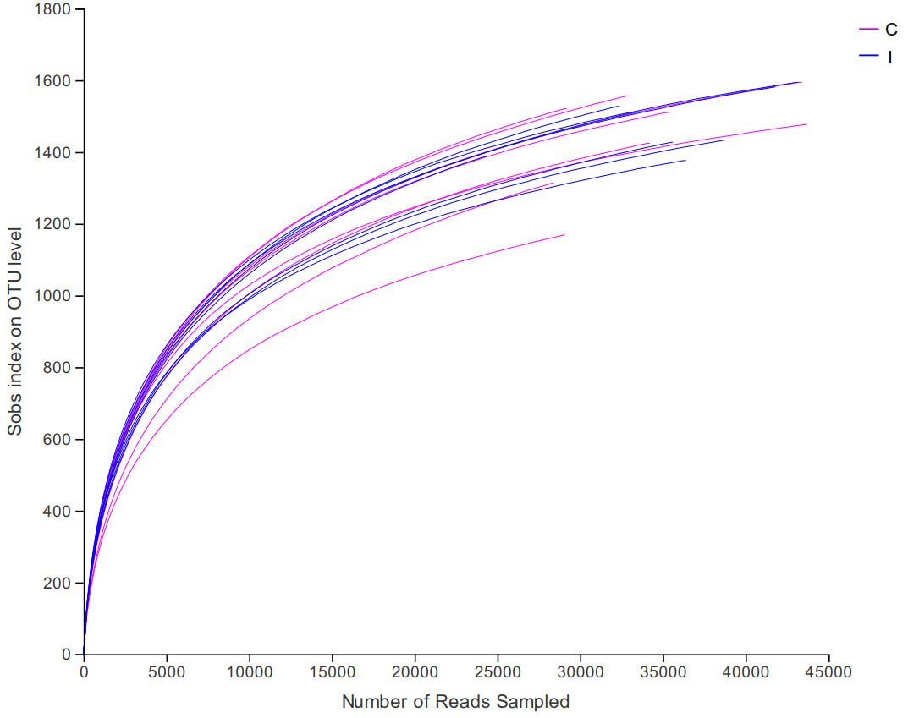

Figure S1. Rarefaction curves of OTU number in rumen fluid samples. C, control group. I, inulin group.

(A)
(B)
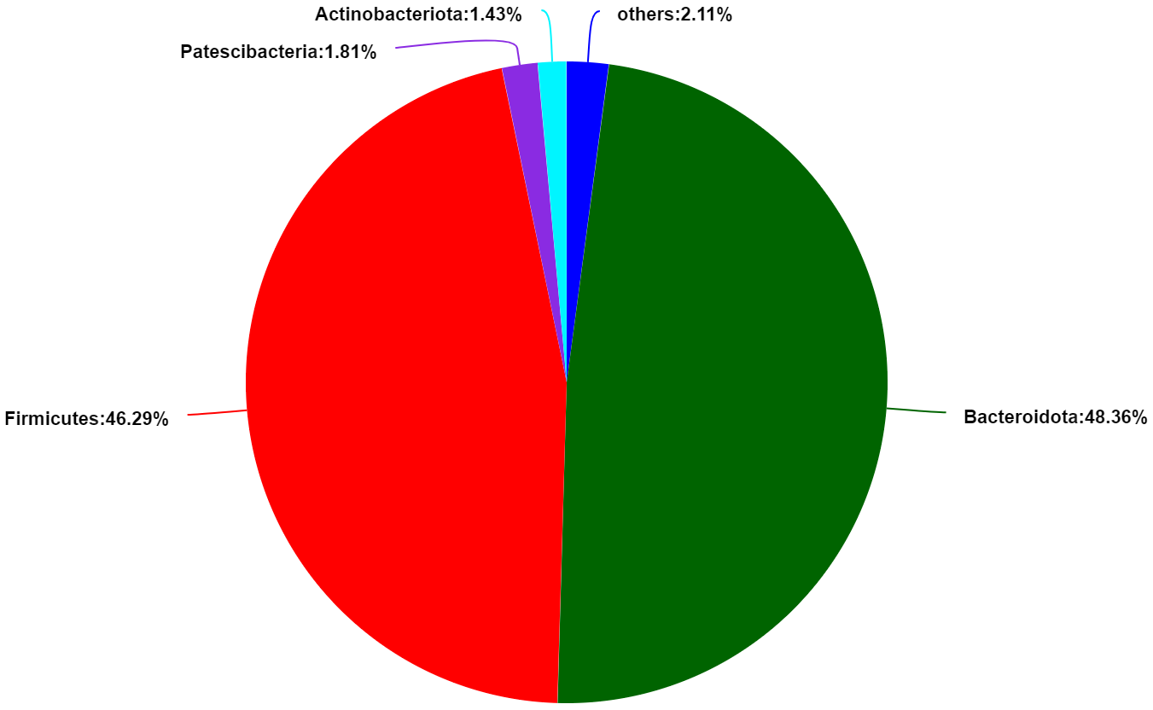
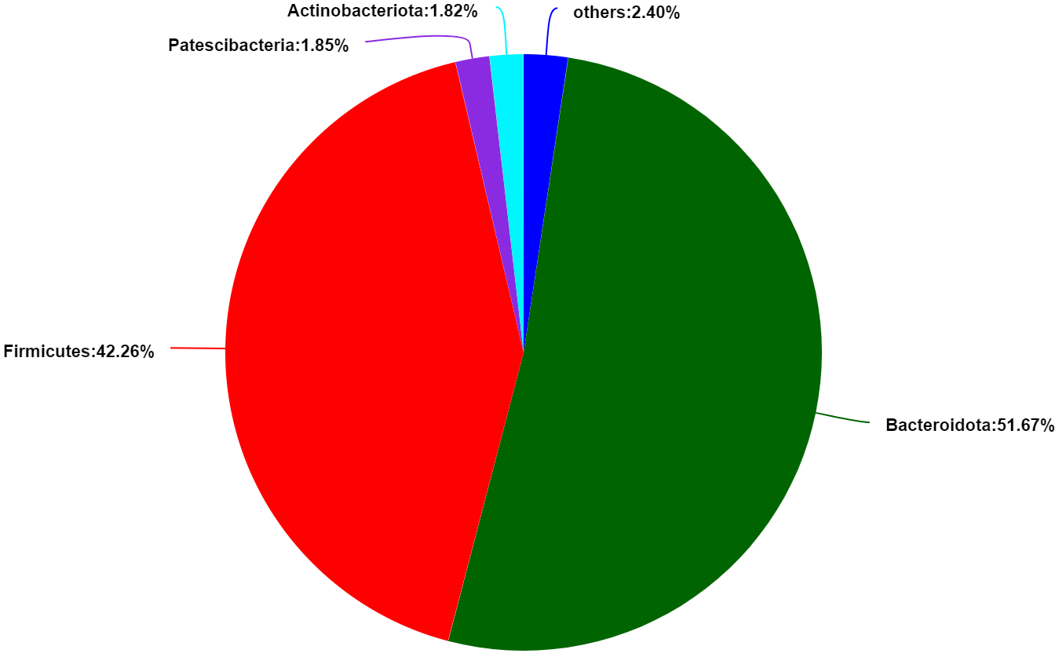

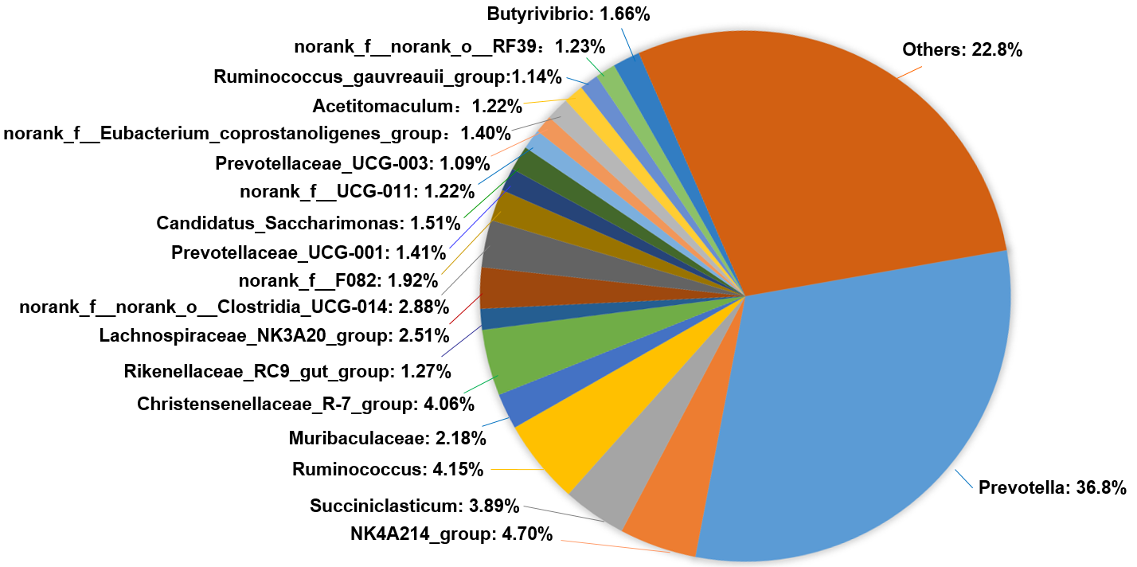
(D)
(C)
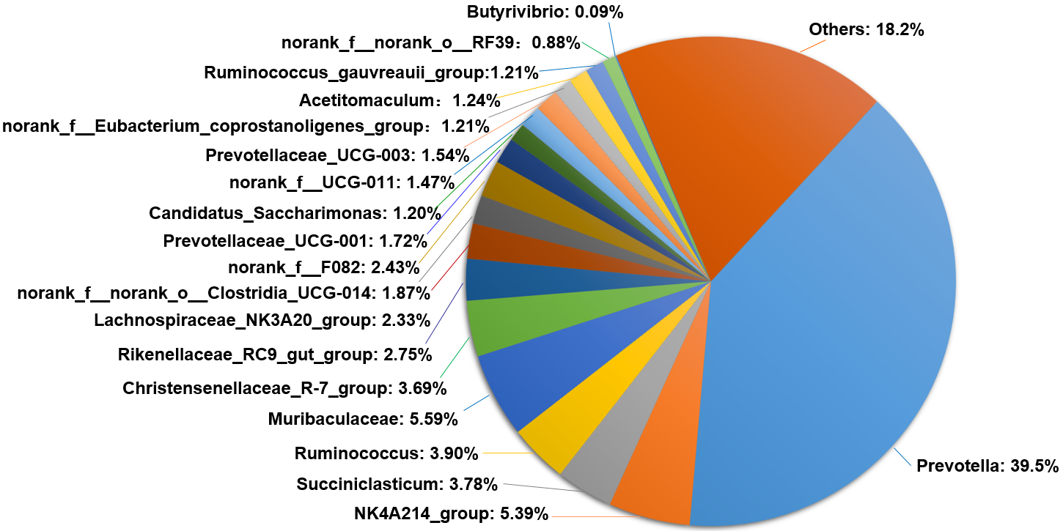

Figure S2 The pie chart of ruminal bacterial community compositions in control (A, C) and inulin groups (B, D) at phylum (A, B) and genus (C, D) level. C, control group. I, inulin group.
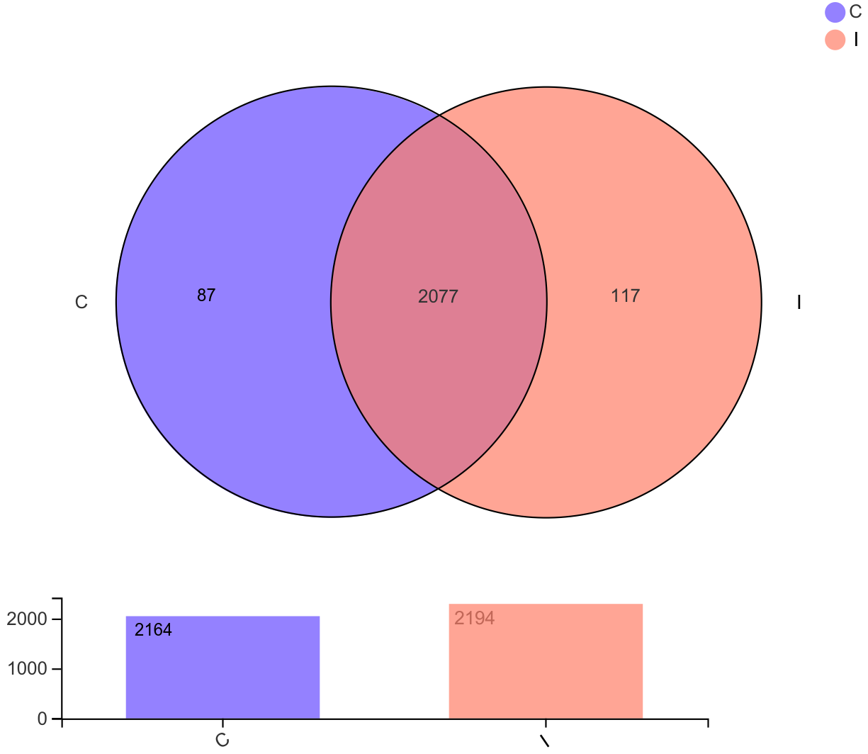

Figure S3. Common and unique OTU number of ruminal bacteria in control group and inulin group. C, control group. I, inulin group.
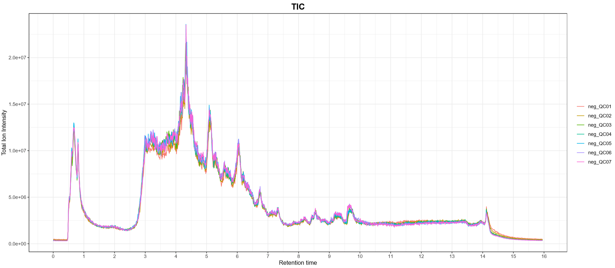
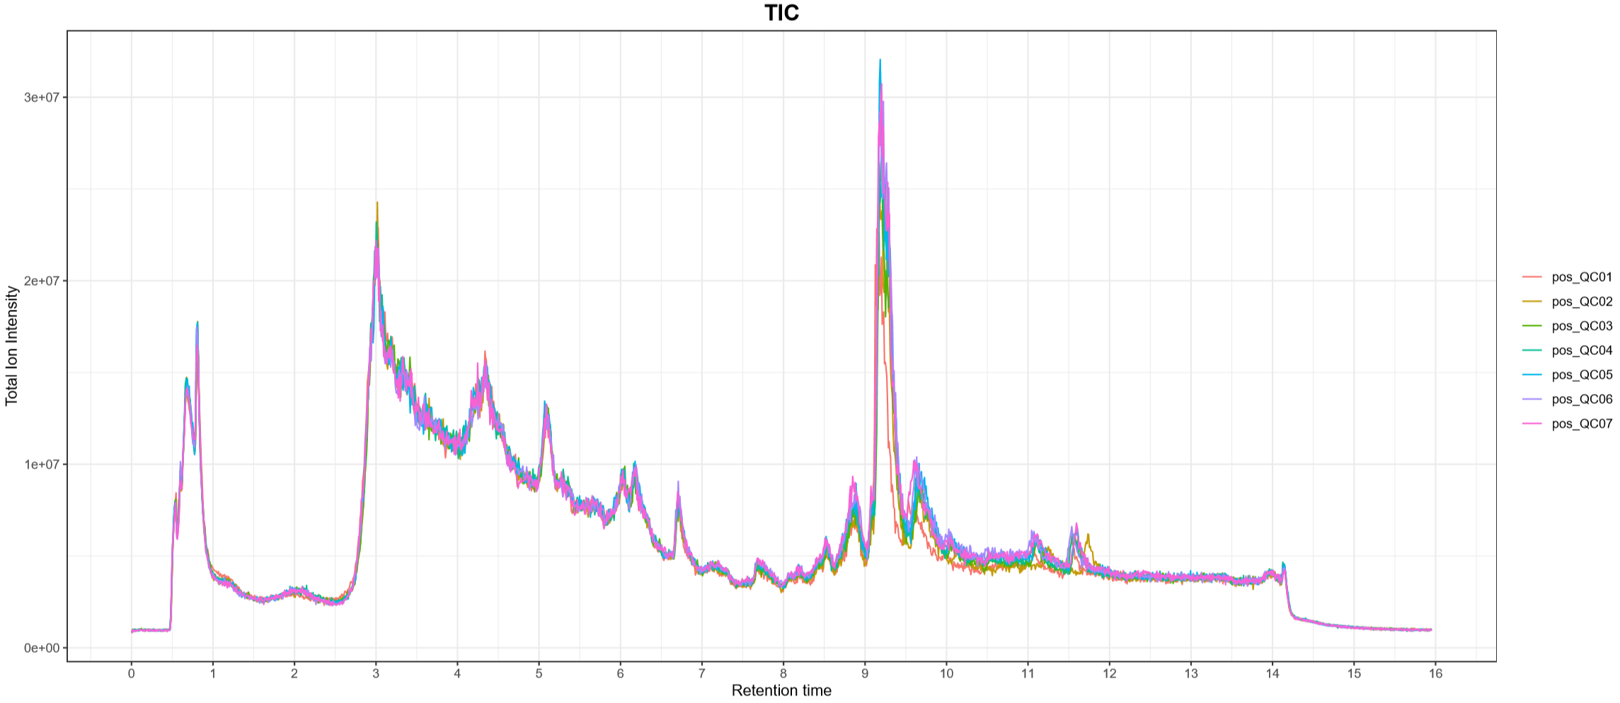
(A)
(B)

Figure S4. The total ion chromatograms (TIC) plot of quality control samples in (A) positive and (B) negative ion mode. QC, quality control.

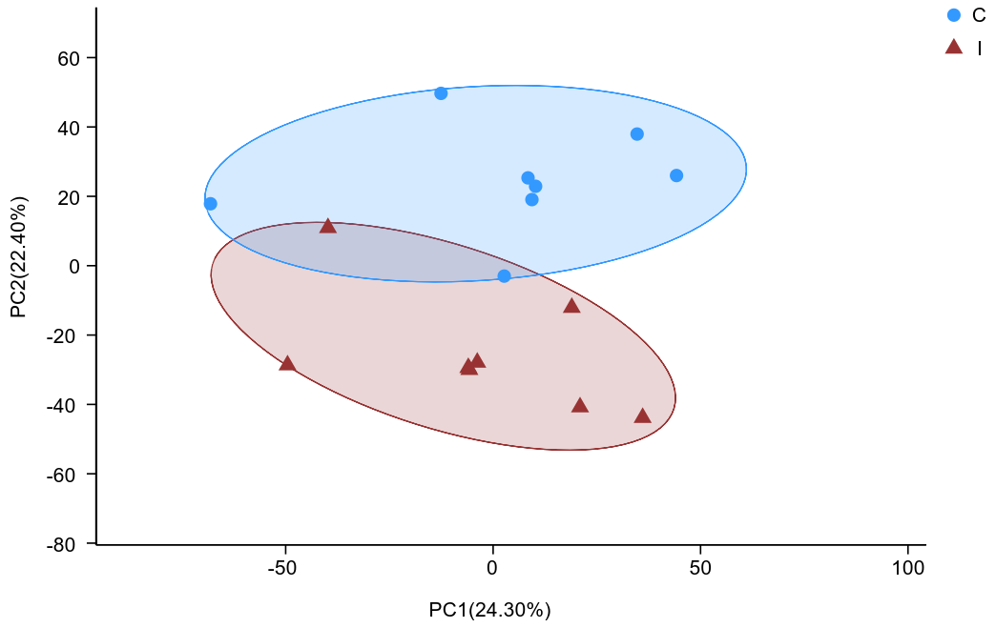
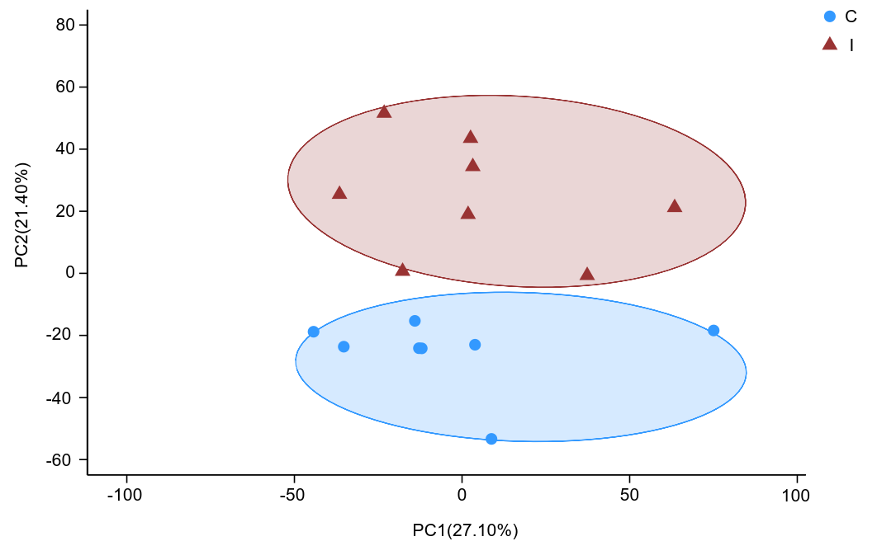
(A)
(B)

Figure S5. Principal component analysis (PCA) score plots of the rumen metabolites in (A) positive and (B) negative ion modes. C, control group; I, inulin group.

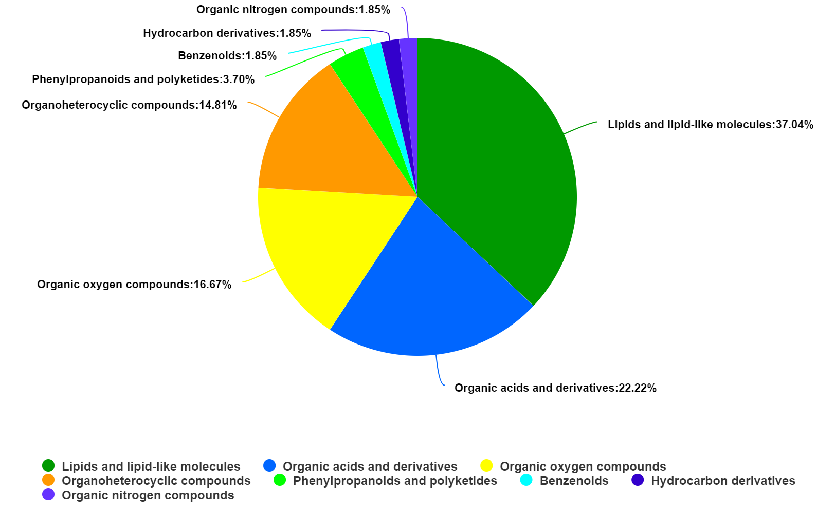
Figure S6. Human metabolome database (HMDB) compound classification of significantly differential ruminal metabolites.

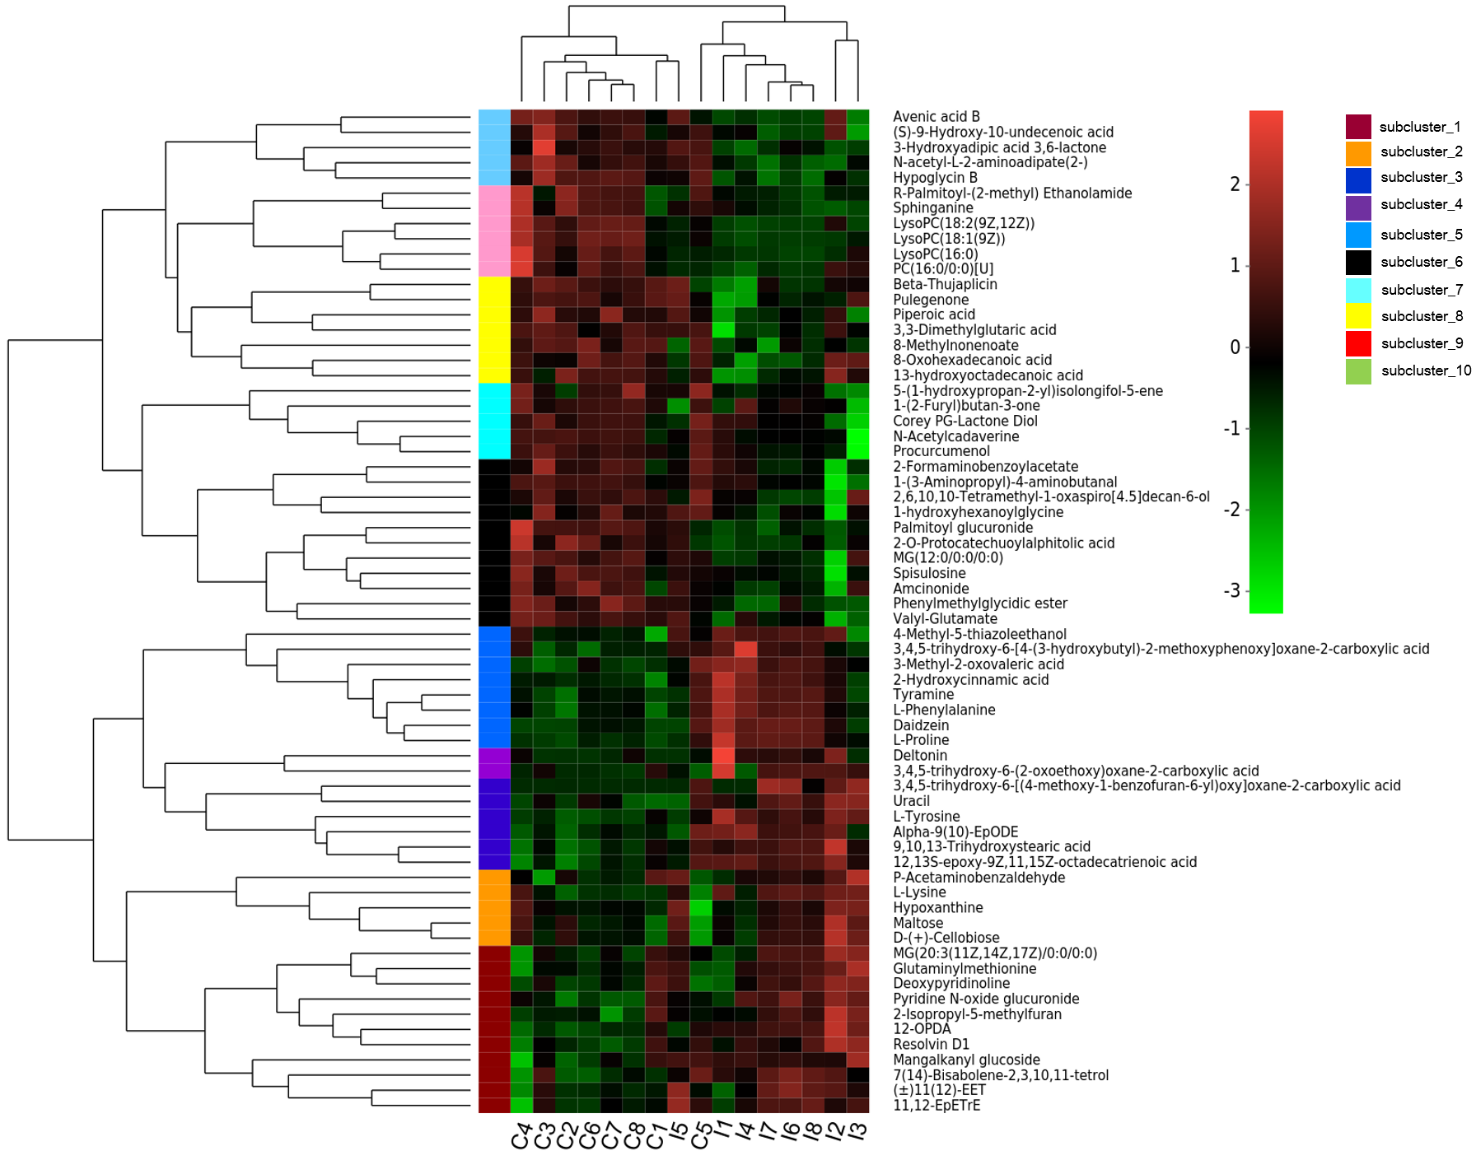
Figure S7. Hierarchical clustering analysis (HCA) for significantly different metabolites in rumen by comparison of the control and inulin groups. Each column in the ﬁgure represents a sample, each row represents a metabolite. Red indicates that the metabolite is expressed at high levels, and green indicates lower expression. C, control group; I, inulin group.

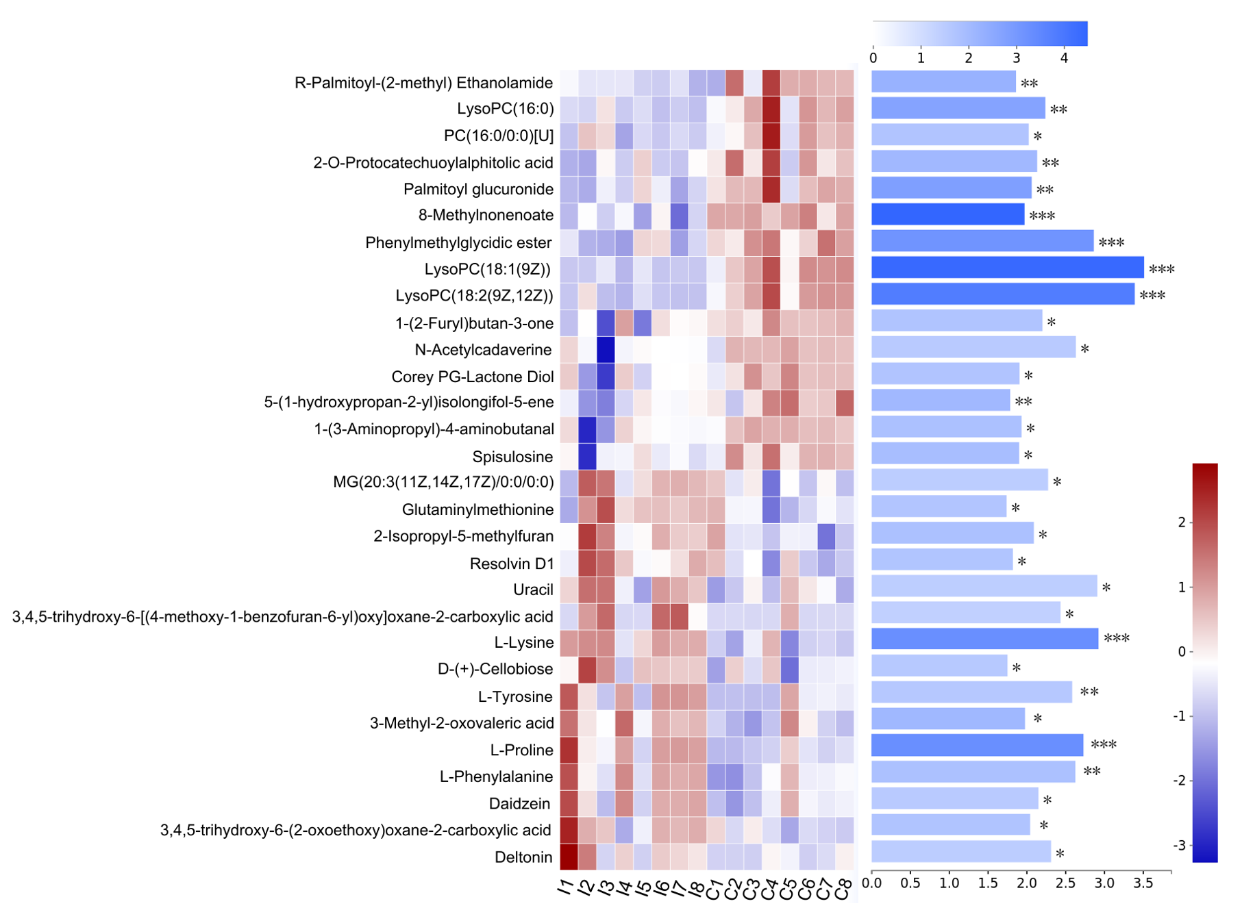
Figure S8. Top 30 of signiﬁcantly differential metabolites in the rumen based on the variable importance in the projection (VIP) value between control and inulin groups under merger mode of positive and negative ion. C, control group; I, inulin group. Each column represents a sample, each row represents a metabolite, and the color indicates the relative expression level of the metabolites in the samples. The right side is the metabolite VIP bar graph, the length of bar represents the contribution of the metabolites to the difference between the two groups (VIP > 1), the color of the bar means the P-value (*0.01< P ≤ 0.05; **0.001< P ≤ 0.01; ***P ≤ 0.001).

