Appendix A. Supplementary Data
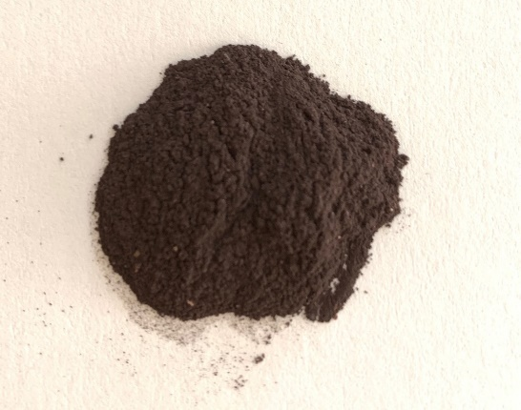
Fig.S1. Powder of gIONPs dried at 70 °C.

Table S1. Experimental design runs for synthesis of gIONPs with the corresponding responses (hydrodynamic size and PDI values of DLS measurements).
No | Extract Concentration (w/w %) | Iron Ion (M) | Time (h) | Temp (°C) | RPM | pH | Hydrodynamic Size (nm) | PDI
1 | 5 | 0,07 | 1 | 25 | 200 | 5 | 302.6±13 | 6.4±0.4
2 | 5 | 0.07 | 1 | 25 | 400 | 8 | 401±27 | 5.6±0.1
3 | 5 | 0.07 | 1 | 25 | 600 | 11 | 448.8±16.9 | 5.3±1
4 | 5 | 0.14 | 2 | 55 | 200 | 5 | 384.7±8.5 | 3.7±0.3
5 | 5 | 0.14 | 2 | 55 | 400 | 8 | 256.3±9.7 | 4.3±0.1
6 | 5 | 0.14 | 2 | 55 | 600 | 11 | 254.1±9 | 4.1±0.1
7 | 5 | 0.28 | 3 | 85 | 200 | 5 | 317.9±5.7 | 2.4±0.4
8 | 5 | 0.28 | 3 | 85 | 400 | 8 | 330±7.8 | 3.3±0.1
9 | 5 | 0.28 | 3 | 85 | 600 | 11 | 384±7.8 | 3.1±0.2
10 | 10 | 0.07 | 2 | 85 | 200 | 8 | 268.3±7.8 | 3.1±0.1
11 | 10 | 0.07 | 2 | 85 | 400 | 11 | 279.7±9 | 2.9±0.02
12 | 10 | 0.07 | 2 | 85 | 600 | 5 | 277.2±14.5 | 2.9±0.2
13 | 10 | 0.14 | 3 | 25 | 200 | 8 | 237.6±5 | 0.6±0.06
14 | 10 | 0.14 | 3 | 25 | 400 | 11 | 288±3 | 0.4±0.08
15 | 10 | 0.14 | 3 | 25 | 600 | 5 | 278.2±7.2 | 0.7±0.1
16 | 10 | 0.28 | 1 | 55 | 200 | 8 | 373.5±11 | 7.5±0.4
17 | 10 | 0.28 | 1 | 55 | 400 | 11 | 372.7±24 | 8.5±1.2
18 | 10 | 0.28 | 1 | 55 | 600 | 5 | 325.8±9 | 8.4±1
19 | 20 | 0.07 | 3 | 55 | 200 | 11 | 800.6±39.5 | 7.5±0.4
20 | 20 | 0.07 | 3 | 55 | 400 | 5 | 661±8 | 4.9±1
21 | 20 | 0.07 | 3 | 55 | 600 | 8 | 721.4±30 | 7.1±0.6
22 | 20 | 0.14 | 1 | 85 | 200 | 11 | 1074.1±7.8 | 5.0±1
23 | 20 | 0.14 | 1 | 85 | 400 | 5 | 645.7±5.8 | 3.1±0.3
24 | 20 | 0.14 | 1 | 85 | 600 | 8 | 826.9±3 | 4.4±0.3
25 | 20 | 0.28 | 2 | 25 | 200 | 11 | 766±3.8 | 3.9±0.5
26 | 20 | 0.28 | 2 | 25 | 400 | 5 | 472.5±2.5 | 3.0±0.4
27 | 20 | 0.28 | 2 | 25 | 600 | 8 | 714.9±5 | 5.7±0.6

Table S2. JCPDS card for Hematite
Name and formula

Reference code: 00-013-0534

Mineral name: Hematite, syn
Compound name: Iron Oxide
PDF index name: Iron Oxide

Empirical formula: Fe2O3
Chemical formula: Fe2O3

Crystallographic parameters

Crystal system: Rhombohedral
Space group: R-3c
Space group number: 167

a (Å): 5.0310
b (Å): 5.0310
c (Å): 13.7370
Alpha (°): 90.0000
Beta (°): 90.0000
Gamma (°): 120.0000

Calculated density (g/cm^3): 5.27
Measured density (g/cm^3): 5.26
Volume of cell (10^6 pm^3): 301.11
Z: 6.00
RIR: 2.60

Status, subfiles and quality

Status: Marked as deleted by ICDD
Subfiles: Alloy, metal or intermetalic
Forensic
Inorganic
Mineral
Pharmaceutical
Quality: Blank (B)

References

Primary reference: Aravindaksham, Ali, Council of Sci. and Ind. Res., Central Fuel Res. Inst., Bimat, India., Private Communication
Unit cell: Kastalsky, et al., Aust. J. Chem., 21, 1061, (1968)

Peak list

No. h k l d [A] 2Theta[deg] I [%]
1 0 1 2 3.66000 24.299 25.0
2 1 0 4 2.69000 33.280 100.0
3 1 1 0 2.51000 35.744 50.0
4 0 0 6 2.28500 39.402 2.0
5 1 1 3 2.20100 40.972 30.0
6 2 0 2 2.07000 43.694 2.0
7 0 2 4 1.83800 49.555 40.0
8 1 1 6 1.69000 54.233 60.0
9 2 1 1 1.63400 56.253 4.0
10 0 1 8 1.59600 57.716 16.0
11 2 1 4 1.48400 62.540 35.0
12 3 0 0 1.45200 64.080 35.0
13 2 0 8 1.34900 69.642 4.0
14 1 0 10 1.31000 72.033 20.0
15 2 2 0 1.25800 75.515 8.0
16 0 3 6 1.22600 77.850 2.0
17 2 2 3 1.21300 78.845 4.0
18 1 2 8 1.18900 80.760 8.0
19 0 2 10 1.16200 83.044 10.0
20 1 3 4 1.14100 84.925 12.0
21 2 2 6 1.10200 88.694 14.0
22 0 4 2 1.07600 91.433 2.0
23 2 1 10 1.05500 93.797 18.0
24 1 1 12 1.04200 95.335 2.0
25 4 0 4 1.03800 95.821 2.0
26 2 3 2 0.98900 102.314 10.0
27 2 2 9 0.97150 104.914 2.0
28 3 2 4 0.96010 106.703 18.0
29 0 1 14 0.95780 107.074 6.0
30 4 1 0 0.95120 108.157 12.0
31 4 1 3 0.93140 111.591 6.0
32 0 4 8 0.92040 113.632 6.0
33 0.90800 116.065 25.0

Table S3. Kirby Bauer Interpretation chart for test antibiotics
Antibiotics | Abbreviation | Disc potency µg/ Disc | Zone of Inhibition in mm
Antibiotics | Abbreviation | Disc potency µg/ Disc | Resistant | Intermediate | Susceptible
Cefotaxime | CTX | 30 | ≤ 14 | 15 – 22 | ≥ 23
Tetracycline | TE | 30 | ≤ 14 | 15 – 18 | ≥ 19
Gentamicin | CN | 10 | ≤ 12 | 13 – 14 | ≥ 15
Cefoxitin | FOX | 30 | ≤ 21 | - | ≥ 22

