Appendix
Sample & Intersectionality
Overall the reduced sample, i.e. the sample after listwise deletion, closely mirrors the demographics in the original ACPP sample of wave 22 (see Table A1). Respondents in the reduced sample are on average a bit older than in the original sample and people not born in Austria are slightly underrepresented, while men are overrepresented. People younger than 30 years are underrepresented in the reduced sample.
Additionally, possession of private health insurance (PHI) in the reduced sample is relatively evenly distributed over gender, level of education and migration background. Though, people with ISCED 3 have PHI less frequently and so do people who were not born in Austria. By contrast, Austrian residents younger than 30 years are covered by PHI more often than people older than them.

 |  | Original sample (N=1488) | Reduced sample (N=1027) | % with PHI in reduced sample
Mean age | Age | 48.50 years | 50.95 years | /
Age group | 14-29 | 17.49% | 11.97% | 31.82%
Age group | 30-64 | 59.20% | 62.12% | 24.99%
Age group | 65+ | 23.30% | 25.91% | 25.36%
Education level | ISCED 1 | 1.84% | 2.13% | 28.49%
Education level | ISCED 2 | 31.46% | 28.79% | 28.03%
Education level | ISCED 3 | 33.92% | 35.65% | 20.11%
Education level | ISCED 4 | 16.59% | 16.38% | 30.80%
Education level | ISCED 5 | 16.19% | 17.06% | 29.39%
Gender | Female | 51.07% | 47.54% | 26.45%
Gender | Male | 48.93% | 52.46% | 25.41%
Migration background | Both/one parent born in Austria | 74.31% | 76.93% | 25.80%
Migration background | Both parents born abroad | 16.80% | 17.38% | 29.64%
Migration background | Self born abroad | 8.89% | 5.69% | 15.80%
Table A1: Sample comparison with key demographic characteristics (with demographic sample weights).

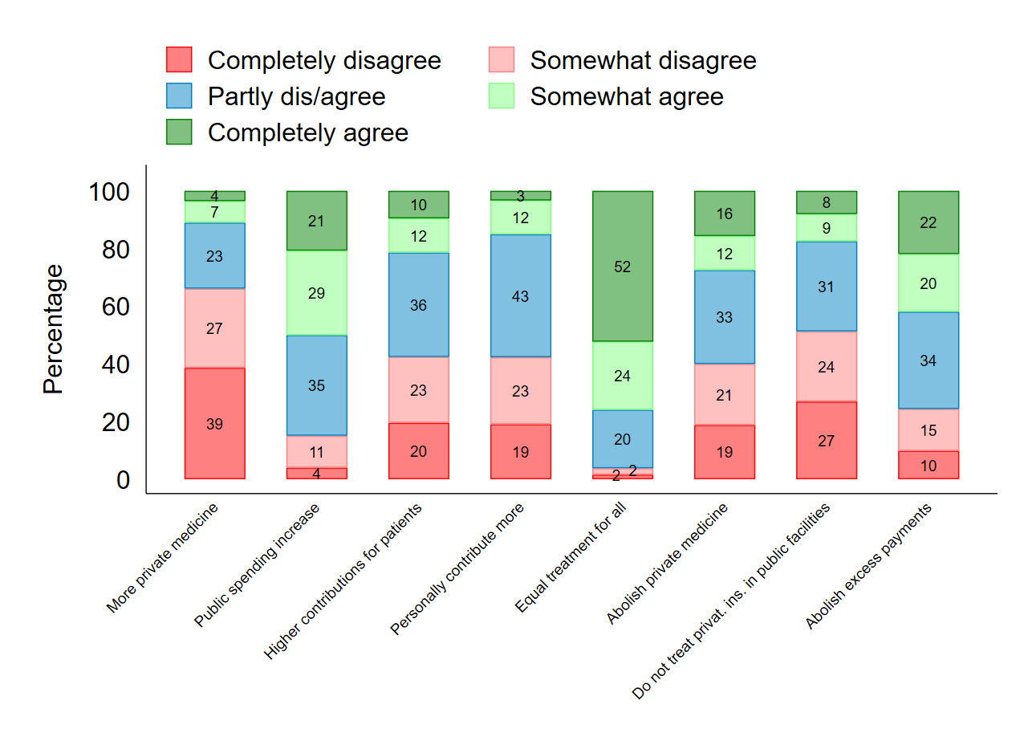
Figure A1: Redistribution preferences in health care (with demographic & political sample weights).

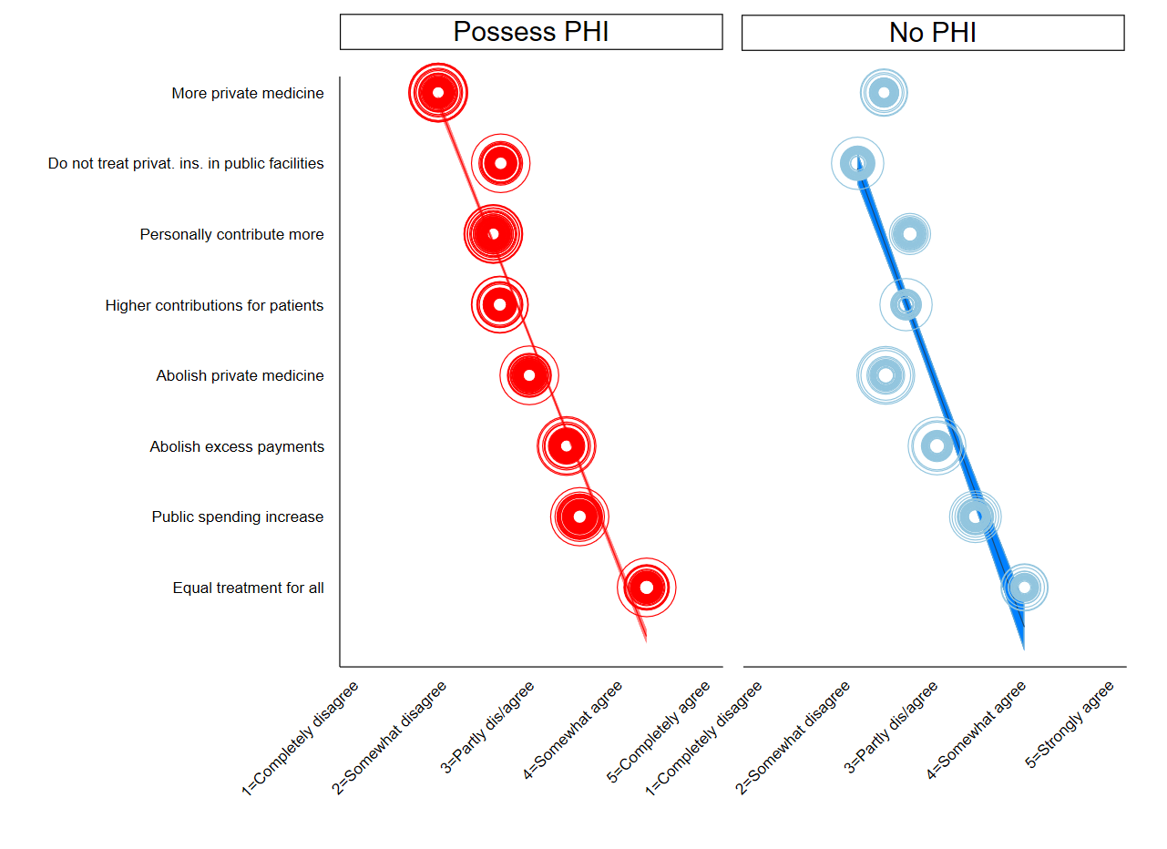
Figure A2: Ordered mean dis/agreement of redistribution preferences with trend-lines and 95% confidence intervals (with demographic and political sample weights).

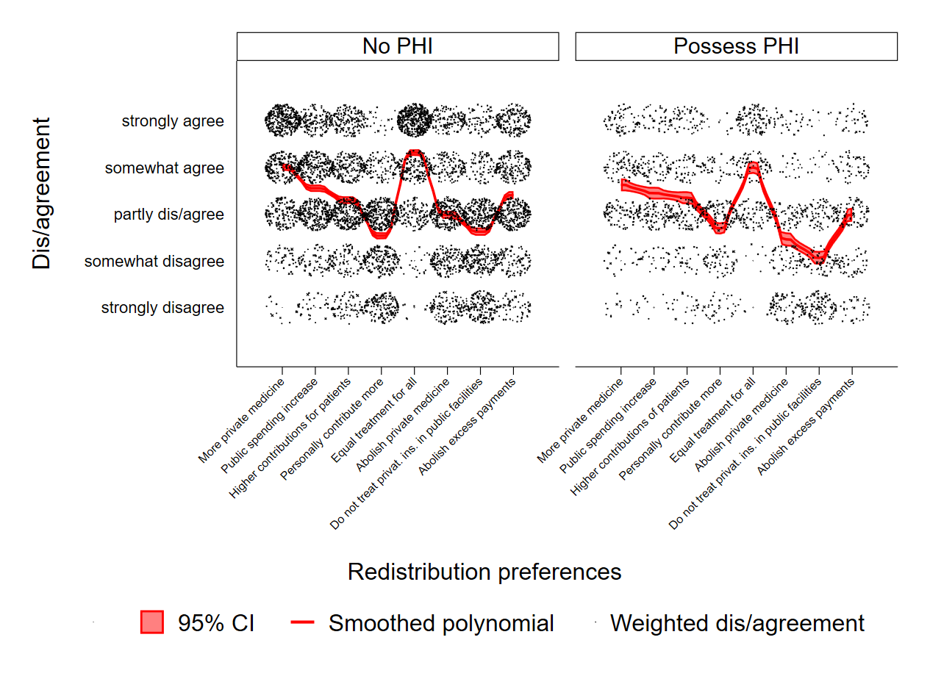
Figure A3: Dis/agreement of redistribution preferences with polynomial trend-lines and 95% confidence intervals (with demographic and political sample weights).

Additive index of eight redistribution preferences in health care

For the additive index all signs are reversed except for ‘More private medicine’ and ‘Higher contributions for patients’.
Weighted mean: 3.267
Weighted Minimum: 1.250
Weighted Maximum: 5.000

Index validation
Multiple/Joint correspondence analysis (MCA) with Burt/adjusted inertias yields that the eight redistribution preferences load on the first dimension with 61.33% (principal inertia are 0.081 of 0.133). The respective MCA coordinate plot visualises the results for the first two dimensions (Fig. A4).
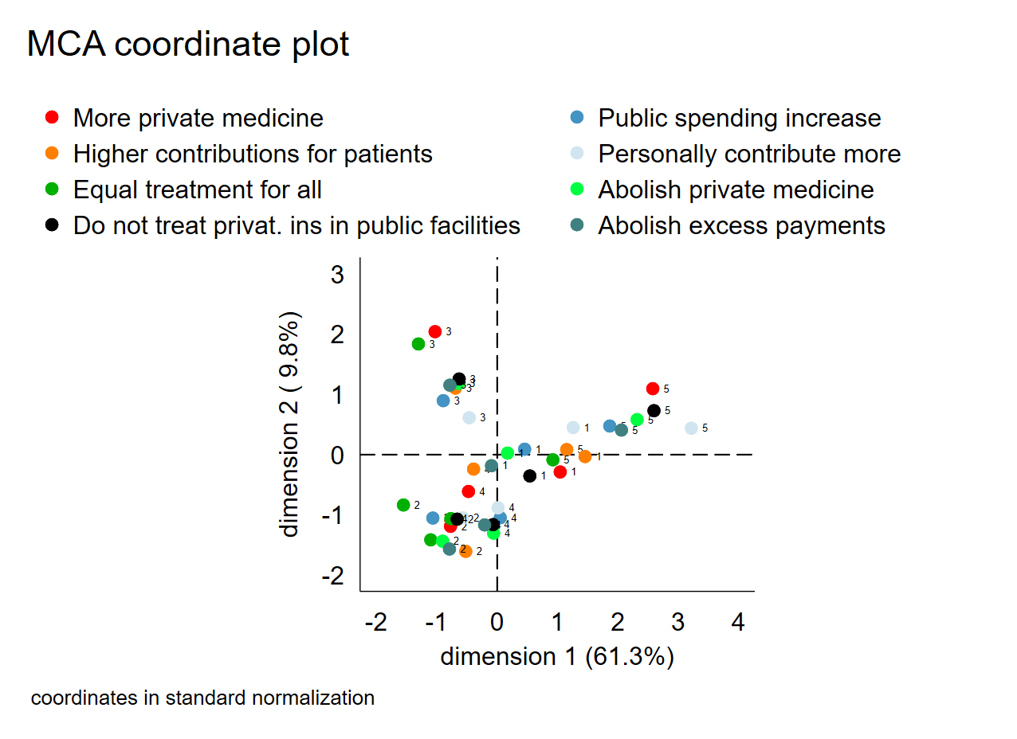
Figure A4: Multiple/Joint correspondence analysis (MCA) coordinate plot. 1=Completely disagree, 2=Somewhat disagree, 3=Partly dis/agree, 4=Somewhat agree, 5=Completely agree.
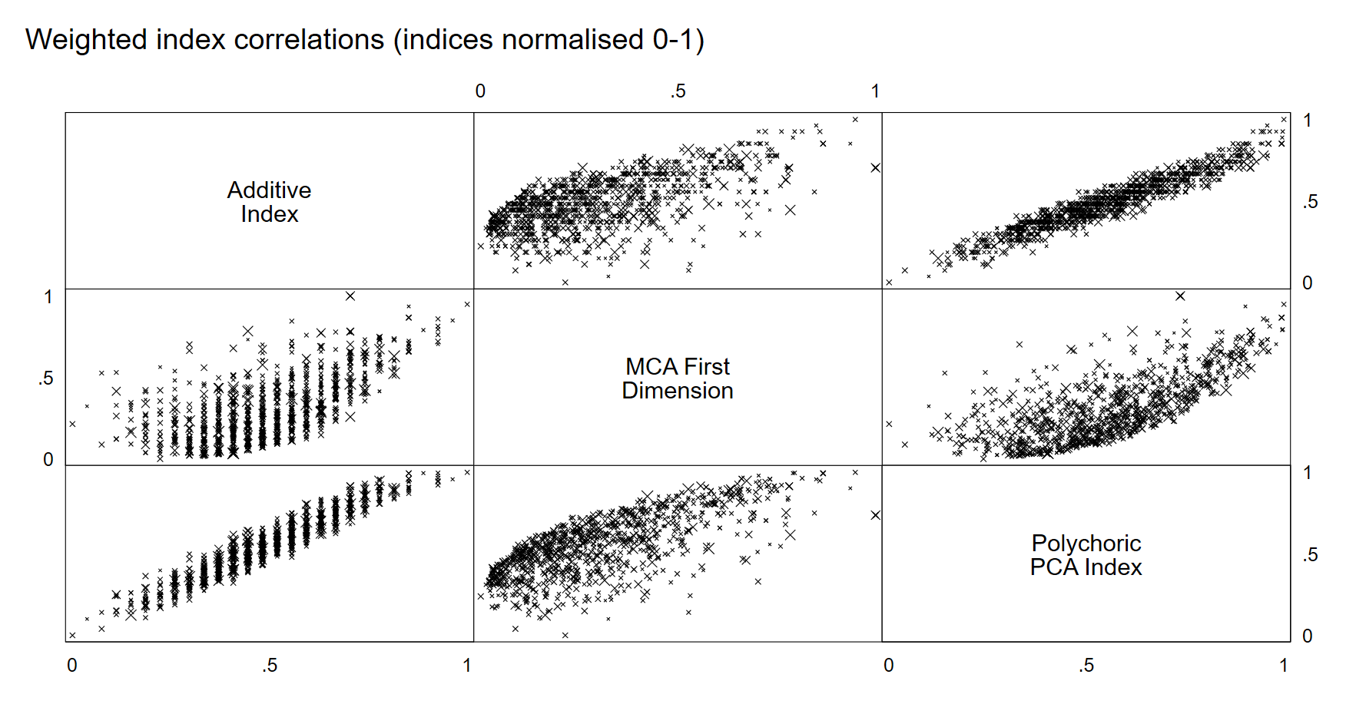Figure A5: Correlation-Matrix of three index measures of redistribution preferences in health care (with demographic & political sample weights).
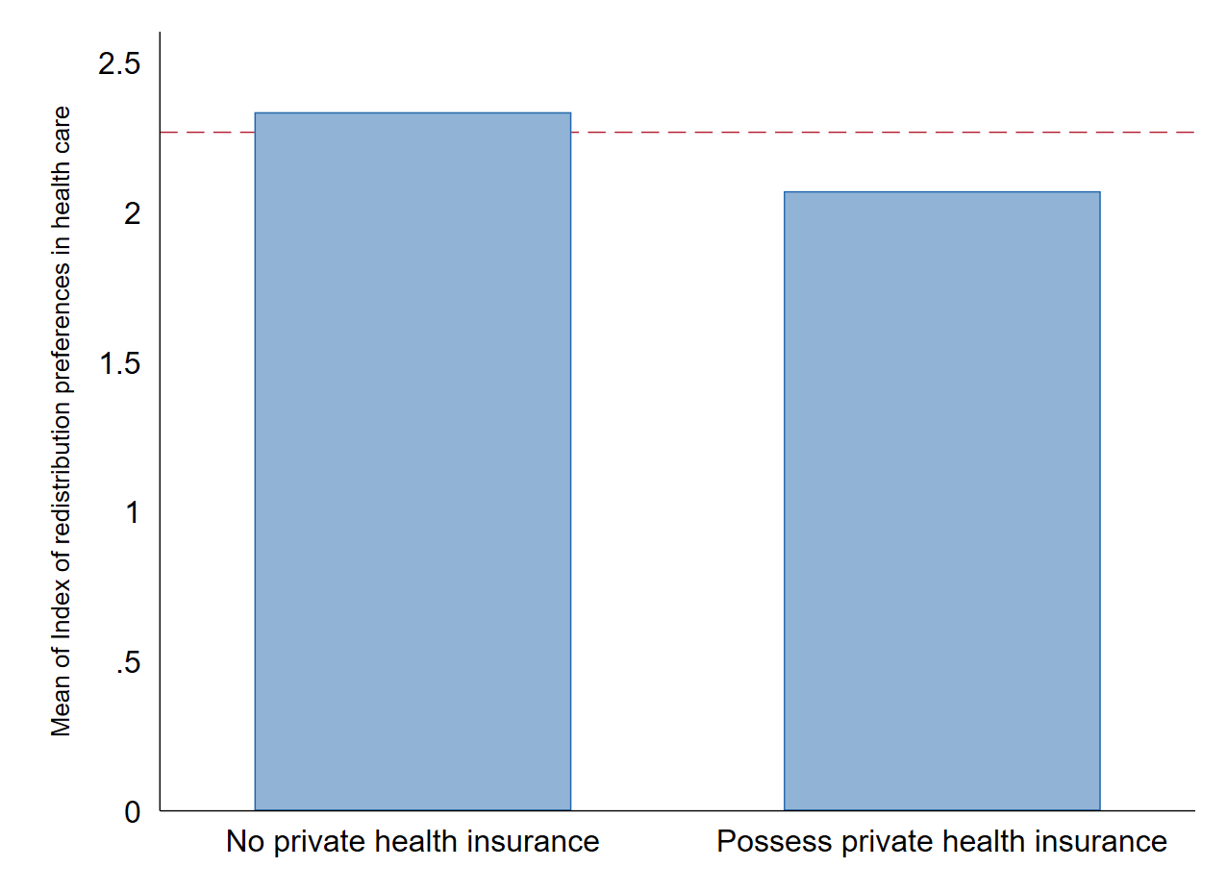
Fig. A6: Means of redistribution preferences in health care (Additive index, with demographic & political sample weights, red dotted line shows weighted mean).

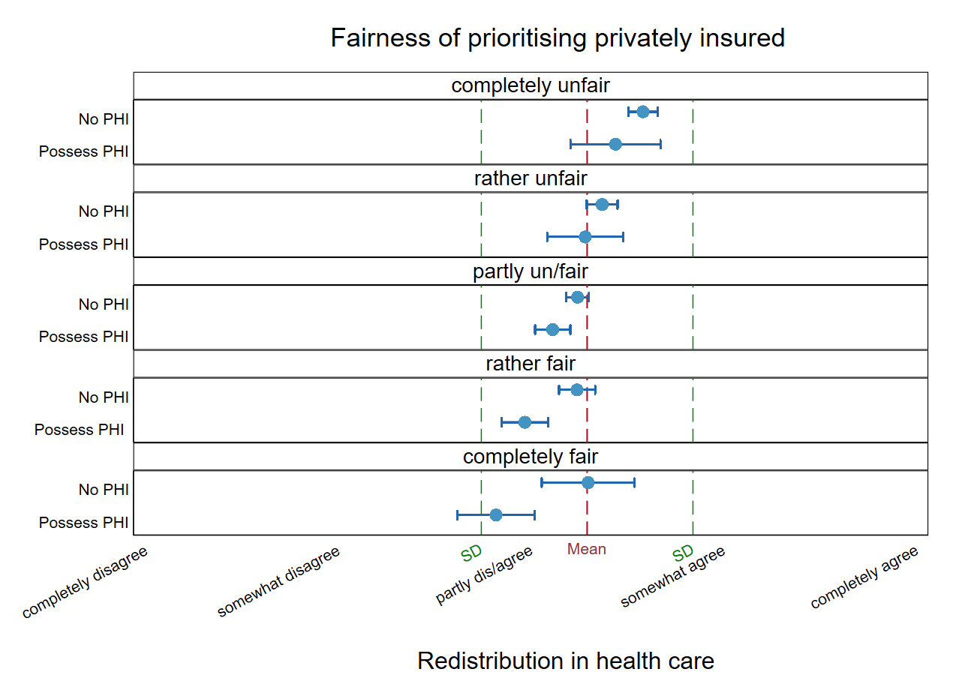

Fig. A7: Distributions of dis/agreement to redistribution preferences in health care (additive index) grouped by insurance status and fairness attitudes.

Robustness checks

Table A2 : GSEM with CFA
Latent dependent variable: Redistribution preferences in health care

 | GSEM
Possess PHI | -0.192***
 | (0.05)
Fairness of prioritising privately insured | -0.140***
 | (0.02)
Trust in public health care system | 0.064**
 | (0.02)
Trust in government | -0.141***
 | (0.02)
Party preference for left-wing | 0.109*
 | (0.04)
Party preference for conservatives, liberals, right-wing | Reference
Other/No party preference | 0.069
 | (0.05)
Government responsibility | 0.131***
 | (0.02)
Social redistribution | 0.035
 | (0.02)
Health risk for Austrian population | 0.041*
 | (0.02)
df | 30
AIC | 21543.35
BIC | 21691.38
N | 1027
* p < 0.05, ** p < 0.01, *** p < 0.001

Table A3 : OLS Regressions
Dependent Variable: Polychoric PCA index of redistribution preferences
Demographic & political sample weights
 | Baseline Model | Fairness Model | Auxiliary Model | Full Model | Interaction Model
 | b/se | b/se | b/se | b/se | b/se
Possess PHI | -0.674*** | -0.452*** |  | -0.462***
 | (0.11) | (0.12) |  | (0.11)
Fairness of prioritising privately insured |  | -0.361*** |  | -0.319***
 |  | (0.06) |  | (0.06)
Trust in public health care system |  |  | 0.051 | 0.047 | 0.034
 |  |  | (0.07) | (0.07) | (0.07)
Trust in government |  |  | -0.293*** | -0.248*** | -0.246***
 |  |  | (0.07) | (0.07) | (0.07)
Party preference for left-wing |  |  | 0.237 | 0.216 | 0.192
 |  |  | (0.13) | (0.12) | (0.12)
Party preference for conservatives, liberals, right-wing |  |  | Reference | Reference | Reference
Other/No party preference |  |  | 0.207 | 0.171 | 0.182
 |  |  | (0.15) | (0.14) | (0.14)
Government responsibility |  |  | 0.275*** | 0.269*** | 0.270***
 |  |  | (0.06) | (0.06) | (0.07)
Social redistribution |  |  | 0.114* | 0.099 | 0.101*
 |  |  | (0.05) | (0.05) | (0.05)
Health risk for Austrian population |  |  | 0.169** | 0.147* | 0.148*
 |  |  | (0.06) | (0.06) | (0.06)
Do not possess PHI X Fairness of prioritising privately insured |  |  |  |  | -0.330***
 |  |  |  |  | (0.07)
Possess PHI X Fairness of prioritising privately insured |  |  |  |  | -0.475***
 |  |  |  |  | (0.10)
Constant | 0.129* | 0.096 | -0.141 | 0.011 | -0.084
 | (0.07) | (0.06) | (0.07) | (0.08) | (0.08)
R-sqr | 0.047 | 0.111 | 0.099 | 0.193 | 0.175
dfres | 1025 | 1024 | 1019 | 1017 | 1017
BIC | 3508.5 | 3443.7 | 3492.9 | 3393.9 | 3416.5
N | 1027 | 1027 | 1027 | 1027 | 1027
* p < 0.05, ** p < 0.01, *** p < 0.001 (All VIFs are below 2)

The ACPP questions (Wave 22) used for this article (in English translation) are available here:
https://viecer.univie.ac.at/en/projects-and-cooperations/austrian-corona-panel-project/austrian-corona-panel-data/questionnaires/

