Extended Figure 1 Breeding of perennial rice. JH refers to Jinghong station in Yunnan, China. HN refers to Hainan station in Sanya, Hainan, China. FS, first (i.e., hot and dry) season in double-crop region. WC or WS, second (i.e. cool and wet) season in double-crop region. Red font indicates the different generations. SP1 is Oryza sativa spp. indica ‘RD23’ (P1), SP2 is Oryza longistaminata (P2), and SP3 is RD23 / O. longistaminata (F₁). SP4 to SP11 are single individuals selected from the previous generation, with both good fertility and good rhizome characteristics. Yellow boxes indicate O. sativa, purple box indicates O. longistaminata, blue boxes indicate interspecific breeding lines, and orange boxes indicate interspecific cultivars.

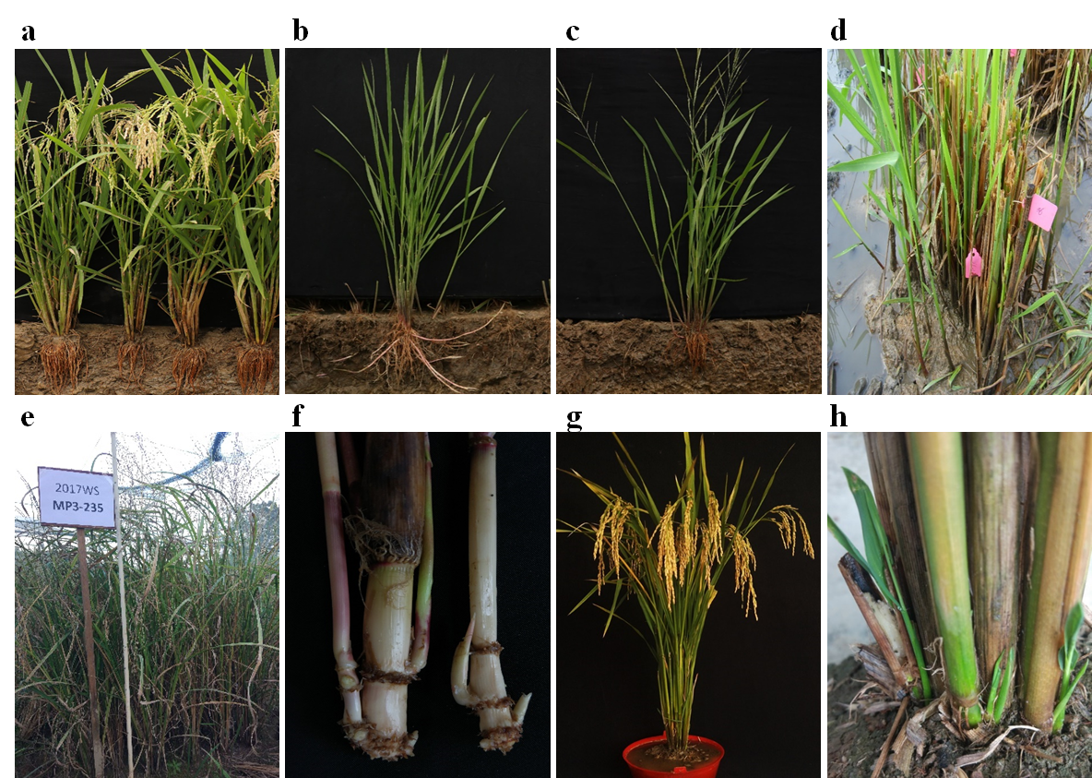
Extended Figure 2 Selecting elite breeding lines of perennial rice with strong perenniality. a, O. sativa ‘RD23’ as female parent. b, O. longistaminata as male parent. c, F₁ (interspecific hybrid between RD23 and O. longistaminata). d, 36-1 (F₂ individual, was derived from F₁).e-f, MP3-235 (an F9 individual chosen as a breeding line donor of perenniality for breeding), with desirable short rhizomes, but showing other undesirable agronomic traits, including plant height over 2 m and strong seed shattering. g, Perennial Rice cultivar PR107 at maturity. h, PR107 regrowth after 3 days of harvest.

Extended Figure 3 Changes in agronomic traits over generations of breeding perennial rice. a, Rhizome number (pl⁻¹). b, Rhizome length (cm). c, Pollen fertility (%). d, Plant height (cm). e, Tiller number (pl⁻¹). f, Grain number (pl⁻¹). g, seed setting rate (%) h, Panicle length (cm). i, Grain weight (mg). P1, O. sativa ‘RD23’ as female parent (red). P2, O. longistaminata as male parent (blue). F₁-F₉ (black).
Extended Figure 4 Comparison of grain yield and agronomic traits of perennial rice cultivar PR23 from a single planting and replanted annual rice seasonally over five years with 10 seasons during 2016-2020. The experiment was conducted at three field trial locations in Yunnan, China: Mengzhe (MZ; 21°57′N, 100°14′E, elevation 1255 m), Xinping (XP; 24°02′N, 101°34′E, elevation 760 m) and Menglian (ML; 22°33′N, 99°59′E, elevation 980 m). a-c, Grain yield of annual rice replanted from seed each season and perennial rice planted once in 2016 at three field trial locations in Yunnan, China (Mg ha⁻¹). d, Duration of perennial rice (d). e, Regrowth rate of perennial rice (%). f, Panicle number m⁻² of perennial rice. g, Spikelet number panicle⁻¹ of perennial rice. h, Grain weight of perennial rice (mg). i, Seed setting rate of perennial rice (%). F1 to F5 represent the first season of year 1 to year 5, S1 to S5 represent the second season of year 1 to year 5. The elite annual rice for Mengzhe, Xinping and Menglian were Diantun502, Wenfu6 and Yunhui290, respectively and all of these three locations are double cropping paddy area. The data were from experiment 3, see Extended Table 5.
.
Extended Figure 5 Grain yield and agronomic traits of perennial rice cultivar PR25 over 3 years at six locations. a, Grain yield (Mg ha⁻¹). b, Duration (d). c, Plant height (cm). d, Regrowth rate (%). e, Panicle number m⁻². f, Spikelet number panicle⁻¹. g, Grain weight (mg). h, Seed setting rate (%). Field trial locations were double cropping paddy area: Jinghong (JH; 21°59′N, 100°44′E, elevation 550 m), Menglian (ML; 22°33′N, 99°59′E, elevation 960 m), Mengzhe (MZ; 21°57′N, 100°14′E, elevation 1255 m), Xinping (XP; 24°02′N, 101°34′E, elevation 600 m) and single cropping paddy area: Wenshan (WS; 23°23′N, 104°13′E, elevation 1260m) and Yiliang (YL; 24°54′N, 103°09′E, 1600 m). F1 to F3 represent the first season of year 1 to year 3, S1 to S3 represent the second season of year 1 to year 3. The data were from experiment 4, in Extended Table 6.
Extended Figure 6 Grain yield and agronomic traits of perennial rice cultivar PR107 over two years at five locations. a, Grain yield (Mg ha⁻¹). b, Duration (d). c, Plant height (cm). d, Regrowth rate (%). e, Panicle number m⁻². f, Spikelet number panicle⁻¹. g, Grain weight (mg). h, Seed setting rate (%). Field trial locations (locations) were double cropping paddy area: Jinghong (JH; 21°59′N, 100°44′E, elevation 550 m), Menglian (ML; 22°33′N, 99°59′E, elevation 960 m), Mengzhe (MZ; 21°57′N, 100°14′E, elevation 1255 m), Xinping (XP; 24°02′N, 101°34′E, elevation 600 m) and single cropping paddy area: Lancang (LC; 22°26′N, 99°58′E , elevation 1020 m). F1 to F2 represent the first season of year 1 to year 2, S1 to S2 represent the second season of year 1 to year 2. The data were from experiment 4, in Extended Table 6.
Extended Figure 7 Comparisons of social-economic benefits between perennial rice (PR) and annual rice (AR) cropping systems over five years with ten seasons. The experiment was conducted at three field trial locations in Yunnan, China: Mengzhe (MZ; 21°57′N, 100°14′E, elevation 1255 m), Xinping (XP; 24°02′N, 101°34′E, elevation 760 m) and Menglian (ML; 22°33′N, 99°59′E, elevation 980 m). a-c, Labour cost ($). d-f, Non-labour cost ($). g, Labour number input (d). h, Output (gross income $). i, Net economic gain ($). In rice production, the economic cost includes labour and non-labour cost. Labour cost includes mainly seedling, plowing, transplanting, crop management and harvest. Non-labour cost includes mainly seed, pesticides, herbicides, fertilizer. The output refers to the gross income from grain sales. The net economic gain equals output minus total cost. For annual rice, seed, plowing, seeding, transplanting, crop management and harvest are all needed in each season. For perennial rice, seed, plowing, seeding, transplanting, crop management and harvest are all needed in the first season that was similar to annual rice; however, in the subsequent seasons, regrowth of the plants is accomplished by regrowth, and thus seed, seedling, plowing and transplanting are not performed, resulting in considerable savings of money and labour. 1 US$ =6.4 China Yuan, the date for exchange was due to the rate of 4 Nov 2021.. The data were from experiment 3, and Extended Table 7.

Extended Figure 8 Differences in soil structure and nutrients between perennial rice (PR) and annual rice (AR) cropping systems. a, pH. b, Soil bulk density (g cm⁻³). c, Soil porosity (%). d, Capillary porosity (%). e, Noncapillary porosity (%). f, Porosity ratio. g, Soil water capacity (%). h, Soil statured water (%). i, Wilting soil water (%). j, SOC distribution (g kg⁻¹). k, Soil nitrogen distribution (TN) (g kg⁻¹). l, C/N. Horizonal bars represent the standard error of different treatments. P<0.05 represent significant difference at P<0.05. ns represents non-significant. AR, annual rice. PR-2y, PR-3y and PR-4y are perennial rice year 2, perennial rice year 3 and perennial rice year 4, respectively. The data were from experiment 3, and Extended Table 8.

Extended Figure 9 The effect of low temperature and its duration on the regrowth of perennial rice. a, The relationship between regrowth rate of perennial rice 23 and average monthly temperature in January. The data derived from Yuanjiang, Jinghong, Lancang, Wenshan, Simao, Yiliang and Baoshan locations, Yunnan Province, Yudu location Jiangxi Province, Congjiang location, Guizhou Province, Shangsi and Guanyang locations, Guangxi Province in 2016-2017. The regrowth rate of perennial rice had a significant quadratic correlation with monthly average temperature of January 2017 (R²=0.73*, P<0.05). b, The effect of low temperature and its duration on regrowth rate of perennial rice 23. D3, D5 and D7 referred to the duration of low temperature condition were 3, 5 and 7 days, respectively. The data derived from experiment 5, Extended Tables 10 and 11.

