Additional file 1
Additional file 1 Index:
- Questionnaire’s sections
- Figure S1. Summary of the answers to the COVID-19 medical knowledge questions among the fourth-, fifth- and sixth-year medical students.
- Figure S2. Summary of the COVID-19 Medical Knowledge Score (max=5 points) among the fourth-, fifth- and sixth-year medical students.
- Figure S3. Summary of the answers to the COVID-19 clinical judgment cases among the fourth-, fifth- and sixth-year medical students.
- Figure S4. Summary of the COVID-19 Clinical Judgment Score (max=5 points) among the fourth-, fifth- and sixth-year medical students.
- Figure S5. Comparison between the results of the Overall Score (max=10 points) of the final-year participants according to the participants' university.
- Table S1. Correlation between the Medical Knowledge Score and each of the university and English level of the final (sixth)-year participants.
- Table S2. Correlation between the Clinical Judgment Score and each of year of the study between the sixth and fourth-year students, the university and English level of the final (sixth)-year participants.
- Table S3. Correlation between the overall score and each of the university and English level of the final (sixth)-year participants.
- Table S4. Sixth-year participants’ answers regarding their willingness to volunteer, fear of being infected, ability to manage airways and do mechanical ventilation, need for supervision, knowledge of the preventive measures and having previous clinical training.
- Table S5. Summary of the correlation between the studied variables of the preparedness and willingness of the final-year medical students to be integrated into healthcare systems (year of the study, willingness to volunteer, fear of being infected, ability to manage airways and do mechanical ventilation, need for supervision, and knowledge of the preventive measures)
Questionnaire’s sections:

The first section: Written informed consent and general information
Information regarding age, gender, governorate, university, year of study, the last clinical training and English level of the participants were collected in this section after giving their written informed consent to participate.

The second section: General knowledge
This section included questions that aimed to evaluate students’ in-depth knowledge about SARS-CoV-2. Participants had to answer five true/false questions with an additional “uncertain” option. Each right answer was given one point with a maximum score of 5 points. An additional final question was about the sources of information that the student used to rely on.

The third section: Clinical judgment
This section included five COVID-19-related clinical scenarios presented as case studies. The participants were asked to select all the appropriate options for approaching each scenario. And one point was given for each question if the participant selected all the right options, while zero points were given for an incorrect or incomplete answer. A maximum score of 5 points was obtained in this section.

The fourth section: Preparedness and willingness
Nine questions were presented in this section with the aim to investigate the students’ own perspective about their ability to interfere, their willingness to volunteer with medical teams, their ability to perform first aid airway management and to have a basic understanding of mechanical ventilation, having fears of the infection, and their need for supervision. Final two questions about previous experience and required preventive measures in certain settings were asked in this section as well. The estimated time needed to complete the questionnaire was requested to be marked on the last page.

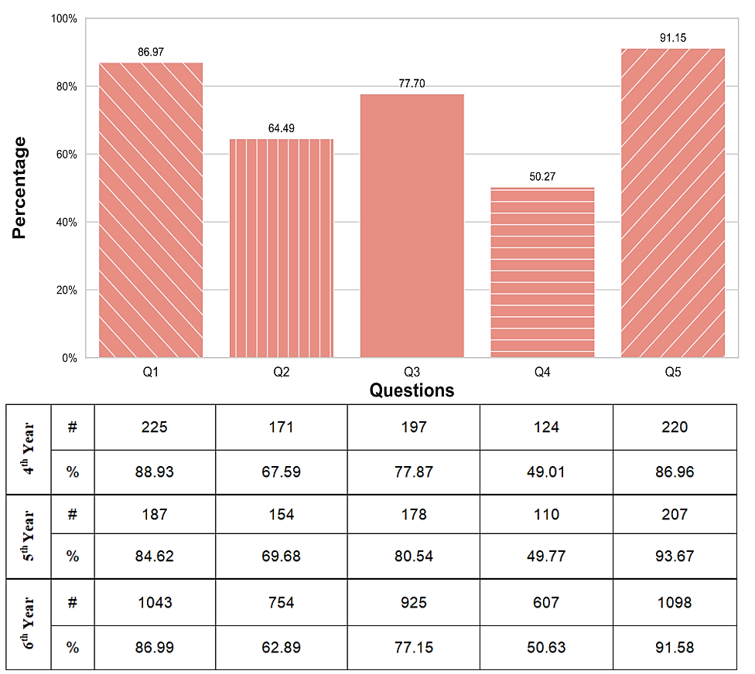

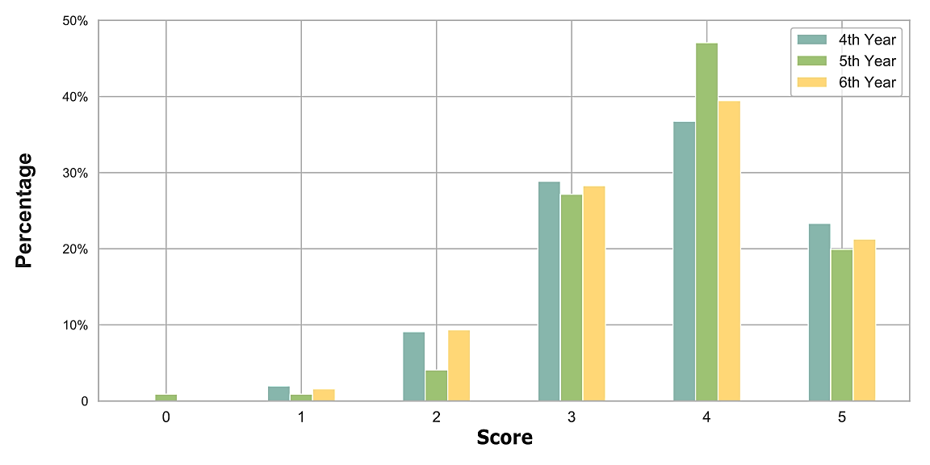
Figure S1. Summary of the answers to the COVID-19 medical knowledge questions among the fourth-, fifth- and sixth-year medical students.
Figure S2. Summary of the COVID-19 Medical Knowledge Score (max=5 points) among the fourth-, fifth- and sixth-year medical students.
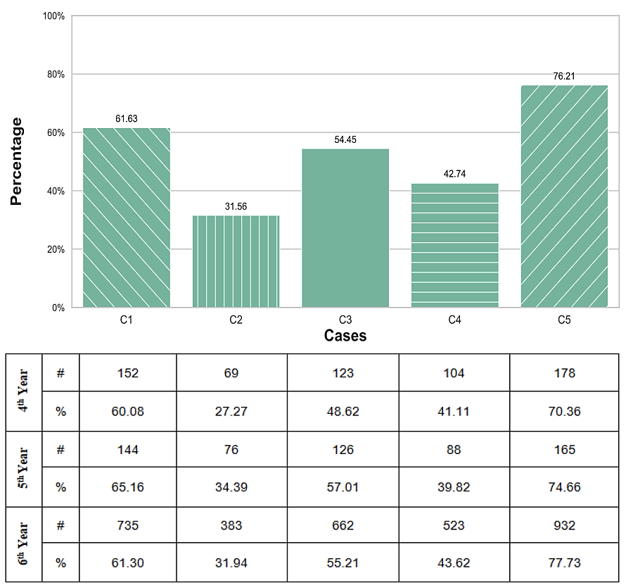

Figure S3. Summary of the answers to the COVID-19 clinical judgment cases among the fourth-, fifth- and sixth-year medical students.
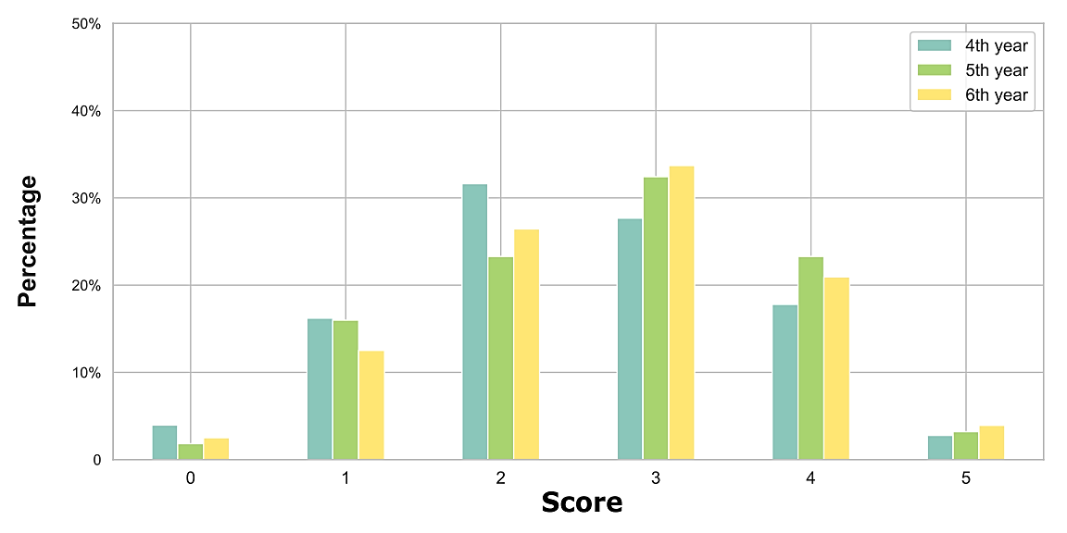
Figure S4. Summary of the COVID-19 Clinical Judgment Score (max=5 points) among the fourth-, fifth- and sixth-year medical students.

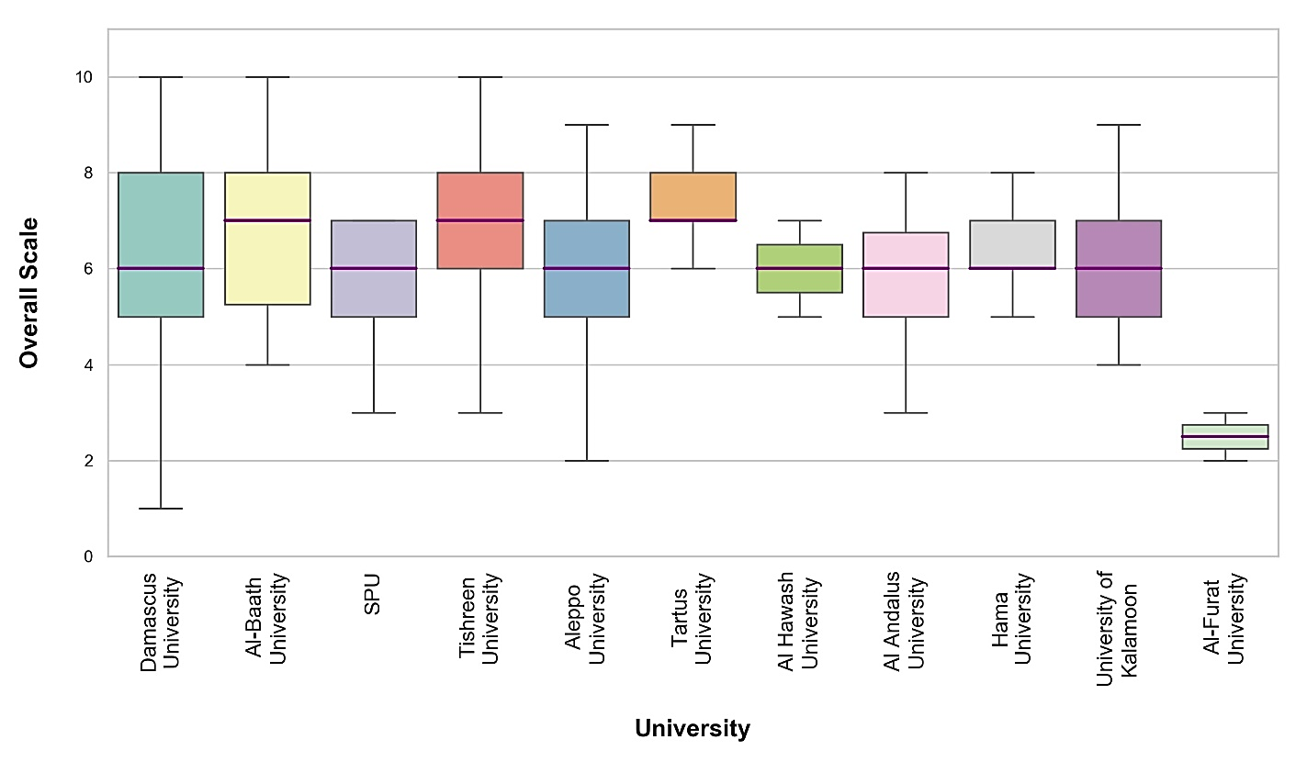

Figure S5. Comparison between the results of the Overall Score (max=10 points) of the final-year participants according to the participants' university.

General Knowledge Score
Adjusted P-value | Difference between the means | 95% CI |  | Comparison
Adjusted P-value | Difference between the means | Upper | Lower
0.02 | -2.36 | -0.16 | -4.56 | Al Furat - Al Baath | Universities of sixth-year students
0.02 | 2.50 | 4.80 | 0.19 | Hama – Al Furat | Universities of sixth-year students
0.006 | 2.72 | 5.01 | 0.42 | Tartus – Al Furat | Universities of sixth-year students
0.02 | 2.38 | 4.57 | 0.19 | Tishreen – Al Furat | Universities of sixth-year students
0.01 | -0.29 | -0.04 | -0.53 | Beginner - Advanced | English Level of sixth-year students
Table S1. Correlation between the Medical Knowledge Score and each of the university and English level of the final (sixth)-year participants.
The results in this table represent the final sub-analysis of significant factors with Tukey HSD test. Abbreviations: CI: Conference Interval.

Clinical Judgment Score
Adjusted P-value | Difference between the means | 95% CI |  |  | Comparison
Adjusted P-value | Difference between the means | Upper |  | Lower
0.01 | 0.22 | 0.40 |  | 0.03 | Sixth year – Fourth year | Year of study
0.01 | -0.32 | -0.04 |  | -0.61 | Beginner - Advanced | English level of sixth-year students
- | - |  | - | - | Could not define significant difference using Tukey HSD test | Universities of sixth-year students
Table S2. Correlation between the Clinical Judgment Score and each of year of the study between the sixth and fourth-year students, the university and English level of the final (sixth)-year participants.
The results in this table represent the final sub-analysis of significant factors with Tukey HSD test. Abbreviations: CI: Conference Interval.

Table S3. Correlation between the overall score and each of the university and English level of the final (sixth)-year participants.
Overall Score
Adjusted P-value | Difference between the means | 95% CI |  | Comparison
Adjusted P-value | Difference between the means | Upper | Lower
0.016 | 3.90 | 7.43 | 0.36 | Damascus – Al Furat | Universities of sixth-year students
0.042 | 3.79 | 7.52 | 0.06 | Hamah – Al Furat | Universities of sixth-year students
0.001 | 4.88 | 8.61 | 1.16 | Tartus – Al Furat | Universities of sixth-year students
0.006 | 4.21 | 7.76 | 0.65 | Tishreen – Al Furat | Universities of sixth-year students
0.016 | 1.36 | 2.60 | 0.12 | Tartus - Aleppo | Universities of sixth-year students
0.005 | 0.68 | 1.25 | 0.11 | Tishreen – Aleppo | Universities of sixth-year students
0.007 | -4.19 | -0.62 | -7.76 | Al Baath - Al Furat | Universities of sixth-year students
0.05 | -0.67 | -0.0002 | -1.34 | Al Baath - Aleppo | Universities of sixth-year students
<0.001 | -0.619 | -0.22 | -1.01 | Beginner - Advanced | English Level of sixth-year students
0.02 | -0.27 | 0.70 | -0.52 | Advanced - Intermediate | English Level of sixth-year students
The results in this table represent the final sub-analysis of significant factors with Tukey HSD test. Abbreviations: CI: Conference Interval.

Number (%) |  | Variables
Sixth-year | Overall
682 (56.88) | 963 (57.56) | Yes |  | Willing to volunteer
402 (33.53) | 560 (33.47) | Hesitant |  | Willing to volunteer
115 (9.59) | 150 (8.96) | No |  | Willing to volunteer
678 (56.55) | 898 (53.67) | Yes |  | Having fears of being infected
142 (11.84) | 202 (12.07) | Not sure |  | Having fears of being infected
379 (31.61) | 573 (34.24) | No |  | Having fears of being infected
153 (12.76) | 217 (12.97) | Yes |  | Ability to manage the airways and do mechanical ventilation
377 (31.44) | 526 (31.44) | Not sure |  | Ability to manage the airways and do mechanical ventilation
669 (55.80) | 930 (55.58) | No |  | Ability to manage the airways and do mechanical ventilation
1091 (90.99) | 1507 (90.07) | Correct | Yes | Need for supervision
64 (5.34) | 103 (6.15) | Incorrect | Yes | Need for supervision
44 (3.67) | 63 (3.76) | No |  | Need for supervision
707 (58.97) | 975 (58.27) | Correct | Yes | Knowing the prevention protocols
329 (27.44) | 477 (28.51) | Incorrect | Yes | Knowing the prevention protocols
163 (13.59) | 221 (13.20) | No |  | Knowing the prevention protocols
628 (52.38) | 870 (52) | Yes |  | Having previous clinical experience
571 (47.62) | 803 (48.99) | No |  | Having previous clinical experience
Table S4. Sixth-year participants’ answers regarding their willingness to volunteer, fear of being infected, ability to manage airways and do mechanical ventilation, need for supervision, knowledge of the preventive measures and having previous clinical training.

Table S5. Summary of the correlation between the studied variables of the preparedness and willingness of the final-year medical students to be integrated into healthcare systems (year of the study, willingness to volunteer, fear of being infected, ability to manage airways and do mechanical ventilation, need for supervision, and knowledge of the preventive measures)
P-Value | Variable
0.34 | Willing to volunteer vs. Year of study
<0.001 | Willing to volunteer vs. The ability to manage airways and do mechanical ventilation
<0.001 | Having fears of being infected vs. Year of study
<0.001 | Having fears of being infected vs. Willing to volunteer
<0.001 | Need of supervision vs. The ability to manage airways and do mechanical ventilation
<0.001 | Need of supervision vs. Having fears of being infected
0.95 | Required preventive measures vs. Having fears of being infected
0.052 | Required preventive measures vs. Willing to volunteer
0.058 | Required preventive measures vs. The ability to manage airways and do mechanical ventilation

